Natural Disasters Data Report

# Trend of Natural Disasters Over the Years

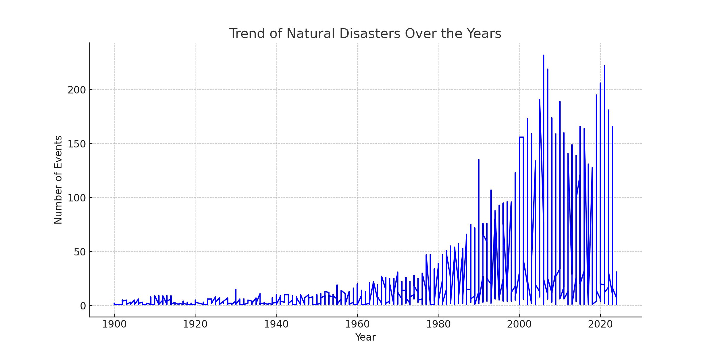

# Boxplot of Number of Natural Disaster Events by Year

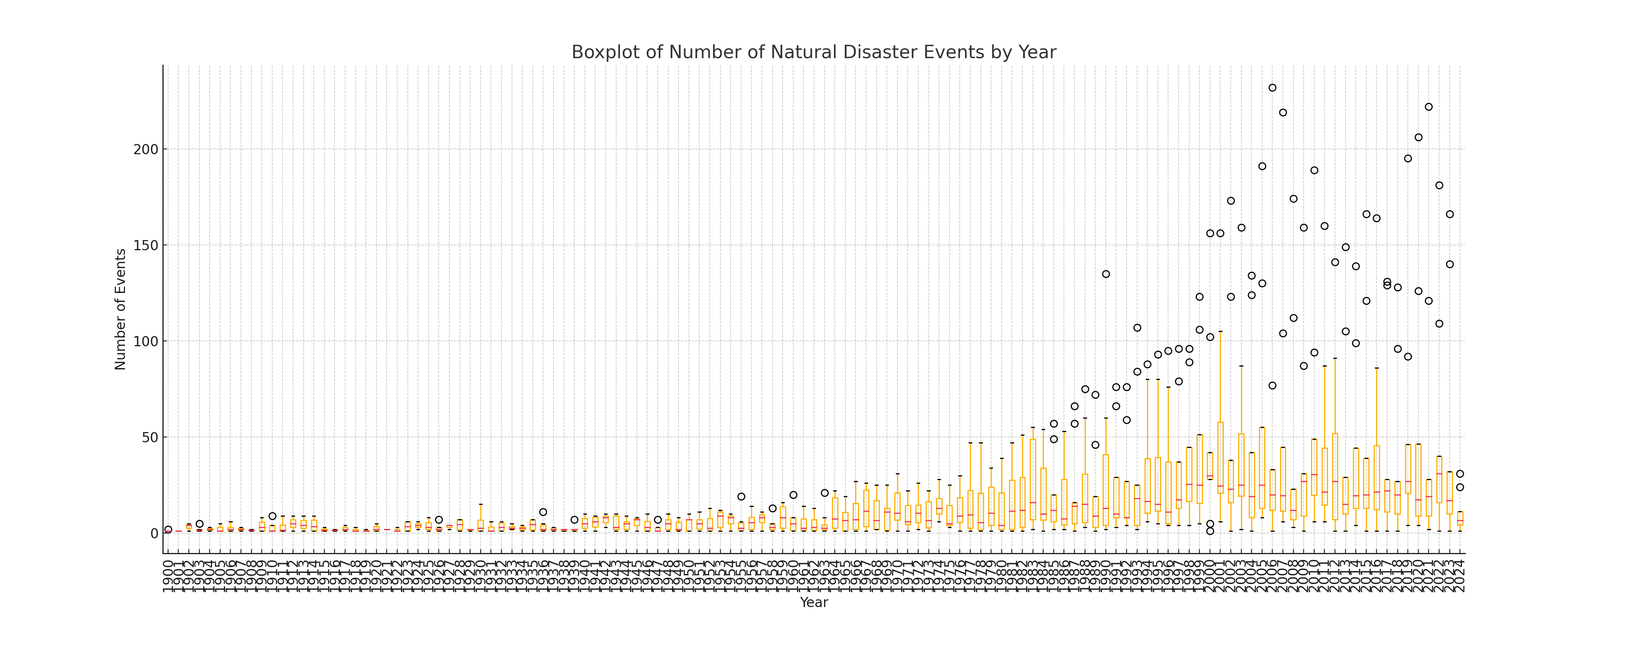

# Percentage of Total Natural Disaster Events by Type

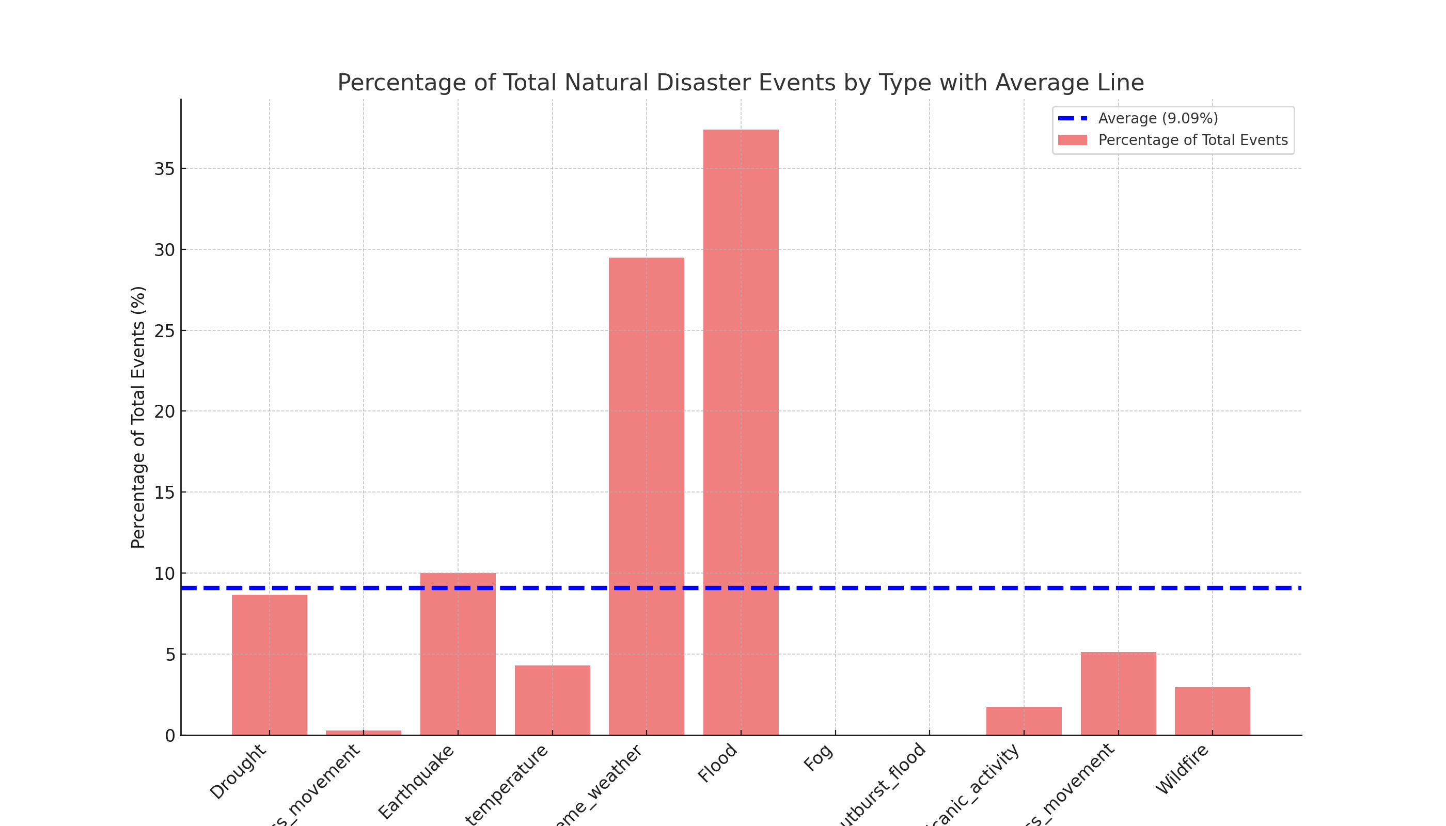

# Correlation Analysis

|  |  |  |
| --- | --- | --- |
| Disaster | Compared With | Correlation Coefficient |
| Drought | Drought | 1.00 |
| Dry_mass_movement | Drought | 0.39 |
| Earthquake | Drought | 0.79 |
| Extreme_temperature | Drought | 0.67 |
| Extreme_weather | Drought | 0.79 |
| Flood | Drought | 0.76 |
| Fog | Drought | -0.08 |
| Glacial_lake_outburst_flood | Drought | 0.19 |
| Volcanic_activity | Drought | 0.69 |
| Wet_mass_movement | Drought | 0.79 |
| Wildfire | Drought | 0.78 |
| Drought | Dry_mass_movement | 0.39 |
| Dry_mass_movement | Dry_mass_movement | 1.00 |
| Earthquake | Dry_mass_movement | 0.35 |
| Extreme_temperature | Dry_mass_movement | 0.20 |
| Extreme_weather | Dry_mass_movement | 0.37 |
| Flood | Dry_mass_movement | 0.23 |
| Fog | Dry_mass_movement | -0.04 |
| Glacial_lake_outburst_flood | Dry_mass_movement | -0.07 |
| Volcanic_activity | Dry_mass_movement | 0.36 |
| Wet_mass_movement | Dry_mass_movement | 0.29 |
| Wildfire | Dry_mass_movement | 0.20 |
| Drought | Earthquake | 0.79 |
| Dry_mass_movement | Earthquake | 0.35 |
| Earthquake | Earthquake | 1.00 |
| Extreme_temperature | Earthquake | 0.72 |
| Extreme_weather | Earthquake | 0.89 |
| Flood | Earthquake | 0.82 |
| Fog | Earthquake | 0.00 |
| Glacial_lake_outburst_flood | Earthquake | 0.24 |
| Volcanic_activity | Earthquake | 0.69 |
| Wet_mass_movement | Earthquake | 0.78 |
| Wildfire | Earthquake | 0.79 |
| Drought | Extreme_temperature | 0.67 |
| Dry_mass_movement | Extreme_temperature | 0.20 |
| Earthquake | Extreme_temperature | 0.72 |
| Extreme_temperature | Extreme_temperature | 1.00 |
| Extreme_weather | Extreme_temperature | 0.74 |
| Flood | Extreme_temperature | 0.83 |
| Fog | Extreme_temperature | -0.05 |
| Glacial_lake_outburst_flood | Extreme_temperature | 0.13 |
| Volcanic_activity | Extreme_temperature | 0.58 |
| Wet_mass_movement | Extreme_temperature | 0.73 |
| Wildfire | Extreme_temperature | 0.69 |
| Drought | Extreme_weather | 0.79 |
| Dry_mass_movement | Extreme_weather | 0.37 |
| Earthquake | Extreme_weather | 0.89 |
| Extreme_temperature | Extreme_weather | 0.74 |
| Extreme_weather | Extreme_weather | 1.00 |
| Flood | Extreme_weather | 0.92 |
| Fog | Extreme_weather | -0.06 |
| Glacial_lake_outburst_flood | Extreme_weather | 0.29 |
| Volcanic_activity | Extreme_weather | 0.74 |
| Wet_mass_movement | Extreme_weather | 0.87 |
| Wildfire | Extreme_weather | 0.82 |
| Drought | Flood | 0.76 |
| Dry_mass_movement | Flood | 0.23 |
| Earthquake | Flood | 0.82 |
| Extreme_temperature | Flood | 0.83 |
| Extreme_weather | Flood | 0.92 |
| Flood | Flood | 1.00 |
| Fog | Flood | -0.06 |
| Glacial_lake_outburst_flood | Flood | 0.33 |
| Volcanic_activity | Flood | 0.76 |
| Wet_mass_movement | Flood | 0.85 |
| Wildfire | Flood | 0.84 |
| Drought | Fog | -0.08 |
| Dry_mass_movement | Fog | -0.04 |
| Earthquake | Fog | 0.00 |
| Extreme_temperature | Fog | -0.05 |
| Extreme_weather | Fog | -0.06 |
| Flood | Fog | -0.06 |
| Fog | Fog | 1.00 |
| Glacial_lake_outburst_flood | Fog | -0.01 |
| Volcanic_activity | Fog | -0.04 |
| Wet_mass_movement | Fog | -0.06 |
| Wildfire | Fog | -0.06 |
| Drought | Glacial_lake_outburst_flood | 0.19 |
| Dry_mass_movement | Glacial_lake_outburst_flood | -0.07 |
| Earthquake | Glacial_lake_outburst_flood | 0.24 |
| Extreme_temperature | Glacial_lake_outburst_flood | 0.13 |
| Extreme_weather | Glacial_lake_outburst_flood | 0.29 |
| Flood | Glacial_lake_outburst_flood | 0.33 |
| Fog | Glacial_lake_outburst_flood | -0.01 |
| Glacial_lake_outburst_flood | Glacial_lake_outburst_flood | 1.00 |
| Volcanic_activity | Glacial_lake_outburst_flood | 0.25 |
| Wet_mass_movement | Glacial_lake_outburst_flood | 0.17 |
| Wildfire | Glacial_lake_outburst_flood | 0.33 |
| Drought | Volcanic_activity | 0.69 |
| Dry_mass_movement | Volcanic_activity | 0.36 |
| Earthquake | Volcanic_activity | 0.69 |
| Extreme_temperature | Volcanic_activity | 0.58 |
| Extreme_weather | Volcanic_activity | 0.74 |
| Flood | Volcanic_activity | 0.76 |
| Fog | Volcanic_activity | -0.04 |
| Glacial_lake_outburst_flood | Volcanic_activity | 0.25 |
| Volcanic_activity | Volcanic_activity | 1.00 |
| Wet_mass_movement | Volcanic_activity | 0.67 |
| Wildfire | Volcanic_activity | 0.66 |
| Drought | Wet_mass_movement | 0.79 |
| Dry_mass_movement | Wet_mass_movement | 0.29 |
| Earthquake | Wet_mass_movement | 0.78 |
| Extreme_temperature | Wet_mass_movement | 0.73 |
| Extreme_weather | Wet_mass_movement | 0.87 |
| Flood | Wet_mass_movement | 0.85 |
| Fog | Wet_mass_movement | -0.06 |
| Glacial_lake_outburst_flood | Wet_mass_movement | 0.17 |
| Volcanic_activity | Wet_mass_movement | 0.67 |
| Wet_mass_movement | Wet_mass_movement | 1.00 |
| Wildfire | Wet_mass_movement | 0.77 |
| Drought | Wildfire | 0.78 |
| Dry_mass_movement | Wildfire | 0.20 |
| Earthquake | Wildfire | 0.79 |
| Extreme_temperature | Wildfire | 0.69 |
| Extreme_weather | Wildfire | 0.82 |
| Flood | Wildfire | 0.84 |
| Fog | Wildfire | -0.06 |
| Glacial_lake_outburst_flood | Wildfire | 0.33 |
| Volcanic_activity | Wildfire | 0.66 |
| Wet_mass_movement | Wildfire | 0.77 |
| Wildfire | Wildfire | 1.00 |