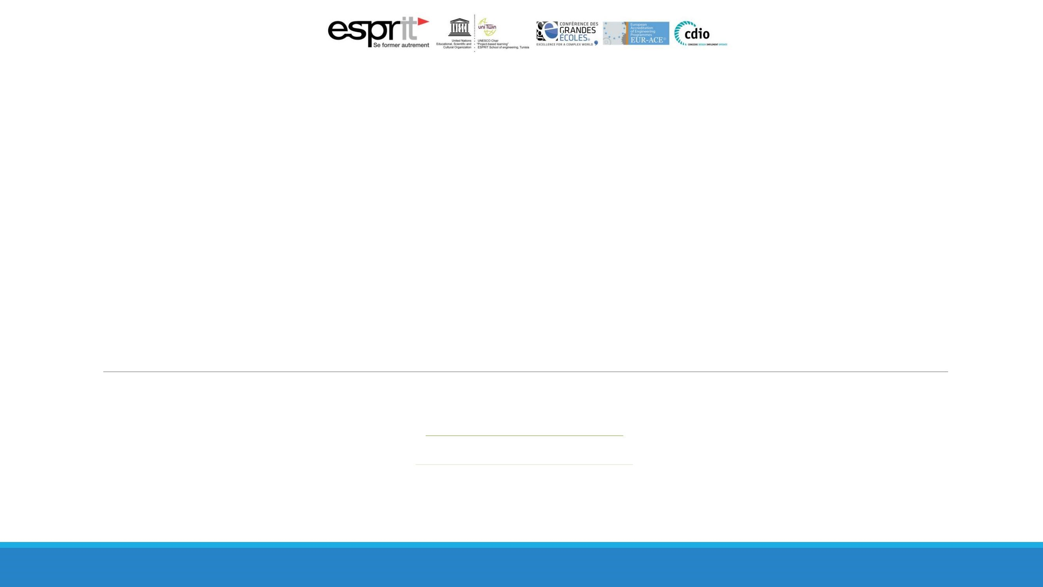

Advanced

Learning

***rania.***

***kallel***

***@***

***spirit.***

***tn***

***wiem.***

***trabelsi***

***@***

***esprit.***

***tn***

Web

Mining

**DS**

**Team**

Machine Translated by Google

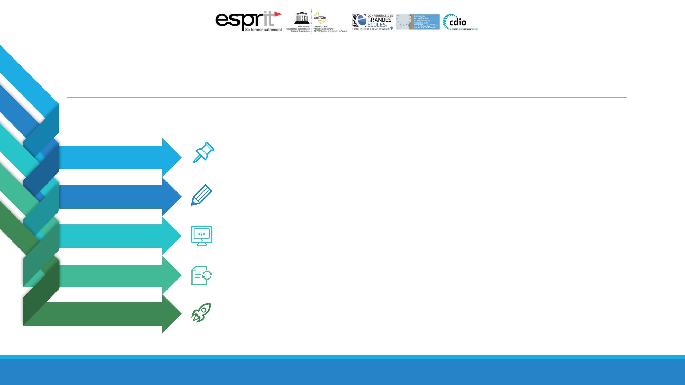

Explanation

of

the

problem

Interpretations

Technical

details

of

the

method

Report

of

the

session

Result

Presentation

of

the

proposed

solution

Machine Translated by Google

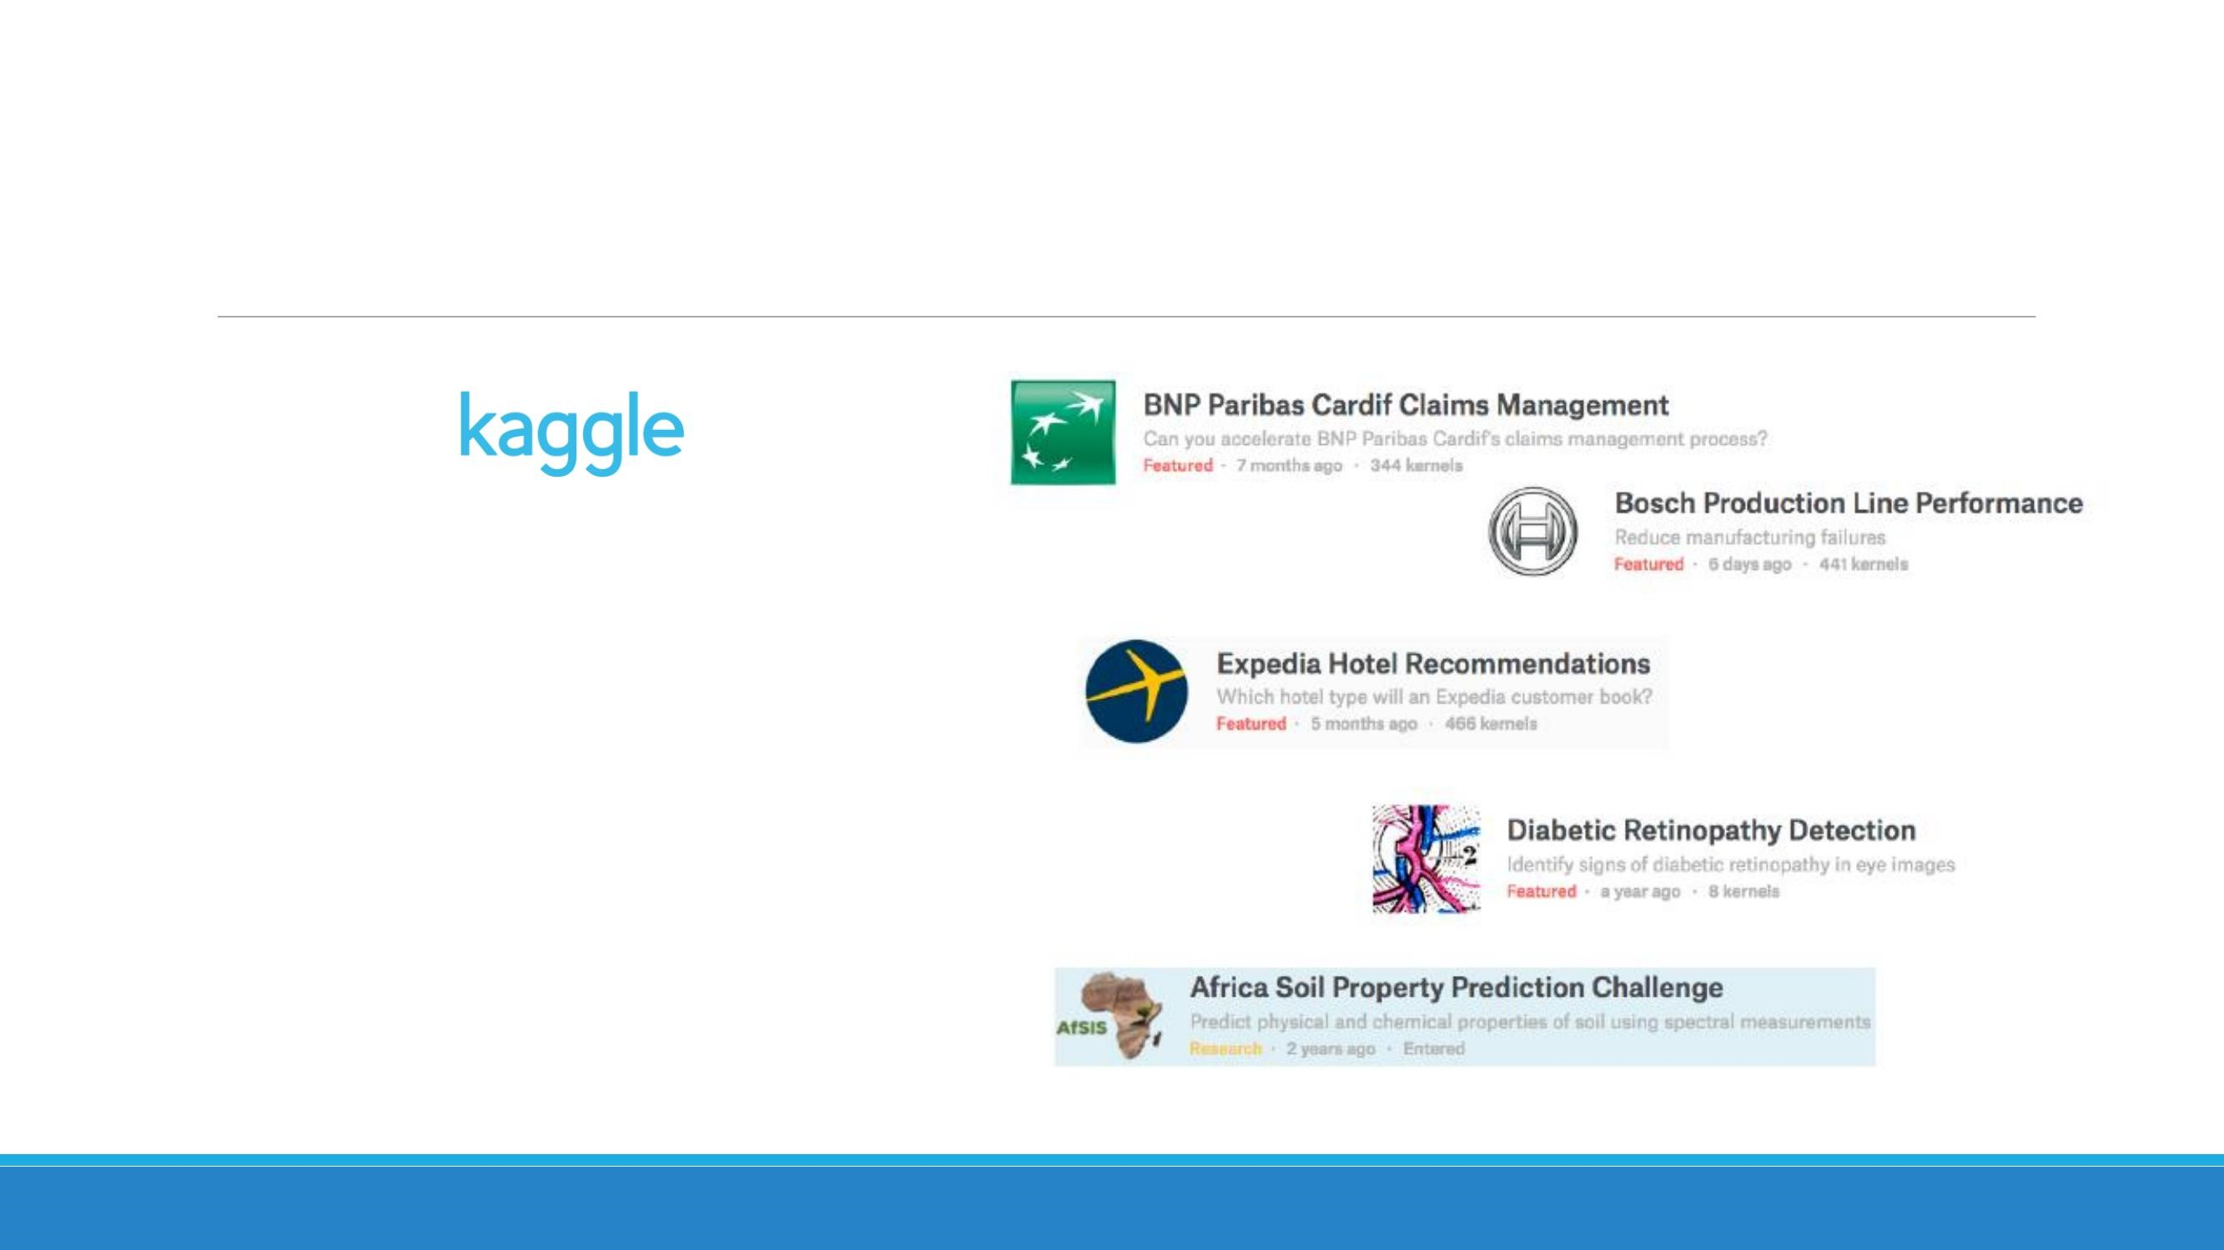

For

several

years,

platform

there

provides

real-

world

datasets

and

activity

questions

for

Data

Science

enthusiasts

to

solve,

known

as:

**Kaggle**

**Challenge.**

Explanation

of

the

problem

(1

/

2)

Machine Translated by Google

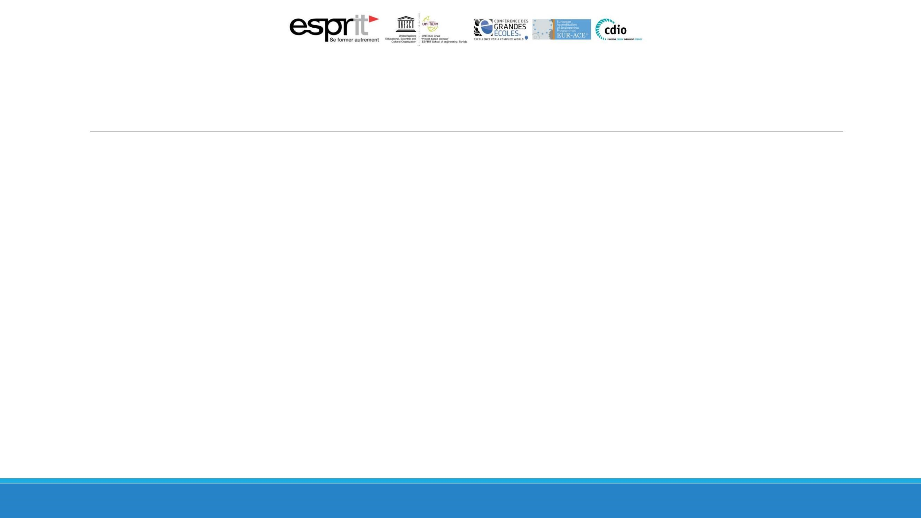

ÿThis

practical

will

be

described

as

a

Kaggle

challenge

for

Web

Mining.

ÿThe

data

that

will

be

used

are

real

(

anonymous)

data

from

a

bank

credit

application.

ÿFrom

a

log

file

you

carry

out

an

analysis

by

going

through

the

following

steps:

ÿ

Transform

the

data

into

an

eventlog.

ÿ

Overview

of

Eventlog

(

summary).

ÿ

Frequency

of

activities.

ÿ

Show

processes

where

an

activity

must

be

present.

ÿ

Generate

the

process

map

graph.

ÿ

Generate

a

matrix

with

an

overview

of

activity

tracker

frequency.

ÿ

Generate

and

explore

the

activity

trace.

ÿ

Show

processing

time

in

hours

by

application

type.

ÿ

Show

processing

time

in

hours

per

loan

(

credit)

purpose.

Explanation

of

the

problem

2)

/

(2

Machine Translated by Google

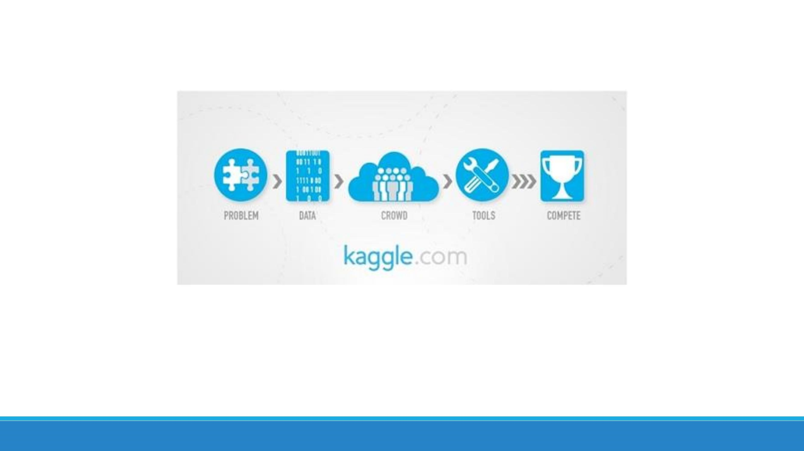

Machine Translated by Google