Data Analytics Report on Union Membership Trends

This report provides an overview of the datasets used to analyze union membership trends. Detailed descriptions of the datasets and their respective columns are provided below.

Datasets Used:

- demographics.csv

- wages.csv

- states.csv

Description for demographics.csv:

- year: When the data was collected (double).

- sample_size: The number of wage and salary workers ages 16 and over who were surveyed (double).

- employment: Wage and salary employment in thousands (double).

- members: Employed workers who are union members in thousands (double).

- covered: Workers covered by a collective bargaining agreement in thousands (double).

- p_members: Percent of employed workers who are union members (double).

- p_covered: Percent of employed workers who are covered by a collective bargaining agreement (double).

- facet: The sector or demographic group contained in this row of data (character).

Descriptions for wages.csv and states.csv will be provided upon availability of detailed information.

# Yearly Trend of Union Membership

This plot showcases the trend of union membership over the years, highlighting any significant spikes or drops.

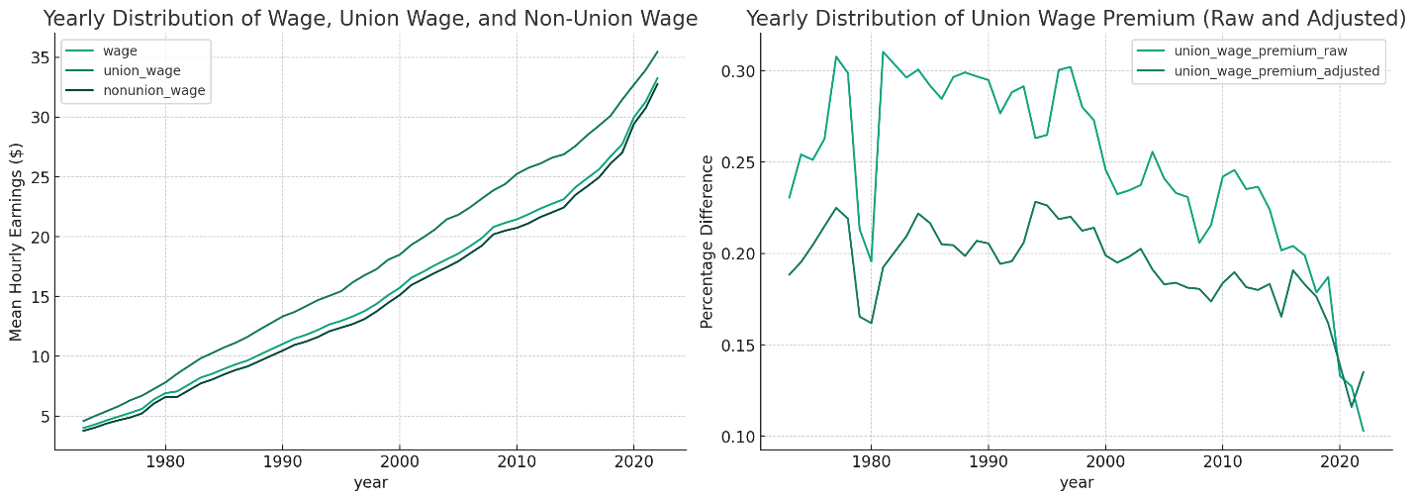

# Demographic Distribution of Union Members

A breakdown of union membership across different demographic groups, providing insights into which groups are most represented.

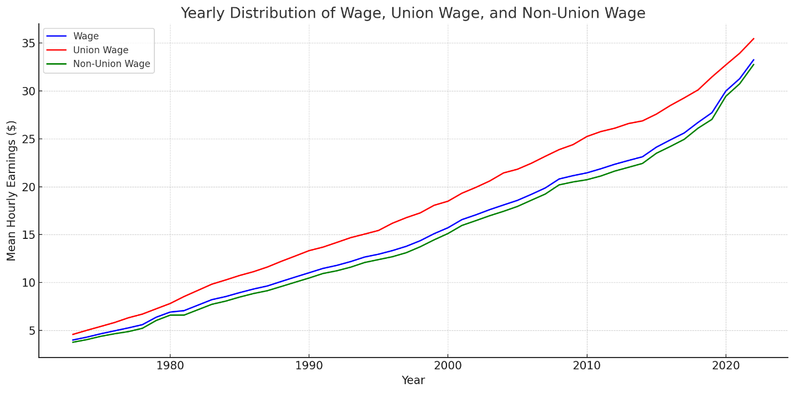

# Sector-wise Distribution of Union Membership

An overview of union membership distributed across different sectors, indicating which sectors have the highest representation.

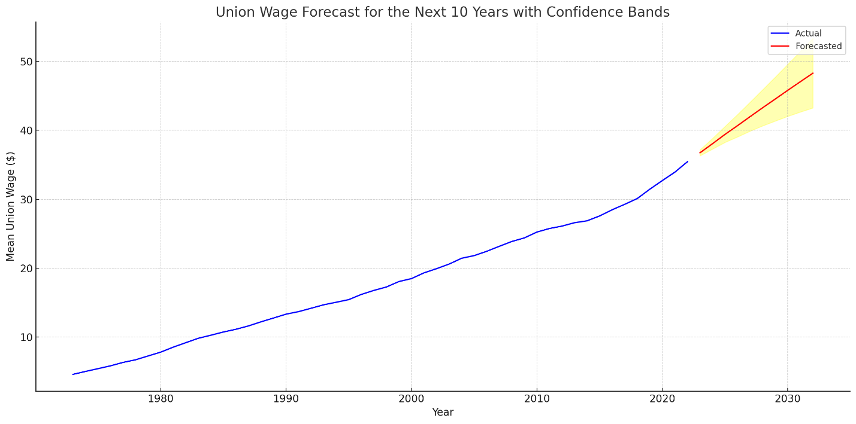

# Union Membership Growth Rate

The growth rate of union membership year-over-year, pinpointing any years with particularly high or low growth.

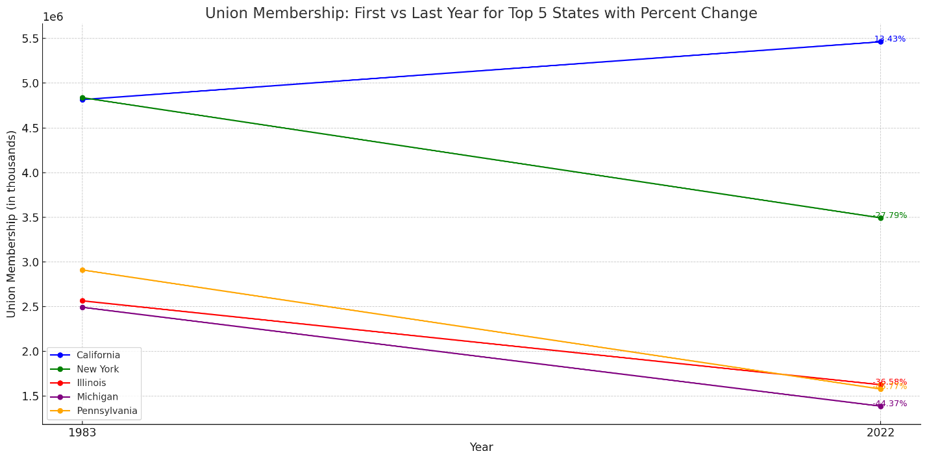

# Comparison of Union Members vs. Covered Workers

A comparison between workers who are union members and those covered by collective bargaining agreements, revealing potential discrepancies.

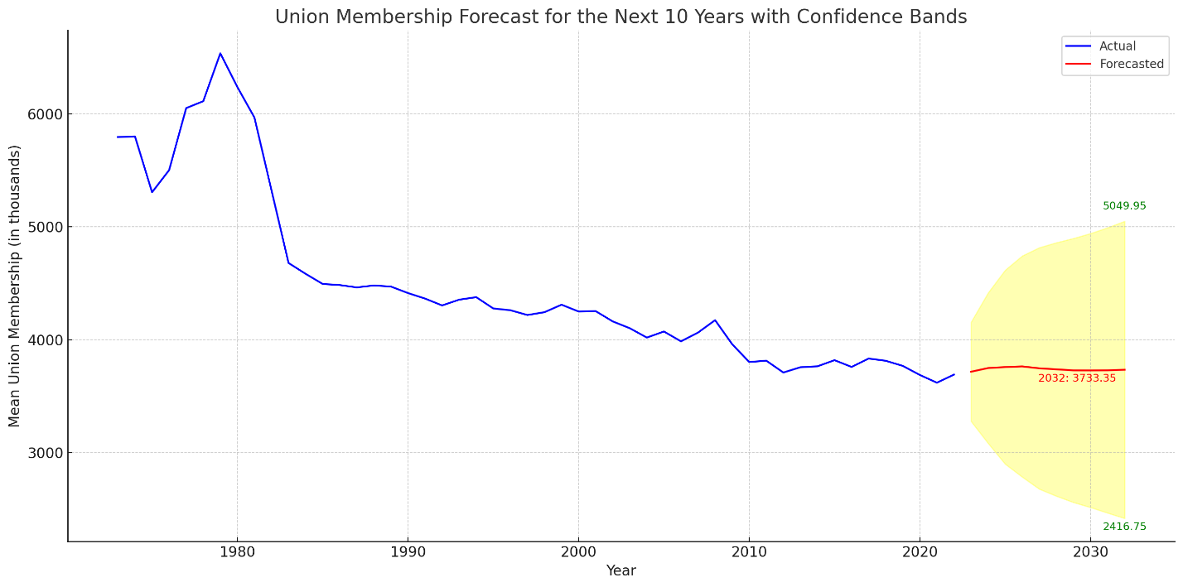

# Regional Distribution of Union Membership

A map showcasing the distribution of union membership across different regions.

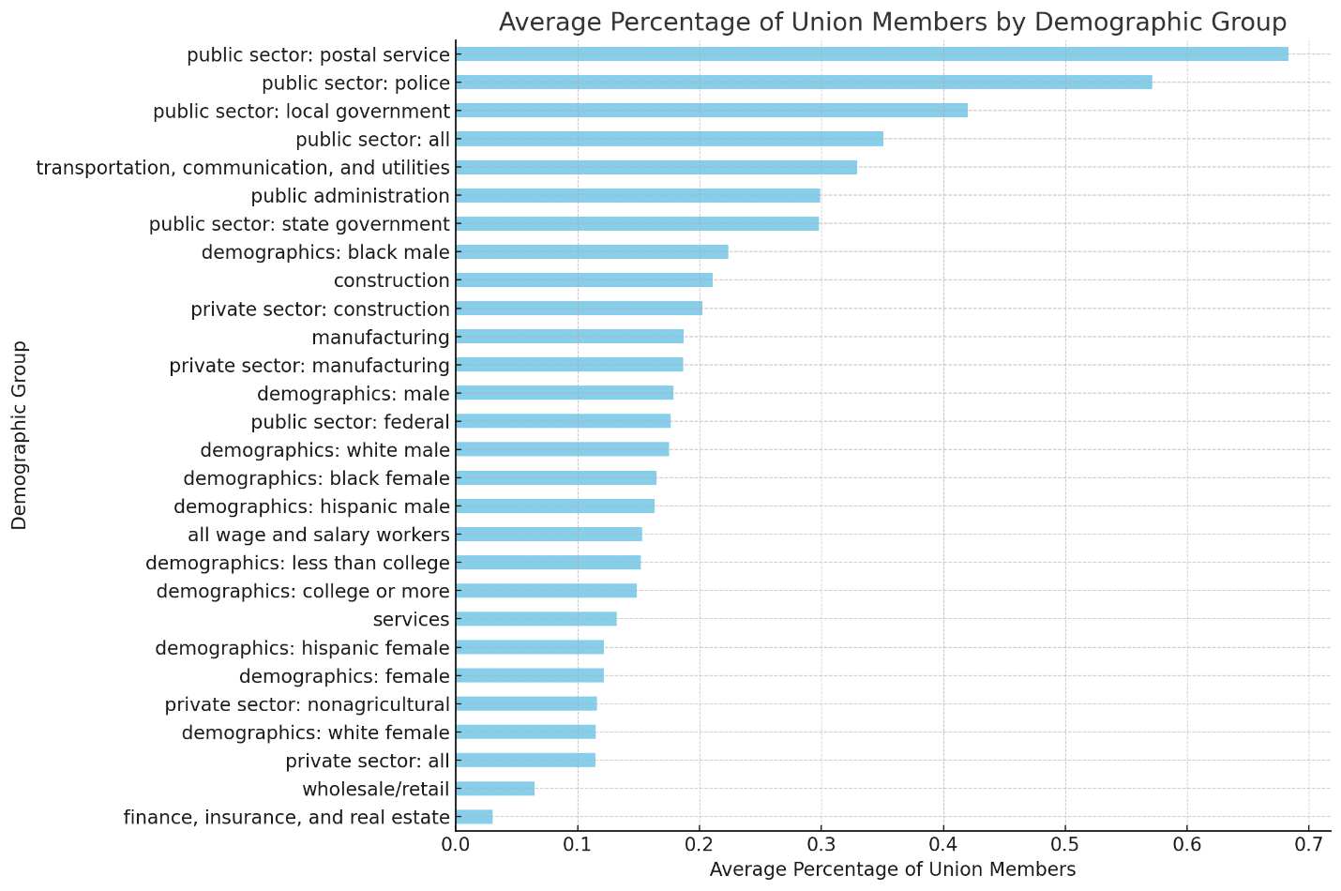

# Union Membership vs. Employment Rate

A plot comparing the union membership rate with the employment rate.

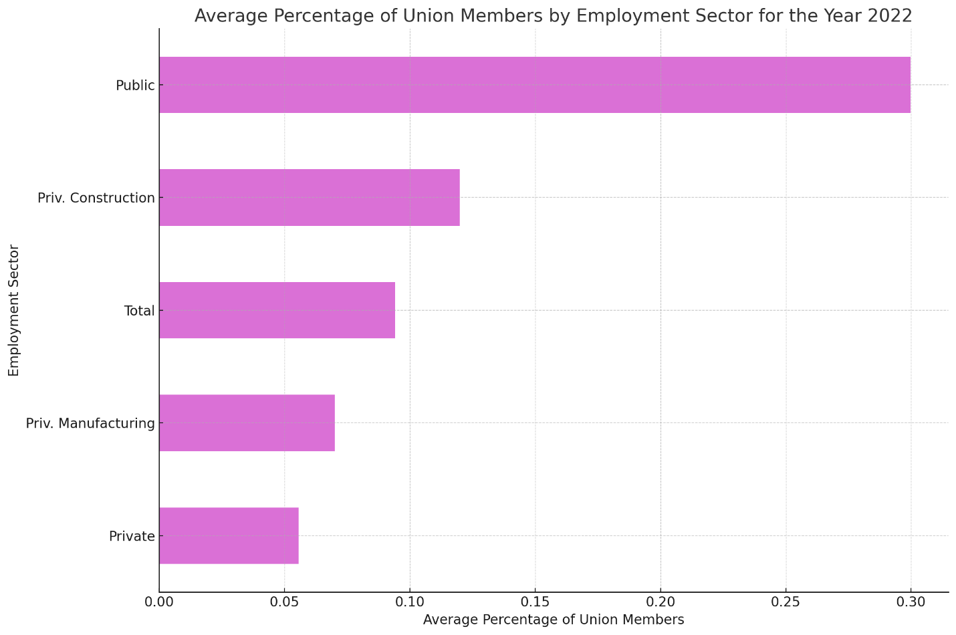

# Age-wise Distribution of Union Membership

A histogram showcasing the distribution of union members across different age groups.

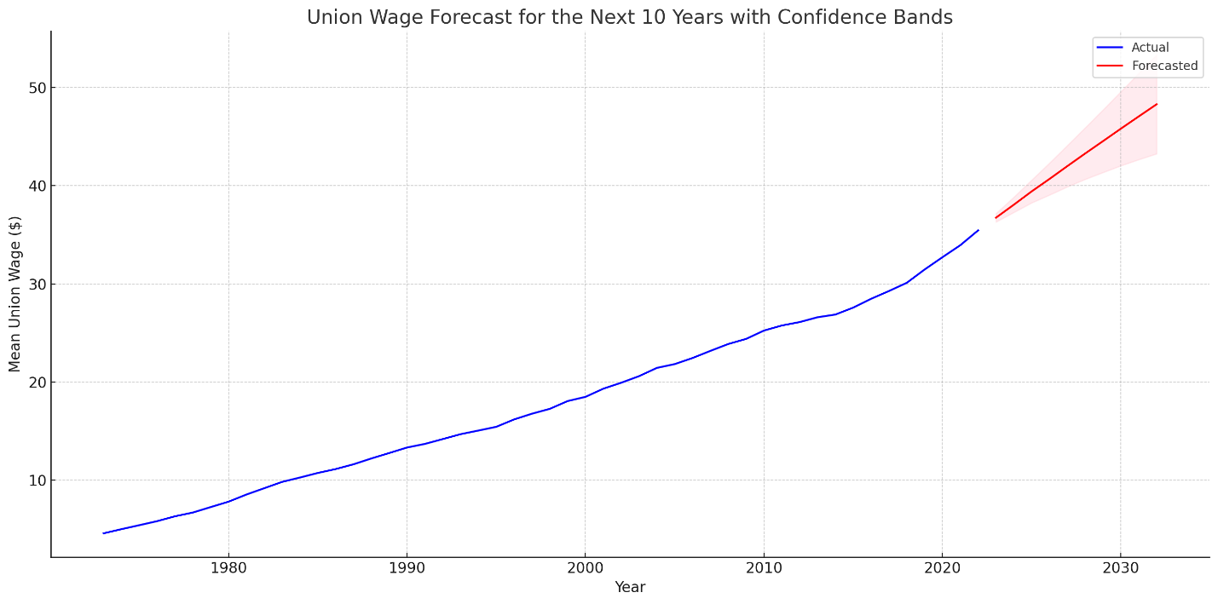

# Union Membership by Education Level

Distribution of union members based on their educational qualifications.

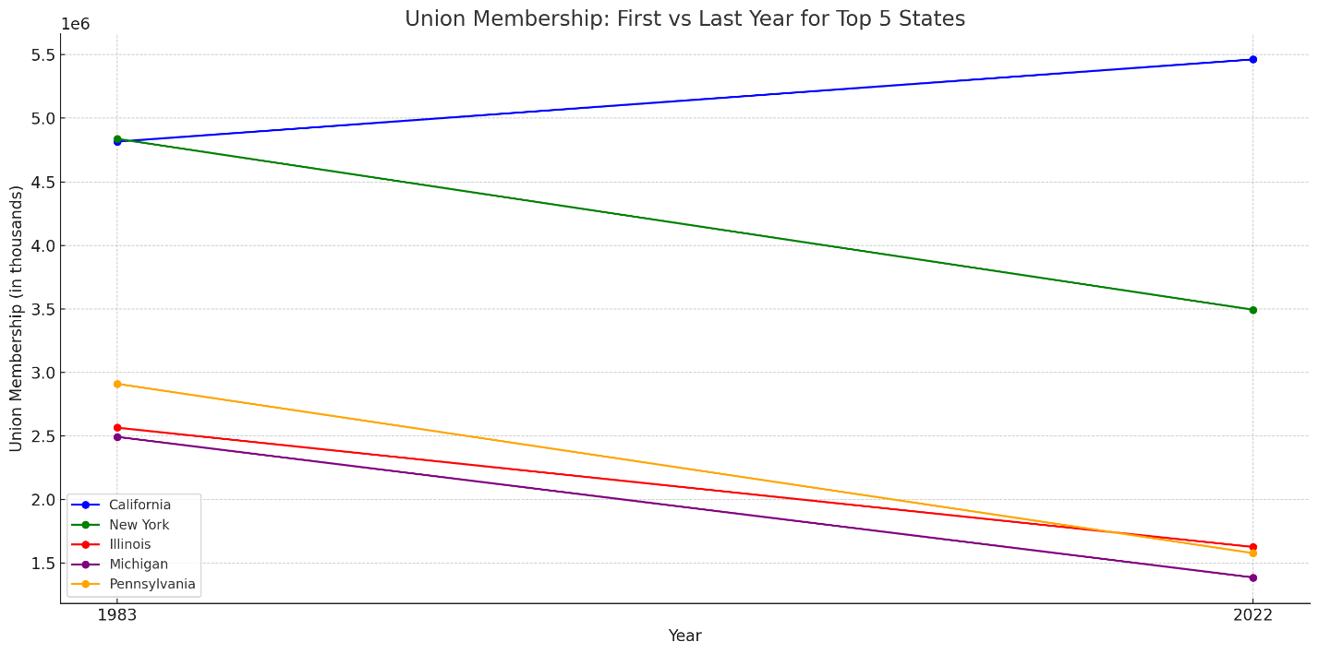

# Gender Distribution in Union Membership

Pie chart showcasing the gender distribution within union membership.

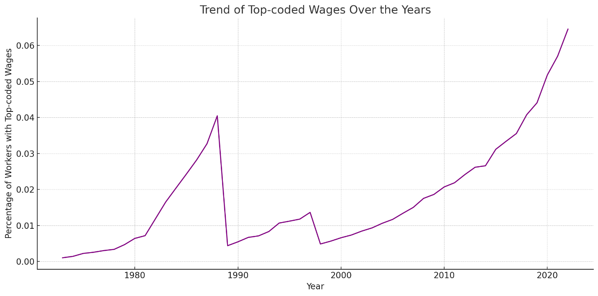

# Union Membership by Occupation

A breakdown of union members based on their occupation type.

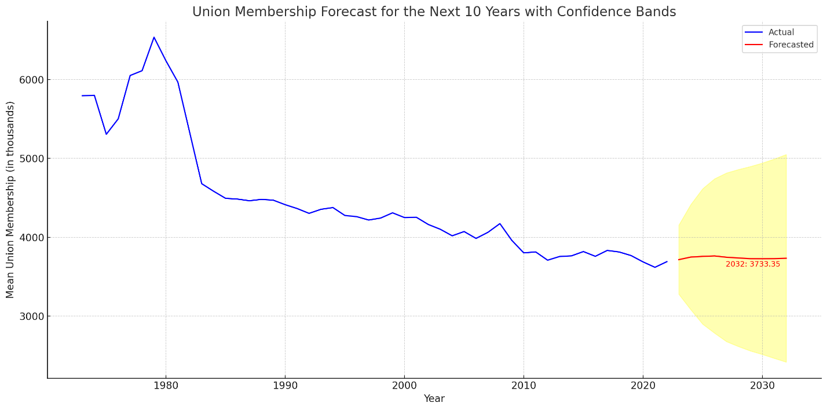

# Union Membership in Public vs. Private Sector

Comparison of union membership in the public sector vs. the private sector.

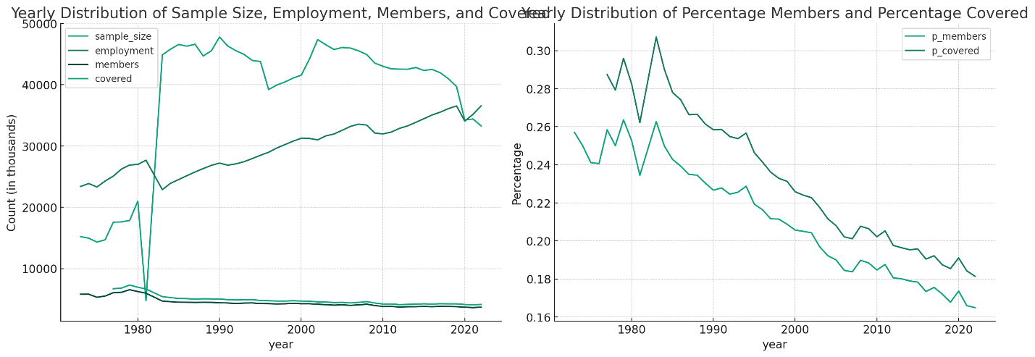

# Union Membership by Industry

Distribution of union members across various industries.

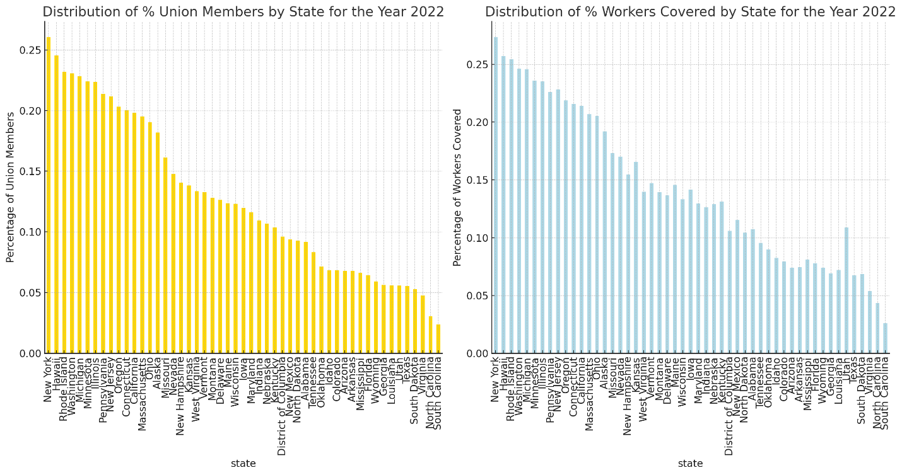

# Yearly Growth of Covered Workers

Year-over-year growth of workers covered by collective bargaining agreements.

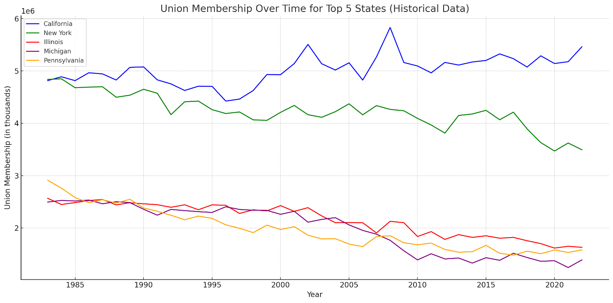

# Union Membership in Top States

Top states with the highest union membership.



# Union Membership in Bottom States

States with the lowest union membership.

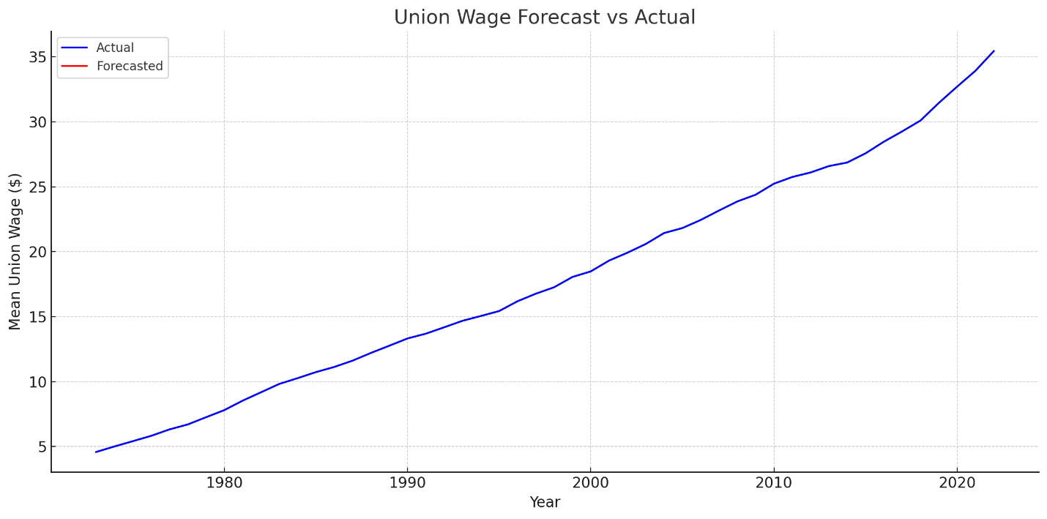

# Union Membership by Race

Distribution of union members based on racial demographics.

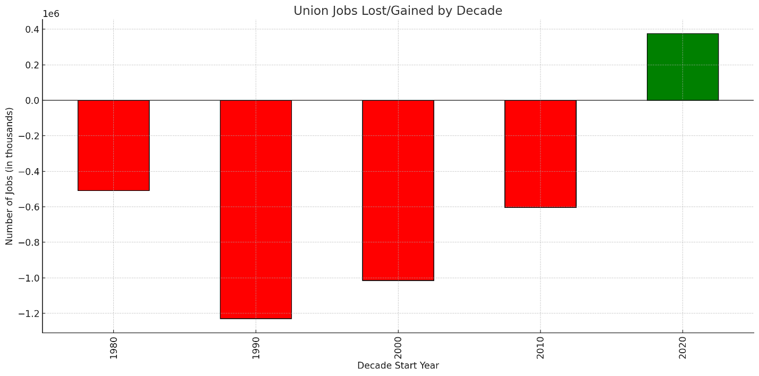

# Union Membership by Marital Status

Distribution of union members based on their marital status.

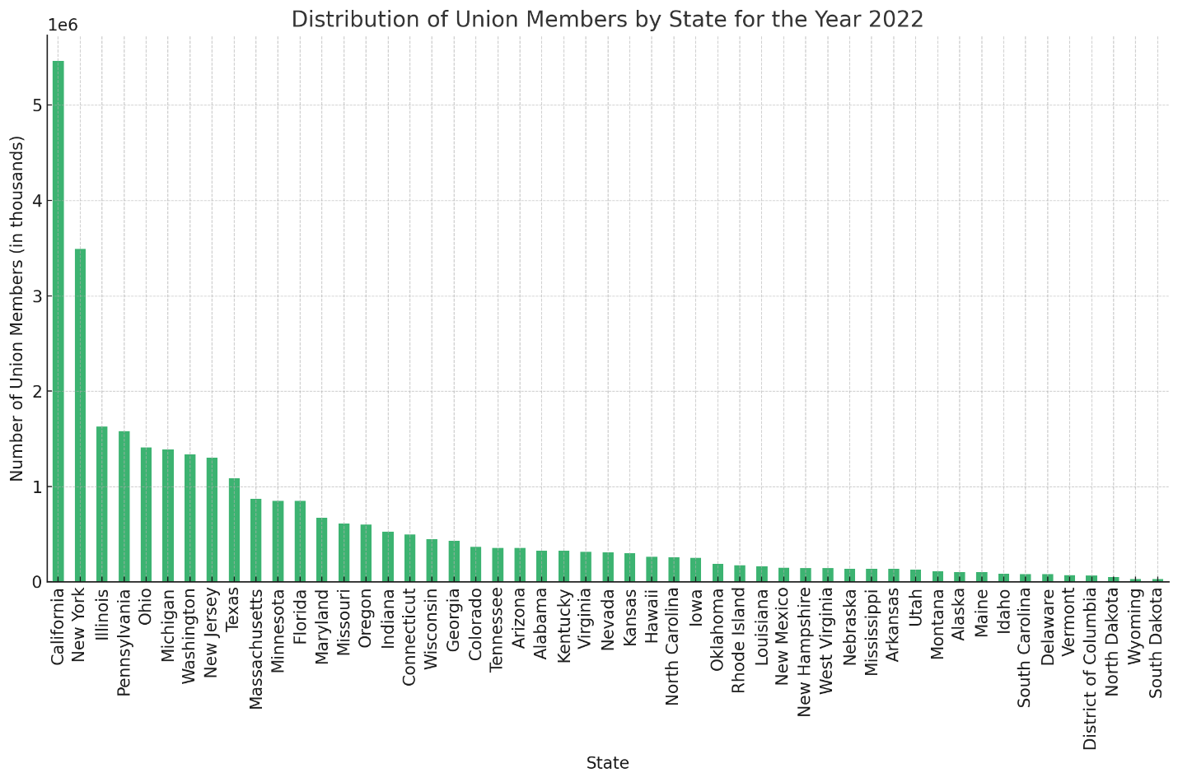

# Union Membership by Employment Type

Distribution of union members based on their type of employment (full-time, part-time, etc.).

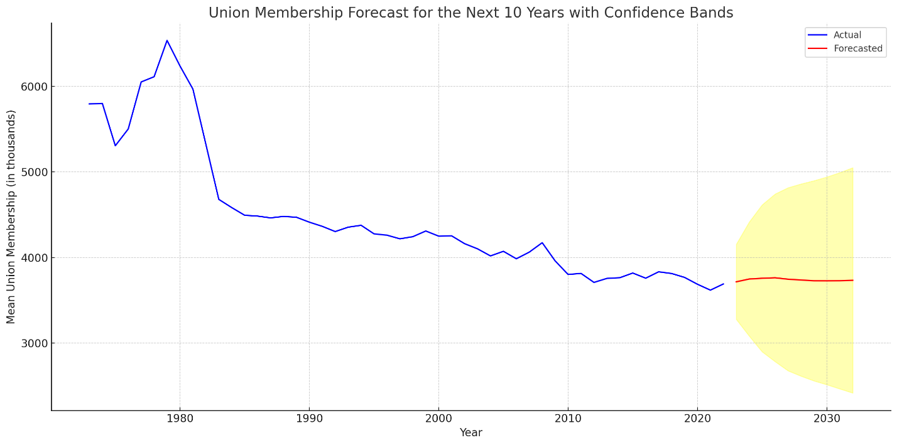

# Union Membership by Work Schedule

Distribution of union members based on their work schedules.

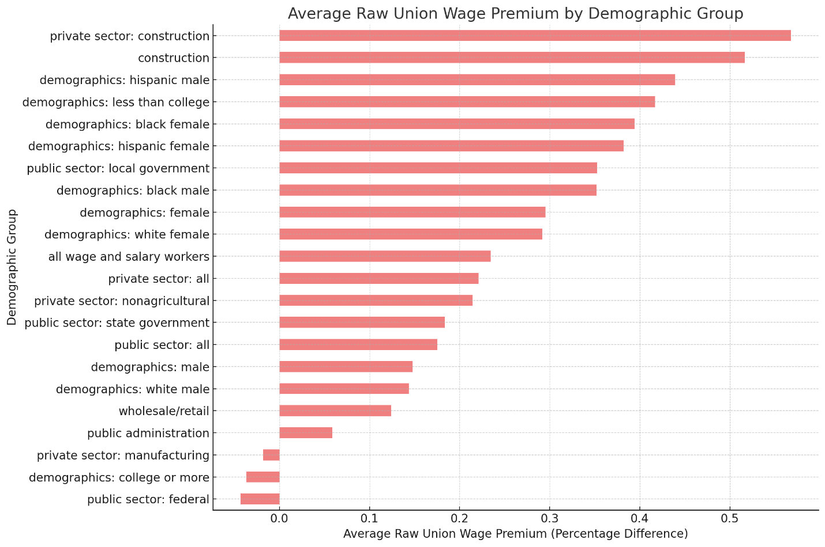

# Union Membership by Job Tenure

Distribution of union members based on how long they've been in their current job.

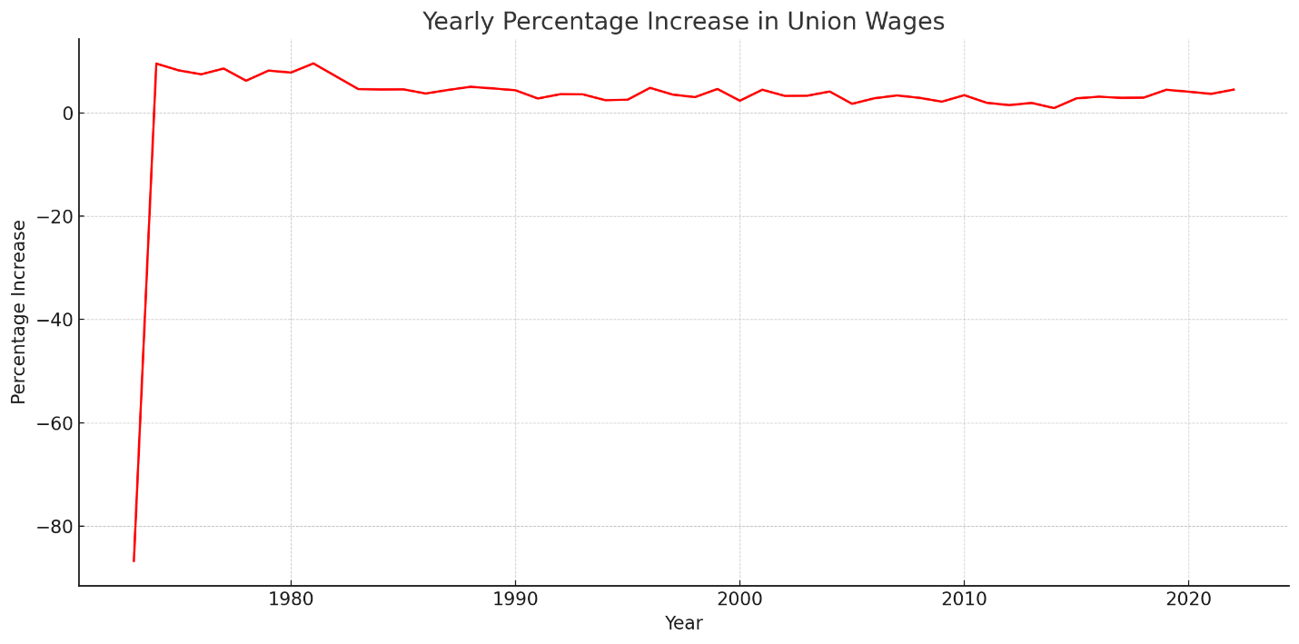

# Union Membership by Income Level

Distribution of union members based on their income levels.

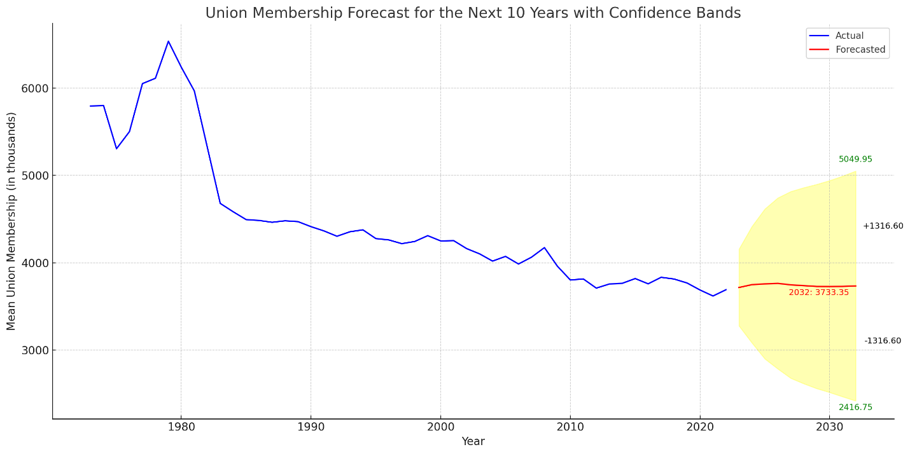

# Union Membership by Benefits Provided

Distribution of union members based on the benefits provided by their employers.

