May 14, 2026

Agenda

April 21, 2026
Agenda
- Roundup
- What’s new?
  - Leadership Retreat/Day .
  - 2027 venue search starting.
- Review of Habits 1-3
- Assignment:
  - Funeral Exercise: Which of the four eulogies would be easiest to write about you as you are today, and which would be hardest? What does that gap tell you about where your time and attention are actually going versus where you say they should go? Four groups: Family, Friends, Coworkers, and Community.
- Next Up: Habits 4-6

April 2, 2026
Agenda
- Roundup
- What’s new?
- Books suggested:
  - Scaling Up: How a Few Companies Make It...and Why the Rest Don't
  - Scaling People: Tactics for Management and Company Building
  - Crucial Conversations: Tools for Talking When Stakes Are High
  - Getting Things Done by David Allen.
  - Turn This Ship Around
- Review of intro
- Assignment:
  - Look for examples of reactive vs. proactive language over the next two weeks. Try to catch yourself in these modes and take note.

Reactive: i have to have a meeting with XXX
Proactive: We can send email updates to team on vision (“weekly newsletter”) to our different audiences: leadership, core team, and outsiders

  - Fill out the Circles Worksheet.
    - Claude Template to fill out -> 3,2,1 order suggested
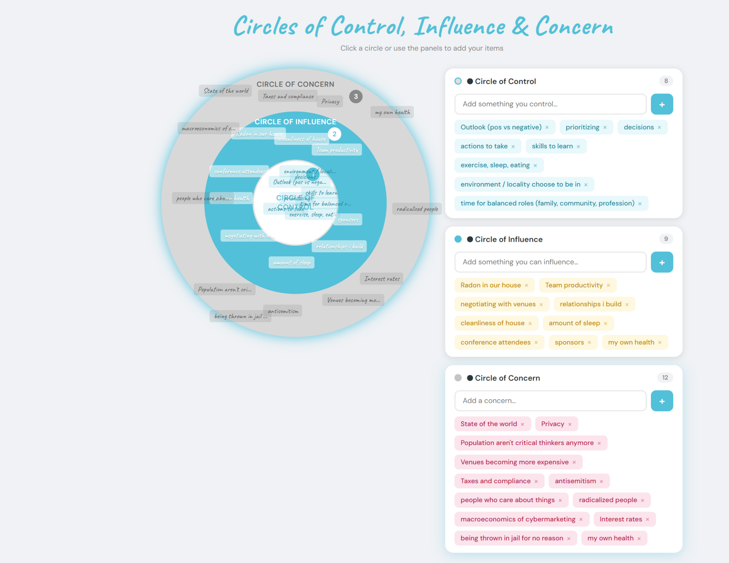
Notes:
- AI search for company knowledge - feed it recorded meetings. Guardrail to not let it make stuff up. Team can query
- Feel, felt, found - reiterating what someone is feeling to help relate to a problem. “When i felt x, here’s what i found”.
  - Works for sales - challenges/goals that we heard.
- Read Habit 1-3.

March 19, 2026
Agenda
- Roundup
- What’s new?
- Review of Unreasonable Hospitality
- Assignment
  - Brainstorm 4 unreasonable hospitality actions that can happen before CyberMarketingCon.
  - Set an Unreasonable Hospitality Committee (By CyberMarketingCon)
  - Assign chapter 18 to teammates
- Check in before next up!
- Next up: 7 Habits of Highly Effective People
  - Read through Habit 1.
Notes:

Iyonna joined! Treasurer hunt, very creative!
- Dee community mod.
- Jen is joining in April.
- Learned tons from the Event conference.
- Get 100% on things that don’t take skill (task management, ops, etc). Skills are relationship mgt, writing, etc.

Feb 19, 2026
Agenda
- Roundup
- Assignment Review
- Review of Tribal Leadership Parts 3 & 4
- Assignment
  - Develop 3 - 4 triad teams.
- Check in before next up!
Notes:

Christine is now on the team!
A true leader trains someone else to become a leader.
Don’t come to me with problems.- come with 3 ideas to solve it.
Exec director tell you, you are paid for your opinion. Everyone should have an opinion
Its my job to make the decision, its your job to bring the info.
Adding crucial convos to book list.
Unreasonable hospitality. Chapters 1-9.

Feb 5, 2026
Agenda
- Review of SOP call with Christina
- Review of Tribal Leadership Part 2
- Assignment
  - https://docs.google.com/document/d/1SpcNhG7J1uuUARaUT0kBuNsUp3k248mGtdMI6asyhak/edit?usp=sharing
- Next Up is Tribal Leadership Part 3 & 4

Notes

Values mean nothing until challenged - until losing something to stand up for them.

Jan 21, 2026
Agenda
- Move calls to Tuesday or Thursdays? DONE - Every 2 weeks thursday at 10
- Review of Assignments
- Tribal Leadership Part 1.
- What’s next?
  - Part II sin Chapter 4.

“One cool thing” practice with the whole team.
Mondays so first part of the week.
Sense of belonging

Jan 14, 2026
Agenda
- Start with Why review
  - Part 1: A World That Doesn't Start With Why
  - Part 2: An Alternative Perspective
  - Part 3: Leaders Need a Following
  - Part 4: How to Rally Those Who Believe
  - Part 5: The Biggest Challenge Is Success
  - Part 6: Discover Why
  - Assignment:
- Next Up: Tribal Leadership
  - Part 1 = 40 pages
  - Part 2 = 110 pages
  - Part 3 = 100 pages
- Action items
  - Start with Why Assignments
    - Golden Circle
    - Label team members: Why, How, What
  - Read Part 1 of Tribal
  - David E to connect G and D with Christina.

Dec 17, 2025
Agenda:
- ✅Congrats on a successful conference!
- Review the Advisory Plan and Schedule
  - Start with Why:
    - Dec 17th: Book assigned and read before next meeting.
      - Set up call with Christina for an overview of how we create SOPs
    - Jan 7th: Review of the book and assignment
    - Jan 14th: Assignment review. Start Tribal leadership.
  - How do we want to set up coms and office hours?

Meeting notes:

Mind Magic (book) - Manifestation
- Gemini Recordings used for AI training after calls.
- Slack connect + David E to build scheduling link for office hours
- Connector for Hubilo - Ryan

Nov 12, 2025
Agenda:
- P&L Review
  - Where to save
  - Where to expand
  - Where to make
- Budgeting Template review
  - Rev
  - Exp

October 29, 2025
Agenda:
- 4 Quadrants Overview
- Deeper discussion on Friction Areas:
  - Fine Details for Conference: Program Polish
    - Responsibility: David A
    - Direct Financial Impact: -EXP
    - Business Impact: +Delight moment.
    - Quadrant: Ideally, Quad II, Ends up in Quad I
  - Fine Details for Conference: Programming Alignment (Sessionize - $500)
    - Responsibility: Gianna (cybersec/networking) - Has been a bottleneck in the past.
    - Direct Financial Impact: + EXP, + Reg
    - Business Impact: Positive
    - Quadrant: Ideally, Quad II, Ends up in Quad I
  - Schedule for Conference - Run of Show
    - Responsibility: David A (Auberry 2nd) - Much more than just tracks. Reminders on all aspects. Volunteer leadership and management
    - Direct Financial Impact: Large time EXP.
    - Business Impact: Huge impact
    - Quadrant: Between Quad 1 and 3.
  - SOPs and Knowledge Base - Find in Drive is tough; some are dated.
    - Responsibility: ??
    - Direct Financial Impact: Time cost in explaining, but also in self-executing.
    - Business Impact:
    - Quadrant
  - In-person events (lots of time, and not a lot of revenue)
    - Responsibility:
    - Direct Financial Impact:
    - Business Impact:
    - Quadrant
  - Website Management
    - Responsibility:
    - Direct Financial Impact:
    - Business Impact:
    - Quadrant
  - Sponsorship Deliverable
    - Responsibility:
    - Direct Financial Impact:
    - Business Impact:
    - Quadrant
  - Shared information, planning, and schedule docs
    - Responsibility:
    - Direct Financial Impact:
    - Business Impact:
    - Quadrant

HW for CMS: Send David E your budget and P&L reports for this year. Happy to sign an NDA if you’d like! For review and discussion next time!
- P&L Reports here!

HW for David E.: Send David A. blank budget template.

October 15th, 2025

Gemini Notes

Agenda:
- General Overview of Process Areas
  - Member Solutions
    - Operations
      - Community Member Management - Slack/Processing members
      - Community Communication Management
      - Conference Planning
      - Job Board Function - Daily review by team member on Slack - added to job board - Job Email incoming.
      - Sponsor - intake, deliverables tracking
    - Value:
      - Community Virtual Meetups
      - CEO society
      - Advisory Solution - Matching
      - Conference Execution
        - Speakers
        - Marquee
      - Regional In-person Meetups and or EDU activities
      - Conference Side Events - RSA/Blackhat
      - Job Board - site + Newsletter (weekly)
      - Newsletter - Spoonful (bi-monthly)
      - Podcast Newsletter - (Weekly)
      - Palooza!
  - Marketing Function
    - Content - Random
    - Podcast - Weekly
    - Webinars - 10/20 year
    - Website Management - Webflow
  - Sales
    - General Sponsorships
  - HR
    - Hiring/Sourcing
  - General Business Operations
    - SOPS
    - Locations of information
    - Shared information, planning, and schedule docs
      - Gdrive, Slack, Asana, Email.
- Dive into each process area
- Discussion of revenue and expense impacts of process areas
- Discuss roles, responsibilities, and tools.

Gap:
- Video needs. Current resource at 20 hours/we

Friction Points:
- Fine Details for Conference
- Schedule for Conference
- SOPs and Knowledge Base,
- In-person events (lots of time, and not a lot of revenue)
- Website Management
- Sponsorship Deliverable
- Shared information, planning, and schedule docs

Notes:
- Always have an agenda
- Someone is in charge of something, and there’s always a 2nd person who can step in to that role.
  - They should know what decisions they should make vs what you need to approve
  - Many folks don’t believe they can make decisions
- If you have a good process, you might not need to hire someone for it. Figure out how to solve the person before we put a person in. Better to hire someone to say make this better.
- Answer for repetition - not very useful to show frustration to team. I’m losing time repeating these to you. How can I help you remember so that you and I don't lose time? I’m sure it’s taking your time too to ask me each time.
- Reg desk ->

