The social problem that our Battlehack application addresses is how to make teenage driving safer. This topic was first inspired by [this](http://www.newsobserver.com/news/local/counties/wake-county/article10068941.html) story about a girl who died in an accident last year near Panther Creek High School.

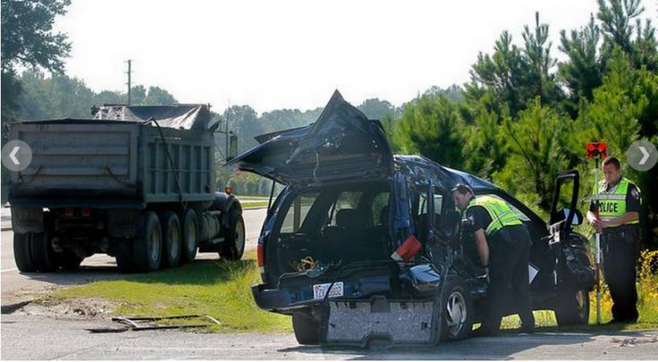

My daughter was friendly with the victim (In fact, she still wears a bracelet with the victim’s name on it) and it seemed like it was the least we could do in her memory.

The first step was some analytics so see if there is indeed a systematic problem. We did a public records request of traffic crash data and did some statistical analysis in R. Indeed, is a statistically significant increase of car crashes around certain local high schools. The common theme of these high schools is that they are over capacity.

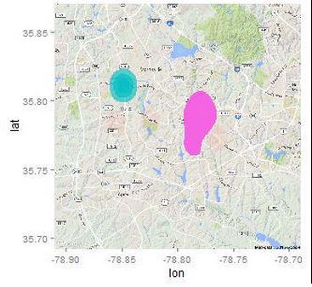

As a final confirmation, members of the team met with the Chief of Police the day before the Hackaton and she agreed that there is a problem but her staff is maxed out.

The team approached safe driving as a “carrot/stick” issue with kids. The phone app will capture the speed at which they are driving. If they stay within a safe range for the week, they will receive a cash payment. If they engage in risky behavior (speeding, fast stops, etc..), they will have some money charged to them. We used the hackathon’s sponsors Braintree’s for payment and SendGrid for email notification.

The application’s dashboard looks like this

<Ian Screen Shot #1>

And the notification list looks like this

<Ian Screen Shot #2>

On the server side, we are using IBMWatson and AzureML to predict when a driver starts showing characteristics of starting to drive aggressively.

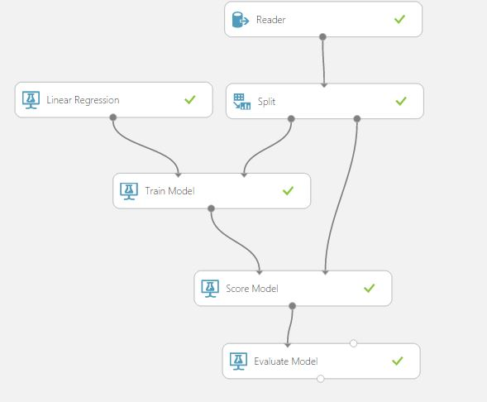

Just like Uber does surge pricing, we would either increase a person’s payout (or payment) for the week or notify them, hopefully to alter their driving. The model is self-learning and constantly updates itself based on additional data that streams into the application.