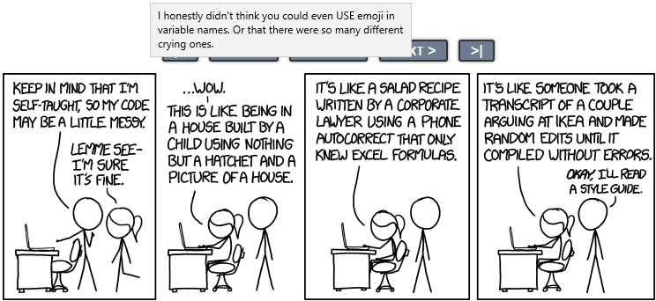

[https://xkcd.com/1513/]

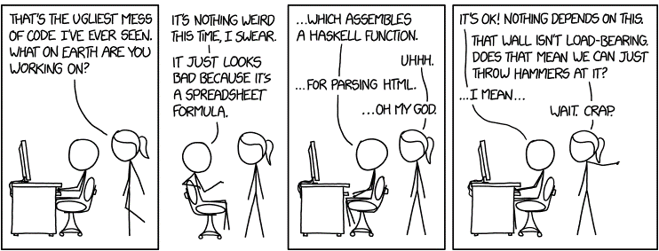

[https://xkcd.com/1926/]