Data Profile Dataframe - Notebook v0.17 - 14 July 2019

mydataset.csv

The main objective of this notebook is **only** to understand raw data profile. i.e. data type, min & max values, ranges, unique values, etc.

In consequent notebooks we will explore further on how to make decisions to make the data tidy and perform the data transformations based on the understanding of the data profile.

*The code is largely kept generic so that it could be used with any shape of data.*

# The Game Changer - Data Profile Dataframe (DPD)

The game changer for exploratory data analysis is the final **Data Profile Dataframe** that is generated which combines **all** the information required to inform data cleaning, tidy data and optimisations (memory and processing) decisions. Instead of using various Pandas commands at different instances and going back and forth to cross refer information, Data Profile Dataframe brings all information into a single dataframe. This will be very useful when reviewing the data profile with the business subject matter or other team members as all information related to data profile is in a single easy to understand format.

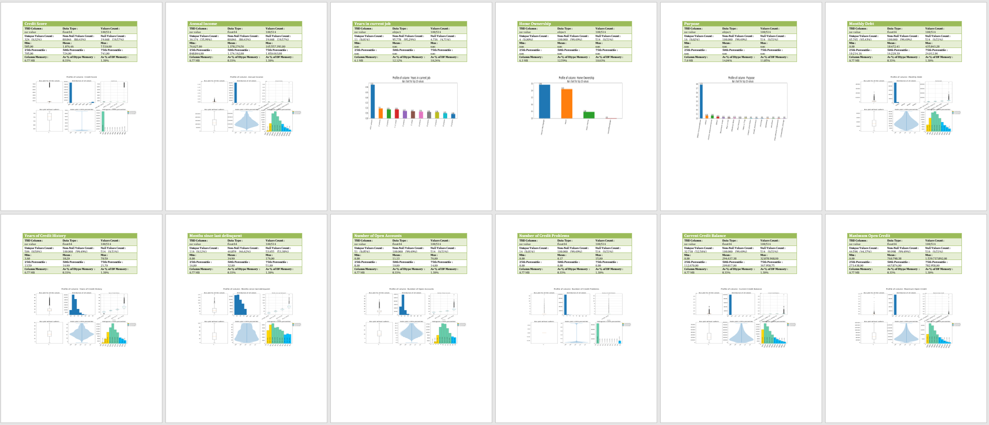

Understanding the data is **the critical step** in preparing the data to be used for analytics. As many experts will point out the data preparation and transforming the data into a tidy format takes about 80% of the effort in any data analytics or data analysis project.

**Understanding the data requires good understanding of the domain and/or access to a subjectmatter expert (SME) to help make decisions about data quality and data usage:**

* What are the columns and what do they mean?
* How to interpret each columns and possible values of a column?
* Should the columns be renamed (and cleaned e.g. trim)?
* Are there columns that may have similar information that could be dropped in favour of one master column?
* Can columns with no values (or all empty) be dropped?
* Can columns which have more than certain threshold of blank values be dropped?
* Can rows that have missing values for certain columns or combination of columns be dropped?

i.e. the row is meaningless wihtout those values.

* Can the numeric data type columns be converted / down casted to optimise memory usage based on the data values?
* or will there be outliers possibly in future data sets that we cannot do this?
* Can the min and max values be used to determine the lowest possible data type?
* Can some string/object columns be converted to Category types?
* based on count of unique values
* Can any columns be discarded that may not be required for analytics?

Columns Data Profile Summary

# Dataset shape

|  |  |
| --- | --- |
| **No.of rows** | **No.of columns** |
| 887 | 8 |

# Dataframe columns summary

|  |  |  |  |  |
| --- | --- | --- | --- | --- |
| **column_name** | **col_data_type** | **non_null_values** | **null_values** | **count** |
| Survived | int64 | 887 | 0 | 887 |
| Pclass | int64 | 887 | 0 | 887 |
| Name | object | 887 | 0 | 887 |
| Sex | object | 887 | 0 | 887 |
| Age | float64 | 887 | 0 | 887 |
| Siblings_Spouses_Aboard | int64 | 887 | 0 | 887 |
| Parents_Children Aboard | int64 | 887 | 0 | 887 |
| Fare | float64 | 887 | 0 | 887 |

Memory Usage Profile

# Data file size on disk vs. dataset size in memory

|  |  |
| --- | --- |
| **Description** | **Size in MB** |
| Data file size on disk | 0.04 |
| Dataset size in memory | 0.16 |

Dataset increase in memory :

# Dataframe column types and size in memory

|  |  |  |  |
| --- | --- | --- | --- |
| **col_data_type** | **dtype_count** | **dtype_total** | **dtype_%_total_mem** |
| float64 | 2.00 | 0.01 | 8.33 |
| object | 2.00 | 0.12 | 74.97 |
| int64 | 4.00 | 0.03 | 16.66 |

"col_data_type" : Column data type

"dtype_count" : Number of oclumns in the dataset of the given data type

"dtype_total" : Total memory in MB for the given data type

"dtype_%_total_mem" : Percentage of the memory used by the given data type out of the total memory used by the dataset

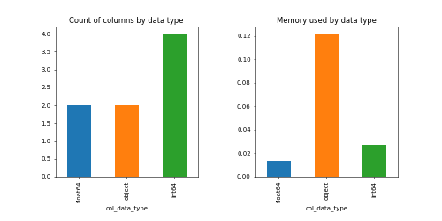

In a memory heavy datasets the above information can shed light into which data type you need to focus if you need to optimise the memory usage.

e.g. may be convert "object" datatype to "category" type if the cardinality is low or may be down cast "float64" to float16 or smaller.

These decision need further information on column cardinality and max/min values which are covered in the next few sections.

# Memory used by "object" data type

|  |  |  |  |  |
| --- | --- | --- | --- | --- |
| **column_name** | **col_memory** | **%_of_dtype_mem** | **%_of_total_memory** | **unique_values_count** |
| Sex | 0.05 | 42.84 | 32.13 | 2.00 |
| Name | 0.07 | 57.16 | 42.87 | 887.00 |

"column_name" : Name of the column in the dataframe

"col_memory" : Memory used by the given column

"%_of_dtype_mem" : Percentage of memory used by the given column out of memory used by the column data type

"%_of_total_memory" : Percentage of the memory used by the given column out of the total memory used by the dataset

"unique_values_count" : Count of the unique values for the given column

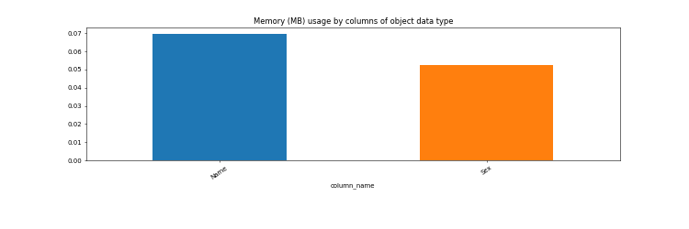

Analysing how many unique values an 'object' column has will be useful to detrminewhich columns are good candidates for *Categorical* data type. In combination with the total memory used by 'object'data type and each 'object' data type column, decisions can be made on converting them Category type.Object or string data type columns with low cardinality is suitable for Category type.**The threshold of 'low cardinality' depends on the domain of the data and data usage patterns.**

# Memory used by "Non-Object" data type

|  |  |  |  |  |
| --- | --- | --- | --- | --- |
| **column_name** | **col_memory** | **%_of_dtype_mem** | **%_of_total_memory** | **unique_values_count** |
| Survived | 0.01 | 25.00 | 4.17 | 2.00 |
| Pclass | 0.01 | 25.00 | 4.17 | 3.00 |
| Siblings_Spouses_Aboard | 0.01 | 25.00 | 4.17 | 7.00 |
| Parents_Children Aboard | 0.01 | 25.00 | 4.17 | 7.00 |
| Age | 0.01 | 50.00 | 4.17 | 89.00 |
| Fare | 0.01 | 50.00 | 4.17 | 248.00 |

"column_name" : Name of the column in the dataframe

"col_memory" : Memory used by the given column

"%_of_dtype_mem" : Percentage of memory used by the given column out of memory used by the column data type

"%_of_total_memory" : Percentage of the memory used by the given column out of the total memory used by the dataset

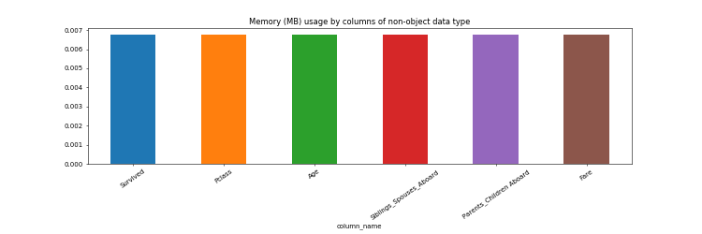

By analysing the min and max values of the numeric columns decions can be made to downcast the data type to more memory efficient storage types.

# Columns with non-null values less than 75.00%

The columns should contain at least 665 (75.00%) non-empty rows out of 887 rows to be considered useful.

The non-empty values threshold can be set using the threshold_perc variable in the code.

|  |  |  |  |  |  |  |
| --- | --- | --- | --- | --- | --- | --- |
| **column_name** | **col_data_type** | **col_memory** | **non_null_values** | **%_of_non_nulls** | **null_values** | **%_of_nulls** |

"column_name" : Name of the column in the dataframe

"col_data_type" : Data type of the given column

"col_memory" : Memory used by the given column

"non_null_values" : Count of non-null values in the given column

"%_of_non_nulls" : Percentage of the non-null values out of total values for the given column

"null_values" : Count of null values in the given column

"%_of_nulls" : Percentage of the null values out of total values for the given column

Generally columns with large percentage of empty values can be *dropped* from the dataset as they will not add any value to the analysis.

**But this depends on the domian of the dataset and usage pattern of the columns/data.**

Data correlation plot

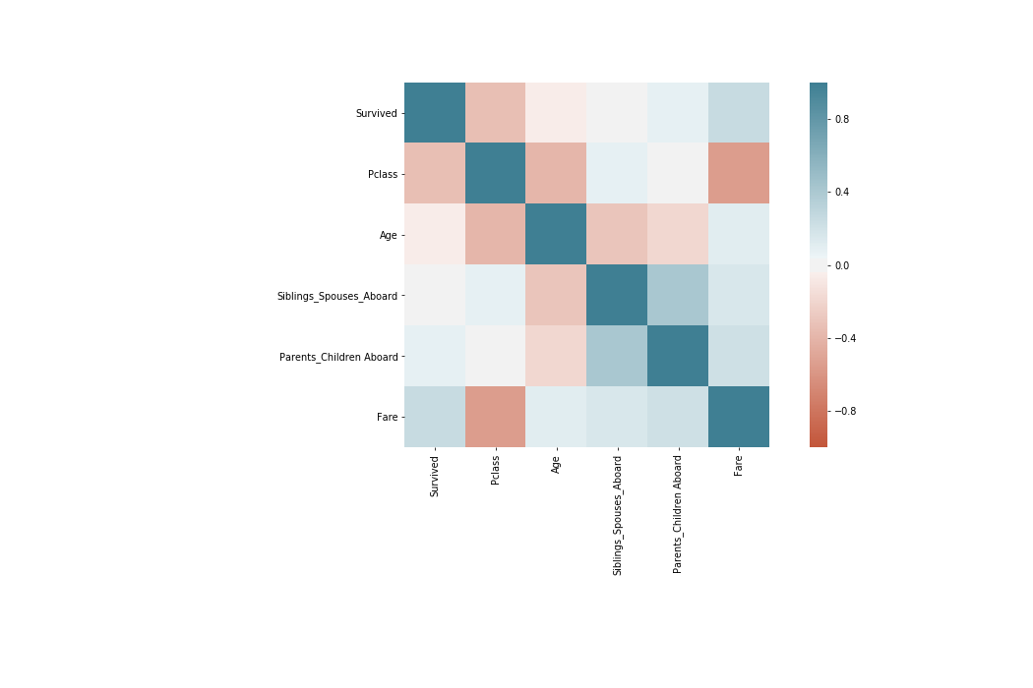

Column Data Profile Details

|  |  |  |  |  |  |
| --- | --- | --- | --- | --- | --- |
| **Survived** | | | | | |
| **TBD Column :** no value | | **Data Type :** int64 | | **Values Count :** 887 | |
| **Unique Values Count :** 2 (0.23%) | | **Non-Null Values Count :** 887 (100.00%) | | **Null Values Count :** 0 (0.00%) | |
| **Min :** 0.00 | | **Mean :** 0.39 | | **Max :** 1.00 | |
| **25th Percentile :** 0.00 | | **50th Percentile :** 0.00 | | **75th Percentile :** 1.00 | |
| **Column Memory :** 0.0068 MB | | **As % of Dtype Memory :** 25.00% | | **As % of DF Memory :** 4.17% | |

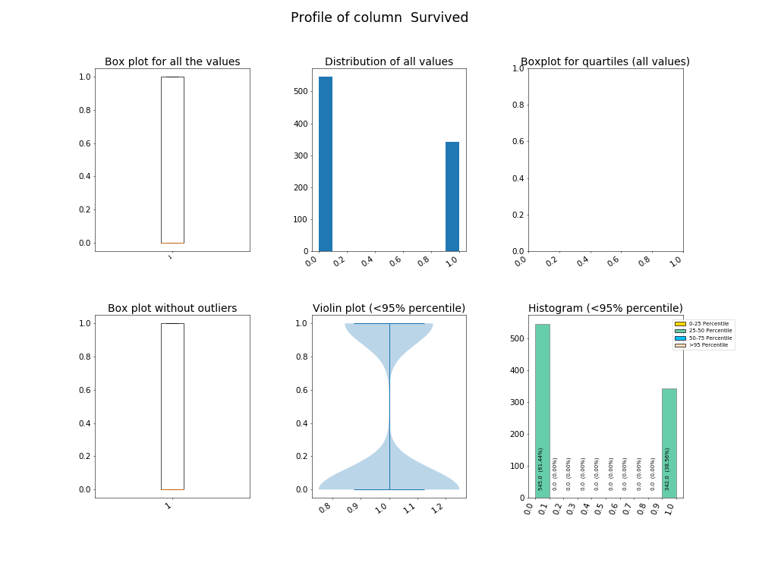

|  |  |  |  |  |  |
| --- | --- | --- | --- | --- | --- |
| **Pclass** | | | | | |
| **TBD Column :** no value | | **Data Type :** int64 | | **Values Count :** 887 | |
| **Unique Values Count :** 3 (0.34%) | | **Non-Null Values Count :** 887 (100.00%) | | **Null Values Count :** 0 (0.00%) | |
| **Min :** 1.00 | | **Mean :** 2.31 | | **Max :** 3.00 | |
| **25th Percentile :** 2.00 | | **50th Percentile :** 3.00 | | **75th Percentile :** 3.00 | |
| **Column Memory :** 0.0068 MB | | **As % of Dtype Memory :** 25.00% | | **As % of DF Memory :** 4.17% | |

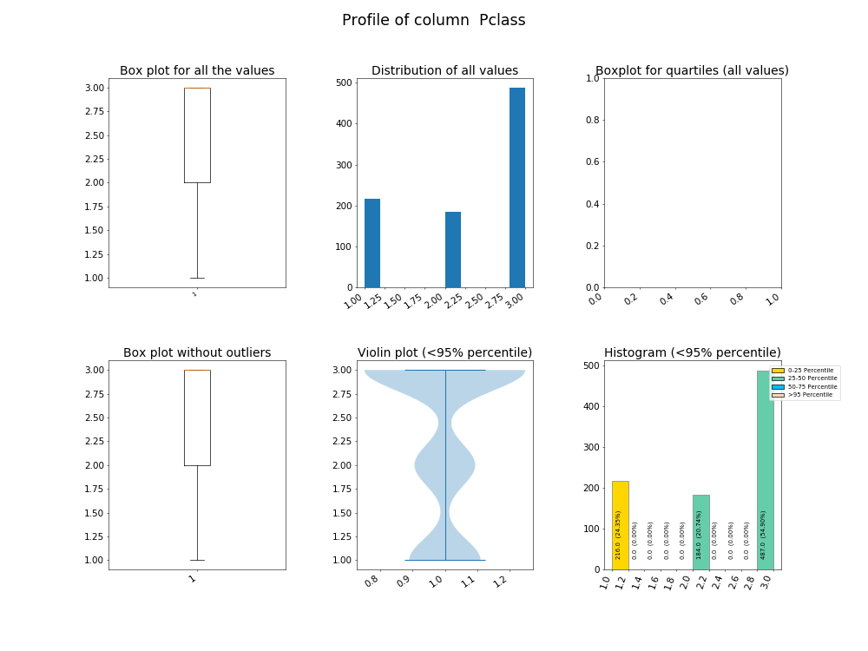

|  |  |  |  |  |  |
| --- | --- | --- | --- | --- | --- |
| **Name** | | | | | |
| **TBD Column :** no value | | **Data Type :** object | | **Values Count :** 887 | |
| **Unique Values Count :** 887 (100.00%) | | **Non-Null Values Count :** 887 (100.00%) | | **Null Values Count :** 0 (0.00%) | |
| **Min :** nan | | **Mean :** nan | | **Max :** nan | |
| **25th Percentile :** nan | | **50th Percentile :** nan | | **75th Percentile :** nan | |
| **Column Memory :** 0.07 MB | | **As % of Dtype Memory :** 57.16% | | **As % of DF Memory :** 42.87% | |

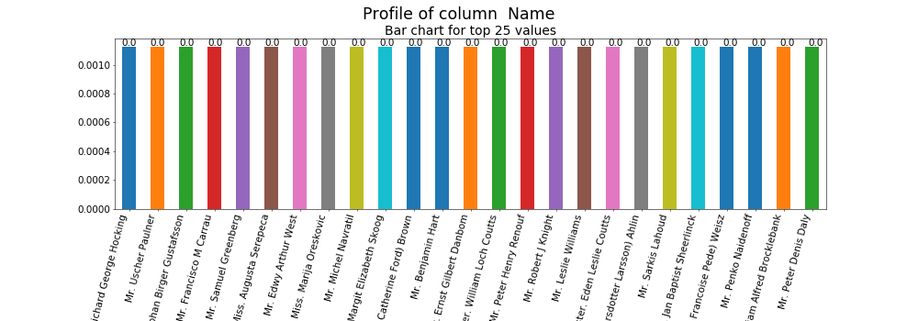

|  |  |  |  |  |  |
| --- | --- | --- | --- | --- | --- |
| **Sex** | | | | | |
| **TBD Column :** no value | | **Data Type :** object | | **Values Count :** 887 | |
| **Unique Values Count :** 2 (0.23%) | | **Non-Null Values Count :** 887 (100.00%) | | **Null Values Count :** 0 (0.00%) | |
| **Min :** nan | | **Mean :** nan | | **Max :** nan | |
| **25th Percentile :** nan | | **50th Percentile :** nan | | **75th Percentile :** nan | |
| **Column Memory :** 0.052 MB | | **As % of Dtype Memory :** 42.84% | | **As % of DF Memory :** 32.13% | |

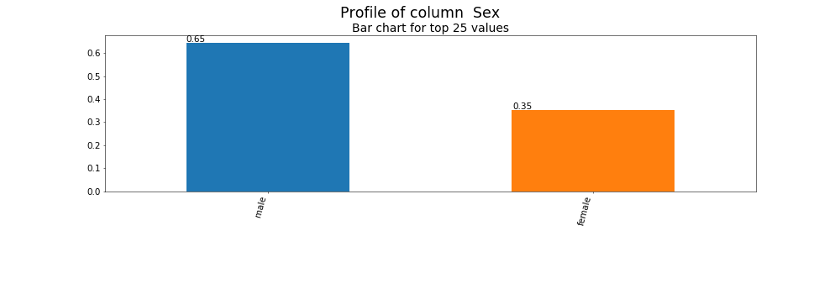

|  |  |  |  |  |  |
| --- | --- | --- | --- | --- | --- |
| **Age** | | | | | |
| **TBD Column :** no value | | **Data Type :** float64 | | **Values Count :** 887 | |
| **Unique Values Count :** 89 (10.03%) | | **Non-Null Values Count :** 887 (100.00%) | | **Null Values Count :** 0 (0.00%) | |
| **Min :** 0.42 | | **Mean :** 29.47 | | **Max :** 80.00 | |
| **25th Percentile :** 20.25 | | **50th Percentile :** 28.00 | | **75th Percentile :** 38.00 | |
| **Column Memory :** 0.0068 MB | | **As % of Dtype Memory :** 50.00% | | **As % of DF Memory :** 4.17% | |

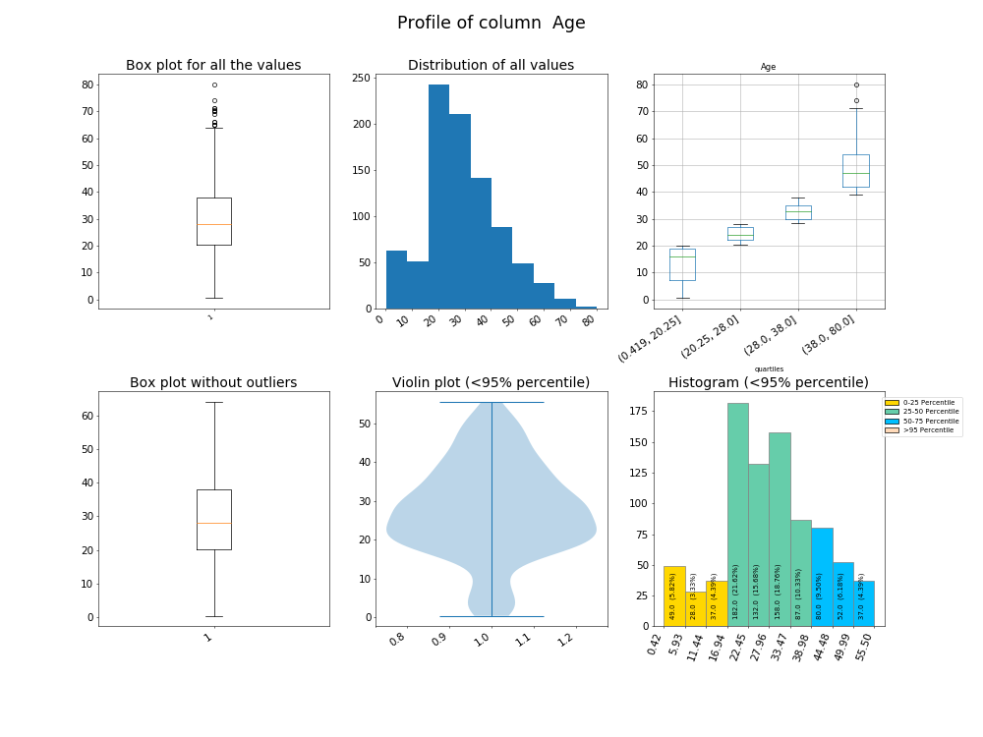

|  |  |  |  |  |  |
| --- | --- | --- | --- | --- | --- |
| **Siblings_Spouses_Aboard** | | | | | |
| **TBD Column :** no value | | **Data Type :** int64 | | **Values Count :** 887 | |
| **Unique Values Count :** 7 (0.79%) | | **Non-Null Values Count :** 887 (100.00%) | | **Null Values Count :** 0 (0.00%) | |
| **Min :** 0.00 | | **Mean :** 0.53 | | **Max :** 8.00 | |
| **25th Percentile :** 0.00 | | **50th Percentile :** 0.00 | | **75th Percentile :** 1.00 | |
| **Column Memory :** 0.0068 MB | | **As % of Dtype Memory :** 25.00% | | **As % of DF Memory :** 4.17% | |

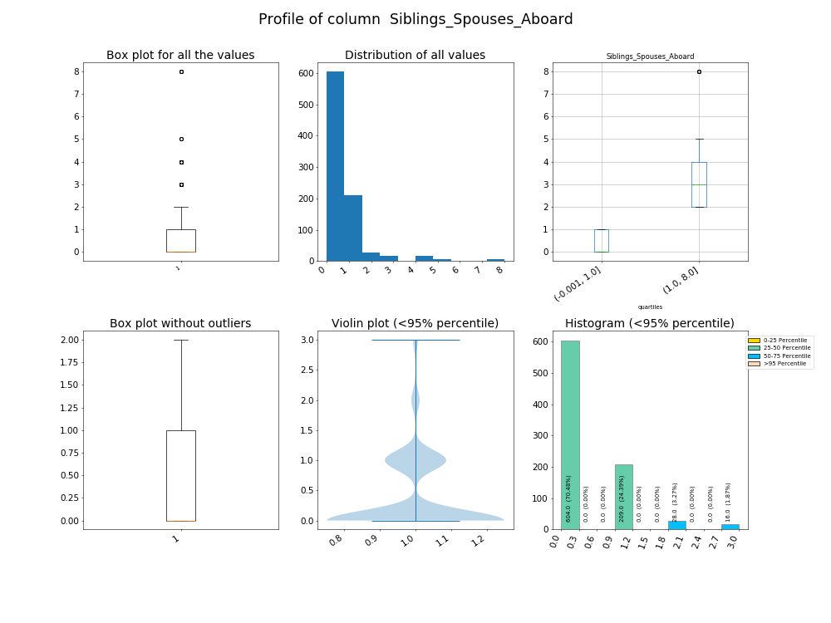

|  |  |  |  |  |  |
| --- | --- | --- | --- | --- | --- |
| **Parents_Children Aboard** | | | | | |
| **TBD Column :** no value | | **Data Type :** int64 | | **Values Count :** 887 | |
| **Unique Values Count :** 7 (0.79%) | | **Non-Null Values Count :** 887 (100.00%) | | **Null Values Count :** 0 (0.00%) | |
| **Min :** 0.00 | | **Mean :** 0.38 | | **Max :** 6.00 | |
| **25th Percentile :** 0.00 | | **50th Percentile :** 0.00 | | **75th Percentile :** 0.00 | |
| **Column Memory :** 0.0068 MB | | **As % of Dtype Memory :** 25.00% | | **As % of DF Memory :** 4.17% | |

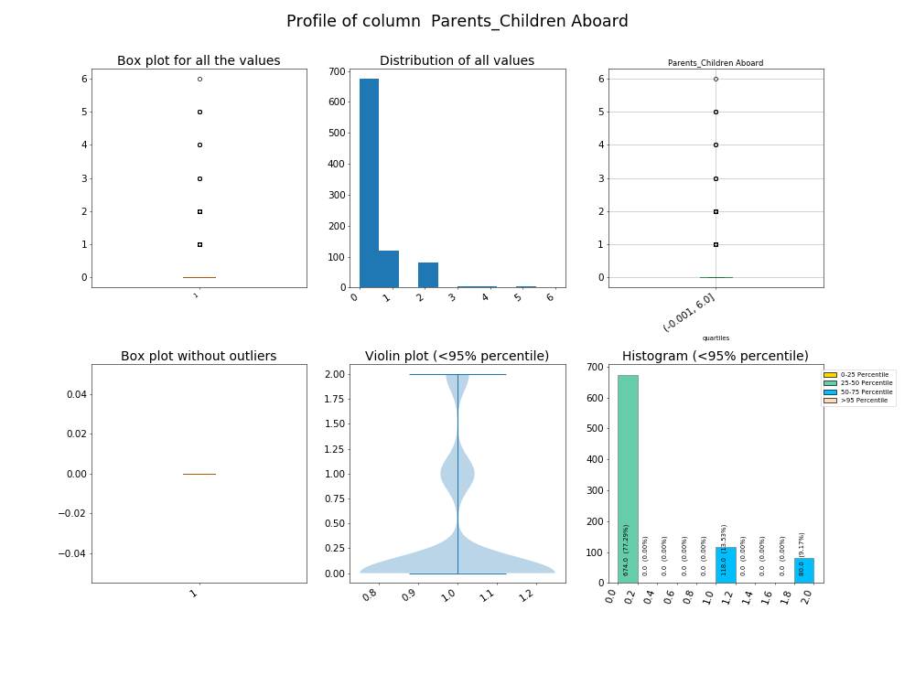

|  |  |  |  |  |  |
| --- | --- | --- | --- | --- | --- |
| **Fare** | | | | | |
| **TBD Column :** no value | | **Data Type :** float64 | | **Values Count :** 887 | |
| **Unique Values Count :** 248 (27.96%) | | **Non-Null Values Count :** 887 (100.00%) | | **Null Values Count :** 0 (0.00%) | |
| **Min :** 0.00 | | **Mean :** 32.31 | | **Max :** 512.33 | |
| **25th Percentile :** 7.92 | | **50th Percentile :** 14.45 | | **75th Percentile :** 31.14 | |
| **Column Memory :** 0.0068 MB | | **As % of Dtype Memory :** 50.00% | | **As % of DF Memory :** 4.17% | |

