Keyword Driven Framework for Automation Testing
Sachin A Khade
Harpreet Kaur Nijjar

Keyword Driven Framework for Automation Testing

Abstract
This paper presents an object based keyword driven framework for J2EE web based application. This framework facilitates integration of keyword driven testing and traditional scripts independent of the application.
This framework is developed to provide an easier approach to Functional Testing and Business Process Testing by passing appropriate Parameters for particular Action words in the framework. This framework allows reasonably intuitive tests to be developed and executed without modifying the test scripts.
Test engineers can use the framework to develop a driver which uses data to vary test script execution instead of using test scripts directly. Team Leads can benefit as far as technical aspects are concerned. Project managers and Business mangers can handle GUI testing in reduced time and minimized cost. Keyword-driven frameworks are very powerful, and they make it super easy for non-testers and non-technical testers to contribute to the test project.
This paper discusses a keyword driven approach for a practical example and highlights the benefits of it in comparison to test library approach for automation testing. The software testing tool integrated is Quick Test Professional. In addition this paper gives a brief introduction to some of methods and QTP (VBS) libraries used in QTP scripts.
The test scenarios are built dynamically based on the selection of the keyword and the parameters passed. Hence, the execution sequence of the Test Scripts is determined by output of each executed step.
The keyword driven framework developed was applied to a J2EE web based application. This paper documents an example of low priority functional test case of the particular application. But the future scope involves Business Process Testing Suite along with entire Functional Testing Suite.
The paper discusses the significant advantages of Keyword driven framework in comparison to Test Library framework. The real benefit is the improved maintainability and reusability of the test scripts. A comparison amongst Keyword driven framework and Test library framework is depicted which signifies the flexibility and minimized cost involved in Keyword driven framework.
An example discussed shows the execution of a particular Functional test suite consumes five hours using Test Library framework whereas for Keyword driven framework same can be accomplished in three hrs.
The Framework design and its components are discussed in detail in the paper. Main components of Keyword driven framework include Test Case IDs, Result, Keyword, Output, Parameters and Time-Stamp.
In the Framework Recovery Scenarios (.qrs files in QTP) at appropriate points during Test Suite execution have also been introduced. Hence, on occurrence of application error, respective Recovery Scenario gets enabled. The framework is so designed that, it’s possible to view the snapshot of the application at the very instant when Recovery scenario got enabled, making testing easier and flexible.
This framework has proved to be beneficial to the organization in terms of reduction of the maintenance cost for test scripts. Few problems related to Test Library Framework and Application Under Test were overcome using this framework. Test Library framework encountered synchronization problem which has been discussed and analysed in detail.
This paper also discusses the future enhancements of the Keyword Driven Framework, more problem solving and gaining benefits using this framework

Introduction
Keyword driven framework consists of Data Tables and Keywords, independent of the test automation tool used to execute them and the test script code that "drives" the Application Under Test (AUT) and the data. Keyword Driven Framework looks very similar to manual test cases. In a keyword-driven test, the functionality of the AUT is documented in a table as well as in step-by-step instructions for each test. In this method, the entire process is data-driven, including functionality.
This paper gives a detailed comparison between Test Library framework and Keyword Driven framework. It also discusses issues related to automation of Java applets and how those issues are tackled while designing the framework.

Audience
Test engineers can use the framework to develop a driver which uses data to vary test script execution instead of using test scripts directly. Team Leads can benefit as far as technical aspects are concerned. Project managers and Business mangers can handle GUI testing in reduced time and minimized cost. Keyword-driven frameworks are very powerful, and they make it super easy for non-testers and non-technical testers to contribute to the test project.

Benefits of Keyword Driven Framework over Test Library Framework
Test Library Framework:
The Test Library Framework divides the application-under-test (AUT) into procedures and functions (or objects and methods) instead of scripts. This framework requires the creation of library files (VB Script libraries) that represent modules and functions of the AUT. These library files are then called directly from the test case script.
Various factors why the Keyword driven frame work is implemented in the Business Process Testing

1. Setting up the Automation Test Environment.
2. Flexibility.
3. Reusability.

- Setting up the Automation Test Environment.

With the Test Library driven frame work, the Business analyst or manual testers had to key in too many parameters before starting the execution of the scripts. Hence business analyst required a fair knowledge about the automation script and scripting, this is overcome by using the Key word driven frame work in which the business analyst will have to key in only the Keywords which is related to the business operation. This makes the test suite executable by the Business analyst and even manual testers without having the knowledge of scripting and QTP.

2. Flexible in use.

If a Business analyst has to test only a specific Business Process or functionality or scenario then with the Test Library test frame work it was not possible to do so because all the dependency factors was not handled, where as the Keyword driven frame work helps to achieve the Business processing testing or specific functionality testing or scenario testing just by building in the scenarios as required.

- Reusability.

For each and every scenario that has to be tested the keyword driven frame work reuses the library files that has been developed which in turn reduces the redundancy.

Evolution of Keyword Driven Framework
The issues related to Test Library Framework and J2EE Web Application lead to the evolution of this framework.

Problems related to Test Library Framework:
- Test Runs were frequently going out of sync.

Root-Cause Analysis:
- Framework was not able to handle the dependency between test cases. Whenever test case fails, it used to execute the dependant test cases. Libraries were not returning the ‘Pass / Fail’ Status
- Libraries were not returning the ‘Pass / Fail’ Status

Solution:
1. Designed Keyword Driven Framework in which,
‘If Fail’ column introduced,
- If some test case fails, execution control goes to the test case / step mentioned in the column.
‘If Pass’ column introduced as well,
- If particular test case is disabled, it disables the dependant test cases / steps in the column.

2. Class Libraries modified to return pass fail status.
For example:
-If object is not present the library returns a message ‘Object is not present within the application’,
-If some vb script error occurs, it returns error code and description.
-If some message pops-up, recovery scenario updates an environment variable. The value of the variable is returned by class library to the main driver script. The step is logged as failed.
-If everything is executed as expected then only class library returns ‘Pass’ result.

Problems related to J2EE Web Application

Java Applets:

Every application contains some customized controls based upon the enterprise requirements. There are some customized controls / widgets developed in the form of Java applets in the J2EE application for which this framework is developed. These are customized Applets contained standard Java widgets. These customized applet used to publish only that much data which is needed outside it for programming purpose.

These applets are basically tree and list controls.

List:
A row in the list applet keeps on changing the location (x, y co-ordinates) which is dependant on the sorting of various columns.

Tree:
A tree node keeps on changing the location as per the expansion and contraction of various branches of the tree.

Analysis:
Sorting was taken care previously by QTP libraries (logic implemented in .vbs files). It was dependant on the Automation tester’s perception while designing the test case. Tester used to send the sorting parameters while calling the libraries.

Sometimes, sorting column/order used to change on some builds due to defect fixing.

Windows shell script to select Arrow keys on the keyboard was used to traverse to particular node. This process was time consuming.

There are some methods present in Java for various widgets which will return the rectangle object (x, y co-ordinates and height as well as width) of particular cell of a table / node of a tree at runtime. These methods were not present in those applets. For e.g. getPathBounds() for tree.

Solution:

Development team was requested to introduce some new public methods in the Java applets based on above information.

There were some customized methods already present in the list applet which used to return the position of the row after sorting.

These methods were used in the QTP libraries.

Keyword Driven Framework Overview

.

Scenarios.xls
(Test Cases)
Test Suite.xls
(Control File)
QTP Startup
Script
Driver Script
(vbs: to drive excel)
Functions
Script
(vbs: keywords and
functions mapping)
Functional Expert
QTP Expert
Class
Libraries
(Functions &
parameters)
Component
Libraries
(Functions &
parameters)
Utility
Libraries
(S napshots,
DB connections etc.)
Object
Repository
Setobjects.vbs
(OR Abstraction)

Application
Recovery
Results
Error pop-ups snapshots
Error pop-ups snapshots
Pass / fail
results
Pass / fail
results
scenarios ( keywords & parameters)
launches
designs
designs
designs
Error pop-ups, messages
Error pop-ups snapshots location, filename
Pass / fail status
Pass / fail status
Designs & enables/disables scenarios
Designs
Executes
Executes
Block Diagram of Keyword Driven Framework

Functional Expert: This is Manual Testing Team taking care of Manual Testing Activity.

Test Suite: This excel sheet consists of the Test case format being followed.
Test Suite

Test Scenarios: This is a collection of Test cases that constitutes the end to end operation of an application as per the user role and permissions. Each Test Scenario is independent of other and if one fails execution of another does not get affected.

Results: When the Test is run then Control sheet gets updated with the corresponding results. Also in tool self generated result takes place in xml file.

QTP Expert: This consists of Automation Team who is actually involved into automation of the AUT. Each one of them is aware of QTP operation and Scripting.

QTP Startup Script: This script is used to launch/run the Driver script.

Driver Script: This script is used to drive the excel sheet like Test Scripts, Test Scenario file.
E.g. Open an excel sheet, save excel sheet, close excel sheet.

Class Libraries (Functions & parameters): Class libraries are developed to interact with the application widgets present in the applet (In case of Java based application).It is a collection of vbs to be used with the overall application.

Component Libraries (Functions & parameters): These are business component libraries which are making use of Class libraries to automate the business components like Users, Workflows, and Departments. These are the .vbs Functions already defined which contains application specific steps.

Functions Script (vbs: keywords and functions mapping): These are User Defined functions used to map with the keywords getting used by spreadsheet or control sheet.
E.g. for Login keyword, Login function is created and being called when QTP encounters this Login word it gets executed.

SetObjects.vbs: This is used to map the objects which are present into Object Repository with the VB variables from VB Script.

Object Repository: Stores the AUT object’s properties and its respective values.

Utility Libraries (Snapshots, DB): These are general purpose libraries with the help of them we can perform different tasks like Event logging, logging results to DB and connection to the database, taking error snapshot while running the script. Etc.

Recovery: This is one of the major components getting used by the test script. Initially recovery is being kept disabled and when it is actually going to be used with Framework then enable and it performs its intended operation.

Brief functional overview of Recovery Scenario is shown as below.

ClassLibraryFunction

Main Function
Recovery Action
Calls
VB errors
ClassLibrary.vbs
Recovery Scenarios
Enables and executes

Application
SubFunctions

Calls
Probes For
Error Conditions
VB errors
Error Msg
Calls
Snap Shot
SubFunctions

Sub Functions
Snap Shot
Utility Library

How Recovery Scenario Works with The Framework?

Some vb script error may occur while executing the main/sub functions in class library. It returns error code and message to class library function then class library gives call to the Recovery action which enables and activate all the Recovery Scenarios.

The Recovery Scenario instantiates post recovery option i.e. function call which takes snap shots of that unpredictable error pop-up by using snap shot Utility library. The snap shot will store in the results directory.

We can customize Recovery Scenarios as per our requirement and error types. By default in this framework Recovery Scenario is disabled. We explicitly enable it at the time of interaction of class libraries with the application.

Keyword Driven Framework User Interface (Table 1)
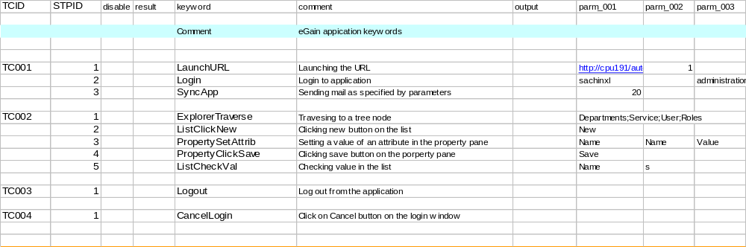

Results after execution (Table 2)

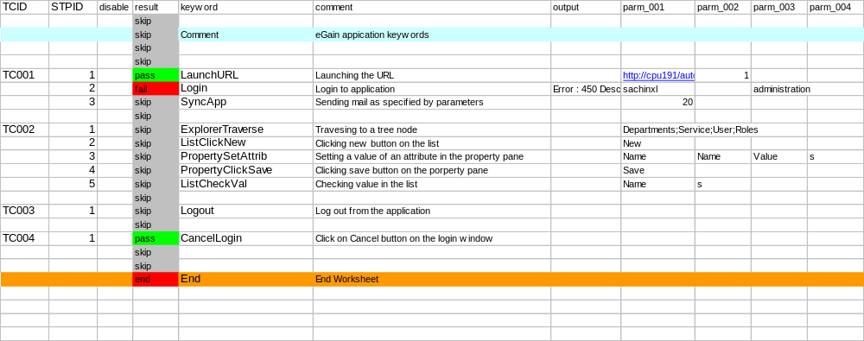

Implementation of Keyword Driven Framework
Description of each column (Table 2)

1. TCID: This field used for unique test case ID given by user.
2. STPID: It consists of sub test case ID for each test case.
3. disable: If ‘True’ parameter is passed for disable column particular test case will not get
executed.
4. result: It show pass/fail/skip status of executed test case.
5. keyword: It take the parameter mapped with particular function.
6. comment: It give the explanation about the selected keyword(What functionality it will
Perform?)
7. output: It display the error message occurred while executing test case with path of the
captured image.
8. Parm_001 to Parm_0010: It take the parameters for function which is mapped with the
specified keyword.
9. IF Pass: It contain the test case ID of subsequent test case to be execute if current test
case is Pass.
10. IF Fail: It contain the test case ID of subsequent test case to be execute if current test
case is Fail.
11. Time_Stamp: It displays execution time of particular sub test case.

How the organization benefited from Keyword Driven Framework?

The Keyword Driven Framework has following benefits:

1. The main advantage of this framework is the low cost for maintenance. If there is change in any test case, only the Test Case File / Single Object Repository needs to be updated and not the Driver Script and Startup script.
Example: For a product based company, maintenance of test scripts is a major task. When the company requirement was to shift to SUNJVM from MSJVM, it took ten days to make all the changes in Scripts as well as individual Object Repositories, whereas using the Keyword Driven Framework, it will require only one day to change the single common Object Repository. Hence 90% cost saving was achieved.

2. Building of Test Scenarios and execution of the Functional Test Suite was feasible without QTP and scripting knowledge.

3. This framework is easy to understand when non-testers come in picture(for test case design).

4. Re-usability significantly increased over a period of time.

5. Test Script development is possible without a functioning application.

6. Test cases designed in this framework are less prone to human errors.

Future Scope
The organization looks forth the execution of Business Process Testing in an unattended mode.
So even in case of new joiners / high retention rate, less training will be required

References
SR.NO | ARTICLE NAME | AUTHOR | DATE POSTED | CONFERENCE
1. | Object based Framework for Risk Driven Test Automation | Reghunath Balaraman | ----- | ------
2. | Keyword-Driven Testing | Danny R. Faught | Nov 5, 2004 | -----
3. | Keyword Testing at the Object Level | Brian Qualters | Jan 6, 2003 | ------
4. | Keyword-Driven Methodology: An Automation Success Story | Paulo Barros, Progressive Insurance |  | STARWEST 2006
5. | Keyword Testing at the Object Level | Brian Qualters, TurboTesting Concepts |  | STARWEST 2002
6. | An Execution Framework for Java Test Automation | Erick Griffin, Tivoli Systems Inc |  | Test Automation 2001
7. | Revolutionize Your Automation with Application Maps and Keywords | Dion Johnson, Pointe Technology Group |  | STAREAST 2003

Author’s biography
The author, Sachin Khade, is a post graduate in Computer Mnagement from university of Pune, India and has over 5.7 years of experience. He has hands on experience in test planning, effort-estimation, test scheduling, test framework development, test suite development, test execution and issue management during various phases of TDLC. Since last 4 years, he is actively involved in test architecting, test Planning and management and process tailoring. He has worked on J2EE test automation project in eCRM domain applications. He has extensively worked on Functional and Performance Scenarios automation and test management products from Mercury Interactive, and has also exposure to several other Industry standard testing tools.
Currently, he is working as a Sr. QA Analyst for automation projects with eGain.

The author Harpreet Kaur Nijjar is a post graduate in Electrical engineering from Maharaja Sayajirao University (Vadodara) and has 1 year of experience. She has experience in test scheduling, test framework development, test suite development and test execution during various phases of TDLC. She has worked on test automation and test management product from Mercury Interactive.
Currently, she is working as QA Engineer for automation projects with eGain.

