Medidata Knowledge Hub

Medidata Solutions is a leading provider of cloud-based software for clinical trials, helping pharmaceutical, biotech, and medical device companies design, run, and manage the studies that bring new drugs and treatments to market.

It's part of Dassault Systèmes (acquired in 2019) and its platform — including products like Rave EDC — is one of the most widely used systems for capturing and managing clinical trial data worldwide.

What We're Building
Client: Medidata (a Dassault Systèmes company) · Our product: Ingeniux Discover CX
The short version
- Medidata has a help website where their customers read product documentation. It's called the Knowledge Hub.
- That website runs Zoomin — and Zoomin is shutting down this October. So Medidata needs a new home for it.
- We replace it with our platform, Discover CX — a fresh, Medidata-branded help website.
- Their writers don't change anything. They keep writing in Confluence like always. We automatically pull their pages into the new website.

What it looks like today
These are screenshots of the current site. We're rebuilding this — same idea, newer and better. Pictures first, so everyone can see what “the portal” actually means.
Note: I demoed the Discover CX base templates (customizable home page, light/dark mode, language picker, notifications), and Alex engaged positively — he asked about adapting them (home-page design changes, grouping products into "experience" categories, the glossary. We need to add a "Medidata-branded responsive theme... configured to match and improve on the current Zoomin experience.
customizable themes plus custom CSS/JS.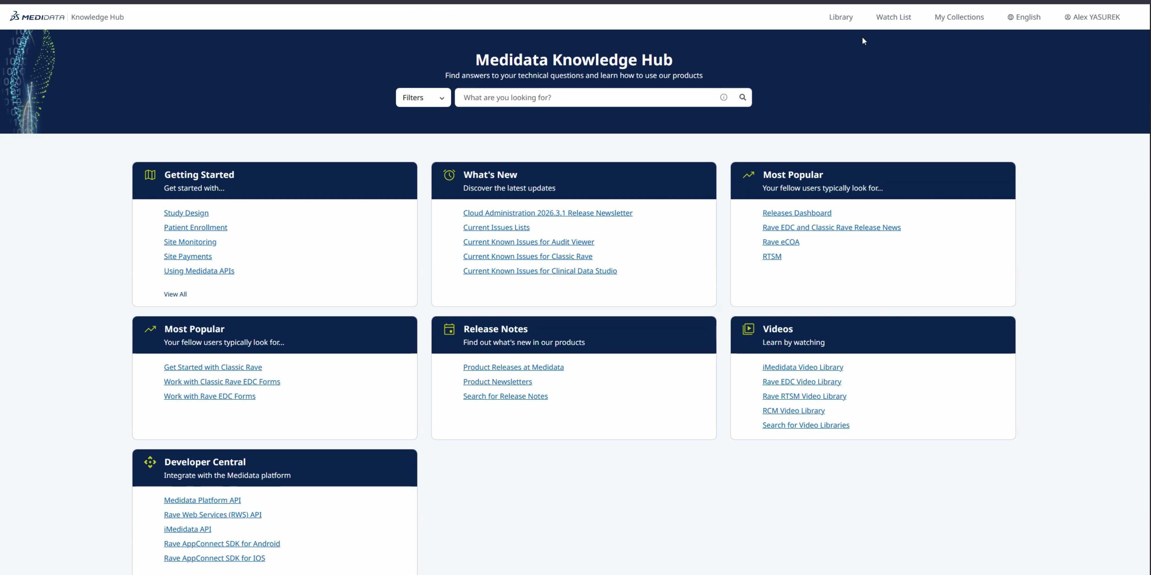
The home page customers land on — tabs for Getting Started, What's New, Release Notes, Videos, and more.
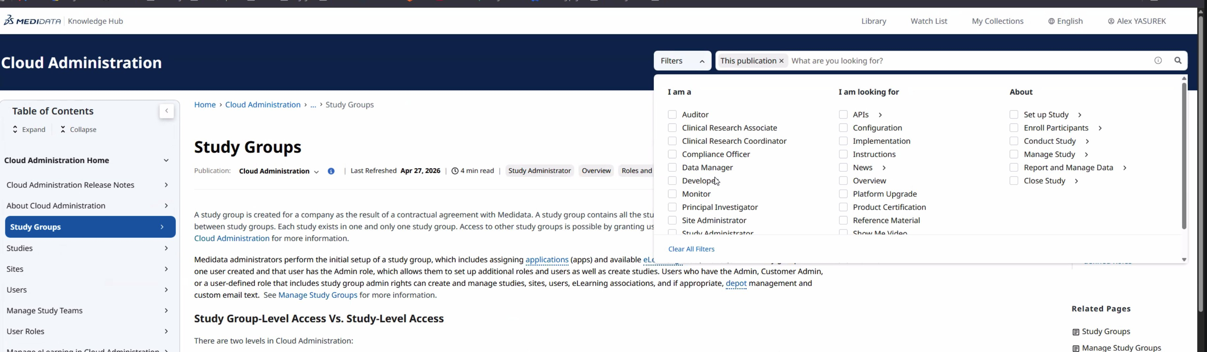
A documentation page with the search filters open on the right — customers narrow results by their role and topic.
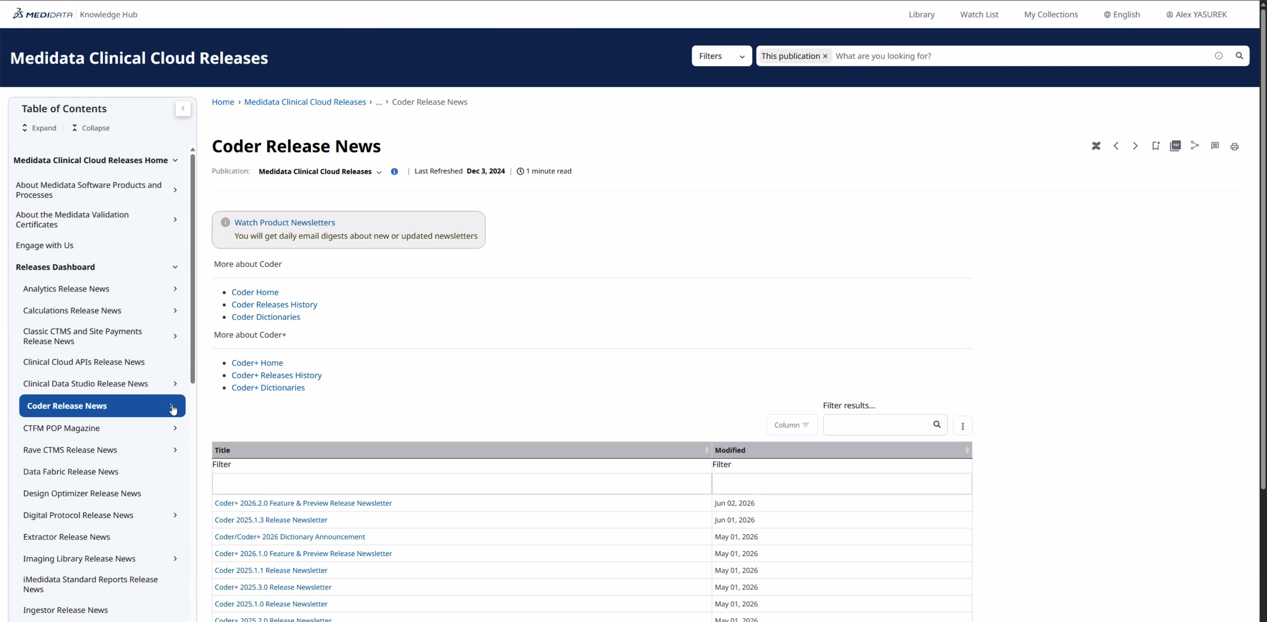
Release news. Customers can subscribe to email updates so they hear about new releases.
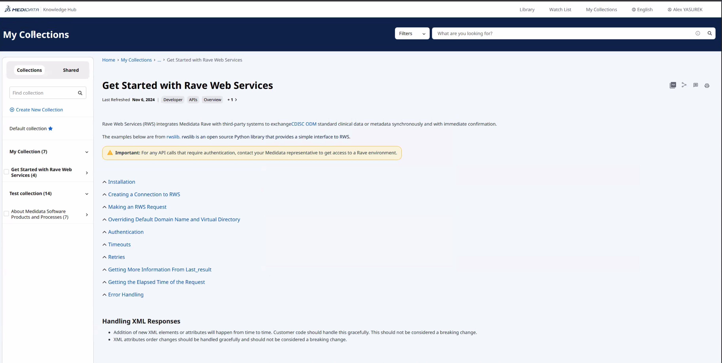
“My Collections” — customers save pages into their own folders to come back to later.
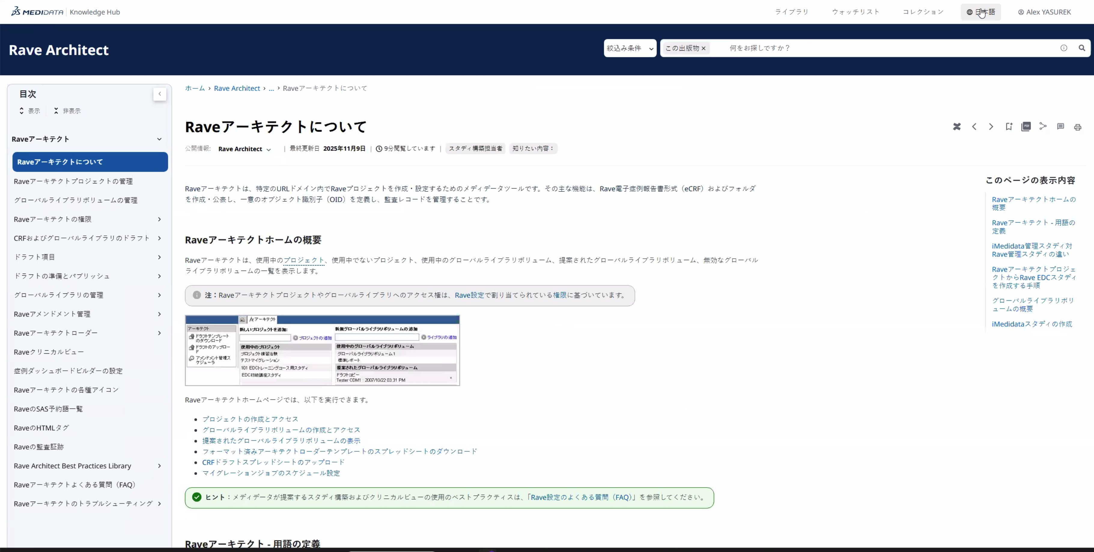
The same content in Japanese. The site runs in four languages (English, Japanese, Chinese, Korean).
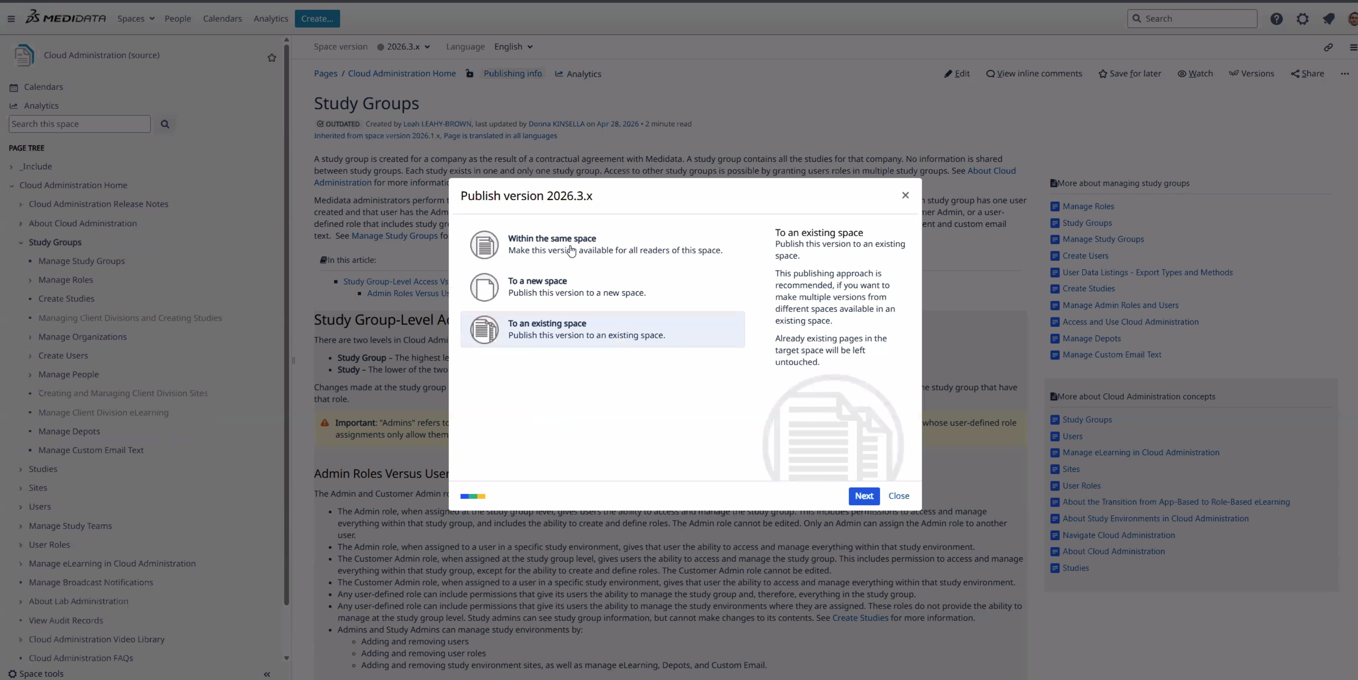
Behind the scenes: a writer publishes from Confluence, and the page flows out to the website automatically.

What we're building
Here's the whole job in plain terms. “Effort” is a rough size, not a price — it just shows where the big and small pieces are.
Pulling pages from Confluence — The automatic pipe that brings their writers' pages into the new site and keeps it up to date. This is the heart of the project. (Effort: Large)
The new website (portal) — The branded site customers see — pages, menus, layout, and look-and-feel. (Effort: Medium)
Search and filters — Fast search, plus filters so customers find the right doc by role and topic. (Effort: Medium)
Login for staff and customers — Staff sign in one way, customers another. Each person sees only what they're allowed to. (Effort: Medium)
Four languages — English, Japanese, Chinese, and Korean, with a language switcher. (Effort: Medium)
Moving the existing content over — A one-time move of today's pages into the new site, checked side-by-side. Size depends on how many pages they have. (Effort: Medium)
Handy extras — Save-as-PDF, saved collections, email update subscriptions, and a feedback button. (Effort: Small)
Testing, training, and go-live — Make sure it all works, teach their team to use it, and flip the switch. (Effort: Medium)

Key dates
Timeline is very short. I’ve asked for ability to issue a work order ahead of the MSA so we can start development earlier.

Aug 14 — We're picked.
Sep 1 — Project officially begins.
Oct 1 — New site goes live.
Oct 17 — All finished and cleaned up.

