Cover Page

|  |  |
| --- | --- |
| Student Name: | Jobe David Castro and Wayne Barrow |
| Student Number: | 00075634,00078091 |
| Topic: | Ministry of Tourism |
| Date Given: | Wednesday Nov 27th, 2024 |
| Course Code: | ITEC 240 |
| Course Title: | Web Page Design |
| Presentation Date: | Wednesday December 18th, 2024 |
| Due Date: | Wednesday December 18th, 2024 |
| Teacher Name: | Alicia Dennis-Nagee |
| CRNS: | 10077 |
| Total No. of Pages: | 8 |
| Project Weighting: | 25% |
| Center: | South |

Table of Contents

|  |  |
| --- | --- |
| Organization Background: | 3 |
| Storyboard: | 4-7 |
| Screenshots of your website in operation: | 8-16 |
| Appendices: | 16-20 |
| Appendix 2: | 21-22 |
| Appendix 3: Reference: | 23-24 |

Organization Background

Trinidad and Tobago were ceded to Britain in 1802 under the Treaty of Amiens as separate states and unified in 1889. Trinidad and Tobago obtained independence in 1962, and became a republic in 1976. Culture is shaped by a variety of influences, including Indigenous, African, European, and other. Our website would be dealing with the tourism, culture and the Arts sector.

Storyboard:

|  |  |  |  |  |  |  |  |  |
| --- | --- | --- | --- | --- | --- | --- | --- | --- |
| Index/Home Page | | | | | | | | |
| Home | About | Contact Us | | | Arts | Culture | Registration | Login |
| Logo | | | | | | | | |
| Image | | | | Information | | | | |
| Image | | | | | | | | |
| Information | | | Image | | | | | |
| Footer | | | | | | | | |

|  |  |  |  |  |  |  |  |
| --- | --- | --- | --- | --- | --- | --- | --- |
| About Us Page | | | | | | | |
| Home | About | Contact Us | | Arts | Culture | Registration | Login |
| Logo | | | | | | | |
| Information | | | Information | | | | |
| Footer | | | | | | | |

|  |  |  |  |  |  |  |
| --- | --- | --- | --- | --- | --- | --- |
| Contact Us Page | | | | | | |
| Home | About | Contact Us | Arts | Culture | Registration | Login |
| Logo | | | | | | |
| Table with information | | | | | | |
| Footer | | | | | | |

|  |  |  |  |  |  |  |  |
| --- | --- | --- | --- | --- | --- | --- | --- |
| Arts Page | | | | | | | |
| Home | About | Contact Us | | Arts | Culture | Registration | Login |
| Logo | | | | | | | |
| Logo | | | Information | | | | |
| Footer | | | | | | | |

|  |  |  |  |  |  |  |  |  |
| --- | --- | --- | --- | --- | --- | --- | --- | --- |
| Culture Page | | | | | | | | |
| Home | About | Contact Us | | | Arts | Culture | Registration | Login |
| Logo | | | | | | | | |
| Image | | | Information | | | | | |
| Logo | | | | | | | | |
| Information | | | | Image | | | | |
| Footer | | | | | | | | |

|  |  |  |  |  |  |  |
| --- | --- | --- | --- | --- | --- | --- |
| Registration Page | | | | | | |
| Home Page | About Us | Contact Us | Arts | Culture | Registration Page | Login |
| Logo | | | | | | |
| Image | | | Registration information | | | |
| Footer | | | | | | |

|  |  |  |  |  |  |  |
| --- | --- | --- | --- | --- | --- | --- |
| Login | | | | | | |
| Home Page | About Us | Contact Us | Arts | Culture | Registration | Login |
| Logo | | | | | | |
| Login Information | | | | | | |
| Footer | | | | | | |

Screenshots of your website in operation

Home Page

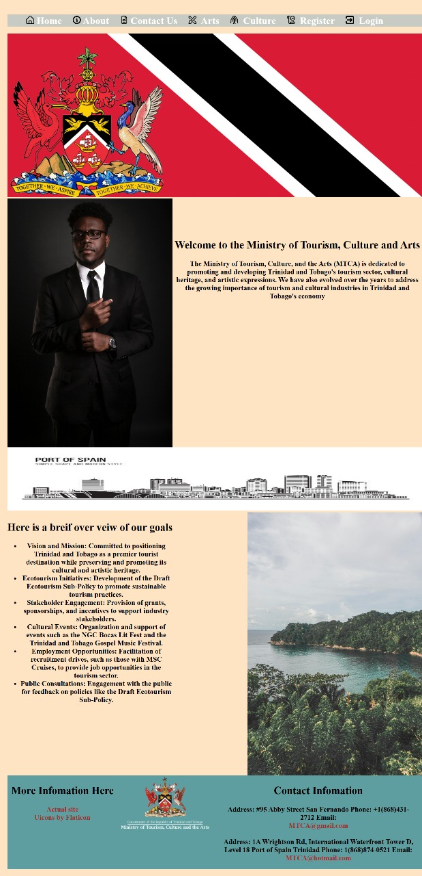

About Us

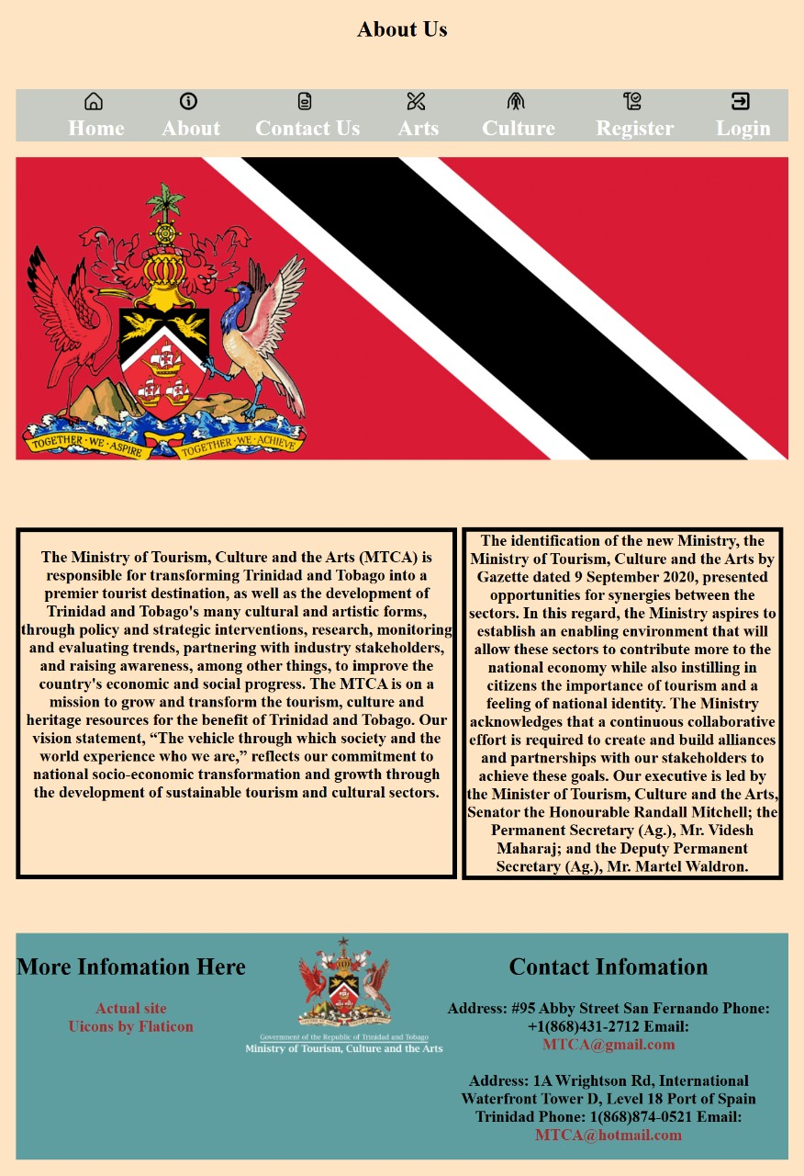

Contact Us

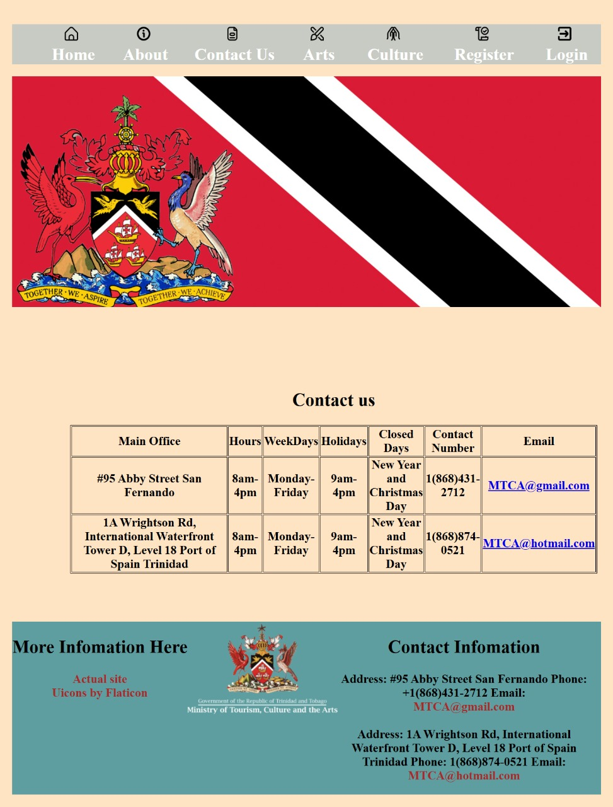

Arts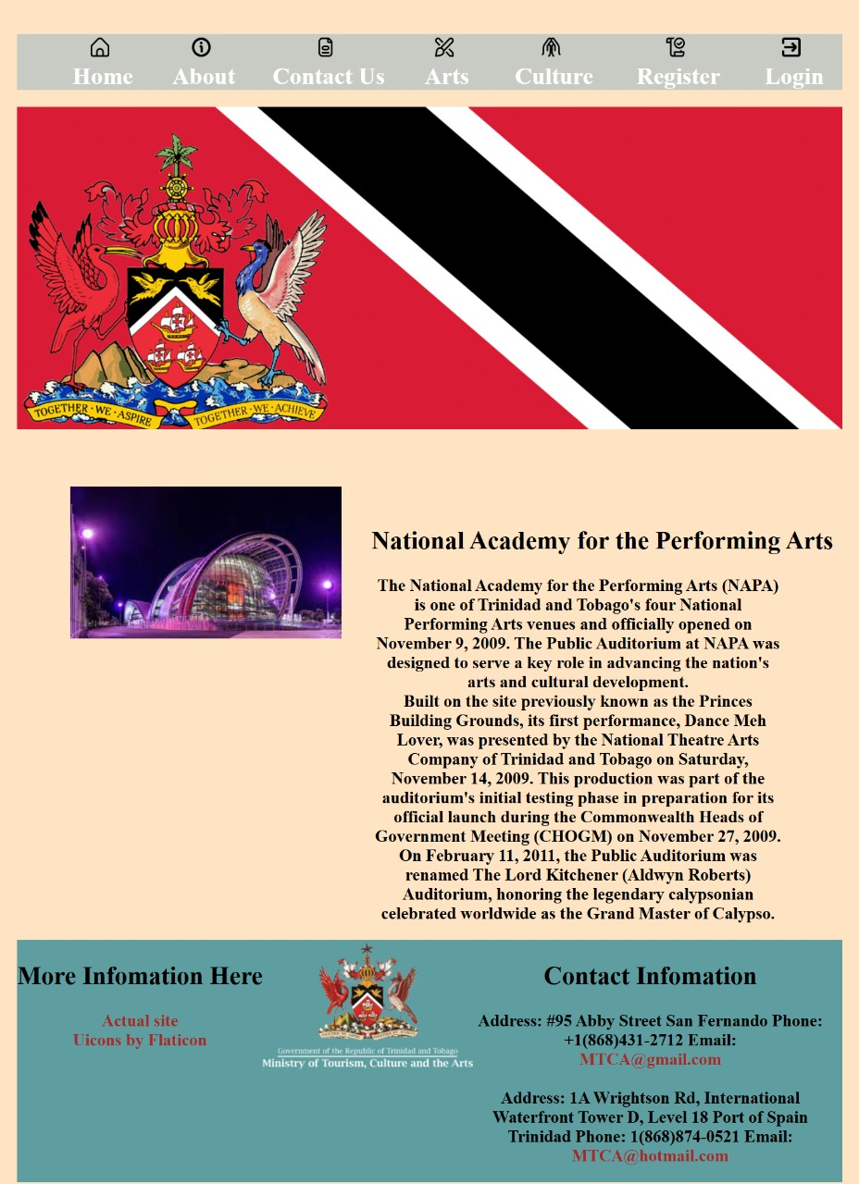

Culture

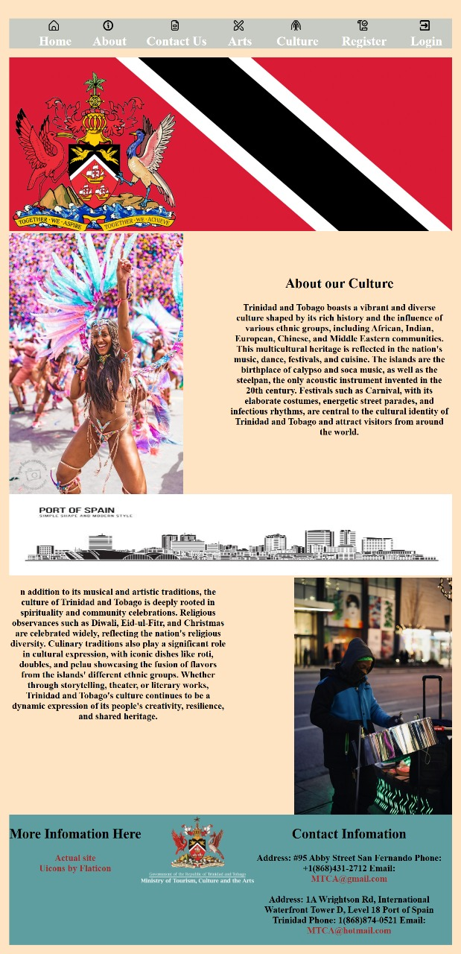

Register

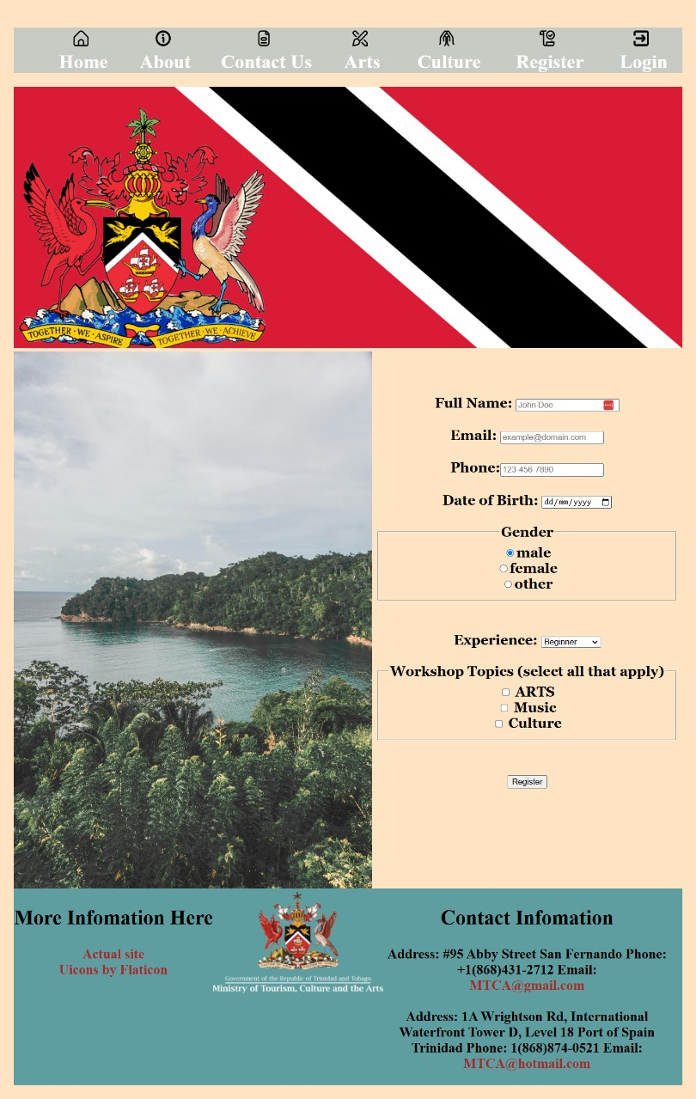

Login

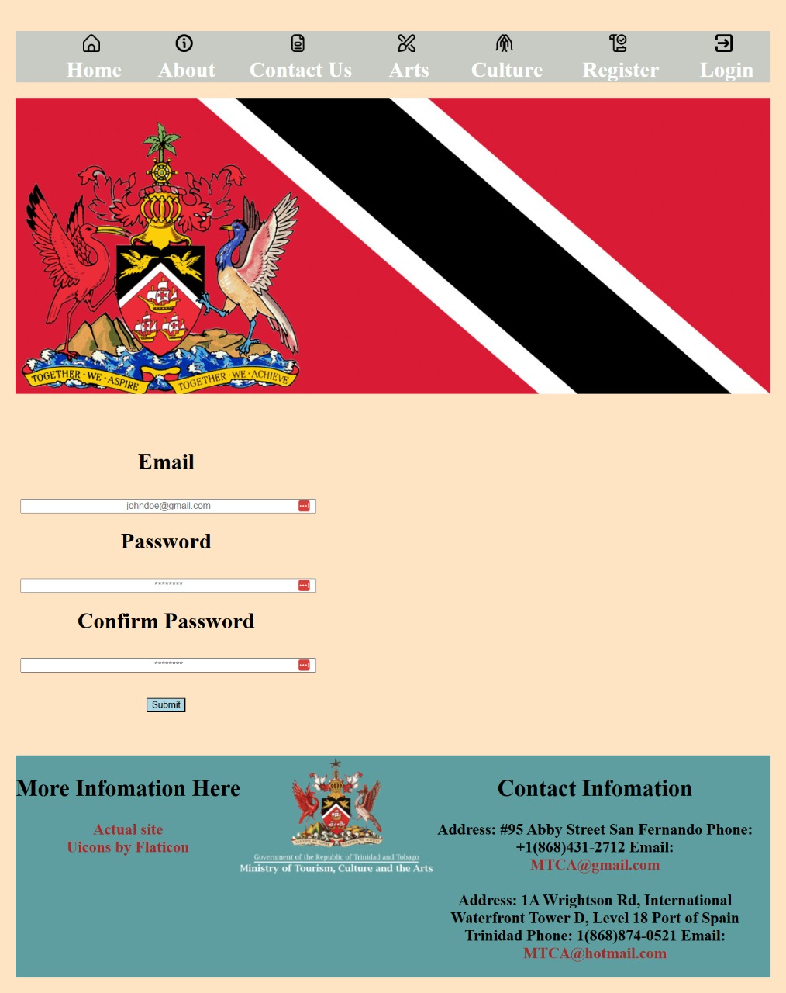

Thank You Page

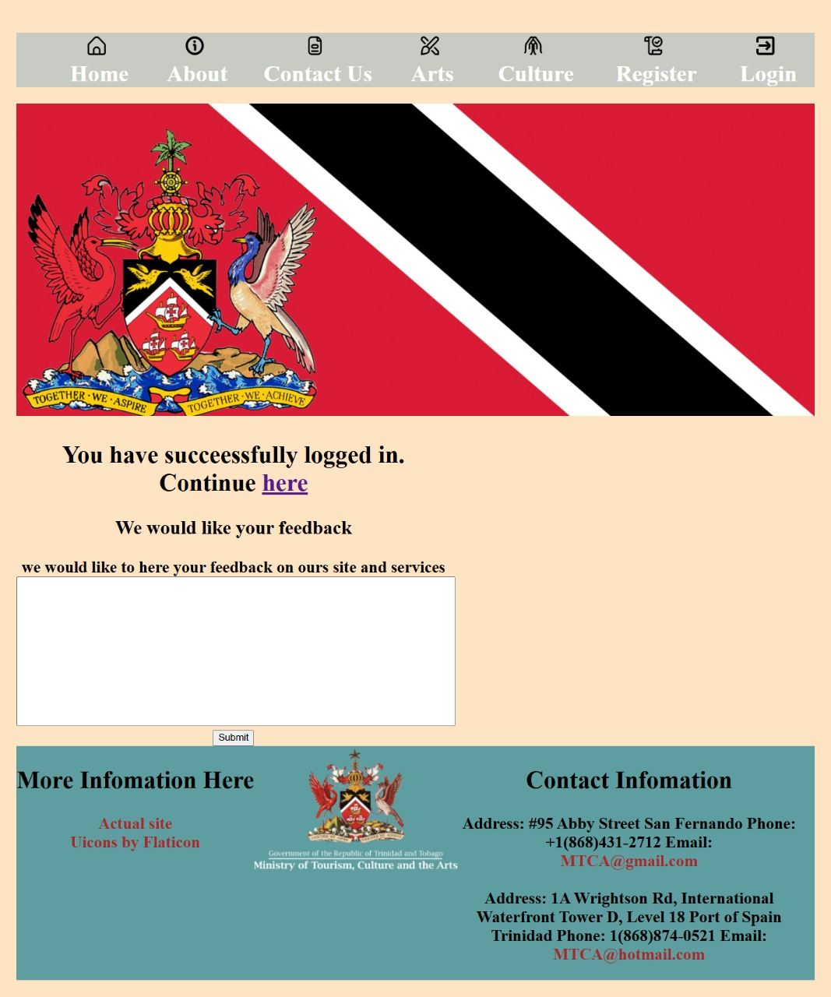

Appendices:

• Appendix 1 – Screenshots of validation (HTML and CSS)

Home Page

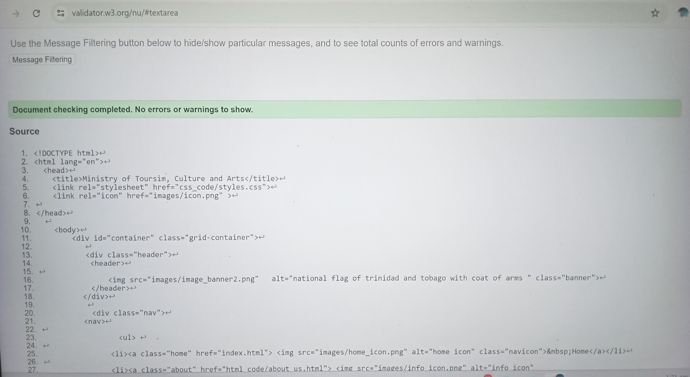

About Us

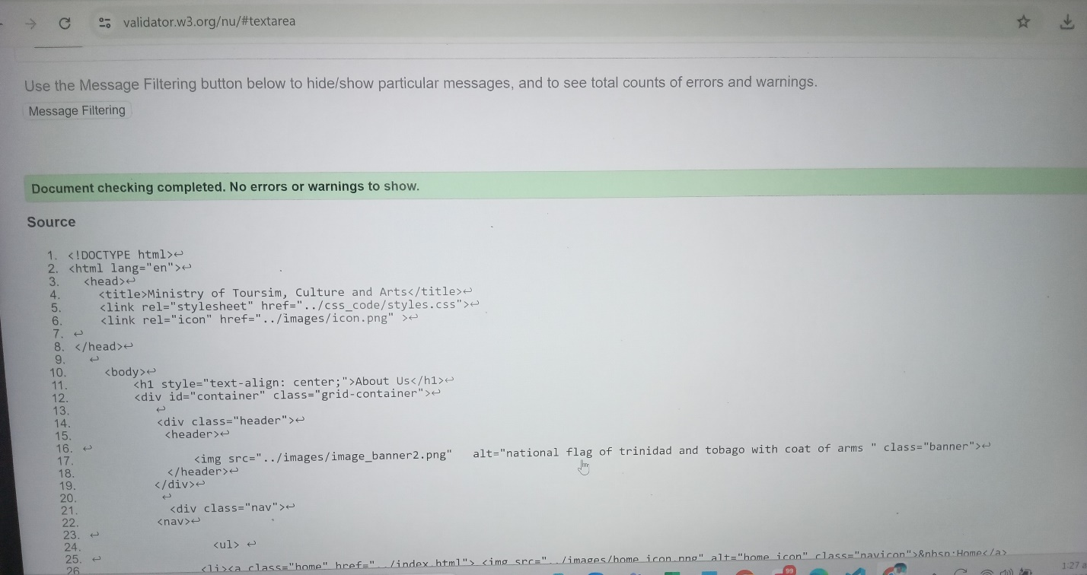

Contact Us

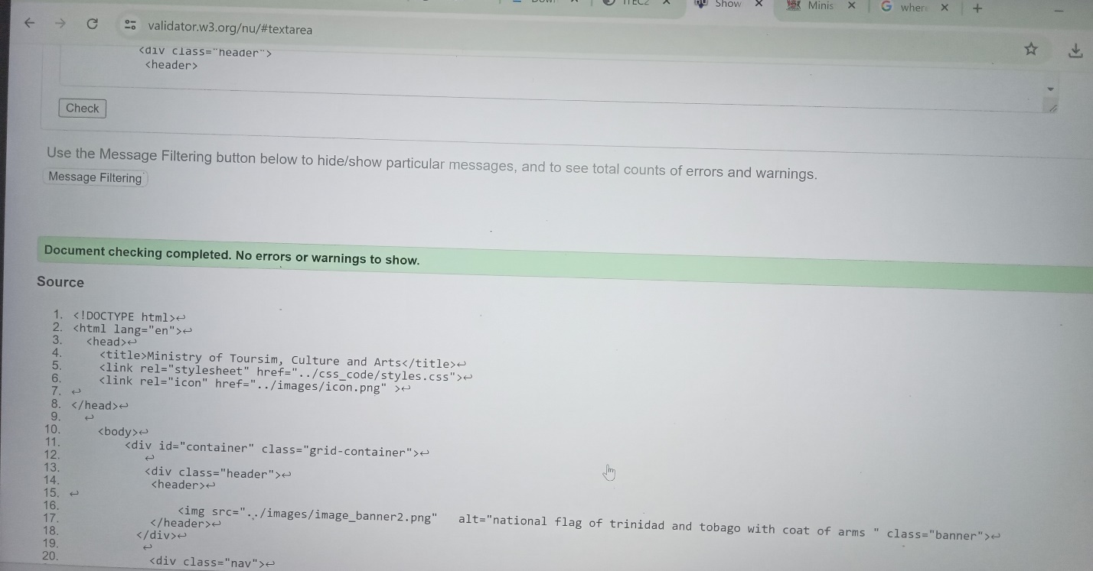

Arts

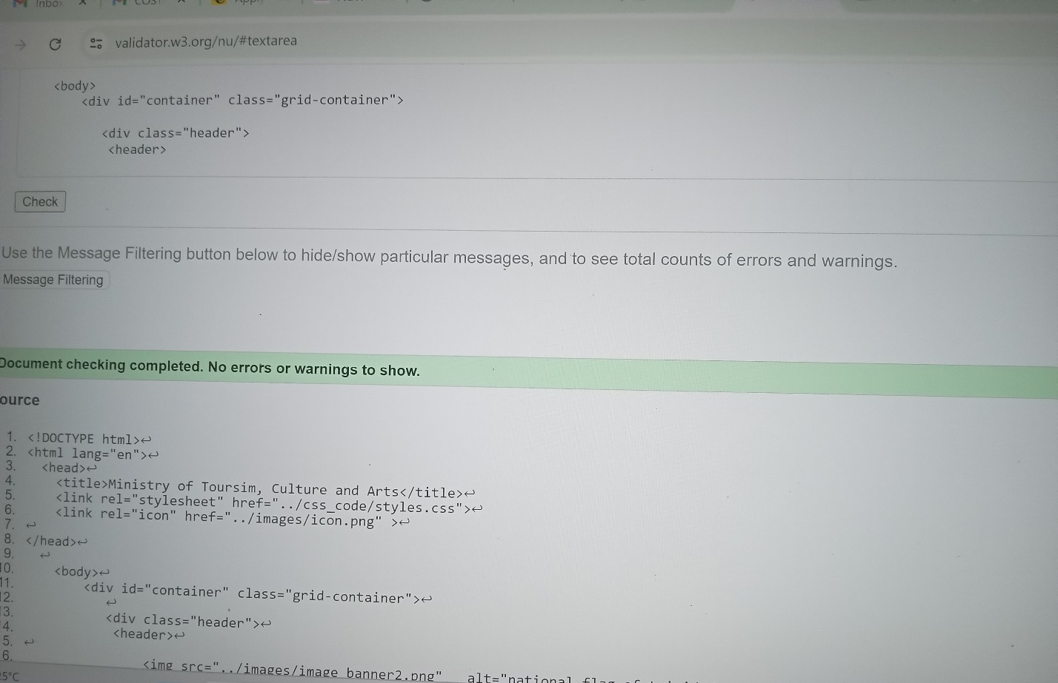

Culture

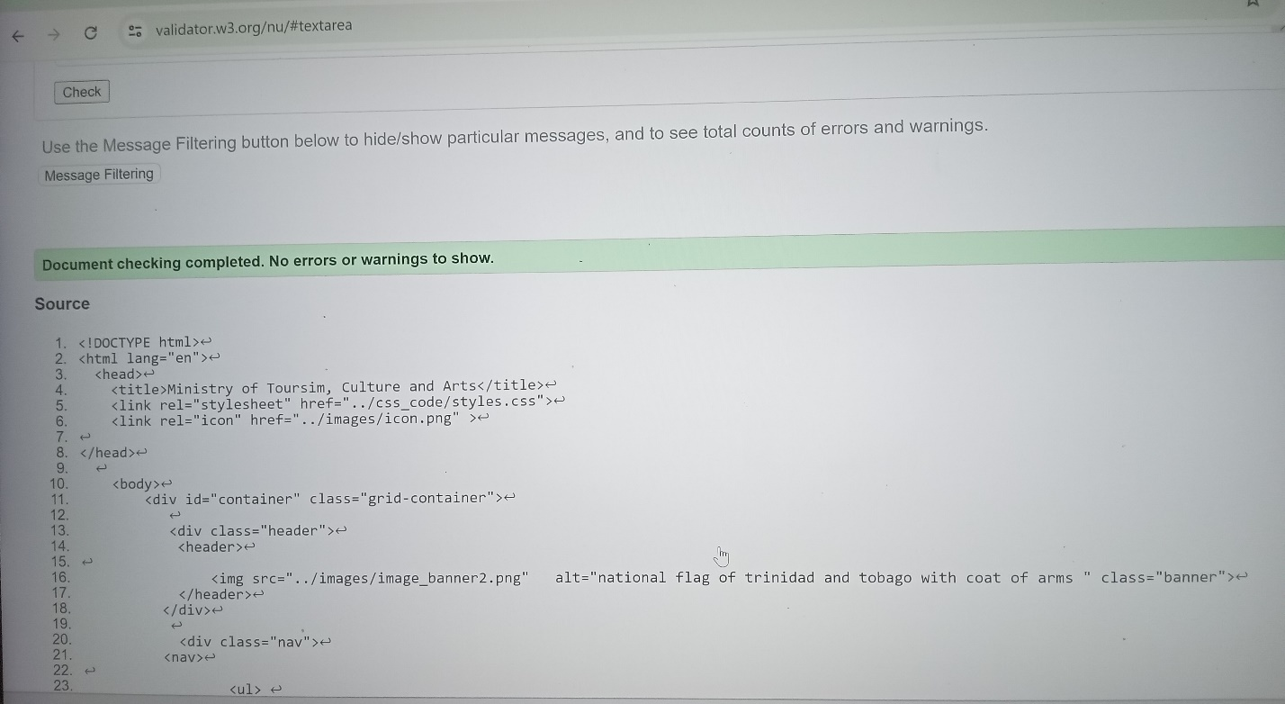

Registration

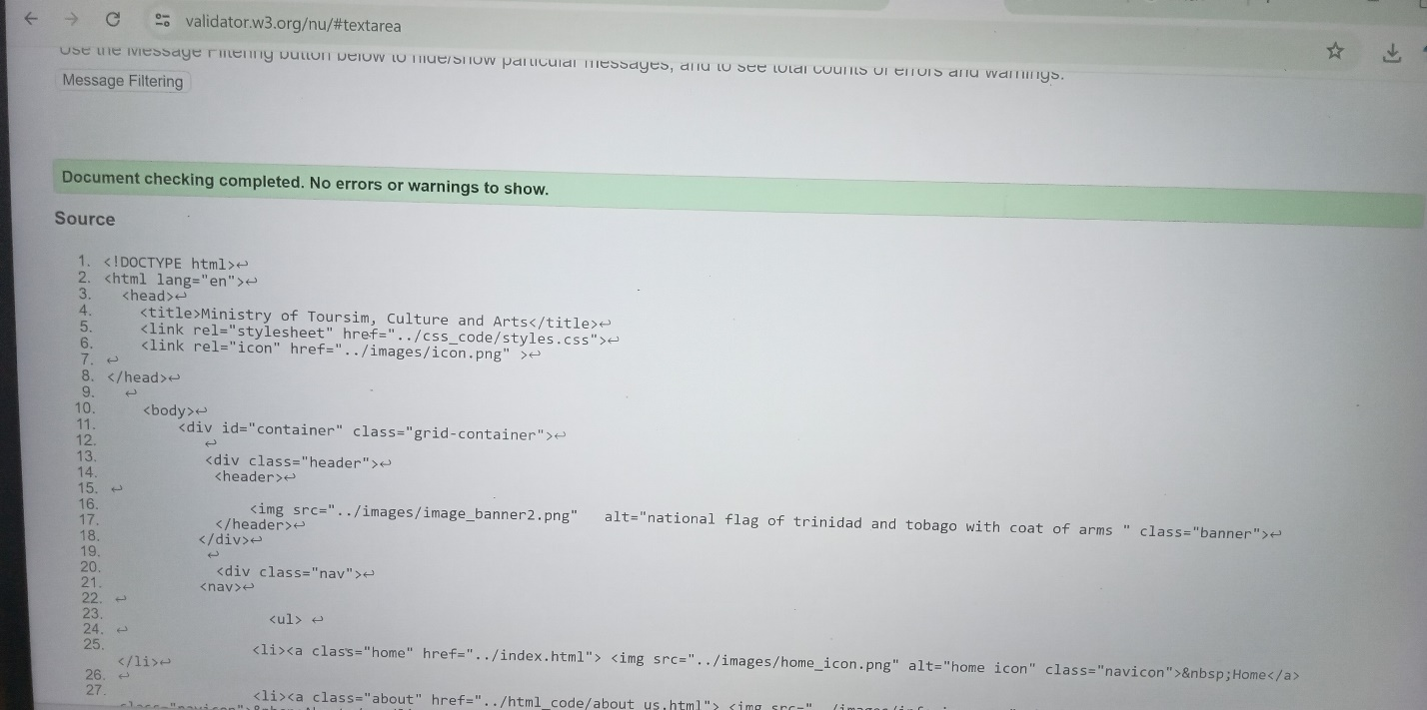

Login

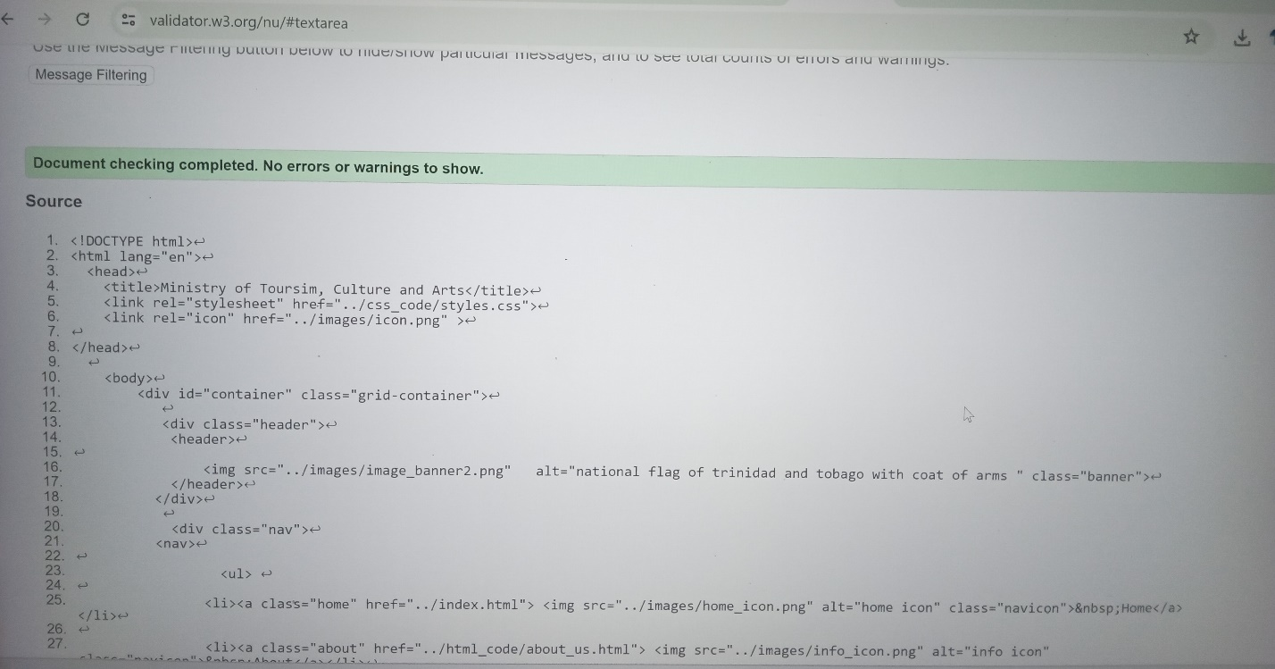

CSS

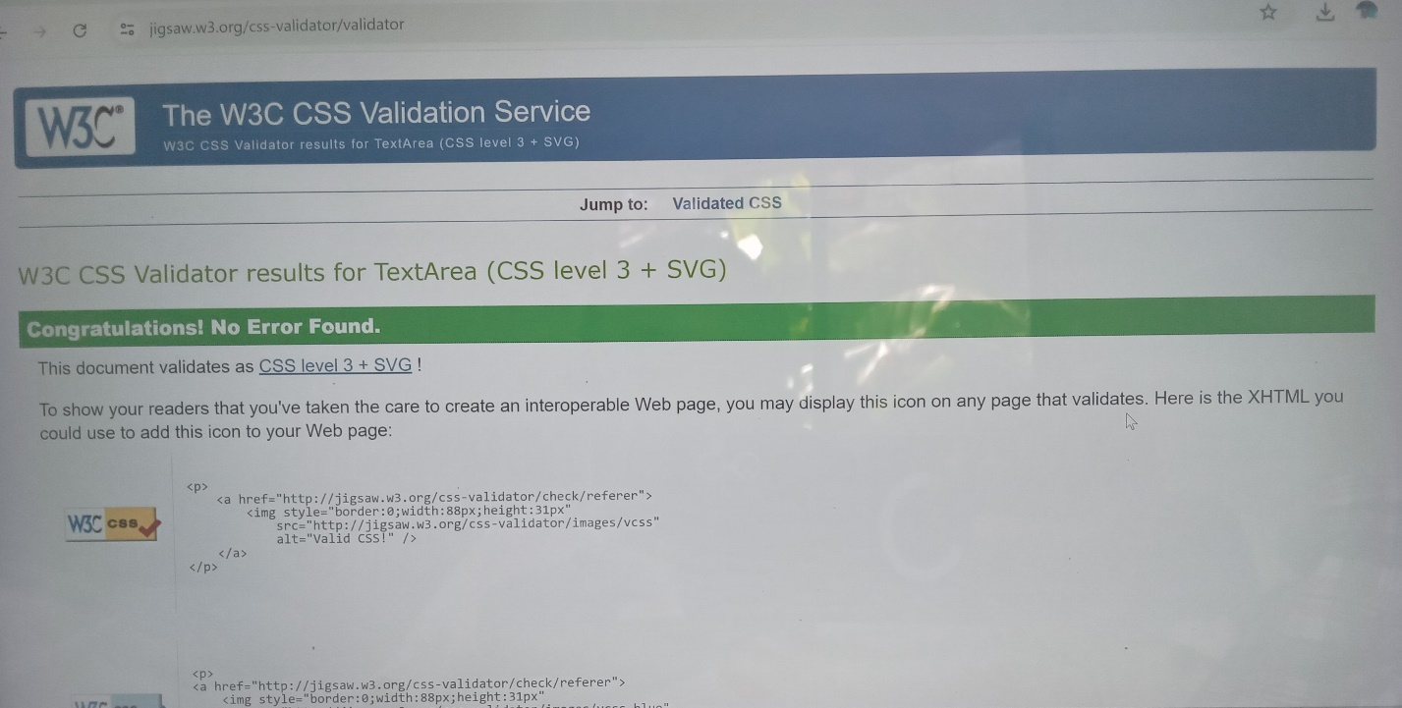

Appendix 2

Work Schedule

|  |  |  |  |
| --- | --- | --- | --- |
| Exercise/Activity | Date | Time | Duration |
| Index | 15thth Dec | 8pm | 3hr |
| About Us | 16th Dec | 10am | 1hr |
| Contact Us | 16th Dec | 9pm | 1hr |
| Arts | 16th Dec | 12pm | 30 mins |
| Culture | 16th Dec | 1pm | 30 mins |
| Registration | 17th Dec | 7pm | 30mins |
| Login | 17th Dec | 7pm | 15mins |
| CSS | 15-17th Dec | 8pm-11pm | 4hr |
| Presentation and written document | 18th Dec | 12-3am | 3hr |

Appendix 3 – Bibliography

We use the images from google and it’s on the Trinidad and Tobago culture.

[***https://en.wikipedia.org/wiki/Trinidad_and_Tobago#:~:text=Trinidad%20and%20Tobago%20were%20ceded,became%20a%20republic%20in%201976***](https://en.wikipedia.org/wiki/Trinidad_and_Tobago#:~:text=Trinidad%20and%20Tobago%20were%20ceded,became%20a%20republic%20in%201976)***.***

[***https://mtca.gov.tt/about/***](https://mtca.gov.tt/about/)

The [first online HTML validation service](http://lists.w3.org/Archives/Public/www-html/1994Jul/0015) was created by [Dan Connolly](http://www.w3.org/People/Connolly/) and [Mark Gaither](http://www.markgaither.com/).

The W3C Markup Validation Service was created and maintained by [Gerald Oskoboiny](http://www.w3.org/People/Gerald/). In a previous incarnation it was known as "The Kinder, Gentler, HTML Validator" ("Kinder, Gentler" than Dan and Mark's original), but has since found a new home at W3C, and is now maintained under the auspices of the [Quality Assurance](http://www.w3.org/QA/) Activity *Markup Validation Service*.

[***The W3C Markup Validation Service***](https://validator.w3.org/)

The W3C Markup Validation Service was created and maintained by [Gerald Oskoboiny](http://www.w3.org/People/Gerald/). In a previous incarnation it was known as "The Kinder, Gentler, HTML Validator" ("Kinder, Gentler" than Dan and Mark's original), but has since found a new home at W3C, and is now maintained under the auspices of the [Quality Assurance](http://www.w3.org/QA/) Activity *Markup Validation Service* [***The W3C CSS Validation Service***](https://jigsaw.w3.org/css-validator/)

***By Sodacan -  
Own work, CC BY-SA 3.0,*** [***https://commons.wikimedia.org/w/index.php?curid=18484190***](https://commons.wikimedia.org/w/index.php?curid=18484190) ***Flaticon license   
  
  
  
  
  
Admin.  
(2024, March 18). About - the Ministry of Tourism, Culture and the Arts  
(MTCA). The Ministry of Tourism, Culture and the Arts (MTCA).***[***https://mtca.gov.tt/about/***](https://mtca.gov.tt/about/) ***Ananaline.  
(2022, February 14). Cityscape Building Abstract Simple shape and modern  
style art Vector. . . iStock.***[***https://www.istockphoto.com/vector/cityscape-building-abstract-simple-shape-and-modern-style-art-vector-design-port-of-gm1370453491-439999206***](https://www.istockphoto.com/vector/cityscape-building-abstract-simple-shape-and-modern-style-art-vector-design-port-of-gm1370453491-439999206) ***Flaticon. (n.d.).*** [***https://www.flaticon.com/***](https://www.flaticon.com/)***.***[***https://www.flaticon.com/***](https://www.flaticon.com/) ***Key  
Government Ministries | AMCHAM T&T. (n.d.). AMCHAM T&T.***[***https://www.amchamtt.com/govt-ministries***](https://www.amchamtt.com/govt-ministries) ***Littdev.  
(2024, September 29). National Birds - Life in Trinidad & Tobago.  
Life in Trinidad and Tobago.***[***https://lifeintrinidadandtobago.com/national-birds/***](https://lifeintrinidadandtobago.com/national-birds/) ***Trinidad  
2024 MAS Bands & Costume Guide | Come to the Islands — Come to the Islands. (n.d.). Come to the Islands.***[***https://www.cometotheislands.co/choosing-a-mas-band***](https://www.cometotheislands.co/choosing-a-mas-band) ***Wikipedia  
contributors. (2024, September 8). Coat of arms of Trinidad and Tobago.  
Wikipedia.***[***https://en.wikipedia.org/wiki/Coat_of_arms_of_Trinidad_and_Tobago#/media/File:Coat_of_arms_of_Trinidad_and_Tobago.svg***](https://en.wikipedia.org/wiki/Coat_of_arms_of_Trinidad_and_Tobago#/media/File:Coat_of_arms_of_Trinidad_and_Tobago.svg) ***Log in or  
sign up to view.  
(n.d.).*** [***https://www.facebook.com/NAPALKARA/?locale=hr_HR***](https://www.facebook.com/NAPALKARA/?locale=hr_HR)[***W3Schools.com***](http://W3Schools.com)***. (n.d.).***[***https://www.w3schools.com/html/html_forms.asp***](https://www.w3schools.com/html/html_forms.asp)