Chapter 2, Problem 2.
Find the hot resistance of a light bulb rated 60W, 120 V.
[Hint: p = v²/R → R = v²/p]

Chapter 2, Problem 4.
(a) Calculate current i in Fig. 2.68 when the switch is in position 1.
(b) Find the current when the switch is in position 2.
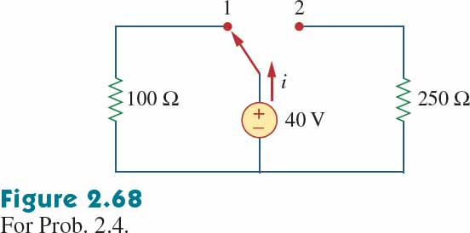

Chapter 2, Problem 9.

Find i₁, i₂, and i₃ in Fig. 2.73.

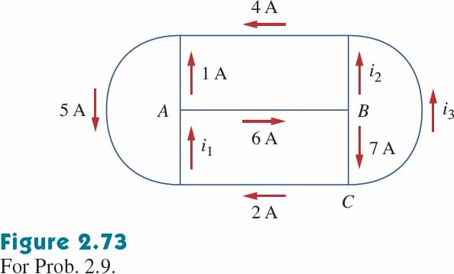

Chapter 2, Problem 10.
Determine i₁ and i₂ in the circuit of Fig. 2.74.

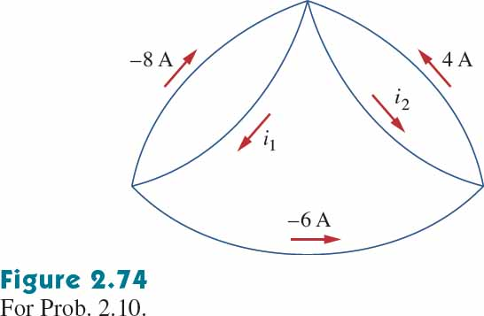

Chapter 2, Problem 11.

In the circuit of Fig. 2.75, calculate V₁ and V₂.

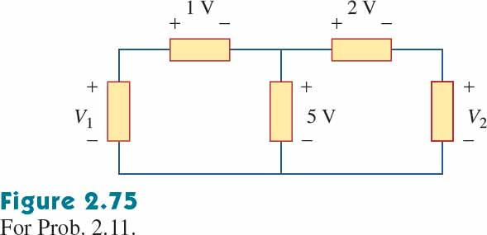

Chapter 2, Problem 13.
For the circuit in Fig. 2.77, use KCL to find the branch currents I₁ to I₄.

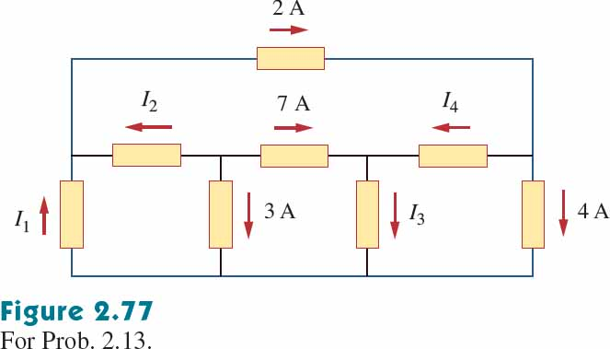

Chapter 2, Problem 14.

Given the circuit in Fig. 2.78, use KVL to find the branch voltages V₁ to V₄.

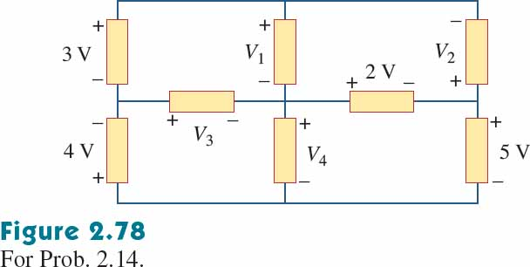

Chapter 2, Problem 15.
Calculate v and i_{x} in the circuit of Fig. 2.79.

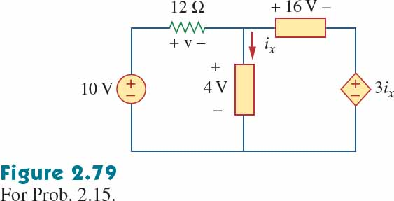

Chapter 2, Problem 16.
Determine V_{o} in the circuit in Fig. 2.80.

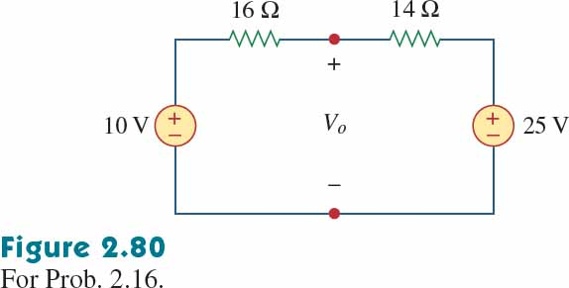

Chapter 2, Problem 18.

Find I and V_{ab} in the circuit of Fig. 2.82.

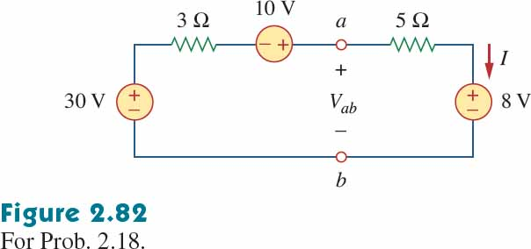

Chapter 2, Problem 19.
From the circuit in Fig. 2.83, find I, the power dissipated by the resistor, and the power supplied by each source.

