- Chapter 3, Problem 1.
Given R₁ = 4 kΩ, R₂ = 2 kΩ, and R₃ = 2 kΩ, determine the value of I_{x} using nodal analysis.

R₁

R₂

12 V

+
−

I_{x}

R₃

9 V

+
−

Figure 3.50
For Prob. 3.1

.

- Chapter 3, Problem 2.
For the circuit in Fig. 3.51, obtain v₁ and v₂ using nodal analysis.
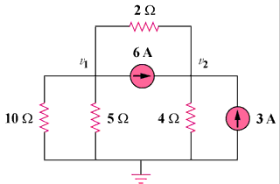

Figure 3.51
For Prob. 3.2.

- Chapter 3, Problem 3.
Find the currents i₁ through i₄ and the voltage v_{o} in the circuit in Fig. 3.52 using nodal analysis.
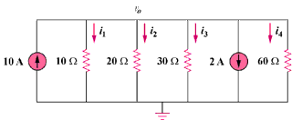

8 A

20A

Figure 3.52
For Prob. 3.3.

- Chapter 3, Problem 4
Given the circuit in Fig. 3.53, calculate the currents i₁ through i₄ using nodal analysis.

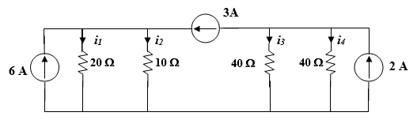
Figure 3.53
For Prob. 3.4.

- Chapter 3, Problem 5.
Obtain v₀ in the circuit of Fig. 3.54 using Mesh analysis.

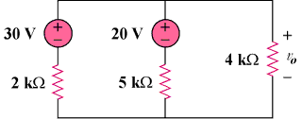

Figure 3.54
For Prob. 3.5.

- Chapter 3, Problem 6.
Solve for V₁, in Fig. 3.55, using Mesh analysis.
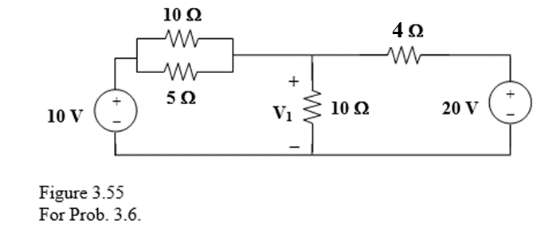

- Chapter 3, Problem 37.
Using mesh analysis, find v₀ in the circuit in Fig. 3.57.
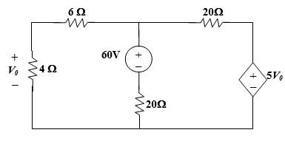
Figure
For Prob. 3.37.

- Chapter 3, Problem 41.
Apply mesh analysis to find i in Fig. 3.87.
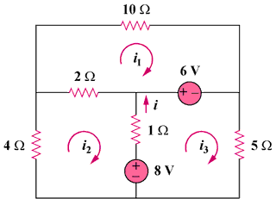

Figure 3.87
For Prob. 3.41.

- Chapter 3, Problem 54
Given the circuit Fig. A, use mesh analysis to find the mesh currents.
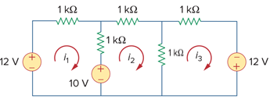
Figure 3.99
For Prob. 3.54

- Chapter 3, Problem x
Given the circuit below, use mesh analysis to find the mesh currents voltages v_{1,} v₂ and v_{3.}
