- 6.16 The equivalent capacitance at terminals a-b in the circuit of Fig. 6.50 is 30 μF. Calculate the value of C.
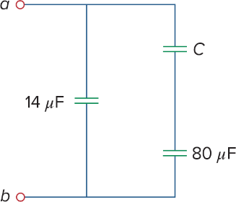
Figure 6.50 For Prob. 6.16.

- 6.17 Determine the equivalent capacitance for each of the circuits of Fig. 6.51.
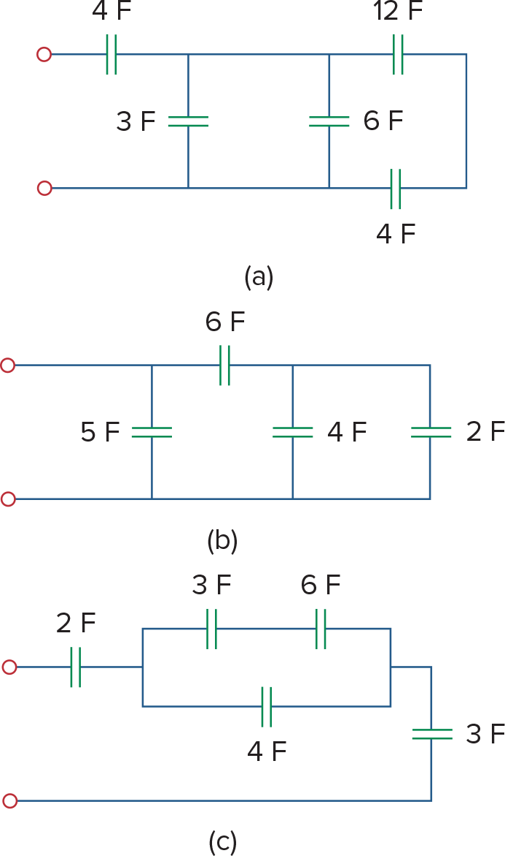
Figure 6.51 For Prob. 6.17.

- 6.18 Find Ceq in the circuit of Fig. 6.52 if all capacitors are 4 μF.
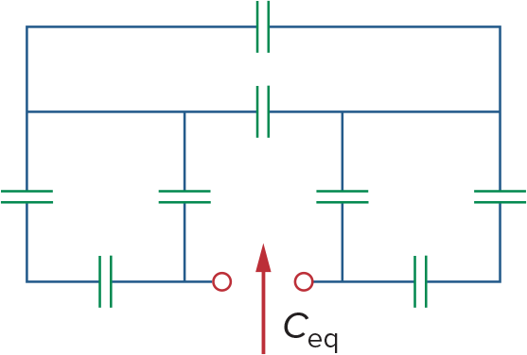
Figure 6.52 For Prob. 6.18.

- 6.26 Three capacitors, C1=5 μF, C2=10 μF, and C3=20 μF, are connected in parallel across a 150-V source. Determine:
- (a)the total capacitance,
- (b)the charge on each capacitor,
- (c)the total energy stored in the parallel combination

- 6.32 In the circuit in Fig. 6.64, let is=50e^{−2t} mA and v₁(0)=50 V, v₂(0)=20 V.
Determine: (a) v₁(t) and v₂(t), (b) the energy in each capacitor at t=0.5 s.
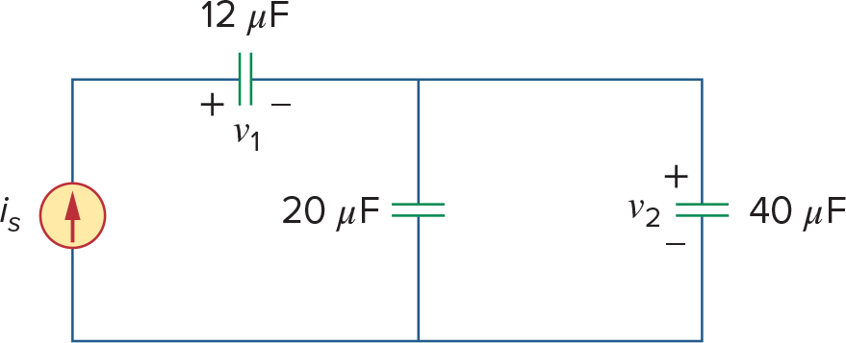
Figure 6.64 For Prob. 6.32.

- 6.40 The current through a 5-mH inductor is shown in Fig. 6.66. Determine the voltage across the inductor at t=1, 3, and 5 ms.
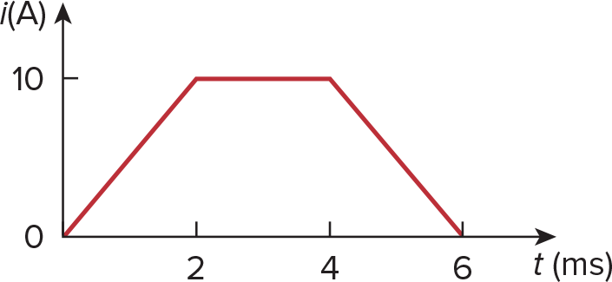
Figure 6.66 For Prob. 6.40.

- 6.43 The current in an 80-mH inductor increases from 0 to 60 mA (steady state). How much energy is stored in the inductor?

- 6. 51 Determine Leq at terminals a-b of the circuit in Fig. 6.73.
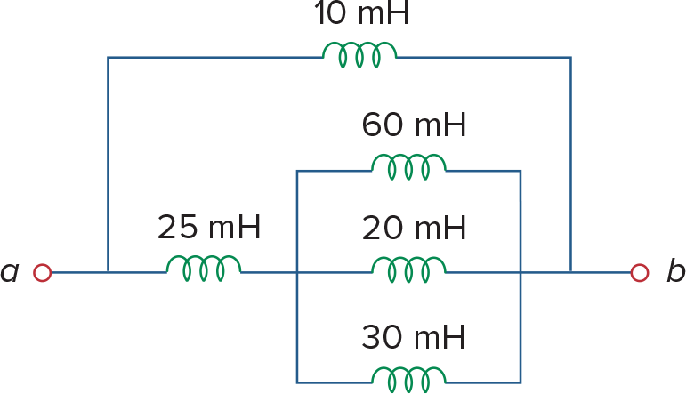
Figure 6.73 For Prob. 6.51.

- 6.53 Find Leq at the terminals of the circuit in Fig. 6.75.
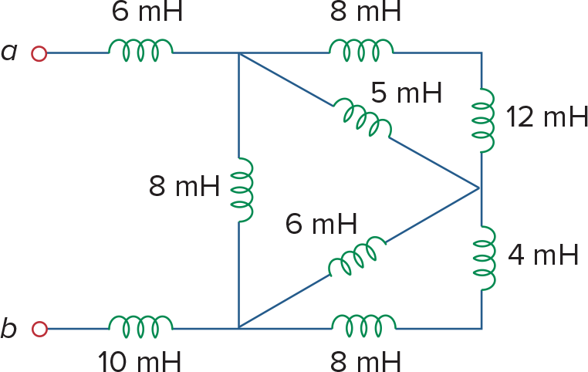
Figure 6.75 For Prob. 6.53.

- 6.60 In the circuit of Fig. 6.82, io(0)=2 A. Determine io(t) and vo(t) for t>0.
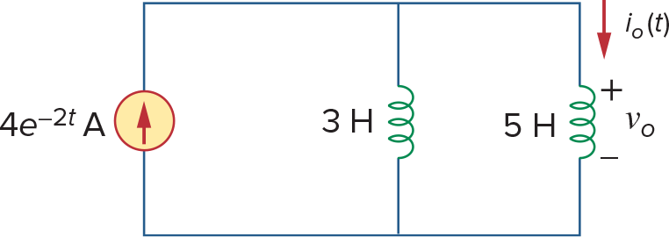
Figure 6.82 For Prob. 6.60.

