Source Free Series RLC Circuits:
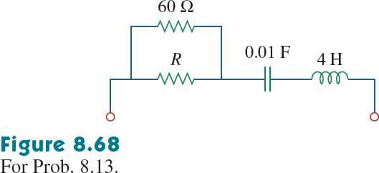
- Problem 8.13 For the circuit in Fig. 8.68, calculate the value of R needed to have a critically damped response.

- Problem 8.17 In the circuit of Fig. 8.71, the switch instantaneously moves from position A to B at t = 0. Find v(t) for all t ≥ 0.
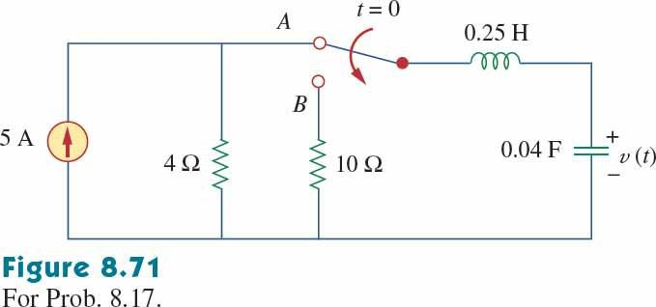

SOURCE FREE PARALLEL RLC:
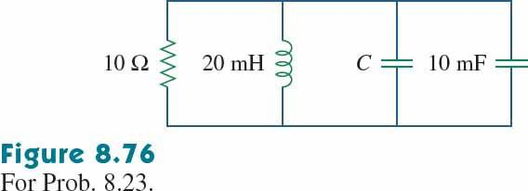
- Problem 8.23 For the network in Fig. 8.76, what value of C is needed to make the response underdamped with unity damping factor (α = 1)?

Step response parallel RLC circuits:
- Problem 8.47 Find the output voltage vo(t) in the circuit of Fig. 8.94.
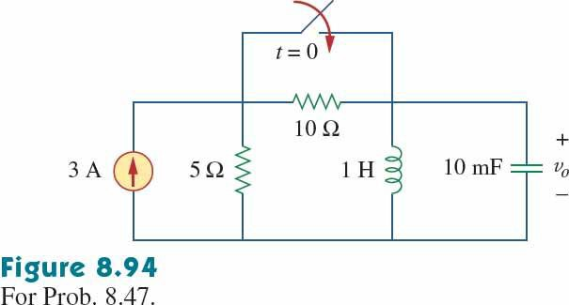

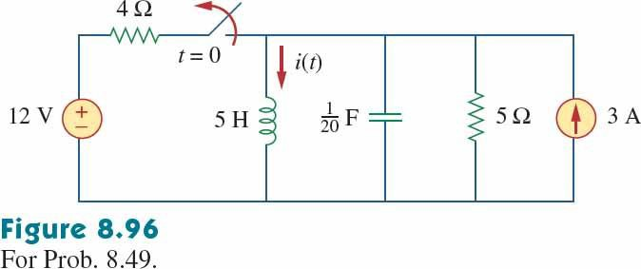
- Problem 8.49 Determine i(t) for t > 0 in the circuit of Fig. 8.96.

