
Electronics and Computer Technology
ECET 250E: Lab 02 IMPLEMENTATION OF SIMPLE CIRCUITS USING BREADBOARD, RESISTANCES AND DC POWER SUPPLY

I. OBJECTIVES:

1. To become familiar with the breadboard.
2. To become familiar with the DC power supply equipment
3. To become familiar with the measuring instruments like the Digital Multimeter (DMM) for measuring voltage, current and resistance.
4. To become familiar with the color banding of resistors.
5. To become familiar with potentiometers.

II. Background

- The breadboard

You may encounter two types of breadboards. Type 1 is shown in Figure 1. Notice that there is a gap in the horizontal rails. These gaps are discontinuities between left and right horizontal lines. It is as if you have two bradboards in one. You may use a wire (jumper) to connect these horizontal lines and make it as one breadboard (Figure 2). All other connections are the same. Horizontal dots (points) are connected together. Vertical dots (points) are connected together.

In this scheme, a Positive (+ve) voltage rail and a Ground (or “-” or “common”) rail is established at the top and bottom of the breadboard. This approach allows the + and - of the power supply to be easily accessed by any component inserted in the experimenter’s board. It is suggested (for consistency) that red wires are used for all connections to positive Volts, and that black is used for Ground.

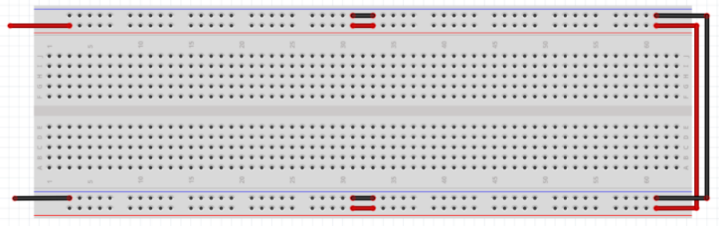
BLACK
RED
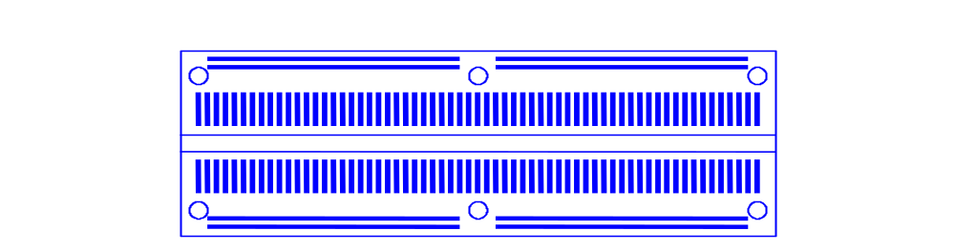
Figure 1 - Bottom View
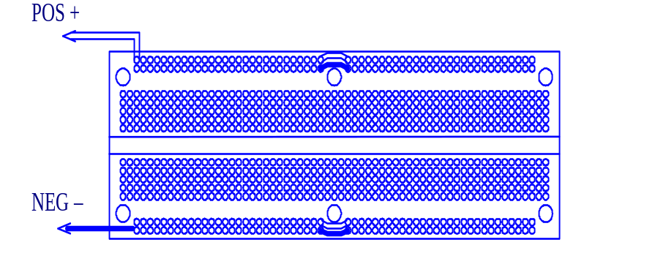
Figure 2 - Top View

For more information check out the link below:
https://www.youtube.com/watch?v=6WReFkfrUIk

- Voltage and current measurement

In order for an electronic circuit to function a current must flow through the circuit. A current is the measure of the rate of change of charge (electrons) flowing past a certain point in the circuit. Current is measured by an ammeter (DMM set in current measuring mode) placed in the circuit which displays the result in Amperes.

In order for the current to flow in the circuit there must be a potential difference (voltage) across the circuit. This potential difference is measured by using a voltmeter (DMM set in voltage measuring mode). This instrument measures the potential difference between two points in the circuit. The potential difference is measured in units of Volts.

A voltmeter is connected across a component or circuit ( connected in parallel with the component or circuit) and at this point in our course we consider it not to affect the circuit in any way. The voltmeter may show a positive or negative value depending on the polarity ( a voltage is an algebraic value).
An ammeter has to “see” the electrons, therefore it must be connected in the currents path (in series with the circuit elements of the branch being measured). To make a measurement in a circuit, the circuit must be broken at the point in which the current is to be found and the meter inserted between the two parts of the circuit. The red terminal or the terminal marked with a + must be connected towards the side of the circuit connected to the red terminal or positive marking of the supply in order to obtain the correct polarity.
Note that the DMM terminals used to measure voltage and resistance are different than the one's used to measure current. If you mix these up you may blow a fuse or damage the equipment. Make sure you confirm that your DMM and power supply are properly connected to the circuit before switching the power on. If in doubt, get the instructor to check your circuit first.
- Resistance measurement

We will be building some simple electronic circuits using resistors. As their name might suggest to you, they resist the flow of current in the circuit.
Resistance is the opposition a substance offers to current flow. The unit of resistance is the ohm, and the symbol is the Greek letter capital omega (Ω). A resistor is designed to have a specific resistance and power (wattage) rating. Resistors limit current but in doing so, produce heat. The physical size of a resistor is related to its ability to dissipate heat (absorb power). A higher power (wattage) one will be physically larger if made from the same material.
Resistors are either fixed in value or variable. Non-precision resistors are usually marked with four bands of colour. This colour code is explained below.
Resistors are usually marked with four bands of colour. The fourth band indicates the tolerance to which the resistor was made. Each colour represents a numerical value. This colour code is shown in Table 1 below. There are also mnemonics to help in remember this code.

Table 1: Resistor Colour Codes

Color | Color | Value | Multiplier | Tolerance
Black | Blk | 0 | 10⁰
Brown | Brn | 1 | 10¹
Red | R | 2 | 10²
Orange | O | 3 | 10³
Yellow | Y | 4 | 10⁴
Green | Grn | 5 | l0⁵
Blue | Blu | 6 | 10⁶
Violet | V | 7 | 10⁷
Gray | Gry | 8 | l0⁸
White | W | 9 | 10⁹
Gold | Au |  | 10⁻¹ | 5%
Silver | Ag |  | 10⁻² | 10%

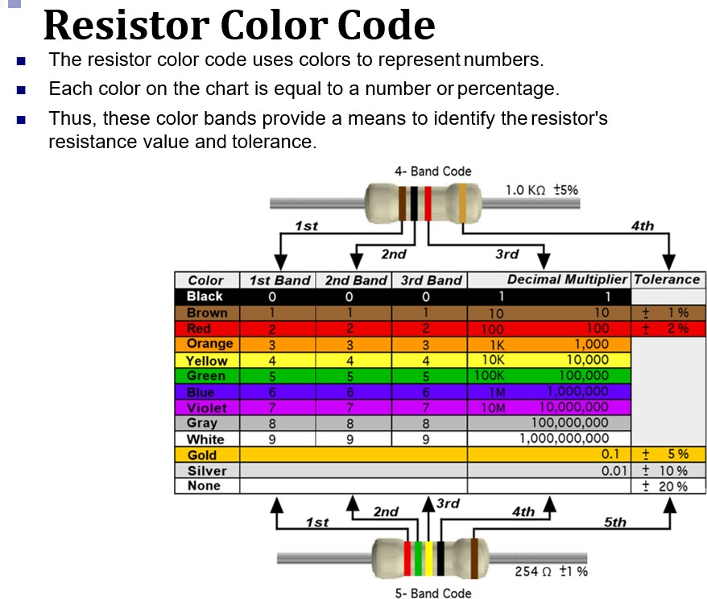
For more information check out the link below:
https://www.youtube.com/watch?v=SjlnW5g9np4

For example, a resistor marked with Red (2), Violet (7), Yellow (4), and Silver (10%) bands, would have a value of 27x10⁴Ω or 270kΩ, with a tolerance of ±10%

The resistance of resistors can be measured using an ohmmeter. In this lab we will use the ohmmeter function of a Digital Multimeter (DMM).

Note: Resistance is not normally measured “in circuit” as part of a complete circuit, and therefore at least one end of the resistor must be disconnected while the measurement is made (isolated from the circuit). Also, more importantly, power must not be applied to the circuit while a resistance measurement is being made!

The meter itself will pass a small current through the resistor in order to establish its value. The unknown resistance is placed between the two terminal leads (the polarity of the leads does not matter.) Try not to hold both ends of the meter leads with your fingers; otherwise the meter will also measure your body resistance. It is OK to hold only one end, however, as you are then not part of the circuit! Better yet, insert the resistor to be measured into your breadboard.
Potentiometers:
The most common form of variable resistance is the potentiometer. The potentiometer is a three terminal device with the outer terminals having a fixed resistance which is the resistance that will be marked on its case. The middle terminal, internally connected to a moving wiper, is adjusted by means of either a screw head or a shaft. Rotating either type will cause the wiper to move from one end of the resistance medium to the other. If you connect a DMM to measure resistance between the wiper and either one of the end terminals you will observe a varying resistance.

III. PROCEDURE

- VOLTAGE MEASUREMENT

It is important to ensure you are using the correct voltage when powering up your electronic circuits. To do this you should always check the voltage from the power supply first with the multimeter before attaching your circuit. Do not rely on the meter reading on the power supply.

Connect the voltmeter (DMM) to the power supply terminals and adjust the supply until 15 V is indicated. Compare the reading on the power supply with the DMM reading. Repeat the comparison for several different voltage ranges on the DMM. Discuss the accuracy of the power supply vs the DMM for the different ranges. Turn off the power supply.

- RESISTANCE MEASUREMENT

Obtain 6 four band resistors from the front of the Lab. Use the resistor colour code to identify the resistor values. Measure each resistor using the DMM. Tabulate these readings along with the % error between the color code and the DMM reading for each range. Comment on the error between color code and actual readings.

Table 2: Resistor Values
Resistor | Colour of band |  |  |  | Colour code  Value | Measured  Value | +/- %  Difference
Resistor | 1 st | 2nd | 3rd | 4th | Colour code  Value | Measured  Value | +/- %  Difference
1
2
3
4
5
6

- USE OF A POTENTIOMETER

Obtain a potentiometer. Mark the middle terminal with the number 2 and the two outside terminals 1 and 3. Measure and record the resistance between terminals 1 and 3. Does this value match the marked value? Turn the potentiometer to mid position. Measure the resistance between 1 and 2 and then between 2 and 3. Does the sum of these two resistance equal the value measured in part 4 above? Comment on your results.

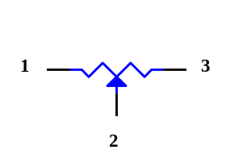
Potentiometer Schematic

Discussion & Conclusion -- Write down your comments on this Lab.

[Hint:
  - What does this lab try to show you?
  - What have you learned/achieved from this lab?
  - Any problem did you have and how did you solve it?]

