
Electronics and Computer Technology
ECET 250E: Lab 04 Resistive DC Circuits (Kirchhoff’s law and Voltage Divider)

Objectives:
- To confirm KVL and the idea of the voltage divider.
- To familiarize yourself with the design and use of Voltage Dividers.
- To use a potentiometer as a voltage divider.

INTRODUCTION
In this lab, you will familiarize yourself with Kirchhoff’s Voltage Law and voltage dividers using the potentiometer.

Kirchhoff’s Voltage Law and the Voltage Divider
Kirchhoff’s Voltage Law (KVL) says that the algebraic sum of voltages around a mesh or loop of a circuit is zero. See Figure 1, the voltages around this loop are summed algebraically according to the polarity of the voltages across each component. The voltage source has a voltage “rise” of 12 V and each resistance “drops” a voltage (opposite in sign to the source) in proportion to the ratio of that resistance to the total resistance.
For example: the voltage across R3 is:
$$V_{R3}=V_{CD}= \frac{R3}{R_{Total}}×V_{1}= \frac{2200 Ω}{11200 Ω}×12 V=2.36 V$$
In this loop the sum of the voltages across the resistors will add up to the source voltage. We can say that the source voltage (12 V) is divided up between the resistors. In this sense we have a Voltage Divider.
If we could somehow combine all those resistances into one resistor and “tap off” that resistor at any point then we could realize any voltage from 0 – 12 V off that resistance. Such a device is called a potentiometer.

PROCEDURE

Part A: Voltage Dividers
Build the following circuit as shown in Figure 1. Measure the voltage across each resistor and the total current through the circuit. Record the data in Table A. Compare the measured values with the calculated values. The ‘XMM1’ is the ammeter (setup to measure current). (If you would like you can use the MultiSim to verify your answers too)
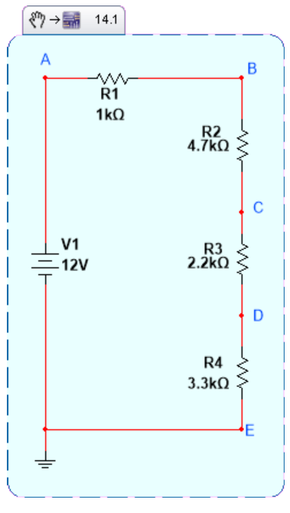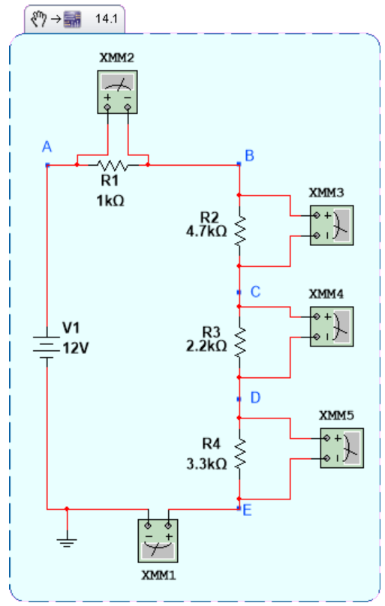
Figure 1: Series Circuit
With a voltmeter measure the voltage drops between each point as specified in the Table A. Also measure the total current in the circuit.
RESULTS: Table A
MEASUREMENT | CALCULATED | MEASURED
V_{AB}
V_{BC}
V_{CD} | 2.36V
V_{DE}
V_{AC}
V_{DC} | -2.36V
V_{EC}
I_{TOTAL} | $$I_{T}=\frac{V}{R_{T}}$$
- Confirm Ohm’s Law (by measuring the circuit current and total circuit resistance). and explain differences (if any) between measured and calculated values.
- Compare V₁ to the sum of all drop voltages (KVL).

Part B: Voltage Dividers and Potentiometers
Build the following circuits shown in Figures 2, 3, and 4. Measure the range of output voltage between X and Y (Max-Min) for each circuit (This means once Potentiometer will be at its full range (Max) and next time at minimum range (Min)). Record this data in Table B, on the following page. Compare the measured values with the calculated values.
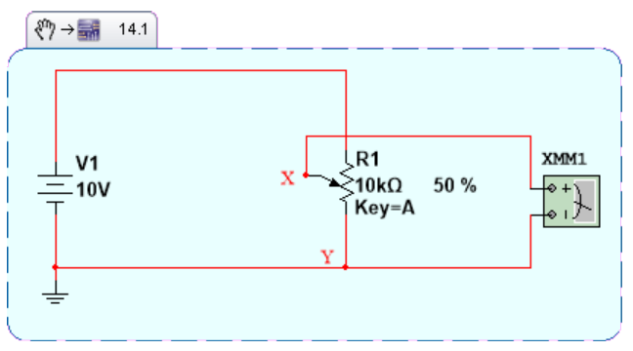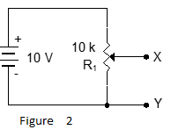
Figure 2.

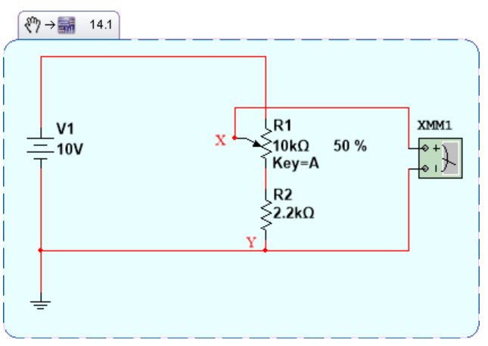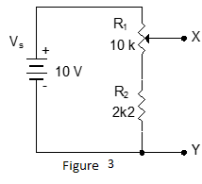
Figure 3.
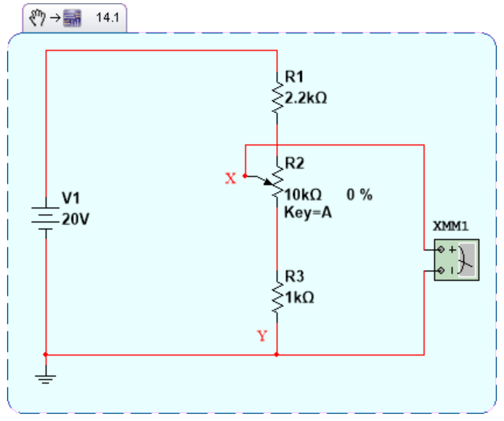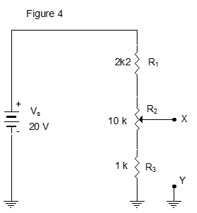

Figure 4.

RESULTS: Table B
Circuit | Calculated Range of V_{XY} (Max-Min) | Measured Range of V_{XY}(Max-Min)
Figure 2
Figure 3
Figure 4

Discussion & Conclusion
  - Were the objectives met? Use your data to show that the lab objectives were met.
  - What else did you learn?
  - What problems did you encounter and how did you solve them?

[Submit the completed lab report. Attach Picture of your work with all connections as part of your lab report ]

