
Electronics and Computer Technology
ECET 250E: Lab 05 Thevenin’s Theorem and Maximum Power Transfer

Objectives
- To verify Thevenin's Theorem
- To determine the load resistance required for Maximum Power Transfer
Background
Often, we are interested in determining a node voltage or branch current of a particular sub circuit without having to determine all the other node voltages or branch currents. For instance, we may want to find the voltage and/or current for a load (and subsequently power dissipated by the load) for several different resistor values, and if the circuit is complex, calculating the value of the current or power for each value of the load resistance could be time-consuming.
There are two theorems that can be applied to situations like this: Thevenin’s theorem and Norton's theorem. We do not have anything that closely resembles an ideal current source (required to implement Norton's Theorem) so we will only deal with Thevenin’s theorem for this lab.

Thevenin’s theorem
Any linear circuit can be represented at a given pair of nodes by an equivalent circuit consisting of a single voltage source in series with a single resistor.
Consider the circuit in Figure 1.
If we were particularly interested in the current I_{L} through R_{L}, the voltage V_{L} across R_{L}, and the power (P_{L}) absorbed by the load resistor R_{L}, then it makes sense to apply Thevenin’s theorem to the circuit on the left side of terminals A and B in Figure 1. The Thevenin equivalent circuit is shown in Figure 2.
Once we have determined the Thevenin equivalent circuit (V_{th} and R_{th} in series), we need only be concerned with what is connected between the terminals A and B.
The Thevenin equivalent circuit can be determined theoretically by finding R_{th} and V_{th}.
To calculate R_{th}, the Thevenin resistance:
- Remove R_{L} from the circuit
- Zero all independent sources in the circuit (short-circuit independent voltage sources; open-circuit ideal current sources)
- Calculate the resistance seen looking into the circuit at terminals A and B
- This is the Thevenin resistance R_{th}

To calculate V_{th}, the Thevenin voltage:
- Remove R_{L} from the circuit
- Use an appropriate combination of circuit analysis methods to determine the voltage seen between the terminals A and B with all sources turned on
- This open circuit voltage is the Thevenin voltage V_{th}

Maximum power transfer
Power is defined as the rate of doing work and is measured in watts. We have seen that power can be calculated from the following:

P = IV P = I²R P = V²/R
Every circuit has a theoretical maximum power that it can deliver to a load resistance. This power delivery will vary with the load resistance, R_{L}. If the load resistance is varied and the resulting power delivery is graphed against the load resistance, the resulting curve will have a maximum. This maximum will occur for R_{L} = Rth.
PROCEDURE 1

- Build the circuits of Figures 1 on Breadboard, to complete Table A for V_{s} = 12 volts and V_{s} = 15 volts.
- Calculate the voltage (V_{L}) across the load R_{L}, the current (I_{L}) flowing through R_{L} and power absorbed by the load resistor (P_{L}) in circuits Figure 1. Enter these data into Table A. (In this procedure we won’t use Thevenin Theorem, use any other theorems or laws to solve your circuit.)
- Use all the calculated results to compare with the measured values in Table A.
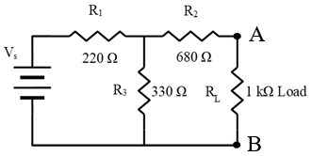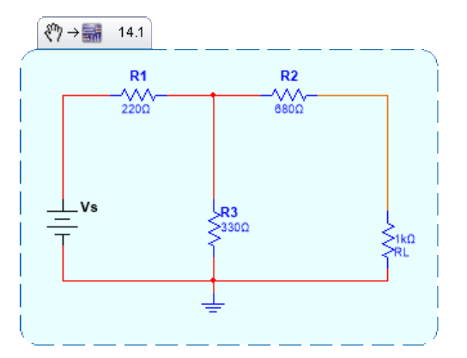

Figure 1.

TABLE A

Source voltage used ► |  | 12 V | 15 V
I_{L}  _{(mA)} | Calculated
I_{L}  _{(mA)} | Measured
V_{L}  (V) | Calculated
V_{L}  (V) | Measured
P_{L}  _{(mW)} | Calculated
P_{L}  _{(mW)} | Measured  (calculate with the measured values of V,I)
[Use the measured voltage and current values to calculate the measured power.]

PROCEDURE 2

- Now determine the Thevenin equivalent circuits for Figure 1 for both V_{s} = 12 volts and V_{s} = 15 volts (Figure 2).
- Build the circuit of Figure 2 on the breadboard (use the closest available resistor in the lab room for Resistor Thevenin or series of resistors) [Keep your Figure 1 Circuit in another side of the breadboard].
- Use the Thevenin circuit to find the calculated values listed in Table B.
- Use your results to compare with the measured values in Table B.

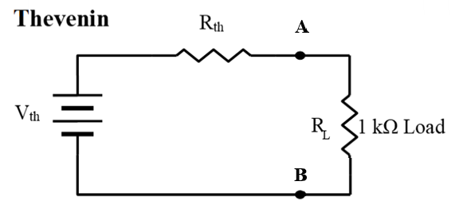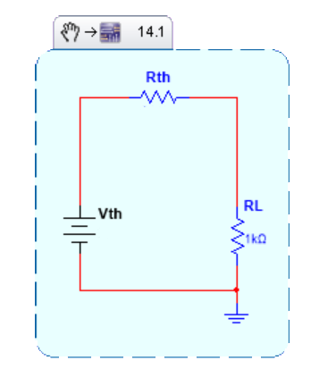

Figure 2.

TABLE B

Source voltage used ► |  | 12v (For original circuit) | 15 v (For original circuit)
V_{th}  _{(V)} | Calculated
V_{th}  _{(V)} | Measured
R _{th}  _{(Ω)} | Calculated
R _{th}  _{(Ω)} | Measured
I_{L}  _{(mA)} | Calculated
I_{L}  _{(mA)} | Measured(From Fig. 2)
V_{L}  (V) | Calculated
V_{L}  (V) | Measured(From Fig. 2)
P_{L}  _{(mW)} | Calculated
P_{L}  _{(mW)} | Measured  (calculate with the measured values of V,I)

*How to Measure Vth and Rth Thevenin*
Measuring Vth:
Build the circuit in Figure 1 on your breadboard.
- Remove the load resistance R_{L}.
- Leave all sources enabled.
- Use the DMM to measure the voltage at terminals A and B, as shown in Figure below. This is Vth.

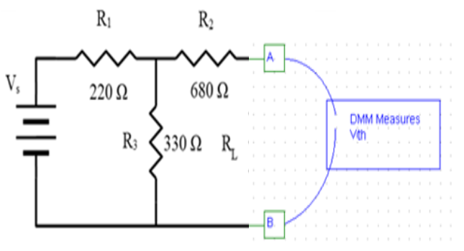
Measuring Vth from the physical circuit

Measuring Rth:
- Remove the load resistance R_{L}.
- Disable all sources. This means turning off all voltage sources, physically disconnecting them from the circuit, and providing a short circuit between network points that used to be connected to the + and - terminals of a voltage source. Make sure you do not short the supply! If there were current sources we would simply remove them from the circuit and leave the connection points open- circuited.
- Use the digital Multimeter (DMM) to measure the resistance at the terminals A and B, as shown in Figure below. Record this value of the Thevenin resistance Rth.
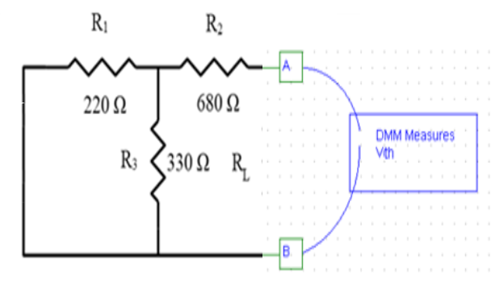
Measuring Rth from the physical circuit

- Is the voltage across the load R_{L} (and therefore the current flowing through R_{L}) the same in the original series-parallel circuit and the new equivalent Thevenin circuit? Prove this with numerical evidence from your results.

- When you measured the open circuit voltage in the circuit of Figure 1, (i.e. no load connected) how did it compare to your calculated value of Vth?

- When you measured the circuit resistance at the output in the circuit of Figure 1, (i.e. the Thevenin or internal resistance of the original series-parallel circuit) how did it compare to your calculated value of Rth? What precautions must you always take when performing this step?

PROCEDURE 3
- Calculate the maximum power transfer for figure 2 for both V_{s} = 12 volts and V_{s} = 15 volts. Use your results to compare with the measured values in Table C.
- By varying the load resistor R_{L} according to Table D and E, measure the voltage across the load resistor R_{L} and record them (V_{L}) into the related tables.
- Calculate relevant power output and fill them into Table D and E.
- Draw graphs (A and B) of P_{L} (measured) vs R_{L} using excel and create maximum power transfer curves.
- Label the maximum power points on these graphs.

TABLE C

Source voltage used ► |  | 12 v (For original circuit) | 15 v (For original circuit)
P_{LMAX}  _{(mW)} | Calculated
P_{LMAX}  _{(mW)} | Measured  (calculate with the measured values of V)

TABLE D (V_{s} = 12 volts)

R_{L}  _{ohms} | V_{L}  _{volts} | P_{L}=V_{L}²/R_{L}  _{mW} | V_{L}  _{volts} | P_{L}  _{mW}
Ω | Calculated | Calculated | Measured | Measured (calculate with the measured values of V)
100
470
812
1200
1800
2700
3300
[For the measurements pick 820 ohms instead of 812 ohms or series of resistors.]
Graph A (V_{s} = 12 volts)

TABLE E (V_{s} = 15 volts)

R_{L}  _{ohms} | V_{L}  _{volts} | P_{L}=V_{L}²/R_{L}  _{mW} | V_{L}  _{volts} | P_{L}  _{mW}
Ω | Calculated | Calculated | Measured | Measured (calculate with the measured values of V)
100
470
812
1200
1800
2700
3300
[For the measurements pick 820 ohms instead of 812 ohms or series of resistors.]
Graph B (V_{s} = 15 volts)

Discussion & Conclusion
  - Were the objectives met? Use your data to show that the lab objectives were met.
  - What else did you learn?
  - What problems did you encounter and how did you solve them?

[Submit the completed lab report. Attach Pictures of your work with all connections as part of your lab report]

