Section 4.3Superposition
- Chapter 4, Problem 11. Use the superposition principle to find io and vo in the circuit of Fig. 4.79.
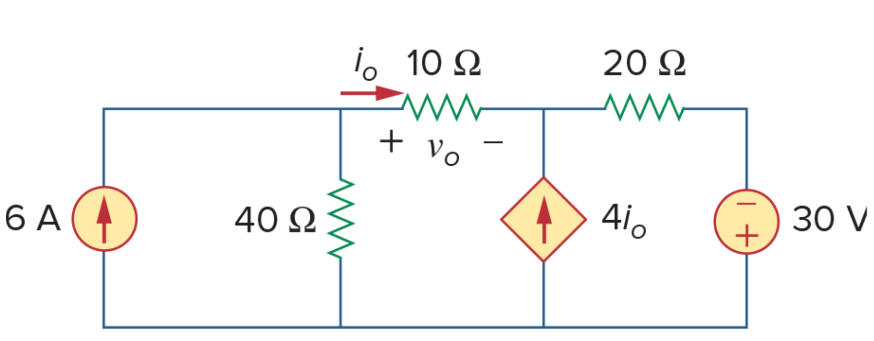
Figure 4.79 For Prob. 4.11.

- Chapter 4, Problem 12. Determine Vo in the circuit of Fig. 4.80 using the superposition principle.
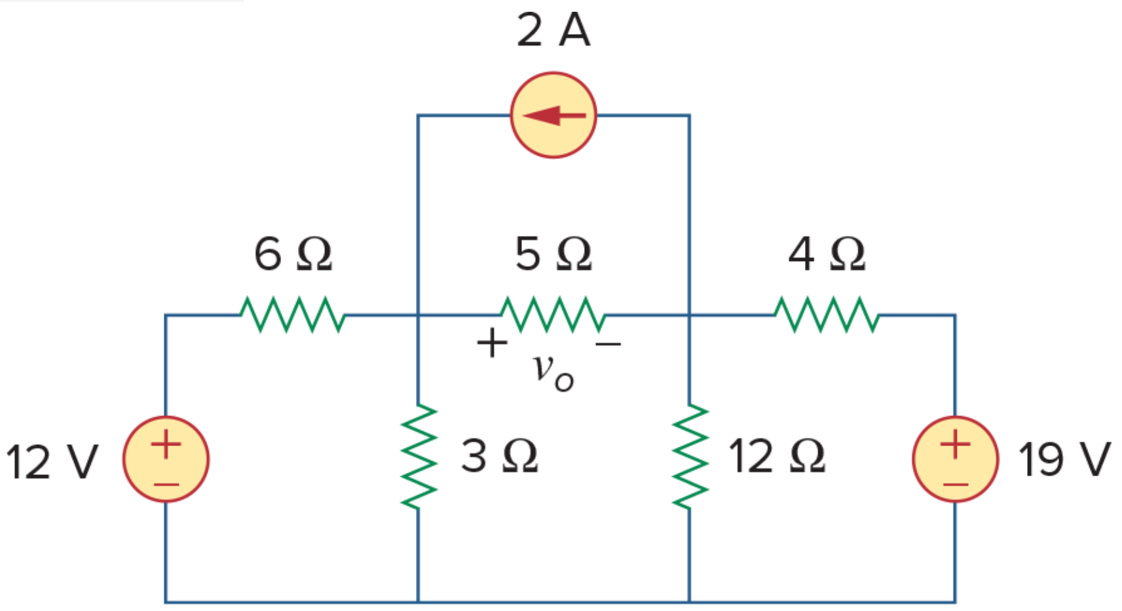
Figure 4.80 For Prob. 4.12.

- Chapter 4, Problem 16. Given the circuit in Fig. 4.84, use superposition to obtain io.
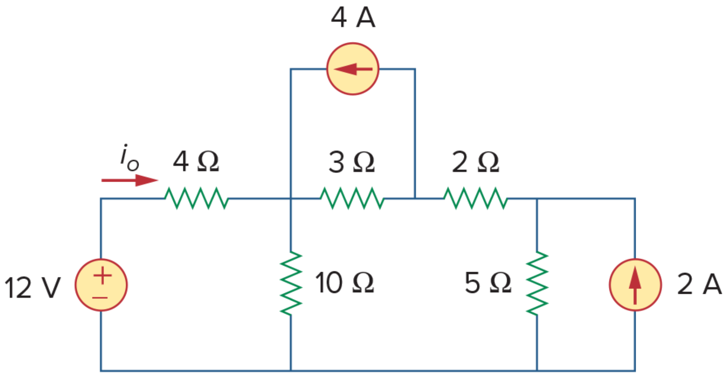
Figure 4.84 For Prob. 4.16.

Sections 4.5 and 4.6Thevenin’s and Norton’s Theorems
- Chapter 4, Problem 33. Determine the Thevenin equivalent circuit, shown in Fig. 4.101, as seen by the 5-ohm resistor. Then calculate the current flowing through the 5-ohm resistor.
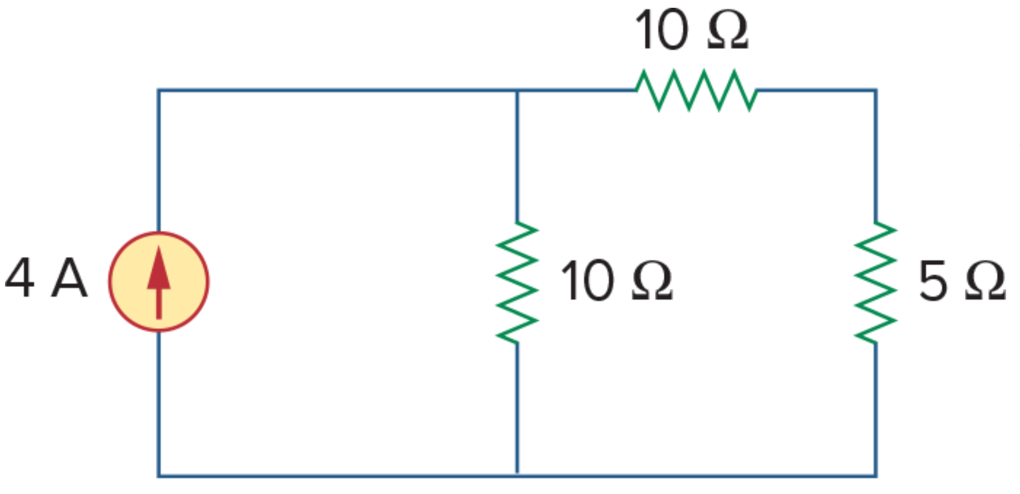
Figure 4.101 For Prob. 4.33.

- Chapter 4, Problem 37. Find the Norton equivalent with respect to terminals a-b in the circuit shown in Fig. 4.104.

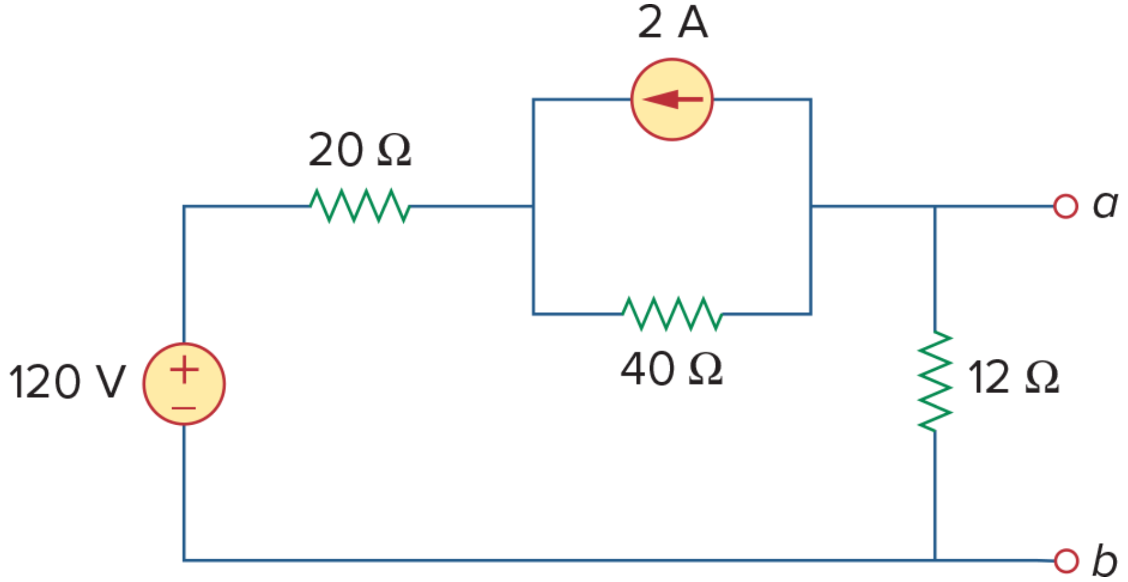
Figure 4.104 For Prob. 4.37.

- Chapter 4, Problem 36. Solve for the current i in the circuit of Fig. 4.103 using Thevenin’s theorem. (Hint: Find the Thevenin equivalent seen by the 40Ω resistor.)
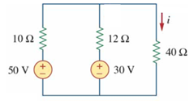
Figure 4.103 For Prob. 4.36.

- Chapter 4, Problem 38. Apply Thevenin’s theorem to find Vo in the circuit of Fig. 4.105.
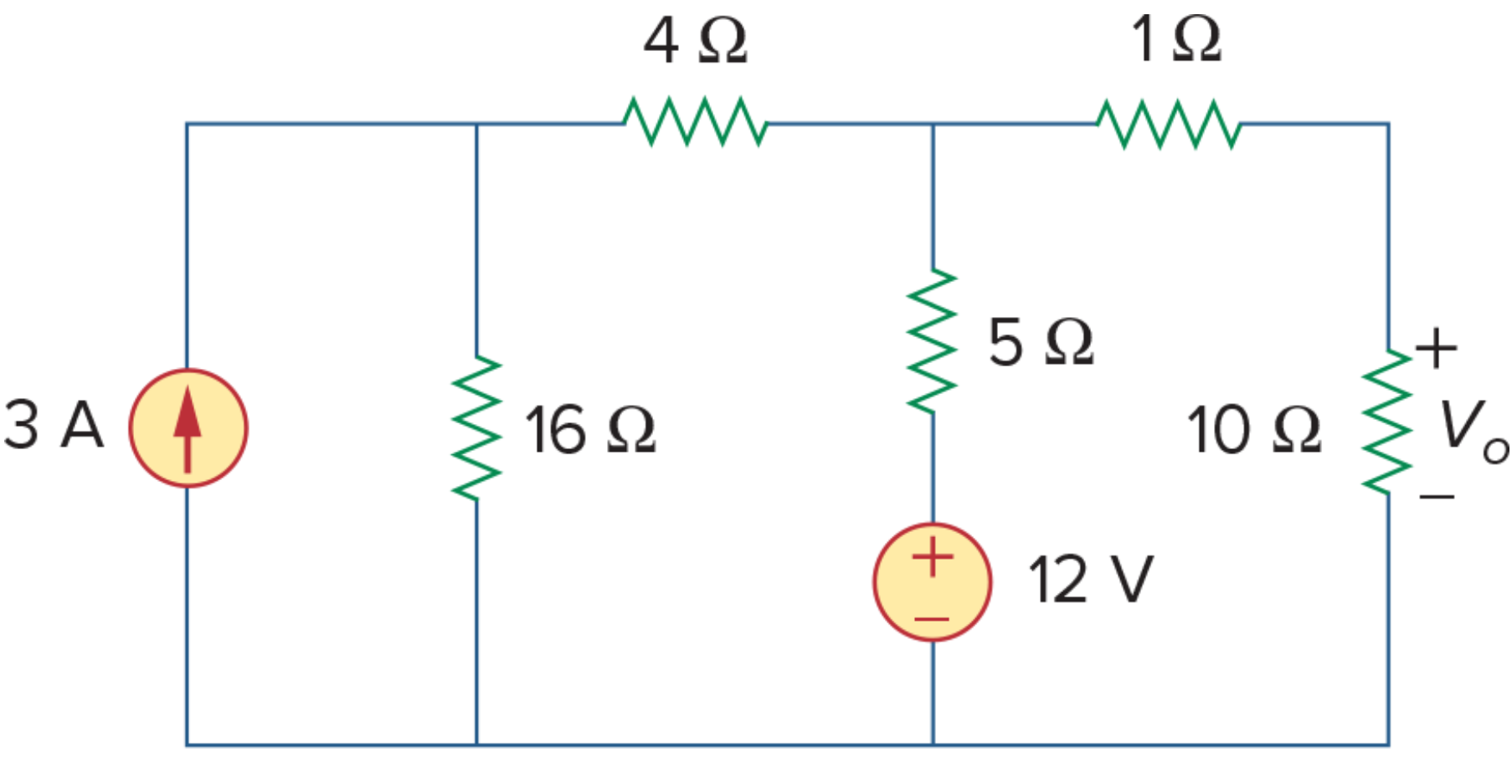
Figure 4.105 For Prob. 4.38.

- Chapter 4, Problem 39. Obtain the Thevenin equivalent at terminals a-b of the circuit shown in Fig. 4.106.
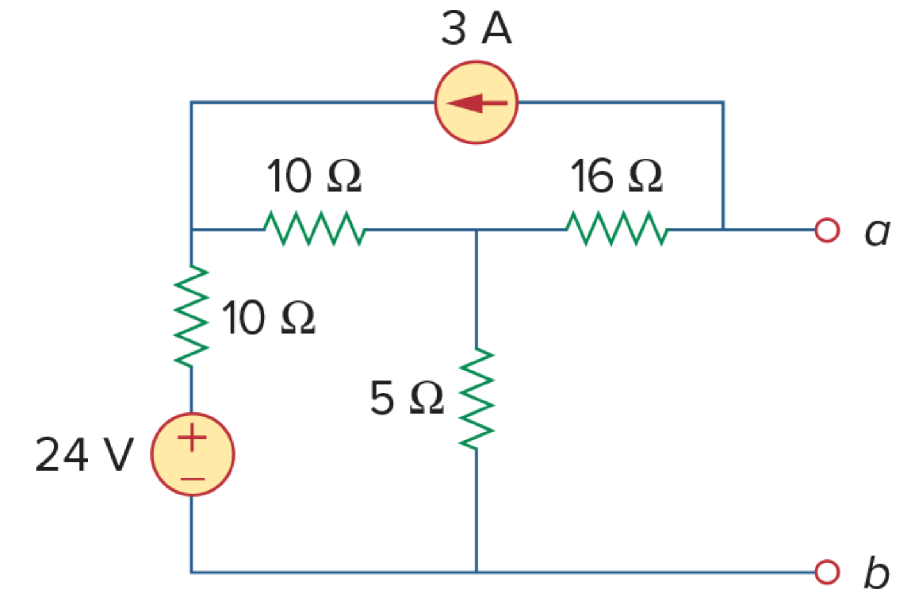
Figure 4.106 For Prob. 4.39.

- Chapter 4, Problem 41. Find the Thevenin and Norton equivalents at terminals a-b of the circuit shown in Fig. 4.108.
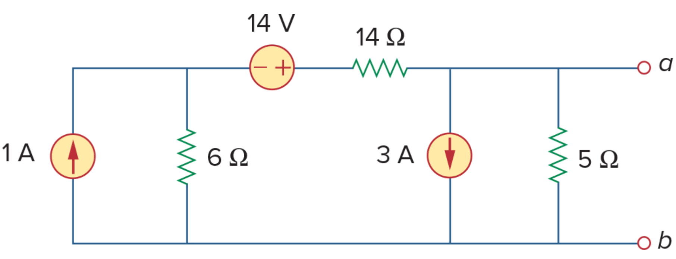
Figure 4.108For Prob. 4.41.

Section 4.8Maximum Power Transfer
- Chapter 4, Problem 66. Find the maximum power that can be delivered to the resistor R in the circuit of Fig. 4.132.
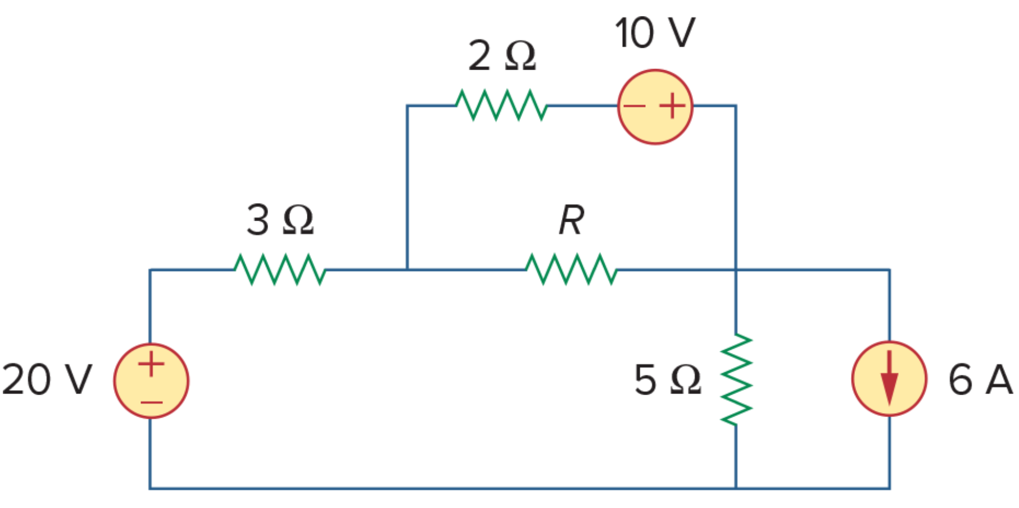
Figure 4.132For Prob. 4.66.

