- 7.2 Find the time constant for the RC circuit in Fig. 7.82.
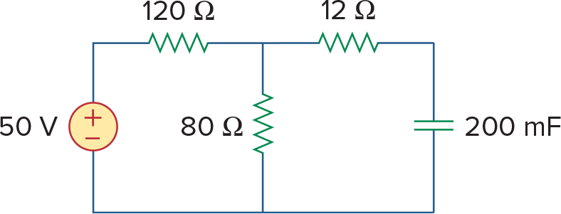
Figure 7.82 For Prob. 7.2.

- 7.6 The switch in Fig. 7.86 has been closed for a long time, and it opens at t=0. Find v(t) for t≥0.

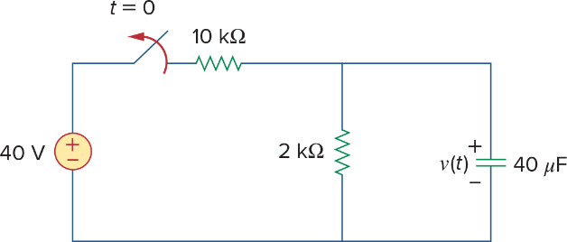
Figure 7.86 For Prob. 7.6.

- 7.9 The switch in Fig. 7.89 opens at t=0. Find vo for t>0.
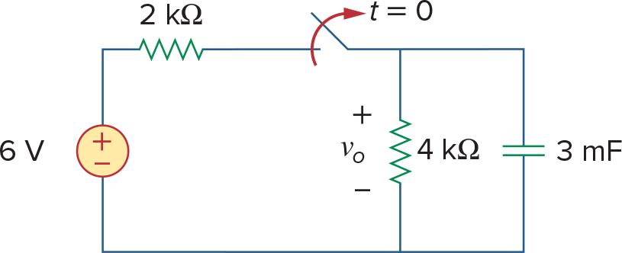
Figure 7.89 For Prob. 7.9.

- 7.11 For the circuit in Fig. 7.91, find io for t>0.
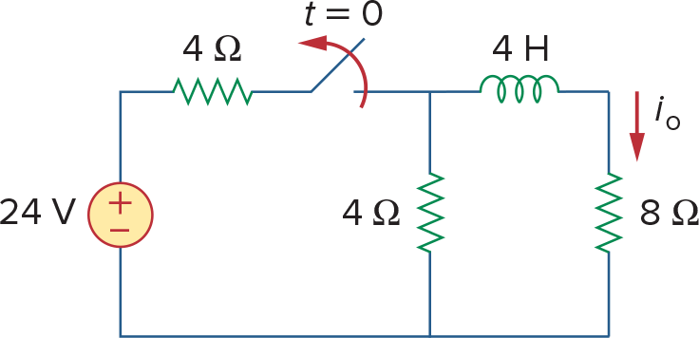
Figure 7.91 For Prob. 7.11.

- 7.13. In the circuit of Fig. 7.93,
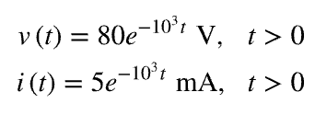
(a)Find R, L, and τ.
(b)Calculate the energy dissipated in the resistance for 0<t<0.5 ms.
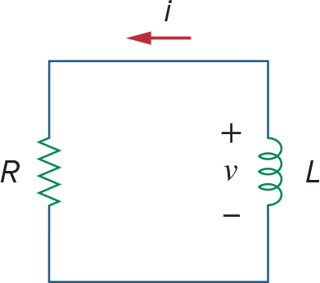
Figure 7.93 For Prob. 7.13.

- 7.14 Calculate the time constant of the circuit in Fig. 7.94.
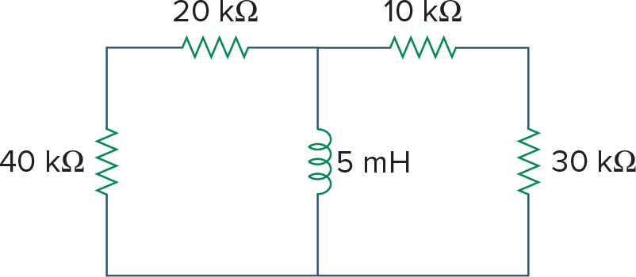
Figure 7.94 For Prob. 7.14.

- 7.39 Calculate the capacitor voltage for t<0 and t>0 for each of the circuits in Fig. 7.106.
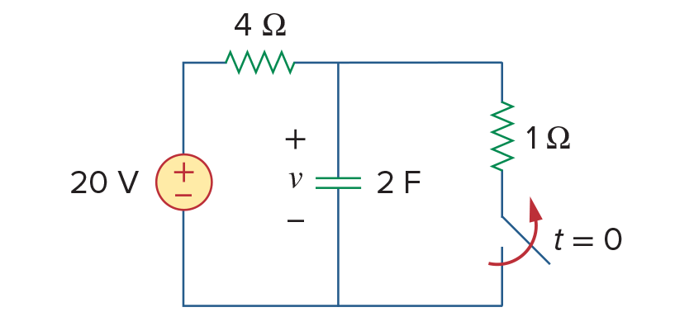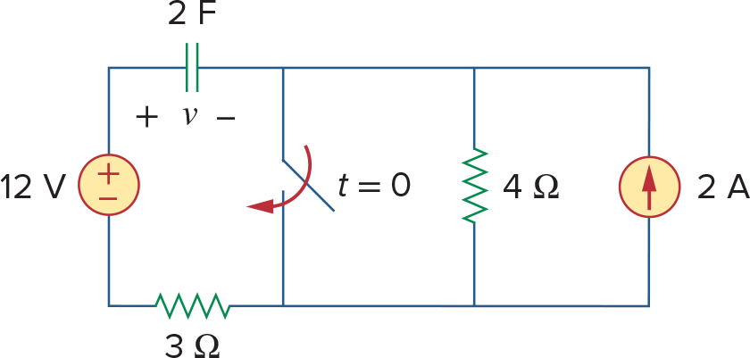
(a) (b)
Figure 7.106 For Prob. 7.39.

- 7.40 Find the capacitor voltage for t<0 and t>0 for each of the circuits in Fig. 7.107.
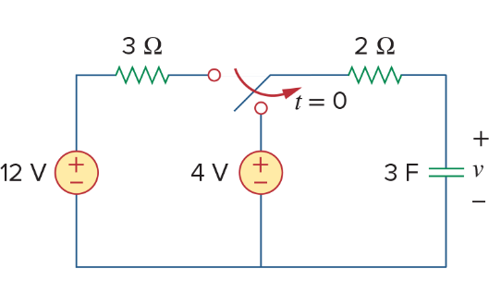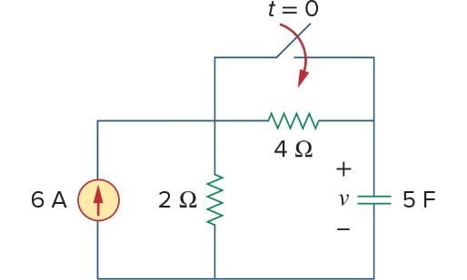
(b)

Figure 7.107 For Prob. 7.40.

- 7.42 (a)If the switch in Fig. 7.109 has been open for a long time and is closed at t=0, find v_{o}(t).
(b)Suppose that the switch has been closed for a long time and is opened at t=0. Find v_{o}(t).
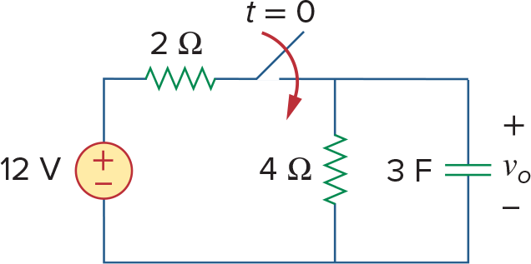
Figure 7.109 For Prob. 7.42.

