
Electronics and Computer Technology

ECET 250E: Lab 03
Multisim Simulation and Experimental Verification

OBJECTIVES:

1. To become familiar with the Multisim software and interface.
2. To measure resistance using a virtual multimeter.
3. To become familiar with basic Multisim functions:
-Open and save Multisim files
-Select and place components
-Modify component parameters
-Make and edit circuit connections
-Connect and use various Multisim virtual instruments
-Run simulations
4. To use a digital multimeter (DMM) to measure voltage and current.
5. To compare and verify measured, simulated, and calculated results for the same circuit.
6. To measure voltage and current in resistive circuits and investigate ammeter placement in a series circuit.

BACKGROUND:

Voltage and current measurement

In order for an electronic circuit to function a current must flow through the circuit. A current is the measure of the rate of change of charge (electrons) flowing past a certain point in the circuit. Current is measured by an ammeter (DMM set in current measuring mode) placed in the circuit which displays the result in Amperes.

In order for the current to flow in the circuit there must be a potential difference (voltage) across the circuit. This potential difference is measured by using a voltmeter (DMM set in voltage measuring mode). This instrument measures the potential difference between two points in the circuit. The potential difference is measured in units of Volts.

A voltmeter is connected across a component or circuit (connected in parallel with the component or circuit) and at this point in our course we consider it not to affect the circuit in any way. The voltmeter may show a positive or negative value depending on the polarity (a voltage is an algebraic value).
An ammeter measures the current flowing through a branch and must be connected in series with that branch. Switch off the power, open the circuit at the measurement point, and insert the meter between the two ends. A positive reading means conventional current enters the red current terminal and leaves the COM terminal.

Use COM and the appropriate voltage/resistance or current terminal for the selected measurement. Switch off the power before changing connections. Never connect an ammeter directly across the power supply. Measure resistance only with the circuit unpowered and the component isolated where necessary. Check the meter mode, terminals, and range before switching on the supply. If in doubt, ask the instructor to check your circuit.

Introduction To Multisim:

Multisim is a software program that allows us to create and test ‘virtual’ circuits without having to physically build them. In this lab we will become familiar with the basic operation of the Multisim program.

Orient yourself in the Multisim environment:

- Start the Multisim application.
- Go to the Help menu
- Select “Getting Started”
- Read Chapter 1: Introduction to the NI Circuit Design Suite
Note that this tutorial involves some advanced devices and concepts that you are not expected to know. The goal here is just to get familiar with the interface.
- Go back to the Help menu and select “Find Examples” to bring up the NI Example Finder.
Browse the NI Example Finder to get a feel for the different circuit simulation possibilities in Multisim.

PROCEDURE 1:

- Start the application NI Multisim from the program list or desktop icon.
- It should come up with a blank schematic. If it doesn’t, Click on File → New to create a new circuit (schematic) diagram.
Click on the resistor symbol on the toolbar (at the top underneath the menubar) then select a resistor from the list in the Select a Component dialog that appears. You may also go to the main menu bar and select Place → Component. Note that the resistor is in the Basic group of components and RESISTOR Family.

For this exercise, select a resistor with a tolerance of 10%.

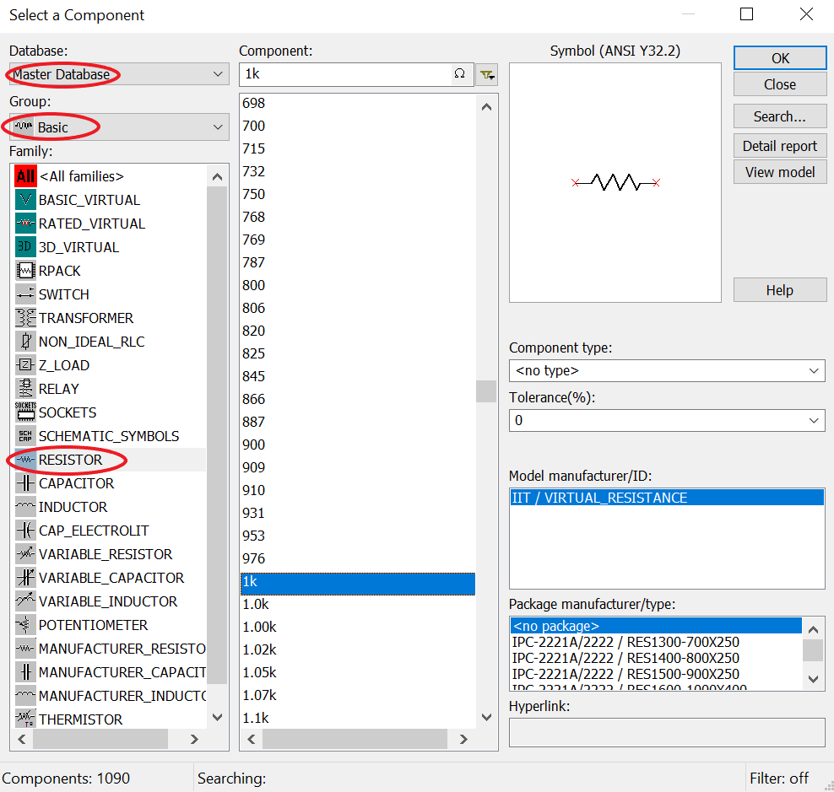
Notice the Database, Group, and Family hierarchy of components.
Database: Master Database
Group: Basic
Family: RESISTOR

- Choose a resistor value other than 1 kΩ (for example, 2.5 kΩ) and place it using a left mouse click.
- Once placed, a component can be moved or edited by selecting it or double-clicking it. Press Ctrl-R to rotate it by 90°.

- What is the nominal value of the resistor you selected?

- What is the color code for that Resistor with tolerance of 10%?

- Find the parts listed below in the appropriate menu and select/place them onto the sheet.

You will need to find the following:
GROUND
DC_POWER
AC_POWER
RESISTOR
CAPACITOR
INDUCTOR
POTENTIOMETER

- Experiment with placing multiple parts, moving them around and changing their orientation.
- Practice changing the component parameters. Double click on a component to access the values and change them to the values shown.
- Place the instruments from the instrument menu on the sheet.
- Double click on each instrument to reveal the controls.

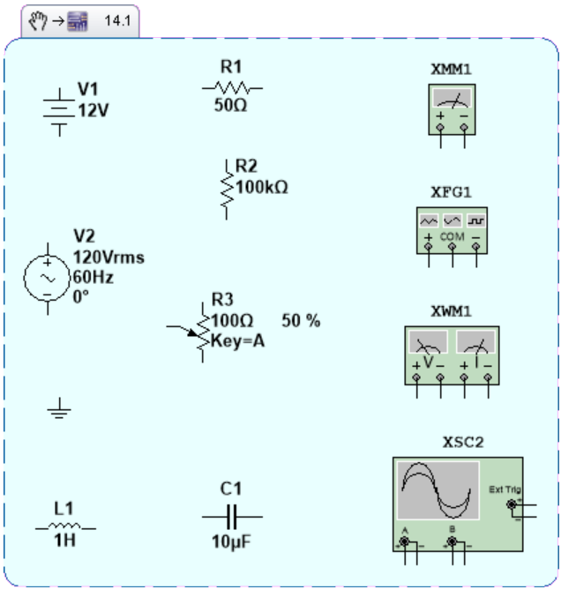

PROCEDURE 2:

Modify the component layout to look like the diagram below.

- Unused parts may be ‘parked’ elsewhere on the sheet until needed
- Use the mouse to make the connections between components and to the instruments

We are now ready to run the simulation.

- Set the Multimeters to read the resistor value.
- Click on the ‘Run’ icon and observe what happens to the Multimeter readouts.

Circuit 1:
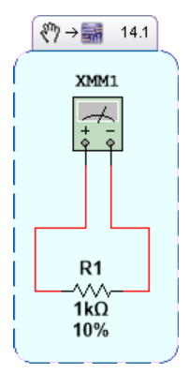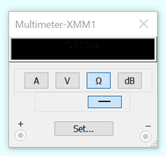
Replace the example screenshot with your own Multisim screenshot showing your name, the resistor value, and the multimeter resistance reading.

Record your results for the following circuit settings:
Note that if you change a fixed component value you will need to stop and restart the simulation.

XMM1 = ________________

- What is the color code for the 1kΩ Resistor with tolerance of 10%?

PROCEDURE 3:

Now reconfigure the circuit as shown below (Circuit 2) with a Potentiometer in the circuit. Make sure to adjust the component value and instrument settings as shown.
Circuit 2:
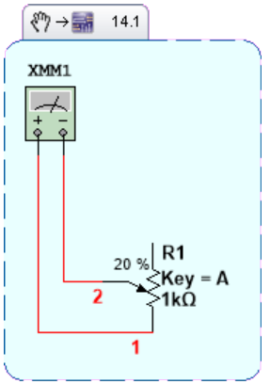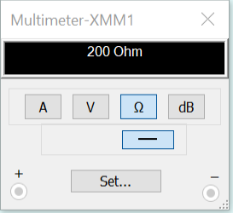
Include your own Multisim screenshots showing your name, the potentiometer setting, and the resistance reading for each setting below.

Record your results for the following circuit settings:

R1 = 30% XMM1 = ________________

R1 = 50% XMM1 = ________________

R1 = 80% XMM1 = ________________

R1 = 100% XMM1 = ________________

- What do you conclude from this simulation about how potentiometers behave in a circuit?

PROCEDURE 4: VOLTAGE AND CURRENT MEASUREMENT IN MULTISIM

- Using Multisim, build and simulate the following three circuits. In every circuit the source is a DC voltage, and ammeters and voltmeters can be added by selecting Simulate-Instruments-Multimeter and choosing A or V (amps or volts). Record the simulated current and voltage for each circuit.
Replace the example screenshots with your own Multisim screenshots showing your name and all ammeter and voltmeter readings.

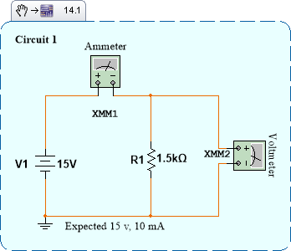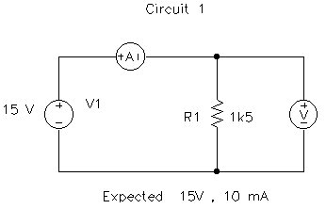

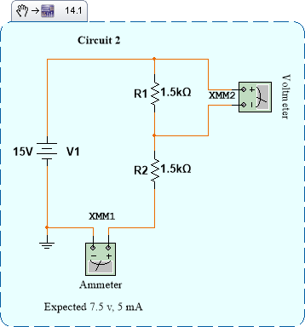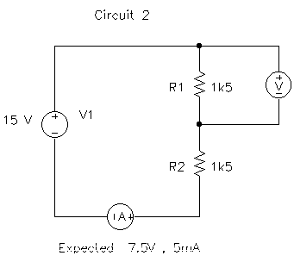

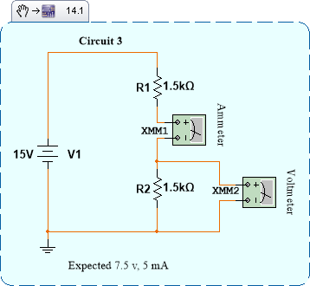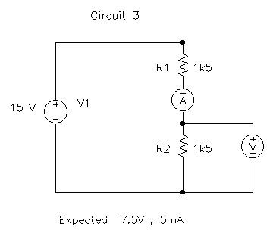

PROCEDURE 5: BREADBOARD MEASUREMENTS AND COMPARISON

Before building any circuit, connect the voltmeter (DMM) to the power supply terminals and adjust the supply until 15 V is indicated.

- Read the DMM manual to determine how to measure current using the DMM.

Build and measure all three circuits below on the breadboard during this lab, using the same resistor values and 15 V supply as in your Multisim simulations. First calculate the expected voltages, currents, and power dissipated by each resistor. Check that each resistor has an adequate power rating. Connect the meters as shown, using suitable ranges, and have the instructor check the first circuit before switching on the supply. Record the actual supply voltage and compare the breadboard measurements with your calculated and simulated results.

Quantity | Calculated | Multisim | Breadboard
Supply voltage (V)
Voltage across R1 (V)
Series current (mA)

Quantity | Calculated | Multisim | Breadboard
Supply voltage (V)
Voltage across R1 (V)
Series current (mA)

Quantity | Calculated | Multisim | Breadboard
Supply voltage (V)
Voltage across R2 (V)
Series current (mA)

Discussion and Conclusion

Discuss the following questions in your report:
  - How closely did your calculated, simulated, and breadboard results agree? Explain possible reasons for any differences.
  - What did you learn about measuring resistance, voltage, and current? What do Circuits 2 and 3 show about current at different points in a series circuit?
  - What problems did you encounter, and how did you resolve them?
Submit your completed lab report on D2L, including comparison tables and Multisim screenshots with your name and readable instrument readings.
Also submit the saved Multisim circuit files for each procedure. Use the native file format produced by your installed version of Multisim.

