ENGR 290 Practice Midterm
110 minutes • 100 marks • Scientific calculator and handwritten sheet
Use separate paper. Show the first equation, substitution and units. Question weights and timing are for this practice paper. The worked key begins after Question 10.

1 Unit cells and directions • 10 marks
An FCC metal has a = 0.400 nm and molar mass 60.0 g/mol. Use Nₐ = 6.023 × 10²³ mol⁻¹. (a) Count atoms per cell and find density in g/cm³. (4) (b) Find the direction from (½, 0, ½) to (1, ½, 0). (2) (c) A plane cuts the axes at a/2, ∞, −a. Give its indices and the spacing of this plane family. (4)

2 Vacancies and slip • 10 marks
(a) At 600 K the vacancy fraction is 10⁻⁵. Estimate it at 800 K for Eᵥ = 0.60 eV and k = 8.62 × 10⁻⁵ eV/K. (4) (b) A single crystal is loaded at 100 MPa with φ = λ = 45°. Will it slip if its critical resolved shear stress is 45 MPa? (3) (c) Distinguish edge and screw dislocations and explain one strengthening method. (3)

3 Carburizing a shaft • 12 marks
A thick steel shaft initially contains 0.20 wt.% C. Hold its surface at 1.00 wt.% C. At the furnace temperature D = 2.00 × 10⁻¹¹ m²/s. (a) How many hours are needed to reach 0.40 wt.% C at 0.80 mm? Use erf(0.80) = 0.7421 and erf(0.85) = 0.7707. Interpolate. (8) (b) How long for 1.60 mm at the same concentration? (2) (c) Name two assumptions. (2)

Solidification and alloy diagrams

4 Growing a casting • 8 marks
(a) Explain why a seed lets crystals form at smaller undercooling. (2) (b) Explain how heat leaves a planar front and why protrusions stop growing into warmer liquid. (4) (c) Why use a single-crystal turbine blade? (2)

5 An aluminium casting • 14 marks
Use the lower wt.% scale in Figure 1. Consider 22 kg at 7.1 wt.% Si. (a) Identify the primary phase and sketch the cooling sequence from liquid to just below 577 °C. (4) (b) Immediately above 577 °C, use endpoints 1.6 and 12.6 wt.% Si to find the masses present. (4) (c) Immediately below, approximate the Si-rich β endpoint as 100 wt.% Si. Find total β mass and mass of the eutectic microconstituent. (4) (d) Explain the difference between those last two quantities. (2)
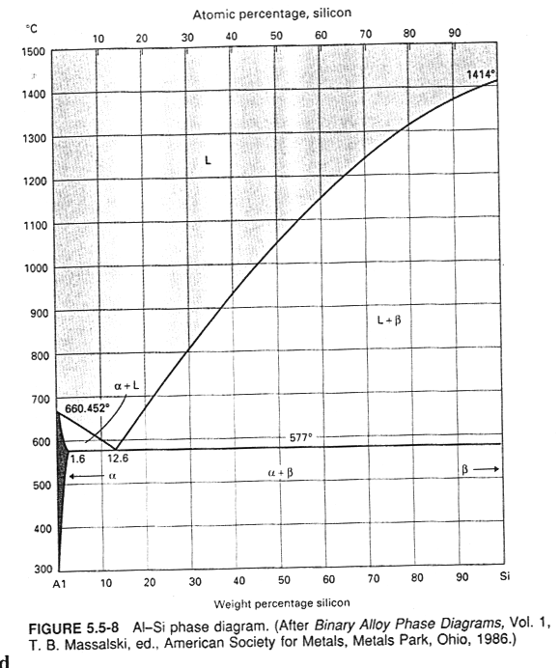
Figure 1. Al–Si equilibrium diagram supplied with Assignment 2, Q7.

Cooling curves and transformations

6 Read a cooling curve • 8 marks
Use Figure 2. Estimate the liquidus, solidus and freezing range. Explain the change in slope during freezing and predict the shape for an equilibrium pure metal freezing at constant pressure.
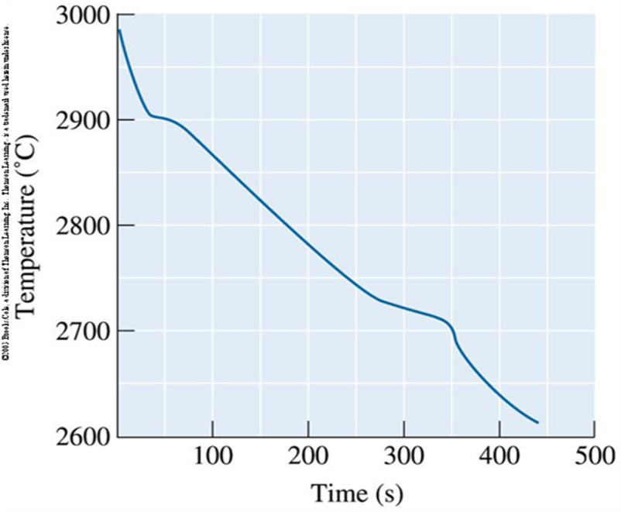
Figure 2. Nb–W cooling trace supplied with Assignment 2, Q11. Approximate readings are appropriate.

7 Steel microstructure • 10 marks
A 0.40 wt.% C steel cools slowly from the single-austenite field. Use the lecture values Cα = 0.02, Cγ = 0.80, CFe₃C = 6.67 wt.% C at 723 °C. (a) Name the constituent that forms first. (2) (b) Find the fraction of pearlite just below 723 °C. (4) (c) Name both phases inside pearlite. Explain what would form first at 1.20 wt.% C. (4)

Mixtures and polymer behaviour

8 Changing bath composition • 8 marks
A 200 kg bath contains 30 wt.% B. At the holding temperature the diagram gives first solid at 40 wt.% B and complete solidification at 60 wt.% B as pure B is added. Find the total mass of B to add for each condition (6), then the additional amount after first solid appears (2).

9 Polymer selection and chain length • 10 marks
Choose a class or process and explain each choice. (a) A seal must repeatedly stretch to three times its initial length. (3) (b) Manufacture long tubing of constant section. (2) (c) Explain why an amorphous thermoplastic becomes much stiffer when cooled below Tg. (2) (d) A polymer has Mₙ = 84,000 g/mol and a 42 g/mol repeat. Find degree of polymerization and explain what it counts. (3)

10 Fastener life and phase rule • 10 marks
(a) At constant strain, stress falls from 12 MPa to 9 MPa in 50 h. Find λ and total time until stress reaches 6 MPa, assuming exponential relaxation. (6) (b) For a two-component alloy with two equilibrium phases, calculate degrees of freedom both with pressure variable and with pressure fixed. Explain why the results differ. (4)

Worked key

1 Unit cells and directions
Eight corners contribute 1 atom and six faces contribute 3. With a = 4.00 × 10⁻⁸ cm, ρ = 4(60.0)/[(6.023 × 10²³)(4.00 × 10⁻⁸)³] = 6.23 g/cm³. The displacement is (½, ½, −½), so the direction is [1 1 −1]. Reciprocal intercepts give (2 0 −1). d = 0.400/√5 = 0.179 nm.

2 Vacancies and slip
f₂ = 10⁻⁵ exp[(0.60/0.0000862)(1/600 − 1/800)] = 1.82 × 10⁻⁴. The increase makes physical sense. τ = 100 cos²45° = 50 MPa. Slip begins by the time 100 MPa is reached because 50 exceeds 45. Edge has b perpendicular to its line and screw has b parallel. Cold work adds dislocations that obstruct one another.

3 Carburizing
erf(z) = (1.00 − 0.40)/(1.00 − 0.20) = 0.75. Interpolate z = 0.80 + 0.05(0.7500 − 0.7421)/(0.7707 − 0.7421) = 0.8138.
$t = x^{2}/({4Dz}^{2}) ≈ 12,080 s ≈ 3.36 h$
Doubling depth multiplies time by four, giving about 13.4 h. Assumptions include uniform initial carbon, fixed surface concentration, constant D and a sufficiently deep body.

4 Growing a casting
A seed provides an existing interface and reduces the free-energy barrier for heterogeneous nucleation. Remove sensible heat to cool the melt. Freezing releases latent heat, conducted through solid to the colder side. A projecting tip enters warmer liquid and stalls or remelts until the front catches it. A single-crystal blade lacks grain boundaries that can slide at high temperature.

Worked key for alloy and polymer questions

5 Aluminium casting
On cooling: L, then primary Al-rich α + L, then primary α surrounded by eutectic α + β. The residual liquid moves toward 12.6 wt.% Si. Just above 577 °C the α fraction is (12.6 − 7.1)/(12.6 − 1.6) = ½. There are 11 kg each of α and liquid. Just below, wβ = (7.1 − 1.6)/(100 − 1.6) = 0.0559, or 1.23 kg β. All 11 kg of remaining liquid becomes eutectic, which contains both α and β.

6 Cooling curve
First knee ≈ 2900 °C, last knee ≈ 2700 °C, range ≈ 200 °C. Latent heat released as solid forms slows cooling. A pure substance at equilibrium gives a thermal arrest at one freezing temperature.

7 Steel microstructure
Proeutectoid ferrite forms first. Just above 723 °C, wγ = (0.40 − 0.02)/(0.80 − 0.02) = 0.487. That γ becomes pearlite, so the result is about 48.7% pearlite by mass. Its plates are ferrite and cementite. At 1.20 wt.% C, proeutectoid cementite forms before the remaining austenite transforms.

8 Bath composition
Initially there are 60 kg B. (60 + x)/(200 + x) = 0.40 gives x = 33.3 kg. At 0.60, x = 150 kg total added. Additional B between the two states = 150 − 33.3 = 116.7 kg.

9 Polymer selection
Use an elastomer above Tg with sparse cross-links so segments can uncoil and recover. Extrude the softened thermoplastic through an annular die. Below Tg, cooling restricts segment motion, raising modulus. DP = 84,000/42 = 2000 repeat units per number-average chain.

10 Fastener life and phase rule
λ = −50/ln(9/12) = 173.8 h. At half the original stress, t = λ ln 2 = 120.5 h from loading. Full rule F = 2 − 2 + 2 = 2. Fixing pressure removes one independent intensive variable, giving F = 1.

