1

Chapter 1

AIM 1.2: ALGORITHMS TO PROCESS NEURAL DATA IN CONTEXT OF ONGOING STIMULATION

1.1 Introduction

The interpretation of neural activity during concurrent electrical stimulation is a challenge. The stimulus artifact induced by electrical stimulation is often orders of magnitude greater than the neural signal of interest, confounding traditional neuroscience analytic techniques such as time-frequency analyses and event-related potential magnitudes [80]. How can we meaningfully interpret the neural response to stimulation during ongoing DCS?

Past approaches to dealing with the stimulus artifact problem have included template subtraction methods [33]. Another employed locally tting the recorded neural signals and subtracting the t function for recordings from extracellular multielectrode array recordings on tissue slices [77]. For single pulse electrical stimulation, and the analysis of cortico-cortical evoked potentials [48], methods based o electrical modeling of the tissue-electrode interface to extract the physiological responses from artifacts have been implemented [73].

Filtering is another approach that has been used, but this runs into the issue of the overlap between the frequency spectra of the neural signal and that of the stimulus artifact, where subsequent ltering of frequency components of the artifact can induce distortions in the neural signal [16]. Recent progress has been made using a recursive Wiener lter to remove time domain artifacts in human electrocorticography recordings [58].

Other groups have made software available for the analysis of neural signals with artifacts [26, 37], but these from our experience tend to work on single trial, single pulse, or single channel bases. Additionally, SARGE, a generalized framework and MATLAB toolbox, by Erez et al., was developed in the context of tungsten microelectrode recordings from monkeys,

2

and assumes saturation of an ampli er, yielding a period of non-usable signal. This presents an opportunity for analysis tools which process all channels simultaneously to allow for increased analytic throughput.

Additional methods decompose the signals into various components through methods such as independent component analysis (ICA), principal components analysis (PCA), and variants of empirical mode decomposition (EMD). Other recent work has employed sequential principal components regression, using generated templates across channels and sequential non-linear regression to extract neural signals [61]. Another approach applied to deep brain stimulator recordings is an ensemble empirical mode decomposition based approach [3]. In-dependent component analysis techniques have been applied to cochlear auditory evoked potential recordings [29] and optic nerve stimulation and subsequent visual cortex reactions in rabbits [45]. Work to separate spikes from retinal stimulation in primates has used an algorithm based on a structured Gaussian process [51].

With all of the work previously done, one may wonder why additional post-hoc tools are needed. Front-end hardware approaches that completely eliminate the need for post-processing would be ideal [80], but these do not yet work without the need for further processing. Therefore, post-hoc processing algorithms are still valuable. Additionally, many existing algorithms and approaches have not been optimized or tuned for electrocorticogra-phy recordings or simultaneous electrocorticographic and deep brain stimulator recordings. Oftentimes software is written to handle single channels, or small groups of channels.

We here discuss the implementation of software for ampli ers that do not saturate during stimulation, to allow for analysis of ongoing trains or single pulses of electrical stimulation, during multi-channel macro-scale human electrocorticographic recordings from human sub-jects. We implement a suite of approaches for comparison metrics, which may prove useful for researchers in other elds. Additionally, we present sets of considerations and assump-tions under which certain approaches may or may not be applicable. Also, we implement algorithms which extract the stimulation onset timing from a single channel, and using the knowledge of volume conduction timing relative to neural signal propagation, extract win-

3

dows of artifacts for all other channels automatically. We provide options to recover within stimulation pulse evoked potentials, to dynamically detect the o set of stimuli pulses on a channel and trial-wise basis. In this way, we seek to create software that scales to the 128 channels or greater that are becoming common in human neurophysiology research.

Also important is the presentation of various curated human electrophysiologic data sets. These are all simple matrices of samples x channels x trials data, which may serve as test data sets for others in the eld who seek to develop and compare algorithms. This hopefully serves as a catalyst towards more open science and data sharing in human electrophysiology.

1.2 Methods

By leveraging timing information on one channel, we are able to better detect and process signals on distant channels with smaller artifacts. We consider the recorded channel with the largest magnitude of artifact to be the channel to base the timing of all other artifacts o .

The rst algorithms implemented were a simple linear interpolation scheme using the endpoints of the stimulus artifact onset and o set, and a shape-preserving piecewise cubic interpolation scheme using data points adjacent to the stimulus artifact. This has the dis-advantage of discarding any high frequency content during this time period, which for trains of stimuli, can result in the loss of large amounts of information (Figure 1.1). The next included an average across all individual stimulus pulses, which fails to capture individual variability in pulses and trials.

1.3 Template Extraction

In order to address issues with slight temporal o sets between artifacts on given trials based on our windowing, as well as di erent stimulus artifacts across trials, we implement a dictio-nary discovery approach to discover all possible families of artifacts in a given window. Using a variant of the DBSCAN algorithm for clustering [27], we employ three di erent possible distance metrics, including euclidean distance, cosine similarity, and correlation, to extract

4

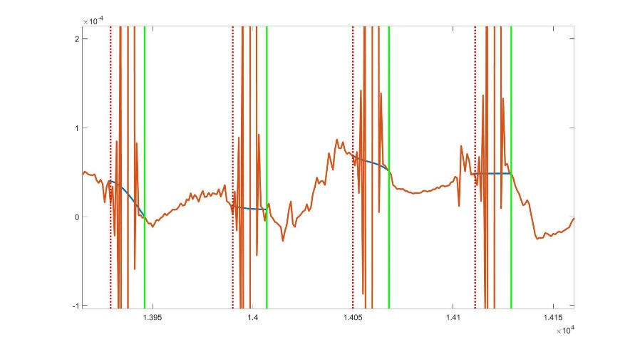

Figure 1.1: Demonstrated is a simple linear interpolation scheme, which eliminates any information about the neural signal present during the stimulus artifact period.

possible templates (Figure 1.2). These can be speci ed by the user, and modi cation to the distances required for grouping as part of a cluster may be needed depending on the data set.

1.4 Template Matching

Once a dictionary of templates has been discovered, we compare each detected artifact on each channel with the dictionary. The best matching artifact (correlation, euclidean distance, or cosine similarity) is subtracted linearly from the artifact, and the neural signal is recovered, allowing for further processing such as time-frequency analysis (Figures 1.3, 1.4).

In order to assess the performance of our algorithm, we also compare the spectral infor-mation across the trials to quantify the reduction in frequency content at the stimulation pulse frequencies, as well as maintenance of other spectral content of interest. We quantify the reduction in artifact by the reduction in RMS value as measured in decibels. There is a trade o between decibel reduction and the loss of meaningful signal, which requires user

5

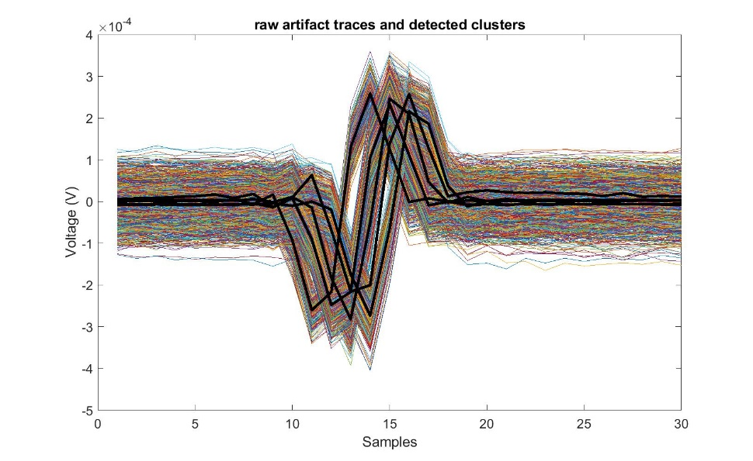

Figure 1.2: Example clusters on a given channel, across all trials. The thicker black lines represent the detected clusters, against which each individual artifact will be compared against and linearly subtracted from.

oversight.

1.5 Discussion

We acknowledge that this approach is not appropriate for all instances of human electro-physiologic data. In particular, if a signal is relatively undersampled for short durations of stimuli, the performance of the algorithm will decrease to the point where the results are not satisfactory, and the neural activity recovered will. From our example data sets, our algorithm performed well with 12 kHz sampling, and poorly with 1.2 kHz sampling with pulse widths of 200 s. The use of upsampling is a future direction to explore for enhancing artifact rejection for slower sampling rates.

Furthermore, these recordings must be made on a system that does not saturate during stimulation, as if clipping occurs, this method will not be able to recover the underlying neural signals.

6

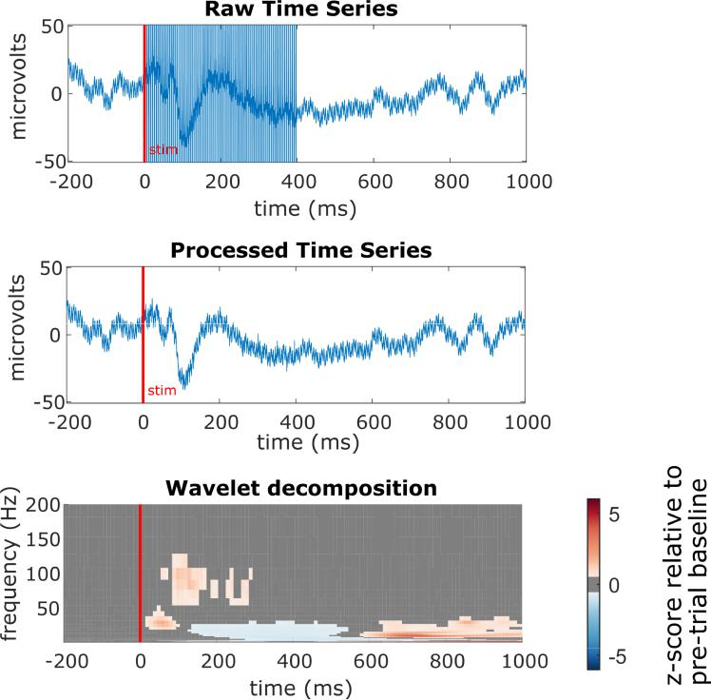

Figure 1.3: In the top plot, the raw, averaged time series during a 400 ms period of stimulation is demonstrated. The average, post-processed signal is shown in the middle plot, upon which time-frequency analysis, as shown in the bottom gure, can be performed.

1.6 Future Directions

We will create a synthetic data set in order to establish as best we can a ground truth scenario. To do this, we will take an experiment where we have both stimulus-free and DCS periods. Upon the DCS period, we will run our algorithm to extract known clusters of activity. We will then apply a random amount of jitter in both time and amplitude to create synthetic artifacts similar to the distributions shown in Figure 1.2, and add these back to the the stimulus free period of recording from the same subject. This is inspired by O'Shea et al, who created synthetic data sets for their algorithm for processing stimulation contaminated recordings from penetrating electrodes in primates [61]. We will then perform our artifact rejection steps, and compare both the evoked responses and time-frequency responses to

7

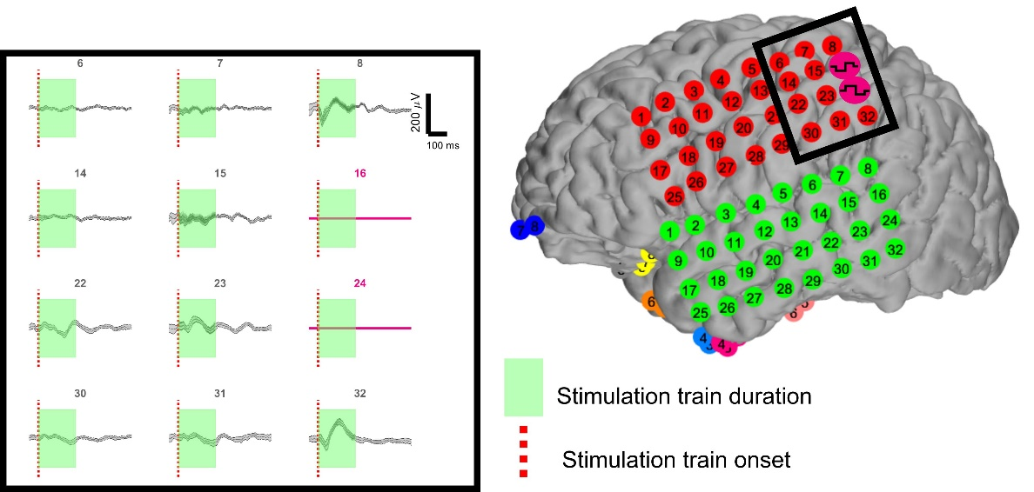

Figure 1.4: This approach allows for the processing of many channels simultaneously. Demon-strated here are 10 example processed time series neural recordings, with the green box representing the duration during which the DCS was applied.

validate performance of our algorithm.

As additional validation, and to ensure that the high frequency band information relevant to human physiology (High gamma band, 70-200 Hz), is minimally a ected by our algorithm, we will perform analysis of cortical responses using the Lomb-Scargle periodogram [59]. Brie y, this algorithm involves the elimination of any parts of the signal with known artifacts, and allows for the estimation of the power spectrum during this now unevenly sampled signal. By comparing the mean power across the signal using both our algorithm and the Lomb-Scargle periodogram, we can assess the e ect of our processing on the frequency content of our signals.

To see if we can gain any increased performance we will attempt an alternative approach of upsampling each artifact period, and extract the most likely artifactual signal using a variant principal component regression [61]. We will only use local components that have the same biphasic orientation as the recorded pulse in each channel, to best ensure that we

8

recreate the signal.

A potential alternative to pursue would be the implementation of a Dirichlet Process Mixture Model [70, 71], in order to use a non-parametric model to cluster the data.

1.7 Code Availability

Full MATLAB code and data sets are available at https://github.com/davidjuliancaldwell/artifactRejection

1.8 Related Publications and presentations

Caldwell DJ, \Understanding the Neural Response to Direct Cortical Stimulation", UW Data Science Summit, April 2018

Caldwell DJ, "Engineering direct cortical stimulation in humans", UW Neural Computation and Engineering Connection, January 2018

9

Chapter 2

AIM 2.2: COMPARISONS BETWEEN TEMPORAL DYNAMICS AND TIME FREQUENCY RESPONSES TO HAPTIC STIMULI AND DCS IN SOMATOSENSORY CORTEX

2.1 Introduction

What is the neural signature of this di erence that drives a slower response to DCS compared to haptic stimuli? Can waveforms be modi ed to reduce this delay? How can we better understand the cortical processing of DCS to S1?

Based o of recent work using implanted depth electrodes in humans following median nerve stimulation and analysis in the broadband gamma range (50-150 Hz), which demon-strated rapid, phasic components in primary somatosensory cortex, as well as neighboring premotor, motor, and inferior parietal regions, as well as tonic components in opercular, in-sular, and parietal rostroventral and ventral medial-superior-temporal areas, a groundwork has been established for regions involved in processing of peripheral stimuli [5, 6].

In our tactile stimuli, we consider components of the ERPs that have been seen for other intracranially recordings for vibrotactile [78] and peripheral electrical stimulation [50]. These include early peaked components within 50-60 ms, as well as later ones between 100-300 ms later. Results from EEG studies from median nerve stimulation and mechanical pulses and vibration [31, 39] point to evoked potential latencies at 30, 50, and 100 ms following stimulation. We plan to analyze both ERP and broadband gamma responses, but recent work has demonstrated in sensory processing that ERP interpretation can be complicated by the complex shapes and waveforms of ERPs [54], so we would anticipate that ERPs may be less consistent across subjects than the broadband gamma responses. Similarly, recent work has demonstrated both DCS of S1 cortex and light touch evokes neural activity primarily in

10

the broadband gamma region [59].

Additionally, we hypothesize that the evoked potential size following stimuli would be a function of the oscillatory phase of the alpha power (8-12 Hz), which is thought to participate as a gating and attention mechanism [2]. An additional line of inquiry will be phase amplitude metrics such as event related phase amplitude coupling [76], to look for the in uence of longer range oscillatory cycles such as theta oscillations (4-8 Hz) on the high gamma power.

We hypothesize that similar mechanisms in terms of local neuronal activity (broadband gamma activity) adjacent to sensory electrodes will exist between the two conditions, but that additional regions involved in processing natural haptic stimuli such as somatosensory association cortex and the supramarginal gyrus will have signi cantly decreased responses in the DCS conditions relative to the haptic stimuli.

To address engineering stimulation for enhanced neuroprosthetic performance, with faster reaction times and more natural sensations, we hypothesize better mimicking the cortical response in S1 to picking up an object, with onset of touch being marked by a burst of activity in S1, with a tonic, lower level of stimulation while maintaining contact, would result in faster reaction times, and perhaps more natural percepts [8, 68].

2.2 Experimental overview

6 subjects with response timing data have been collected as described in Aim 2.1, upon which we will perform our neural and behavioral analyses.

For the response timing experiments and waveform modi cations, we carry out the pro-cedure as demonstrated in Aim 2.1 with additional modi cations on the waveform. Rather than using trains of constant amplitude as in Aim 2.1, we add initial high \priming" pulses on the waveform (Figure 2.1) to better mimic S1 responses to object contact.

2.3 Analysis

Following processing by the methods presented in Aim 1.2, we extract the periods of time (epochs) of the signal centered on the time of stimulus onset for both the haptic and DCS

11

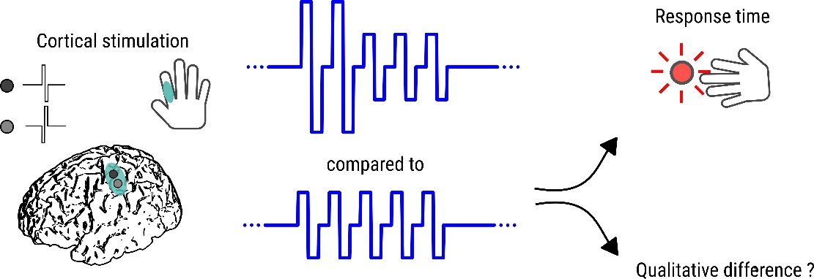

Figure 2.1: Waveforms with amplitude variation throughout are compared to waveforms with constant amplitude, with both perceptual reports and response times as output metrics.

conditions. We extract a window with one second before, and two seconds after stimulus onset. For time-frequency analyses, we perform the continuous wavelet transform with a non-analytic Morlet wavelet to extract the power over frequency bands from 1-300 Hz during the time course of signal. Due to the 1/f power distribution in neural signals, as well as to account for baseline activity, we normalize each trial to the mean and standard deviation of the power in each frequency bin before stimulus onset. Both time frequency and time series analyses are performed on averaged epochs across trials. For broadband high gamma responses, we calculate the amplitude of the envelope of the Hilbert transformed analytic signal of the bandpassed, 70-200 Hz signal, to get an estimate of broadband gamma power. We will additionally compare these results to the average power across these frequency bins from the wavelet transform, although we expect similar results [17, 74].

2.4 Existing results: neural analysis

As shown in gures 2.2 and 2.3, demonstrating example analyses of event related potentials (ERPs) and time frequency data, we observe similar responses between an electrode immedi-ately surrounding the stimulation pair of electrodes (electrode 28, green box), with di erent responses present in the haptic condition (blue boxes) in somatosensory association areas.

12

This suggests that there are regions of cortex that are utilized for processing and responding

to natural, haptic stimuli that are absent in the cortical stimulation condition.

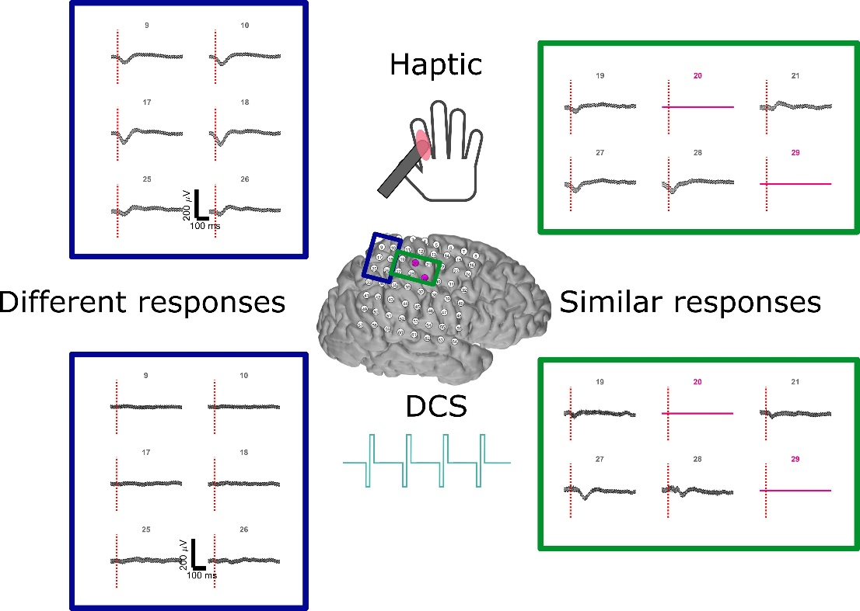

Figure 2.2: Example analysis highlighting the similarities and di erences in the time domain ERPs from both haptic and DCS conditions. Pink electrodes represent the S1 area which was stimulated with DCS, eliciting a spatially similar percept to the haptic condition. In electrodes immediately adjacent to the stimulation electrodes, we observe similar evoked responses in a number of electrodes with (negative de ection), with an increased latency.

2.5 Existing results: modi ed waveform behavioral analysis

In the rst subject analyzed thus far, there is a trend towards faster reaction times with

the initial two high pulses (median response times of 417 ms for the modi ed DCS train, vs

13

473 ms for the constant stimulus train condition), however, this is not signi cant as assessed through a Kruskal-Wallis test (Figure 2.4).

In a second subject, we tested various constant 200 ms train amplitudes (1.25 mA, 3 mA, and 0.8 mA), as well as waveforms with 2 initial high pulses at 3 mA, followed by 38 pulses at a lower frequency. The 200 ms, 3 mA train was reported to feel very intense, whereas the 2 high pulse trains were not reported as so. Anecdotally, this subject also reported the 2 pulses at 3 mA as more \natural" than the longer, constant train stimuli. The two DCS conditions in block 2 were signi cantly di erent from one another (Kruskal-Wallis test), pointing to the fact that two initial high pulses may aid with perception without creating an overly strong stimulus (Figure 2.5).

The time series results (Figure 2.6) for the rst subject with the initial high pulses demonstrates a more robust evoked potential during the stimulation train relative to the constant condition, despite no reports of substantially increased strength of stimuli.

2.6 Future analysis and expected results

In order to better assess and evaluate the signi cance of the di erences between the time series and spectrotemporal data, we will perform permutation testing of both the ERP and time-frequency maps [46,47]. Brie y, we will perform a permutation test on the peak latency and amplitude of the early and late ERP responses if present for the time series data, and a cluster based method on the time frequency maps. We expect to see gamma band responses present in somatosensory association areas and other high level processing areas for the haptic stimuli that are not present for the DCS stimuli.

Further, we will group electrodes by anatomical Brodmann area in each of the subjects to better discriminate the consistent responses to both haptic and DCS conditions. This will allow for a combination of the electrode coverages from the various subjects, to better discern the spatial and temporal patterns of activity in both conditions.

We will continue collecting data on the modi ed stimulus waveform trains, and include charge balanced conditions, as somatosensory cortex may be most sensitive to di erences in

14

charge (discussions with David Bjanes, Jeneva Cronin).

2.7 Related publications and presentations

Caldwell DJ, \Behavioral and neural di erences between haptic stimulation and direct corti-cal stimulation in humans: implications for neuroprosthetics", 7th International BCI Meet-ing, Workshop: Perception of Sensation Restored through Neural Interfaces, Asilomar, CA, May 2018

15

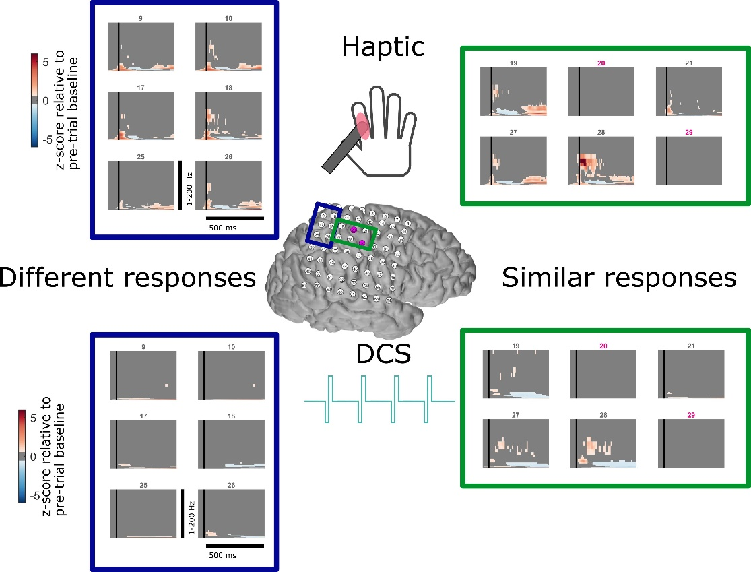

Figure 2.3: Pink electrodes represent the S1 area which was stimulated with DCS, eliciting a spatially similar percept to the haptic condition. In one of the electrodes immediately adjacent to the stimulation electrodes (28), we observe similar high gamma responses to DCS and haptic conditions. In electrodes covering somatosensory association areas and the supramarginal gyrus (blue box, left side), there are robust haptic responses that are absent in DCS conditions.

16

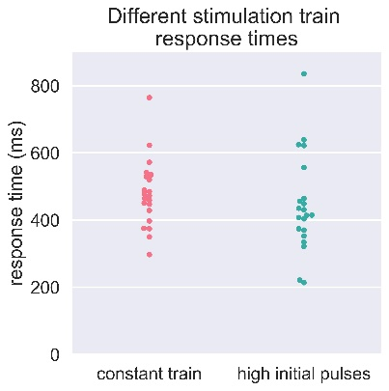

Figure 2.4: The DCS train with two leading pulses has a trend towards faster reaction times than the constant DCS train

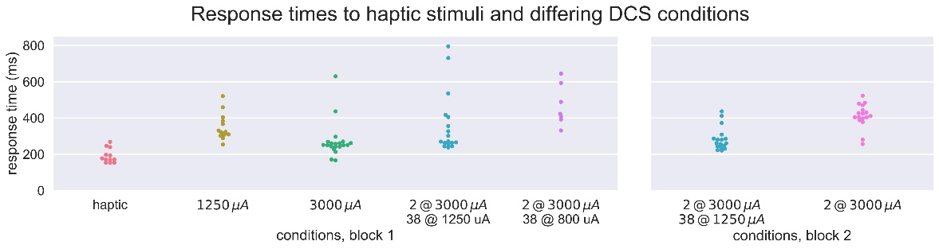

Figure 2.5: The haptic feedback condition has a lower median response time than all other conditions. None of the o -target, null, or 800 A conditions were responded to within our response timing bounds

17

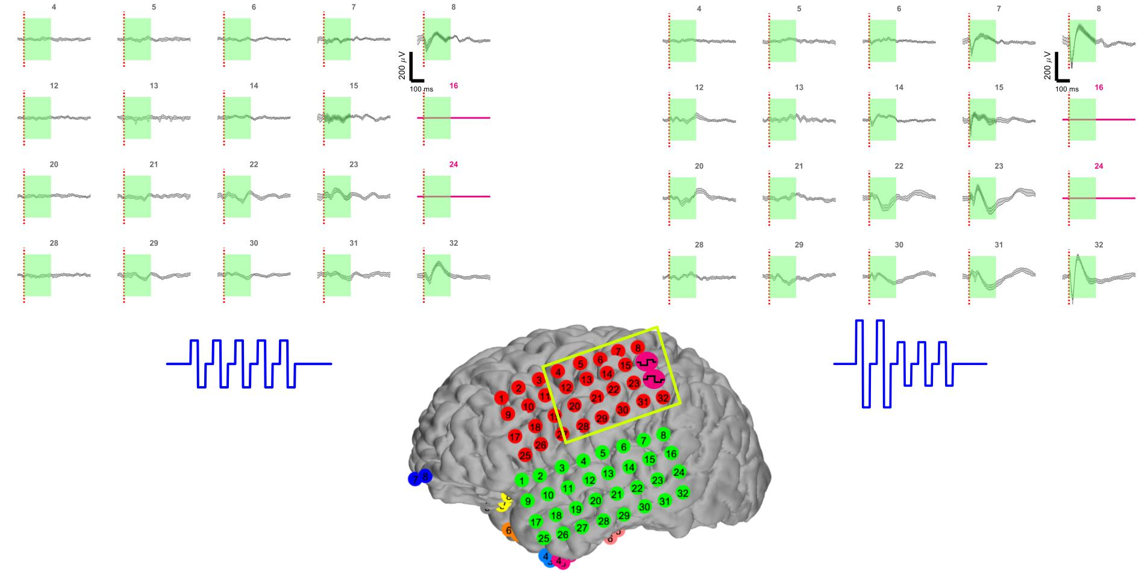

Figure 2.6: Time series di erences between trains with and without leading high pulses following artifact processing. The green window indicates the time during which the stim-ulation artifact has been processed out. Of note is the much larger evoked responses in the highlighted time periods.

18

Chapter 3

AIM 2.3: THE BEHAVIORAL AND NEURAL EFFECTS OF TEMPORALLY SIMULTANEOUS AND SPATIALLY OVERLAPPING HAPTIC STIMULI AND DCS

3.1 Introduction

The results from Aim 2.1 motivate the study of what happens when DCS and haptic feedback are applied concurrently, which will be of critical importance for neuroprosthetics in the real world where natural and arti cial feedback will arrive concurrently. We know from our prior results that there is a signi cant temporal delay in processing and responding to DCS relative to haptic touch, but what are the interference e ects of one modality on the other? Can both be perceived simultaneously, and how do they interact to a ect both behavior and neuronal processing?

One way to assess these interactions is through a temporal order judgement (TOJ) task, where two stimuli are presented in close temporal relation to one another, and subjects are asked to judge which arrived rst [57]. Combinations of stimuli modalities can be presented, such as audio, visual, and tactile stimuli. This task lends insight into the processing of related events, which is critical for interpreting the sensory information arriving from a changing world. How would humans respond to tactile information arriving simultaneously from two overlapping, yet di erent modalities such as DCS and haptic touch?

While the cortical processing of simultaneous events occurs remains largely unexplored, recent clues from fMRI work point to the left ventral, bilateral dorsal premotor cortex, and left posterior parietal cortex for areas of activation speci c to a temporal order judgement task. These areas are known to be part of the motor and perception temporal prediction network [57]. Furthermore, the bilateral premotor cortices, the bilateral middle frontal gyri,

19

the bilateral inferior parietal cortices and supramarginal gyri, and the bilateral posterior part of the superior and middle temporal gyri all were shown to be preferentially activated in a TOJ task compared to a numerosity task, as assessed by fMRI [69]. The authors note that a limitation of this study was the fact that the task involved judging stimulation to two hands, rather than a single spatial location as we will perform in our ECoG patients.

Therefore, inspired to address hypotheses regarding potential masking e ects of tem-porally and spatially overlapping stimuli, and guided by fMRI insight into the locations which are activated during tactile temporal order judgement tasks, we seek to elucidate the behavioral and neural results of stimulating with both haptic and DCS stimuli concurrently.

3.2 Experimental design and analysis methods

We provide haptic stimulation through digital touch probes to the same cutaneous region where sensation was perceived during DCS of S1 hand cortex, as described in the general methods. DCS is applied in close temporal proximity to natural haptic touch with varying time lags (Figure 3.1). We rst run a block of the response timing task (Aim 2.1), and we then calculate the latency of response between haptic and DCS conditions. We then present a distribution of lags (stimulus onset asychrony, SOA) between the DCS and haptic conditions centered around this particular latency with the subject blindfolded. Our rst subject was asked after each trial which stimulus was perceived rst, and also responded via button press to stimulus onset. The rst subject was also given a third option (\same"), for conditions where they were unable to say which came rst. This is called a \ternary-response task", but due to potential subject variability in assessing the threshold for \same", we will focus slowly on TOJ tasks for the subsequent subjects [66]. The second subject was asked to respond via button press, say which came rst, and give a con dence rating (1-5) on how con dent they were in which came rst. We then analyze the response times on each trial based o of the rst stimulus presented (either haptic or DCS).

20

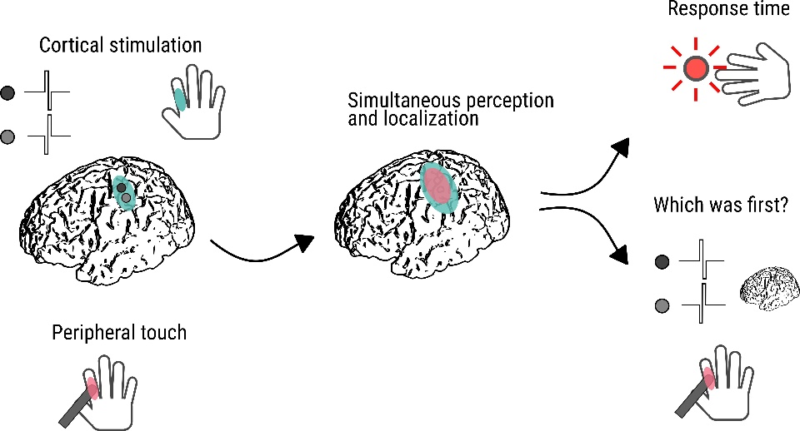

Figure 3.1: Subjects receive DCS and haptic touch to the same location with di ering degrees of lag between the two stimuli. They are asked both to respond via button press, as well as describe which stimulus came rst.

3.3 Existing results

Only in trials where haptic touch trailed DCS by over 200 ms did the rst subject reliably perceive DCS as arriving rst. From haptic touch trailing DCS by 200 ms to approximately both arriving concurrently, there was ambiguity in the subject's perception of which stimulus arrived rst (Fig. 3.2, left). As previously seen, responses to DCS (when perceived rst) were slower than trials when haptic was perceived rst (Fig. 3.2, right). The subject described perception of both sensations as distinct in all conditions, indicating that perception of both stimuli was not masked by simultaneous application.

This suggests there is a range of latencies for which overlapping spatial and temporal DCS and natural stimuli are perceived as arriving simultaneously. This has implications for future brain-computer interfaces, where both cortically-delivered feedback and natural

21

feedback may arrive synchronously. Furthermore, our results demonstrate that spatially and

temporally overlapping natural feedback and DCS can be isolated as distinct sensations.

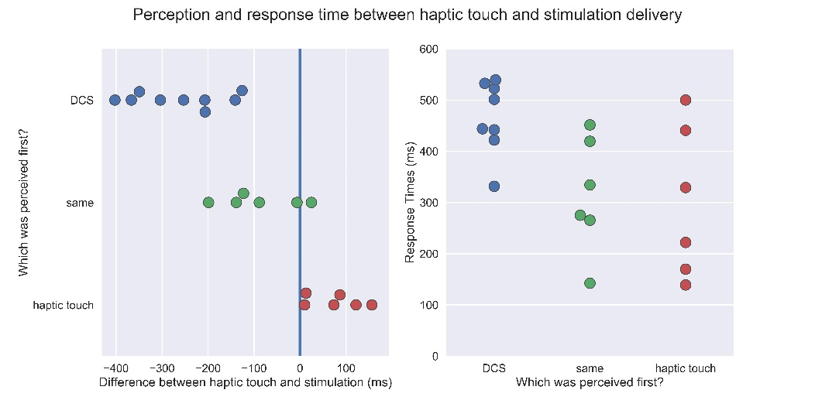

Figure 3.2: With DCS delivered before haptic stimulation with a range of time deliveries from 400 ms to -200 ms, all trials were distinctly perceived as DCS arriving rst. Between -200 ms and 25 ms, with 25 ms representing DCS onset 25 ms after haptic touch onset, the subject reported the stimuli arriving at approximately the same time. With DCS arriving between 75 ms to 150 ms after haptic touch, the subject always reported perceiving haptic touch rst (Left panel). The plot shows a distribution of response times, where following a Kruskal-Wallis test and Nemenyi's multiple comparisons test, the haptic touch condition stochastically dominates the DCS condition, consistent with our previous results that haptic touch results in faster reaction times than DCS (right panel).

3.4 Future analysis and expected results

We will t cumulative distribution gaussian ts to the proportion of trials responded to for

each condition as a function of the SOA. From here, we will calculate the just noticeable

di erence (JND) as half of the temporal interval between the 25% and 75% points on the

curve t, and the point of subjective simultaneity (PSS) as the midpoint of the distribution.

22

The JND provides information about how sensitive the subjects are to asynchrony, while the PSS informs the SOA where trials would be judged with equal probability as either type [57].

We expect to see trials con dently reported as DCS rst where the SOA is bounded by the response time di erence between DCS and haptic touch, and as haptic touch rst with SOAs of 0 and greater.

We will continue analyzing the neural data, as informed by our prior work in Aims 1.2, 2.1, and 2.2. We will assess broadband gamma power, early and late ERP peaks, as well as time frequency plots. We will average our neural data recordings on both DCS onset, haptic onset, and response onset, to see which neural features are most speci c for each condition.

Based o of the reported ability to perceive both modalities independently, we expect to see ERPs and broadband activity representative of the individual stimuli when the analysis is centered on the presentation of each of the stimulus modalities.

From the fMRI literature, we expect to robust broadband gamma activation in the left ventral, bilateral dorsal premotor cortex, and left posterior parietal cortex for areas of activa-tion speci c to a temporal order judgement task. Additional regions to analyze will include the bilateral middle frontal gyri, the bilateral inferior parietal cortices and supramarginal gyri, and the bilateral posterior part of the superior and middle temporal gyri. We expect to observe signi cant changes as assessed in broadband gamma activity in these regions during the temporal order judgement task relative to a simple response timing task.

3.5 Related publications and presentations

Caldwell DJ, \Behavioral and neural di erences between haptic stimulation and direct corti-cal stimulation in humans: implications for neuroprosthetics", 7th International BCI Meet-ing, Workshop: Perception of Sensation Restored through Neural Interfaces, Asilomar, CA, May 2018

23

BIBLIOGRAPHY

1. Rochelle Ackerley and Anne Kavounoudias. The role of tactile a erence in shaping motor behaviour and implications for prosthetic innovation. Neuropsychologia, 79:192{ 205, 2015.
2. Lei Ai and Tony Ro. The phase of prestimulus alpha oscillations a ects tactile percep-tion. Journal of neurophysiology, 111(6):1300{7, 2014.
3. Tarik Al-ani, Fanny Cazettes, Stephane Pal , and Jean Pascal Lefaucheur. Automatic removal of high-amplitude stimulus artefact from neuronal signal recorded in the sub-thalamic nucleus. Journal of Neuroscience Methods, 198(1):135{146, 2011.
4. Kim D Anderson. Targeting Recovery: Priorities of the Spinal Cord-Injured Population. Journal of Neurotrauma, 21(10):1371{1383, oct 2004.
5. P. Avanzini, V. Pelliccia, G. Lo Russo, G. A. Orban, and G. Rizzolatti. Multiple time courses of somatosensory responses in human cortex. NeuroImage, 169(May 2017):212{ 226, 2018.
6. Pietro Avanzini, Rouhollah O. Abdollahi, Ivana Sartori, Fausto Caruana, Veronica Pel-liccia, Giuseppe Casaceli, Roberto Mai, Giorgio Lo Russo, Giacomo Rizzolatti, and Guy A. Orban. Four-dimensional maps of the human somatosensory system. Proceed-ings of the National Academy of Sciences, 113(13):E1936{E1943, 2016.
7. Bruce P. Bean. The action potential in mammalian central neurons. Nature Reviews Neuroscience, 8(6):451{465, 2007.
8. Sliman J Bensmaia. Biological and bionic hands : natural neural coding and arti cial perception. Philosophical Transactions Royal Society, B, 370( gure 1):20140209, 2015.
9. Sliman J Bensmaia and Lee E Miller. Restoring sensorimotor function through in-tracortical interfaces: progress and looming challenges. Nature reviews. Neuroscience, 15(5):313{25, 2014.
10. G Q Bi and M M Poo. Synaptic modi cations in cultured hippocampal neurons: de-pendence on spike timing, synaptic strength, and postsynaptic cell type. The Journal of neuroscience : the o cial journal of the Society for Neuroscience, 18(24):10464{10472, 1998.

24

1. Elaine Biddiss, Dorcas Beaton, and Tom Chau. Consumer design priorities for upper limb prosthetics. Disability and Rehabilitation: Assistive Technology, 2(6):346{357, jan 2007.
2. Tim Blakely, Kai J Miller, Stavros P Zanos, Rajesh P N Rao, and Je rey G Ojemann. Robust, long-term control of an electrocorticographic brain-computer interface with xed parameters. Neurosurgical Focus, 27(1):E13, jul 2009.
3. Nadia Bolognini, Cristina Russo, and Dylan J. Edwards. The sensory side of post-stroke motor rehabilitation. Restorative Neurology and Neuroscience, 34(4):571{586, aug 2016.
4. Svenja Borchers, Marc Himmelbach, Nikos Logothetis, and Hans-Otto Karnath. Direct electrical stimulation of human cortex - the gold standard for mapping brain functions? Nature reviews. Neuroscience, 13(1):63{70, nov 2012.
5. M. R. Borich, S. M. Brodie, W. A. Gray, S. Ionta, and L. A. Boyd. Understanding the role of the primary somatosensory cortex: Opportunities for rehabilitation. Neuropsy-chologia, 79:246{255, 2015.
6. Ed Joseph D Bronzino. Nagel, J. H. \Biopotential Ampli ers.". 2000.
7. Andreas Bruns. Fourier-, Hilbert- and wavelet-based signal analysis: are they really di erent approaches? Journal of neuroscience methods, 137(2):321{32, aug 2004.
8. Cathrin Buete sch, Roman Heger, Wilfried Schicks, Rudiger Seitz, and Johannes Netz. Hebbian-type stimulation during robot-assisted training in patients with stroke. Neu-rorehabilitation and neural repair, 25(7):645{55, 2011.
9. Sergejus Butovas and Cornelius Schwarz. Spatiotemporal e ects of microstimulation in rat neocortex: a parametric study using multielectrode recordings. Journal of neuro-physiology, 90(5):3024{39, 2003.
10. CDC. Stroke Facts, 2015.
11. C Cedzich, M Taniguchi, S Schafer, and J Schramm. Somatosensory evoked potential phase reversal and direct motor cortex stimulation during surgery in and around the central region. Neurosurgery, 38(5):962{970, 1996.
12. Jennifer L Collinger, Michael L Boninger, Tim M Bruns, Kenneth Curley, Wei Wang, and Douglas J Weber. Functional priorities, assistive technology, and brain-computer interfaces after spinal cord injury. Journal of rehabilitation research and development, 50(2):145{60, 2013.

25

1. Kelly L Collins, Arvid Guterstam, Jeneva Cronin, Jared D Olson, H Henrik Ehrsson, and Je rey G Ojemann. Ownership of an arti cial limb induced by electrical brain stimulation. Proceedings of the National Academy of Sciences, 114(1):166{171, jan 2017.
2. Maria C Dadarlat, Joseph E O'Doherty, and Philip N Sabes. A learning-based ap-proach to arti cial sensory feedback leads to optimal integration. Nature Neuroscience, 18(1):138{144, jan 2015.
3. Benoit P. Delhaye, Hannes P. Saal, and Sliman J. Bensmaia. Key considerations in designing a somatosensory neuroprosthesis. Journal of Physiology Paris, pages 1{7, 2016.
4. Yaara Erez, Hadass Tischler, Anan Moran, and Izhar Bar-Gad. Generalized framework for stimulus artifact removal. Journal of Neuroscience Methods, 191(1):45{59, 2010.
5. Martin Ester, Hans-Peter Kriegel, J•org Sander, and Xiaowei Xu. A Density-based Algorithm for Discovering Clusters a Density-based Algorithm for Discovering Clusters in Large Spatial Databases with Noise. In Proceedings of the Second International Conference on Knowledge Discovery and Data Mining, volume 70 of KDD'96, pages 156{7. Elsevier, mar 1996.
6. Christopher & Dana Reeve Foundation. Stats about paralysis, 2013.
7. Phillip M. Gilley, Anu Sharma, Michael Dorman, Charles C. Finley, Arunachalam S. Panch, and Kathryn Martin. Minimization of cochlear implant stimulus artifact in cortical auditory evoked potentials. Clinical Neurophysiology, 117(8):1772{1782, 2006.
8. David J. Guggenmos, Meysam Azin, Scott Barbay, Jonathan D. Mahnken, Caleb Dun-ham, Pedram Mohseni, and Randolph J. Nudo. Restoration of function after brain damage using a neural prosthesis. Proceedings of the National Academy of Sciences, 110(52):21177{21182, dec 2013.
9. Heikki H•am•al•ainen, Jouni Kekoni, Mikko Sams, Kalevi Reinikainen, and Risto N•a•at•anen. Human somatosensory evoked potentials to mechanical pulses and vibra-tion: contributions of SI and SII somatosensory cortices to P50 and P100 components. Electroencephalography and clinical neurophysiology, 75(1):13{21, 1990.
10. Group. Harvey RL. Winstein CJ. Everest Trial. Design for the everest randomized trial of cortical. Neurorehabilitation & Neural Repair, 23(1):32{44, 2009.
11. Takao Hashimoto, Christopher M. Elder, and Jerrold L. Vitek. A template subtraction method for stimulus artifact removal in high-frequency deep brain stimulation. Journal of Neuroscience Methods, 113(2):181{186, 2002.

26

1. D. O. Hebb. The Organization of Behavior; A Neuropsychological Theory. oct 1949.
2. Dora Hermes, Kai J. Miller, Herke Jan Noordmans, Mariska J. Vansteensel, and Nick F. Ramsey. Automated electrocorticographic electrode localization on individually ren-dered brain surfaces. Journal of Neuroscience Methods, 185(2):293{298, 2010.
3. Dora Hermes, Mai Nguyen, and Jonathan Winawer. Neuronal synchrony and the relation between the blood-oxygen-level dependent response and the local eld potential, volume 15. 2017.
4. Jim D Herring, Gregor Thut, Ole Jensen, and Til O Bergmann. Attention Modu-lates TMS-Locked Alpha Oscillations in the Visual Cortex. Journal of Neuroscience, 35(43):14435{14447, oct 2015.
5. Mark H. Histed, Vincent Bonin, and R. Clay Reid. Direct Activation of Sparse, Distributed Populations of Cortical Neurons by Electrical Microstimulation. Neuron, 63(4):508{522, aug 2009.
6. Konstantina Kalogianni, Andreas Da ertshofer, Frans C.T. van der Helm, Alfred C. Schouten, Jan C. de Munck, Gert Kwakkel, Carel G.M. Meskers, Erwin E.H. van Wegen, Aukje S. Andringa, Dirk Hoevenaars, Caroline Winters, Sarah Zandvliet, Teodoro Solis-Escalante, Yuan-Yang, Martijn P. Vlaar, Lena Filatova, Julius P.A. Dewald, and Jun Yao. Disentangling Somatosensory Evoked Potentials of the Fingers: Limitations and Clinical Potential. Brain Topography, 31(3):498{512, 2018.
7. Christian Klaes, Ying Shi, Spencer Kellis, Juri Minxha, Boris Revechkis, and Richard A. Andersen. A cognitive neuroprosthetic that uses cortical stimulation for somatosensory feedback. Journal of Neural Engineering, 11(5):056024, oct 2014.
8. ADominic Kraus, Georgios Naros, Robert Bauer, Fatemeh Khademi, Maria Teresa Le~ao, U Ziemann, and Alireza Gharabaghi. Brain state-dependent transcranial magnetic closed-loop stimulation controlled by sensorimotor desynchronication induces robust increase of corticospinal excitability. Brain Stimulation, 2016.
9. Pawel Kudela and William S. Anderson. Computational Modeling of Subdural Cortical Stimulation: A Quantitative Spatiotemporal Analysis of Action Potential Initiation in a High-Density Multicompartment Model. Neuromodulation: Technology at the Neural Interface, 18(7):552{565, oct 2015.
10. Donald Lloyd-Jones, Robert J. Adams, Todd M. Brown, Mercedes Carnethon, Shi-fan Dai, Giovanni De Simone, T. Bruce Ferguson, Earl Ford, Karen Furie, Cathleen

27

Gillespie, Alan Go, Kurt Greenlund, Nancy Haase, Susan Hailpern, P. Michael Ho, Vir-ginia Howard, Brett Kissela, Steven Kittner, Daniel Lackland, Lynda Lisabeth, Ariane Marelli, Mary M. McDermott, James Meigs, Dariush Moza arian, Michael Mussolino, Graham Nichol, Veronique L. Roger, Wayne Rosamond, Ralph Sacco, Paul Sorlie, Ran-dall Sta ord, Thomas Thom, Sylvia Wasserthiel-Smoller, Nathan D. Wong, and Judith Wylie-Rosett. Heart Disease and Stroke Statistics{2010 Update: A Report From the American Heart Association. Circulation, 121(7):e46{e215, feb 2010.

1. Nikos K Logothetis, Mark Augath, Yusuke Murayama, Alexander Rauch, Fahad Sultan, Jozien Goense, Axel Oeltermann, and Hellmut Merkle. The e ects of electrical micros-timulation on cortical signal propagation. Nature neuroscience, 13(10):1283{1291, 2010.
2. Yiliang Lu, Pengjia Cao, Jingjing Sun, Jing Wang, Liming Li, Qiushi Ren, Yao Chen, and Xinyu Chai. Using independent component analysis to remove artifacts in visual cortex responses elicited by electrical stimulation of the optic nerve. Journal of Neural Engineering, 9(2), 2012.
3. Eric Maris. Statistical testing in electrophysiological studies. Psychophysiology, 49(4):549{565, 2012.
4. Eric Maris, Jan Mathijs Scho elen, and Pascal Fries. Nonparametric statistical testing of coherence di erences. Journal of Neuroscience Methods, 163(1):161{175, 2007.
5. Riki Matsumoto, Dileep R Nair, Eric LaPresto, Imad Najm, William Bingaman, Hiroshi Shibasaki, and Hans O L•uders. Functional connectivity in the human language system: a cortico-cortical evoked potential study. Brain : a journal of neurology, 127(Pt 10):2316{ 30, oct 2004.
6. Cameron C. McIntyre and Warren M. Grill. Selective Microstimulation of Central Ner-vous System Neurons. Annals of Biomedical Engineering, 28(3):219{233, 2000.
7. K. J. Meador, P. G. Ray, J. R. Echauz, D. W. Loring, and G. J. Vachtsevanos. Gamma coherence and conscious perception. Neurology, 59(6):847{854, 2002.
8. Gonzalo E Mena, Lauren E Grosberg, Sasidhar Madugula, Pawel Hottowy, Alan Litke, John Cunningham, E J Chichilnisky, and Liam Paninski. Electrical stimulus artifact cancellation and neural spike detection on large multi-electrode arrays. PLOS Compu-tational Biology, 13(11):e1005842, nov 2017.
9. Daniel R. Merrill, Marom Bikson, and John G.R. Je erys. Electrical stimulation of ex-citable tissue: design of e cacious and safe protocols. Journal of Neuroscience Methods, 141(2):171{198, 2005.

28

1. D. C. Millard, C. J. Whitmire, C. A. Gollnick, C. J. Rozell, and G. B. Stanley. Electri-cal and Optical Activation of Mesoscale Neural Circuits with Implications for Coding. Journal of Neuroscience, 35(47):15702{15715, 2015.
2. Kai J Miller, Gerwin Schalk, Dora Hermes, Je rey G Ojemann, and Rajesh P N Rao. Spontaneous Decoding of the Timing and Content of Human Object Perception from Cortical Surface Recordings Reveals Complementary Information in the Event-Related Potential and Broadband Spectral Change. PLoS computational biology, 12(1):e1004660, jan 2016.
3. Kai J. Miller, Larry B. Sorensen, Je rey G. Ojemann, and Marcel Den Nijs. Power-law scaling in the brain surface electric potential. PLoS Computational Biology, 5(12):1{13, dec 2009.
4. Kai J Miller, Stavros Zanos, Eberhard E Fetz, Marcel Den Nijs, Je rey G Ojemann, Marcel den Nijs, and Je rey G Ojemann. Decoupling the cortical power spectrum reveals real-time representation of individual nger movements in humans. The Journal of Neuroscience, 29(10):3132{7, mar 2009.
5. Makoto Miyazaki, Hiroshi Kadota, Kozue S. Matsuzaki, Shigeki Takeuchi, Hirofumi Sekiguchi, Takuo Aoyama, and Takanori Kochiyama. Dissociating the neural corre-lates of tactile temporal order and simultaneity judgements. Scienti c Reports, 6(July 2015):1{10, 2016.
6. B. E. Mouthaan, M. A. Van't Klooster, D. Keizer, G. J. Hebbink, F. S S Leijten, C. H. Ferrier, M. J A M Van Putten, M. Zijlmans, and G. J M Huiskamp. Single Pulse Electrical Stimulation to identify epileptogenic cortex: Clinical information obtained from early evoked responses. Clinical Neurophysiology, 127(2):1088{1098, 2016.
7. Leah Muller, John D. Rolston, Neal P. Fox, Robert Knowlton, Vikram R. Rao, and Edward F. Chang. Direct electrical stimulation of human cortex evokes high gamma ac-tivity that predicts conscious somatosensory perception. Journal of Neural Engineering, In Press:1{21, 2017.
8. Lionel G. Nowak and Jean Bullier. Axons, but not cell bodies, are activated by elec-trical stimulation in cortical gray matter. I. Evidence from chronaxie measurements. Experimental Brain Research, 118(4):477{488, 1998.
9. Daniel J. O'Shea and Krishna V. Shenoy. ERAASR: An algorithm for removing electrical stimulation artifacts from multielectrode array recordings. bioRxiv, pages 1{27, 2017.

29

1. Tobias Pistohl, Deepak Joshi, Gowrishankar Ganesh, Andrew Jackson, and Kianoush Nazarpour. Arti cial Proprioceptive Feedback for Myoelectric Control. IEEE Transac-tions on Neural Systems and Rehabilitation Engineering, 23(3):498{507, may 2015.
2. Gerwin Schalk. A general framework for dynamic cortical function: the function-through-biased-oscillations (FBO) hypothesis. Frontiers in Human Neuroscience, 9(June):1{10, 2015.
3. Matthew Schiefer, Daniel Tan, Steven M Sidek, and Dustin J Tyler. Sensory feedback by peripheral nerve stimulation improves task performance in individuals with upper limb loss using a myoelectric prosthesis. J Neural Eng, 13(1):016001, 2016.
4. Hyeon Seo, Donghyeon Kim, and Sung Chan Jun. Computational study of subdural cor-tical stimulation: E ects of simulating anisotropic conductivity on activation of cortical neurons. PLoS ONE, 10(6):9{11, 2015.
5. Charles Spence and Cesare Parise. Prior-entry: A review. Consciousness and Cognition, 19(1):364{379, 2010.
6. A. J. Suminski, D. C. Tkach, A. H. Fagg, and N. G. Hatsopoulos. Incorporating Feedback from Multiple Sensory Modalities Enhances Brain-Machine Interface Control. Journal of Neuroscience, 30(50):16777{16787, dec 2010.
7. G. A. Tabot, J. F. Dammann, Joshua A Berg, Francesco V Tenore, J. L. Boback, R Jacob Vogelstein, and Sliman J Bensmaia. Restoring the sense of touch with a prosthetic hand through a brain interface. Proceedings of the National Academy of Sciences, 110(45):18279{18284, nov 2013.
8. Toshimitsu Takahashi, Kenji Kansaku, Makoto Wada, Satoshi Shibuya, and Shigeru Kitazawa. Neural correlates of tactile temporal-order judgment in humans: An fMRI study. Cerebral Cortex, 23(8):1952{1964, 2013.
9. Yee Whye Teh. Dirichlet Process. Encyclopedia of Machine Learning, pages 280{287, 2010.
10. Yee Whye Teh, Michael I. Jordan, Matthew J. Beal, and David M. Blei. Hierarchical Dirichlet processes. Journal of the American Statistical Association, 101(476):1566{ 1581, 2006.
11. E J Tehovnik, A S Tolias, F Sultan, W M Slocum, and N K Logothetis. Direct and indirect activation of cortical neurons by electrical microstimulation. Journal of neuro-physiology, 96(2):512{21, 2006.

30

1. Lena Trebaul, David Rudrauf, Anne Sophie Job, Mihai Dragos Mal^ia, Irina Popa, An-drei Barborica, Lorella Minotti, Ioana M^ndruta, Philippe Kahane, and Olivier David. Stimulation artifact correction method for estimation of early cortico-cortical evoked potentials. Journal of Neuroscience Methods, 264:94{102, 2016.
2. M van Quyen, J Foucher, J P Lachaux, E Rodriguez, A Lutz, J Martinerie, and F J Varela. Comparison of Hilbert transform and wavelet methods for the analysis of neu-ronal synchrony. Journal of neuroscience methods, 11:83{98, 2001.
3. Marion Vincent, Olivier Rossel, Mitsuhiro Hayashibe, Guillaume Herbet, Hugues Duf-fau, David Guiraud, and Francois Bonnetblanc. The di erence between electrical micros-timulation and direct electrical stimulation - Towards new opportunities for innovative functional brain mapping? Reviews in the Neurosciences, 27(3):231{258, 2016.
4. Bradley Voytek, Mark D Esposito, Nathan Crone, and Robert T Knight. A method for event-related phase / amplitude coupling. NeuroImage, 64:416{424, 2013.
5. Daniel A. Wagenaar and Steve M. Potter. Real-time multi-channel stimulus artifact suppression by local curve tting. Journal of Neuroscience Methods, 120(2):113{120, 2002.
6. Remy Wahnoun, Michelle Benson, Stephen Helms-Tillery, and P. David Adelson. De-lineation of somatosensory nger areas using vibrotactile stimulation, an ECoG study. Brain and Behavior, 5(10):1{10, 2015.
7. Jeremiah D. Wander, Devapratim Sarma, Lise a. Johnson, Eberhard E. Fetz, Rajesh P. N. Rao, Je rey G. Ojemann, and Felix Darvas. Cortico-Cortical Interactions dur-ing Acquisition and Use of a Neuroprosthetic Skill. PLOS Computational Biology, 12(8):e1004931, aug 2016.
8. Andy Zhou, Benjamin C Johnson, and Rikky Muller. Toward true closed-loop neuro-modulation: artifact-free recording during stimulation. Current Opinion in Neurobiol-ogy, 50:119{127, 2018.