Part A: The Council/Board of Governors:

SN. | Member/ Director | Details
 | 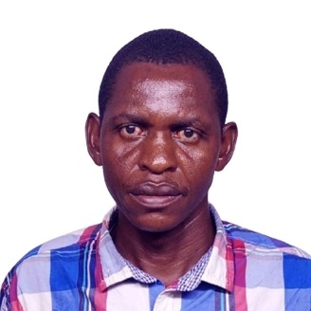  Mr.  Emmanuel Masha  Chairman of the Board | Mr. Emmanuel Masha was appointed as Chairman of GTTI Board on 9th July 2025. He is currently Pursuing PHD at Jomo Kenyatta University of Agriculture & Technology. He has a Masters in HRM from Jomo Kenyatta University of Agriculture & Technology, Higher Diploma from Institute Of Human Resources Nairobi, Diploma in Business Management from College of Professional Management UK and Bachelor of Arts from Kenyatta University Nairobi. To date he has over 12 years of working experience and was born in 1989.
 |   Patrick king’oina  Member | Mr. Patrick king’oina joined the board for the first time on 9th July 2025. He holds a master's degree in Infrastructure planning from the University of Stuttgart (Germany), post graduate diploma in housing Studies from the institute of housing studies, Rotterdam, Netherlands, and Bachelor of Architecture Degree from the University of Nairobi. To date he has 40 years of working experience and was born in 1961.
 | Moses Kesis  Member | Mr. MOSES KESIS joined the board on 9th July 2025. He is an effective team worker with administrative and supervisory experience, a diligent, creative and enthusiastic professional who is looking forward to a more challenging role. He has a MSc in Information System from Nairobi University coupled with ISO 9001:2015 QMS Lead Auditor. To date he has 15 years of working experience and was born in 1979.
 |   Esther njoki gacheru  member | Mrs. Esther Njoki Gacheru joined the board on 9th July 2025. A highly personable, competent, and team spirited professional with over 20 years of experience in Lecturing, and Administration. She holds a Master’s Degree in Computer Science from American University in London, Bachelor’s degree in computer Science from Islamic University - Uganda. She was born in 1979.
 | Caroline Chilango  member | Caroline Chilango joined the board on 9th July 2025. She holds a PhD in Business Administration (Strategic Management) from JKUAT, Master’s degree in Business Administration from JKUAT and Bachelor of Business Administration degree from Kenya Methodist University (Marketing Option)  To date she has 15 years of working experience and was born in 1985.
 | Juliet Mapenzi Rua  member | Mrs. Juliet Mapenzi Rua  joined the board on 9th July 2025. She is a horticulturalist who aspires to attain expertise in sustainable agriculture, product development; science and technology management, promotion of technology development and transfer, and to manage agriculture and scientific projects. She is currently a PhD Candidate at Kenyatta University, Has a MSc and BSc in Agriculture & Rural Development from Kenya Methodist University. Born in 1990 she has more than 15 years of working Experience
 | 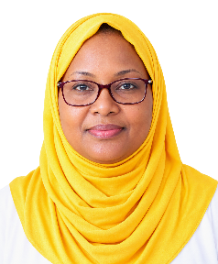  Mwalawari Sheti  member | Mr. Mwalawari Sheti joined the board on 9th July 2025. Currently MSc Candidate in Applied Statistics at Technical University of Mombasa. He has a BSc in Statistics and Programming from Kenyatta University. Born in 1988 with 7 years of working Experience in Programming, Data Management and Analysis in Stata and R; data entry, cleaning, preliminary analysis, and Presentation in R using the R-Studio Integrated Development Environment (IDE).
 | 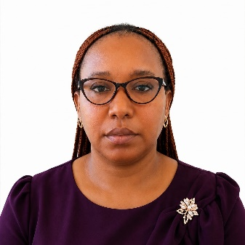  Edith Kwekwe Marafa  member | Edith Kwekwe Marafa  joined the board on 9th July 2025. She holds a PhD in Business Administration (Strategic Management) from JKUAT, Master’s degree in Business Administration from JKUAT and Bachelor of Business Administration degree from Kenya Methodist University (Marketing Option)  To date she has 12 years of working experience and was born in 1988.

Part B: Management Profile
SN. | Member/ Director | Details
 | 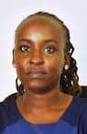  MS CAROLINE  Principal  Ms Caroline has served as Deputy Principal Godoma Technical Training Institute since February 2025. She holds a masters in educational technology and served as an assessment officer/research officer at TVET CDACC. She also served as HOD Mechanical Engineering at Coast Institute of Technology.  To date she has 11 years of working experience and was born in 1991. | Deputy Principal Academics Affairs Responsibilities:  - Teaching the subject of specialization.  - Ensuring that students are adequately prepared registered and presented for the National Examinations in accordance to the Kenya National Examination Council Regulations and other examining bodies.  - Identifying the appropriate curriculum for the institution.  - Ensuring that examinations and assessments are carried out and that proper scheduling of training programmes are implemented.  - Supervision of all training programmes in the institution.  Supervising trainers and other institutional employees.
 | 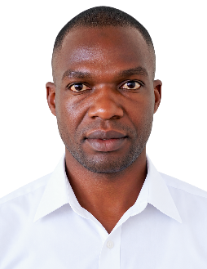  Mr. Erick Mutai  Ag. Registrar  Mr. Erick Mutai has served as Head of Department ICT of Godoma Technical Training Institute since May 2017. Currently she is the Ag. Registrar. She holds a Bachelor of Education (Technology Education – Computer Studies) from University of Eldoret. To date she has 8 years of working experience and was born in 1991. | Registrar Duties & Responsibilities:  - Teaching the subject of specialization.  - Maintenance of students’ academic records.  - Coordination of promotion of all academic programmes.  - Coordination of verification of graduation data.  - Coordination of certification of graduating students.  - Preparation and monitoring of departmental annual budget.  - Supervision and guidance of BOG staff.  - Overall supervision and guidance of departmental staff.  - Secretary to the heads of departments’ committee meetings.  Performing any other relevant duty assigned by the Head of the Institution

