RMIT International University Vietnam

COVER PAGE

BP138 Bachelor of Business Information System Program

|  |  |
| --- | --- |
| Course Code: | ISYS-2119 |
| Course Name: | Mobility Solution |
| Location where you study: | Ho Chi Minh |
| Title of Assignment: | Assignment 1- Part 1- Task 4.4 |
| File(s) submitted: | s3373169-Tran Hoang Son- Assignment 1 - Part 1 |
| Student names: | Tran Hoang Son |
| Student e-mail address: | s3373169@rmit.edu.vn |
| Learning Facilitator in charge: | Mr. ASHISH DAS |
| Assignment due date: | Friday, 25 Nov 2016 |
| Date of submission: | Friday, 25 Nov 2016 |
| Number of pages including this one: | 153 |
| Word Count: |  |

1. **Home Page**

This is prototype of shop 24h’s home page for many types of devices

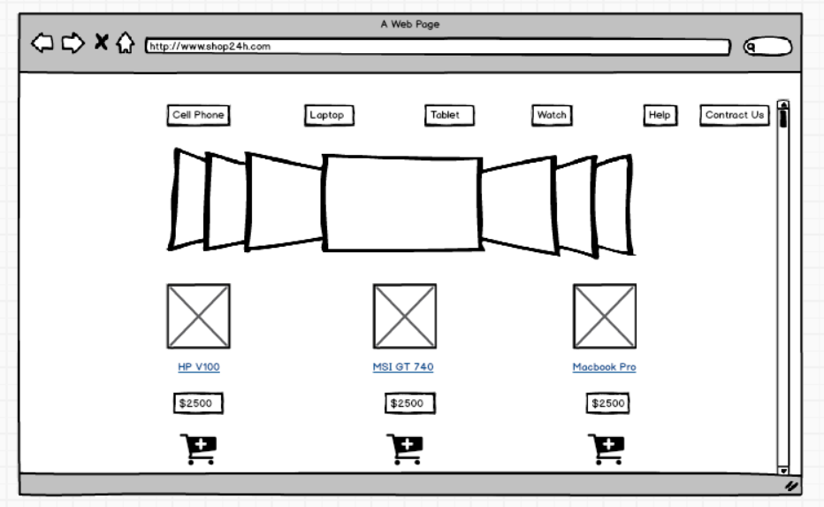

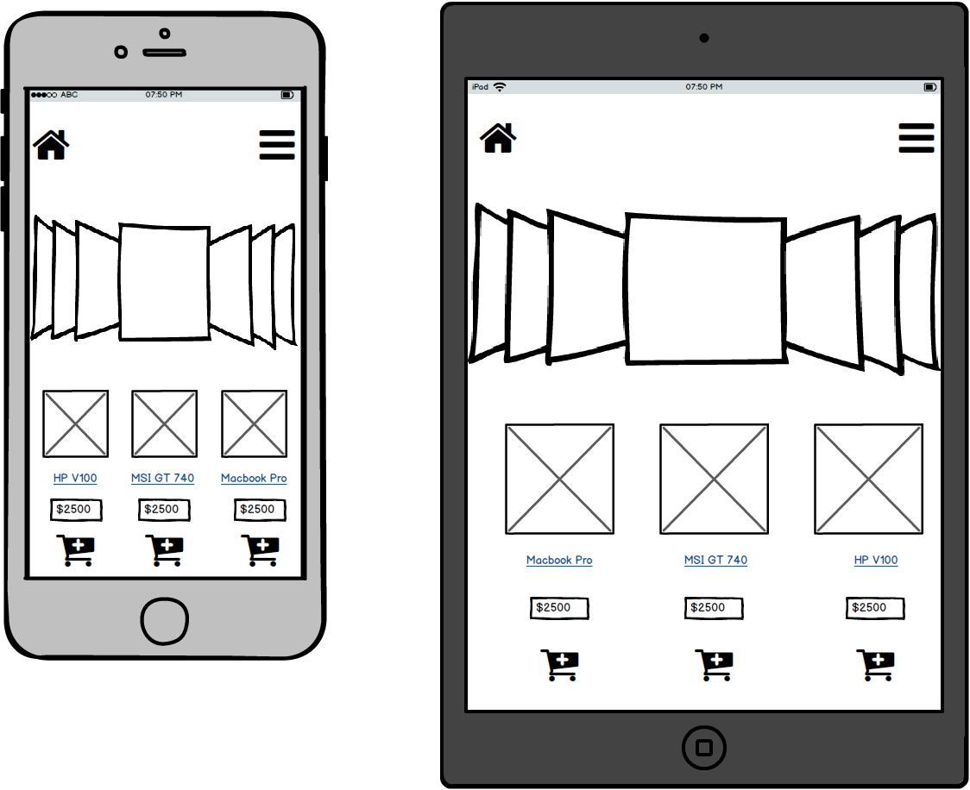

1. **Category Details**

This is the prototype for shop24h’s Category Details for many types of devices

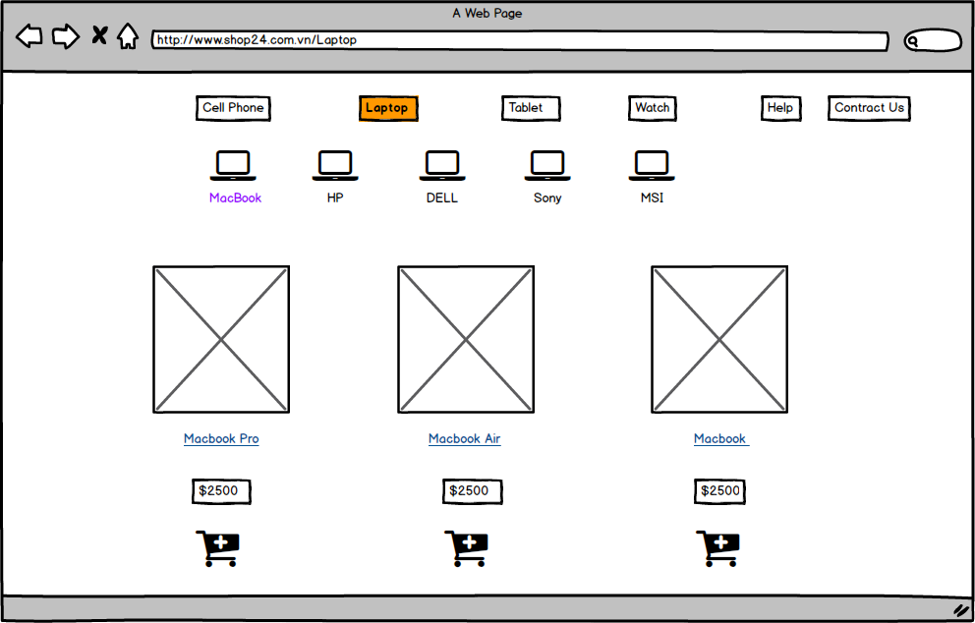

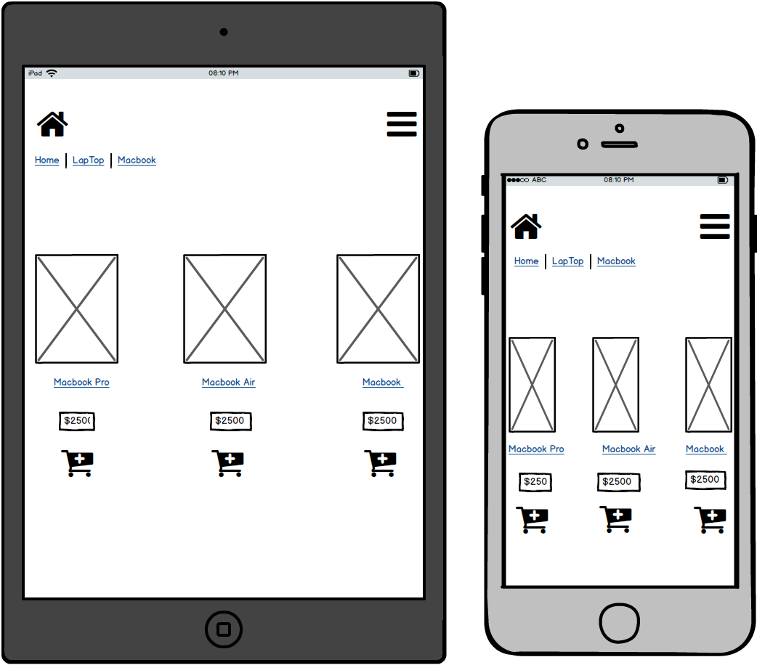

1. **Product Details**

When the user clicks on product name or shopping cart icon, they can see the product details page. The Product Details page will show the brief information about product, quantity and shopping cart icon.

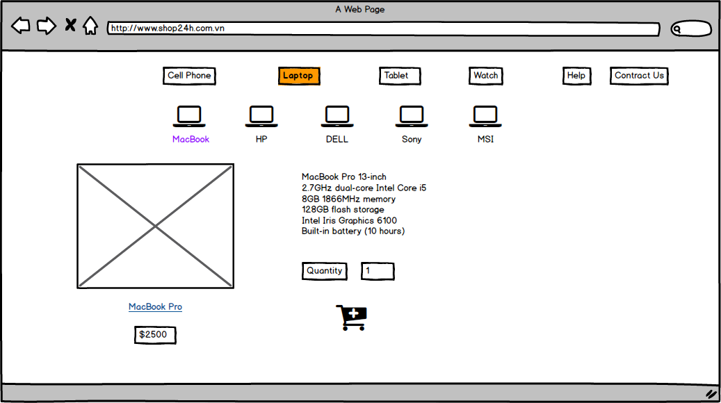

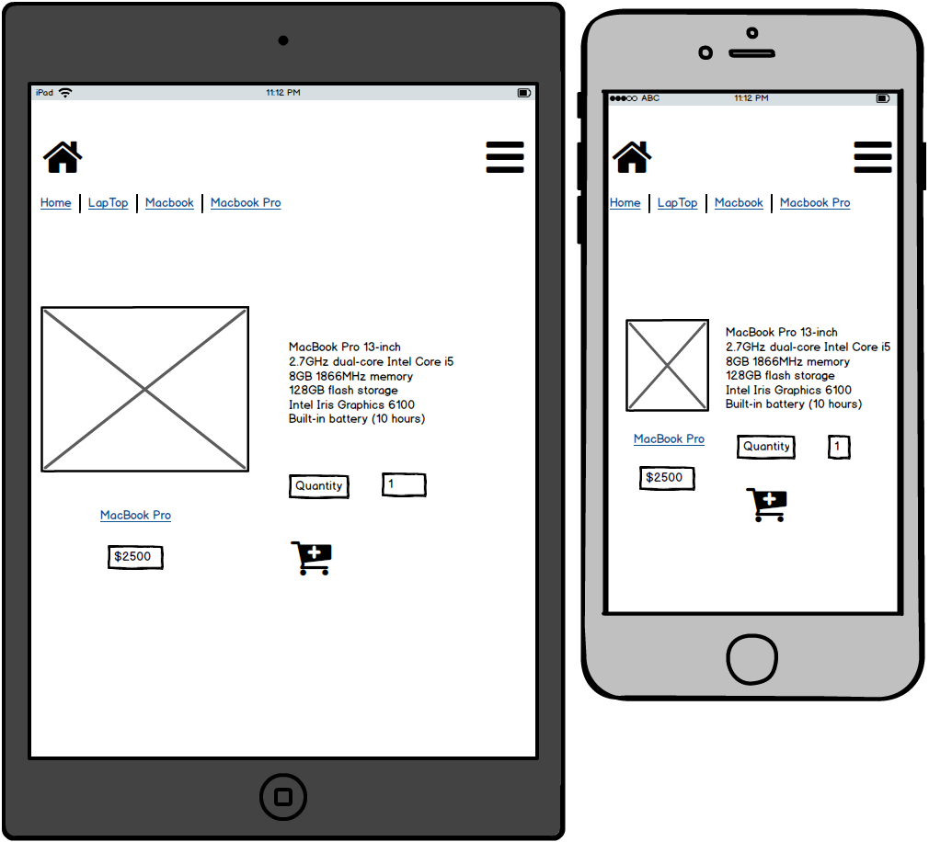

1. **Shopping Cart**

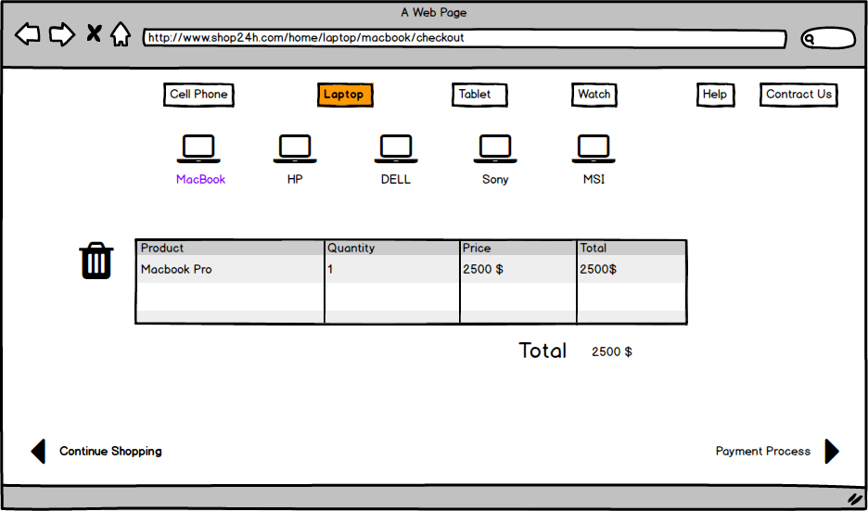

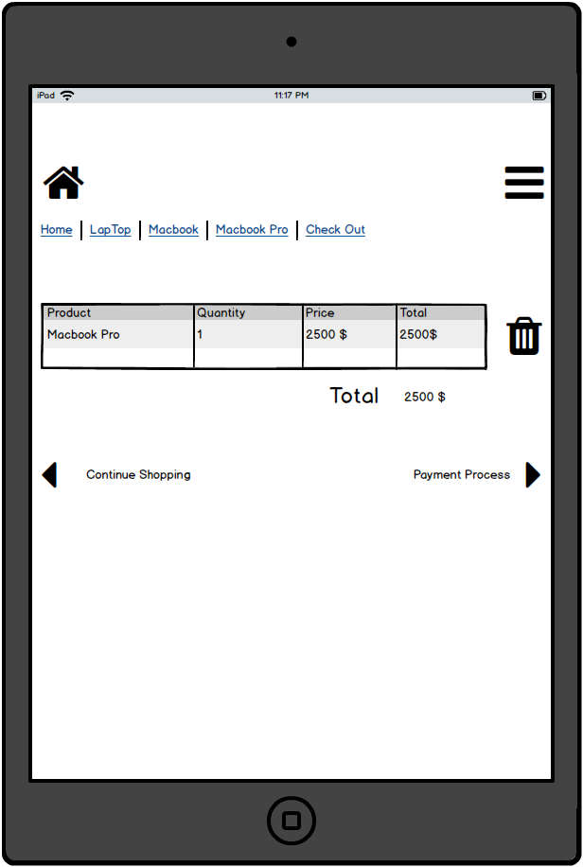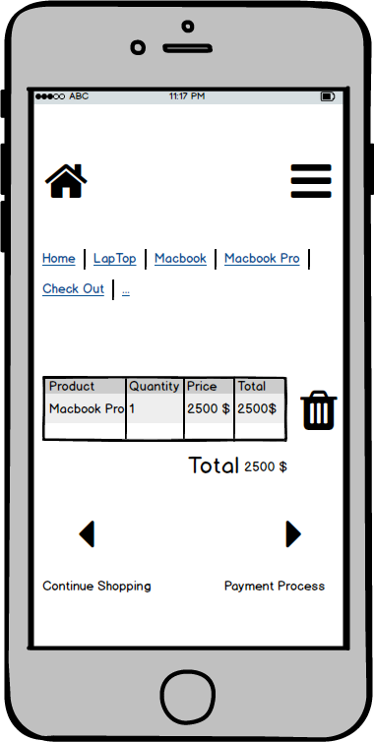

1. **Check out**

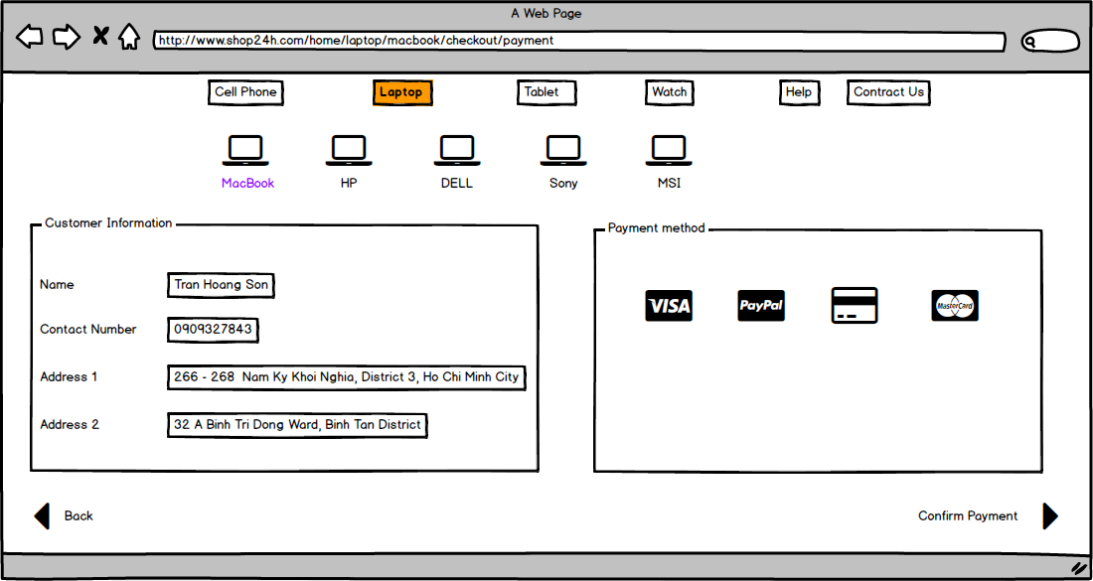

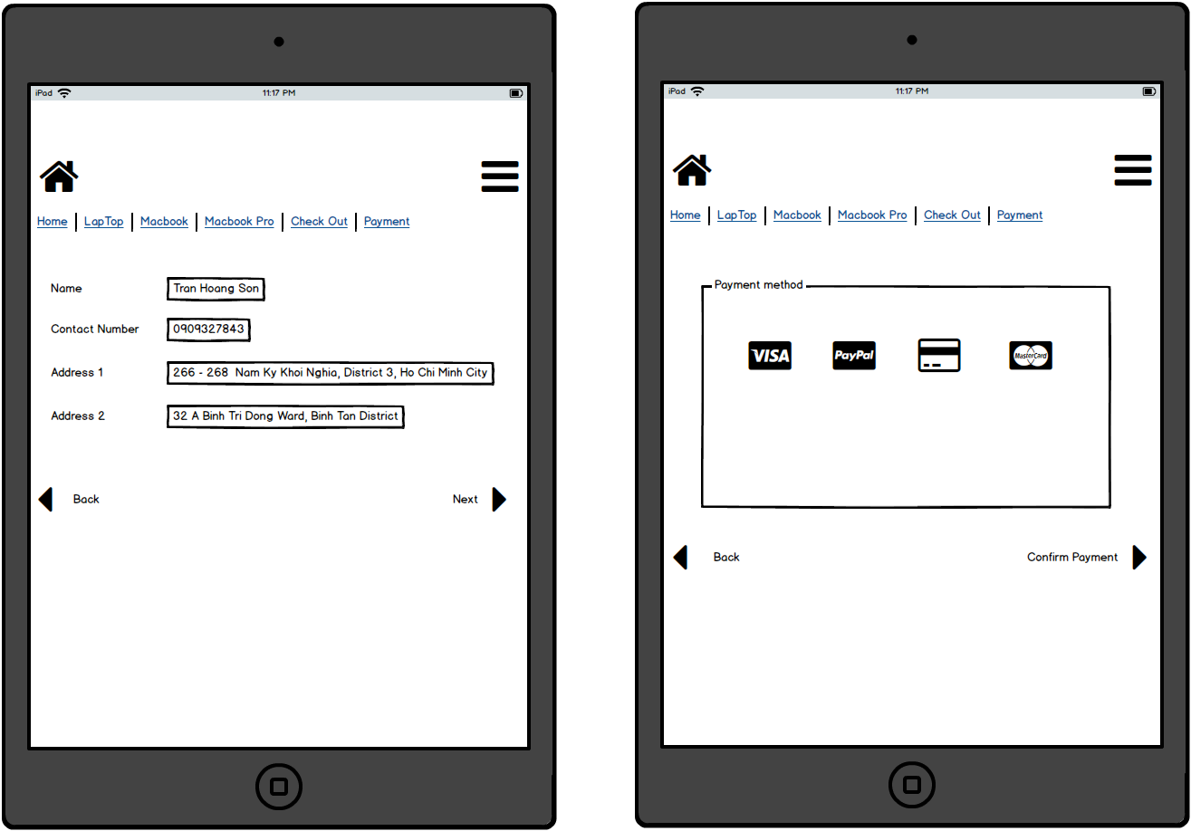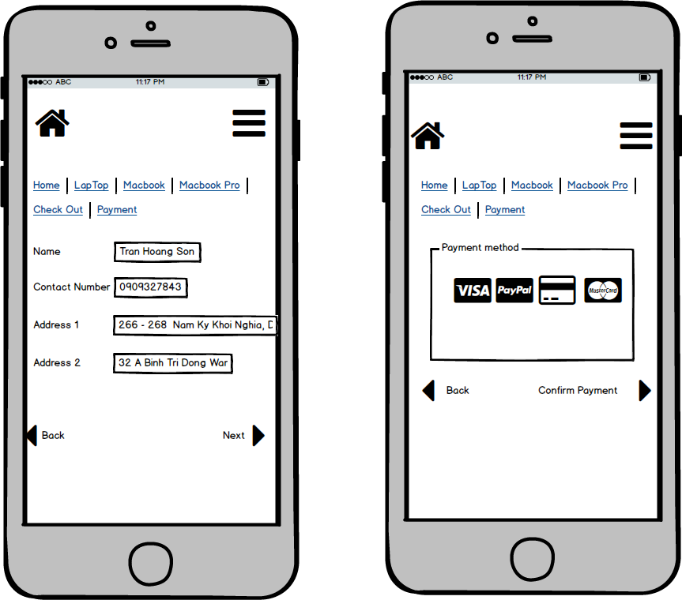

1. **Confirmation Page**

