A Model for the Distribution of SAT Total Scores

Abstract
The College Board’s SAT is the most widely used standardized test for college and university admissions in the United States, with approximately two million test-takers in each graduating class. The College Board does not release anonymized individual-level scores, so a question like “what share of students scoring at least 1500 are Black?” cannot be answered directly from the published data. The College Board’s SAT Suite of Assessments Annual Report does include, for seven racial/ethnic groups across high school graduating classes from 2018 through 2025, the percentage of test-takers in each of six wide score bands. An eighth category (“No response”) is derived by subtraction from the published cohort band counts. We fit a Bayesian hierarchical model to the score band percentages using per-group censored sinh-arcsinh curves (the seven named groups under a shared log-linear scale-trend hierarchy; the No response group with a free per-year scale). We validate the fit by holding out five published cohort numbers per year (the mean, standard deviation, and three quartile scores) and an independent fine-grained percentile reference table, none of which is used during model fitting, and then checking that the fitted distribution approximates them. For the graduating class of 2025, we estimate that approximately 1.0% of SAT-takers scoring 1500 or higher are Black (95% credible interval 0.5%–1.7%).

Introduction
The College Board’s SAT (College Board, 2024; Lemann, 1999) is the most widely used standardized test for college and university admissions in the United States, with approximately two million test-takers in each graduating class. Total scores correlate around 0.8 with omnibus measures of general cognitive ability on the pre-2005 SAT (Frey & Detterman, 2004) and predict post-secondary academic performance (Kobrin & Patterson, 2011; Kuncel & Hezlett, 2010; Sackett et al., 2009). Selective colleges and merit-scholarship programs impose explicit or de facto thresholds on it.
The College Board does not release anonymized individual-level scores. However, it does publish, for seven racial/ethnic groups, the percentage of that group’s test-takers in each of six wide total-score bands. A question like what share of students scoring at least 1500 in a given graduating class are Black?, exactly the kind of compositional question that selective-admissions and scholarship policy depend on, cannot be answered directly from those bands. The 1500 threshold falls inside the top band (1400–1600). Mean group differences on the SAT and on cognitive-ability assessments more broadly have been documented for decades (Hauser, 2002; Reardon, 2011; Reardon et al., 2019; Roth et al., 2001), but the shape of each group’s upper tail, which determines who clusters above any selective cutoff, is not visible from the published summaries alone.
The curves estimated here describe SAT test-takers, not the broader U.S. 18-year-old population. The test-taker cohort is the policy-relevant population for admissions and scholarship decisions that condition on an SAT score. Mapping these quantities back to the broader cohort would require a separate model of test participation which we do not attempt here.
The College Board’s annual SAT Suite of Assessments Annual Report (College Board, 2018–2025) gives, for each graduating class from 2018 through 2025, the number of test-takers and the mean total score on the 400–1600 scale for each of eight racial/ethnic categories (the seven named in the report, plus a “No response” residual we treat as an eighth), and the percentage (integer-rounded) of the group’s test-takers in each of six wide score bands for the seven named groups only (the No response band counts are derived by subtraction from the published cohort band totals). The published cohort SD, quartiles, and fine-grained percentile reference table (College Board, 2025) are held out as external checks.
We model the latent total score for each (group, year) as a censored sinh-arcsinh (“SHASH”) random variable, with the eight per-group curves fit jointly via Bayesian hierarchical Hamiltonian Monte Carlo and a Dirichlet likelihood on the band percentages whose dispersion is decoupled from group size. Methods gives the full specification.
The fit is validated against the cohort quartiles (a test of the model’s calibration at three interior points; the model is never shown these quartiles) and an independent fine-grained percentile reference table (College Board, 2025). Against the percentile reference, properly read against the integer rounding of the published table, the model is consistent with the published values throughout the body of the distribution and through the headline threshold $t=1500$, with a mild residual at $t=1550$ (see Validation).
For the graduating class of 2025, approximately 1.7% of SAT-takers scoring 1400 or higher are Black, a share that involves no model interpolation, since 1400 is a reported band boundary, and follows directly from the College Board’s published numbers. The corresponding share at 1500 cannot be read off the published numbers because 1500 sits inside the top reported band. The Black share of the 1500 or higher pool is estimated at approximately 1.0%, with a 95% credible interval running from 0.5% to 1.7%. The 1500 figure involves interpolation within the top reported band, and the implied cohort share at $t=1500$, for the pooled 2023–2025 cohort, is consistent with the integer-rounded value in the College Board’s SAT User Percentile reference table for that same pooled window. The model estimates an Asian-to-Black ratio of about 43:1 among test-takers scoring 1500 or higher (95% credible interval 25:1 to 79:1).

Data
The data are drawn from the SAT Suite of Assessments Annual Report (College Board, 2018–2025) for the graduating classes of 2018 through 2025. Each report tabulates, by race/ethnicity, the number of test-takers, the mean total score (on the 400–1600 scale), and the percentage of test-takers whose total score falls in each of six bands: 400–590, 600–790, 800–990, 1000–1190, 1200–1390, and 1400–1600. The reports identify seven racial/ethnic categories (White, Black/African American, Hispanic/Latino, Asian, Two or More Races, American Indian/Alaska Native, and Native Hawaiian/Other Pacific Islander) and also report totals for the full cohort, which is larger than the sum of the seven because some test-takers decline to report a category.
Table 1 reproduces the seven per-group rows the report prints for the graduating class of 2025, with the numbers shown exactly as printed (group order in the table does not follow the report’s print order). Three features of that raw table matter for what follows. First, the band percentages are rounded to integers. Second, one of those rounded values is zero (Asian in 400–590), meaning the true value is in $[0,0.5)$ rather than that no test-taker in that group scored in that band. Third, because of integer rounding the six bands of a given group need not sum to exactly 100. The report also publishes test-takers and mean total score for an eighth row, “No response”, which contains test-takers who did not disclose a race or ethnicity, but the report does not print band percentages for that row.
Table 1: Per-Group Inputs from the 2025 SAT Suite Annual Report. Test-takers ($N$), mean total score, and the percentage of each group’s test-takers in each of six total-score bands, as printed by the College Board. Band percentages are integers as printed and may not sum to 100 because of rounding.
Group | N | Mean | 400–590 | 600–790 | 800–990 | 1000–1190 | 1200–1390 | 1400–1600
White | 743,981 | 1077 | 1 | 7 | 27 | 35 | 23 | 7
Hispanic/Latino | 537,624 | 928 | 4 | 22 | 39 | 24 | 9 | 2
Black | 250,887 | 904 | 5 | 26 | 40 | 21 | 7 | 1
Asian | 217,459 | 1229 | 0 | 3 | 13 | 25 | 33 | 26
Two or more | 82,032 | 1073 | 1 | 9 | 28 | 30 | 21 | 9
Am. Indian | 9,237 | 874 | 6 | 31 | 40 | 18 | 6 | 1
Pacific Isl. | 3,053 | 922 | 4 | 24 | 38 | 23 | 9 | 1

The model does not fit Table 1. The printed integer percentages are an integer-rounded representation of a vector of true band proportions that is not observed. The fit therefore draws $M$ datasets from the rounding-induced posterior over plausible per-(group, year) band-proportion vectors, fits the SHASH+Dirichlet model to each, and pools the $M$ sets of posterior draws (multiple imputation; see A Dirichlet Likelihood on Band Proportions). Each imputation proceeds in two steps. First, for each named-group row, we draw a six-cell proportion vector uniformly from the rounding-box-intersected simplex: the set of $(π_{1},…,π_{6})$ satisfying $π_{b}∈[(k_{b}−0.5)/100, (k_{b}+0.5)/100)$ for each band $b$ (with the lower edge clamped at $0$ when $k_{b}=0$) and b​πb=1. Operationally, we sample five cells independently from their intervals, set the sixth to $1−∑$, and accept only if the sixth lies in its own rounding interval; the accepted draws are within their rounding intervals by construction and sum to one without any renormalization step. Second, we derive the No response band counts by subtraction from the exact published cohort band counts. The College Board publishes the cohort Total row’s band counts as integers (not as rounded percentages), so the cohort row carries no rounding error of its own, and the imputation’s No response count in each band is the cohort count minus the sum of the seven named-group counts implied by their sampled percentages.
Because the procedure samples afresh on every imputation, there is no single cleaned table the model fits. The pooled posterior across $M=50$ imputations reflects band-rounding uncertainty in addition to whatever uncertainty the Dirichlet likelihood already captures.
Two further College Board sources are held out for validation only and are described below where they are used (see Validation): the published cohort summaries (mean, SD, and three quartiles per year) and the SAT User Percentile reference table (College Board, 2025), constructed from individual scores in ten-point steps.
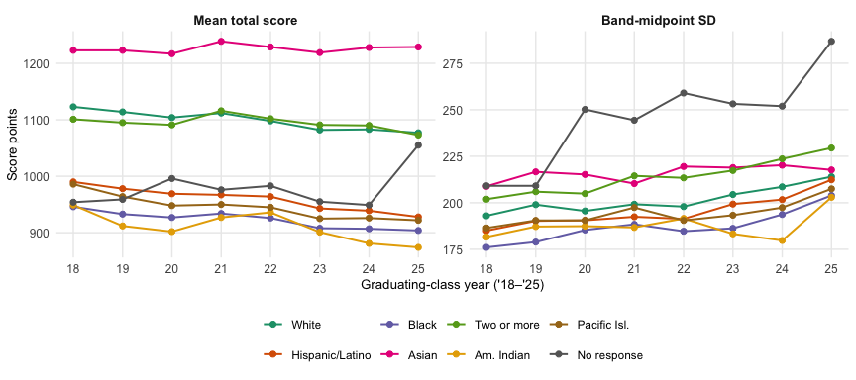
Figure 1: Mean Total Score and Band-Midpoint SD by Group, 2018–2025. Left: published mean total score. Right: SD computed by placing each band’s mass at its nominal midpoint $500,700,900,1100,1300,1500$ (the exact 10-point-grid midpoints are $495,695,895,1095,1295,1500$; only the last falls on the round-hundred grid, because the top band 1400–1600 is 200 points wide rather than 190). The band-midpoint SD is a coarse proxy for each group’s within-group SD, not the published cohort SD recovered in Validation.
Two features of Figure 1 matter for the modeling choices that follow. First, the No response mean drifts gently between approximately 949 and 996 across 2018–2024 and then steps to approximately 1055 in 2025, a roughly 100-point one-year jump with no parallel in any named group, whose means move smoothly across the period. The model fits this because every (group, year) cell has its own free mean parameter $θ_{r,y}$ under a weakly informative prior. No smoothness across years is imposed on any group’s mean. Second, the No response standard deviation rises from approximately 211 in 2018 to approximately 287 in 2025, a 76-point increase that dwarfs the 9–27-point rises shown by the seven named groups, and the rise is not a smooth drift but a step pattern, with most of the jump appearing in 2020 and a further jump in 2025. The smooth log-linear scale trend the named groups follow cannot reproduce that step structure, so the model gives No response a free per-year scale parameter, decoupled from the named-group hierarchy, as detailed below. No claim is made about the cause of these movements in the No response numbers. The public record does not distinguish a shift in who declines to disclose from a stable population changing how it self-identifies.
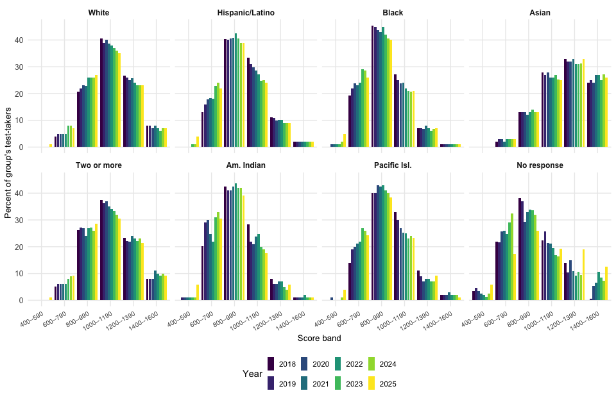
Figure 2: Score-Band Composition over Time, by Group. Each panel shows one racial/ethnic group. Within a panel, score band runs along the horizontal axis and the eight side-by-side bars within each band give the percentage of the group’s test-takers in that band, by graduating-class year from 2018 (darkest) through 2025 (lightest).
Figure 2 makes two further patterns visible. The first is the year-to-year stability of most named-group band shares: the 1400–1600 share moves by at most two or three percentage points for every named group, with similarly narrow ranges across the bands and across the smaller groups, and for most named-group bands the eight side-by-side bars are close to the same height, leaving the model’s year-constant skewness and tail-weight little to fit against. The second is a steady decline in the 1000–1190 band across White, Black, and Hispanic/Latino test-takers, mirroring the slow downward drift in those groups’ means in Figure 1.

Methods
The model has three structural components: a flexible parametric shape for each group’s score distribution, a likelihood that connects the shape to the rounded band proportions, and a hierarchical structure that ties the per-group parameters together. The three are described in turn, followed by the priors and the estimation procedure.

A Censored Sinh-Arcsinh Shape
For racial/ethnic group $r$ ($r=1,…,8$) and graduating-class year $y$, we model an individual total score $S$ as a sinh-arcsinh (“SHASH”) random variable (Jones & Pewsey, 2009), a four-parameter generalization of the normal with separate parameters for asymmetry and tail-thickness, used within the GAMLSS framework for individual-level distributional modeling (Rigby & Stasinopoulos, 2005; Stasinopoulos & Rigby, 2007). If $Z∼N(0,1)$, the standardized SHASH variable is
$$X = sinh​\left(\frac{asinh(Z)+ϵ}{δ}\right), δ>0, (1)$$
and the score is $S=μ_{r,y}+σ_{r,y}X$, with location $μ_{r,y}$, scale $σ_{r,y}$, skewness $ϵ_{r}$, and tail-weight $δ_{r}$; $ϵ=0, δ=1$ recovers the standard normal, $δ<1$ gives heavier tails and $δ>1$ lighter. The skewness and tail-weight are group-level and year-constant, pooled hierarchically; the location is a free per-(group, year) parameter under a weakly informative prior, with the published mean playing no part. The scale varies by year through a per-group log-linear trend plus a small per-cell residual.
Because $sinh$ and $asinh$ are monotone, the SHASH CDF is the normal CDF $Φ$ composed with the inverse transformation:
$$F(s∣μ,σ,ϵ,δ) = Φ​\left(sinh​\left(δ asinh​\frac{s−μ}{σ}−ϵ\right)\right). (2)$$
Censoring at the reporting range is handled by folding it into the band boundaries. SAT total scores are reported in 10-point steps, so the latent cut between bands “400–590” and “600–790” sits at the midpoint of the gap, 595, and the interior cuts likewise at 795, 995, 1195, 1395. With edges $(−∞,595,795,995,1195,1395,+∞)$, the bottom band collects mass the smooth distribution would place below 400 and the top band mass above 1600, so the model probability that a member of group $r$ in year $y$ falls in band $b$ is
$$π_{r,y,b} = F(e_{b}∣μ_{r,y},σ_{r,y},ϵ_{r},δ_{r})−F(e_{b−1}∣μ_{r,y},σ_{r,y},ϵ_{r},δ_{r}), (3)$$
a difference of two closed-form CDF evaluations. The same 10-point convention applies to threshold questions later (a reported score $≥t$ corresponds to a latent score $≥t−5$). The model fits on latent scores; the censoring fold means that any latent mass the SHASH would put above 1600 is assigned to the 1400–1600 band, and the band probabilities are computed accordingly. Threshold queries $P(\text{score}≥t)$ are correspondingly latent-score queries, which is an honest reading of the data the College Board reports (they too truncate at 1600). For the highest-mean group (Asian, approximately 26% of mass in the top reported band) the unrealizable latent mass above 1600 is non-trivial; we treat within-top-band shape as unidentified by the band data alone and revisit the practical consequence in Composition of the High-Scoring Pool.
Of the four parameters, only the scale is given time structure. The published cohort SD rose from approximately 204 to 235 across 2018–2025 as the SAT-taking population broadened post-SAT-optional; a model with fixed per-group scales would sit at the all-years average and be too narrow in recent cohorts. For each of the seven named groups we let
$$σ_{r,y} = σ_{r}exp​\left(λ_{r}z_{y}+η_{r,y}\right), (4)$$
with $σ_{r}$ the mid-period scale, $z_{y}$ the standardized year, $λ_{r}$ a per-group log-linear growth rate (pooled toward a common $β_{λ}$), and $η_{r,y}$ a per-cell residual around that trend (held close to zero by a tight prior, but a genuine free parameter so the cohort statistics inherit its uncertainty rather than treating the parametric form as exact). The fitted $β_{λ}≈0.03$ corresponds to scales about 10% wider in 2025 than in 2018.
The eighth group, “No response”, receives a free per-year log scale instead of the log-linear trend, for the empirical reasons given in Data: its band-midpoint SD follows a step pattern across 2018–2025 that a smooth trend cannot track, and forcing it into the named-group hierarchy distorts that hierarchy.
The per-group-year location is a free parameter $μ_{r,y}$. The published group mean ${\overset{‾}{S}}_{r,y}^{\text{pub}}$ is not used in the fit. It and the band percentages come from the same test-takers, so treating the mean as a separate exact fact would double-count. Holding it out also turns “the model recovers the published group means from the band percentages alone” into a check comparable to those on the cohort SD and quartiles.
The “Two or More Races” group is fit with the same single-(skewness, tail-weight) SHASH as each named single-race group.

A Dirichlet Likelihood on Band Proportions
For each group and year, let ${\hat{p}}_{r,y,•}=({\hat{p}}_{r,y,1},…,{\hat{p}}_{r,y,6})$ be the six band proportions for that imputation (each in $[0,1]$, summing to one by construction of the imputation procedure in Data). We model the observed proportions directly, with no reconstructed counts:
$${\hat{p}}_{r,y,•} ∼ \text{Dirichlet}​\left(ϕ_{r} π_{r,y,•}\right), (5)$$
where $π_{r,y,•}$ are the SHASH band probabilities of Equation 3 and $ϕ_{r}>0$ is a per-group concentration parameter, pooled hierarchically across groups (see Hierarchical Structure below). The Dirichlet has mean $π_{r,y,•}$ and component variances $π_{r,y,b}(1−π_{r,y,b})/(ϕ_{r}+1)$, which do not depend on $N_{r,y}$. A small group is therefore not treated as orders of magnitude noisier than a large one. The precision of every reported proportion is governed by the per-group concentration, fit from the data.
The group-size-invariance the Dirichlet provides addresses a mismatch in the data. The published band percentages are coarsened in the grouped-data sense of Heitjan (1989) and the coarsened-data sense of Heitjan & Rubin (1991) and Heitjan (1994), with rounding to the nearest integer percentage point ($±0.5$ percentage points by construction). Related parametric and imputation-based treatments of similarly coarsened or heaped data appear in Wang & Heitjan (2008). A multinomial likelihood on reconstructed counts would tighten the largest group’s band-proportion standard errors by a factor of about $\sqrt{N_{\text{max}}/N_{\text{min}}}≈16$ relative to the smallest’s, even though the actual measurement noise — integer rounding to the nearest percentage point — is the same in percentage points across all groups; empirically, that specification gives only about 13% coverage of nominal-90% predictive intervals. The Dirichlet decouples dispersion from $N$ and leaves the per-group concentration to absorb the within-group residual misfit.
Rounding noise is handled outside the Dirichlet by multiple imputation (Rubin, 1987), using the rejection-sampling procedure described in Data: each named-group row is drawn uniformly from the rounding-box-intersected simplex, and No response is derived by subtraction from the exact published cohort band counts. The full SHASH+Dirichlet model is fit to each of $M=50$ such imputed datasets and the resulting posterior draws are pooled. Printed zeros require no separate treatment because the rounding interval $[0,0.5)$ is sampled natively.
Within a group, a single concentration forces the dispersion of the wide central bands and the narrow tail bands to be governed by one number, where in fact the rounding noise is constant in percentage points and the Dirichlet variance scales with $π(1−π)$. A per-band $ϕ_{r,b}$ orthogonal to the per-group pooling would be more faithful. We do not pursue it here, and the resulting over-coverage in the tail bands is documented in the posterior predictive check below.

Hierarchical Structure
For the seven named groups, all six per-group parameters are pooled hierarchically across groups on the same pattern (each on a Gaussian centered at a cross-group mean), so that the smallest groups (Native Hawaiian/Other Pacific Islander, American Indian/Alaska Native) shrink toward the cross-group average rather than tracking their own sampling noise. This applies small-area estimation (Fay & Herriot, 1979; Pfeffermann, 2013; Rao & Molina, 2015) at the group level. The three parameters whose natural scale is unconstrained (the log-scale, the skewness, and the log-scale growth rate) are pooled directly:
$$logσ_{r}∼N(β_{σ},τ_{σ}), ϵ_{r}∼N(β_{ϵ},τ_{ϵ}), λ_{r}∼N(β_{λ},τ_{λ}). (6)$$
The three positive parameters (the tail-weight, the Dirichlet concentration, and the scale-residual SD) are pooled on the log scale:
$$logδ_{r}∼N(β_{δ},τ_{δ}), logϕ_{r}∼N(β_{ϕ},τ_{ϕ}), logτ_{η,r}∼N(β_{τ_{η}},τ_{τ_{η}}). (7)$$
The per-group tail-weights are a priori the parameters most exposed to the within-band identifiability concern, since the within-band shape of the top band (1400–1600) they govern is exactly what six band totals cannot directly recover (see Discussion). In the fitted model, the per-group tail-weight posterior medians span a narrow range of about 0.02, all sitting just above one. The per-group-year scale residuals themselves are $η_{r,y}∼N(0,τ_{η,r})$, year-level departures from the log-linear scale trend rather than additional structure. The “No response” group’s scale is unpooled, as described above. Its skewness $ϵ_{\text{NR}}$, tail-weight $δ_{\text{NR}}$, and concentration $ϕ_{\text{NR}}$ remain in the hierarchies of Equation 6 and Equation 7.

Priors and Estimation
The model’s hyperparameters fall into three groups. The named-group hierarchies on the within-group scale, skewness, and scale-growth rate take weakly informative settings, with a Gaussian prior on each mean and a half-normal prior on each spread:
$$\begin{aligned}β_{σ}&∼N(log230, 0.4),& τ_{σ}&∼N^{+}(0, 0.35), \\ β_{ϵ}&∼N(0, 0.6),& τ_{ϵ}&∼N^{+}(0, 0.8), \\ β_{λ}&∼N(0, 0.15),& τ_{λ}&∼N^{+}(0, 0.06).\end{aligned} (8)$$
The hierarchies on the tail-weight, Dirichlet concentration, and per-group scale-residual SD are likewise weakly informative, with the $β_{δ}$ and $τ_{δ}$ settings centering each $δ_{r}$ near $1$:
$$\begin{aligned}β_{δ}&∼N(0, 0.3),& τ_{δ}&∼N^{+}(0, 0.2), \\ β_{ϕ}&∼N(log300, 1.5),& τ_{ϕ}&∼N^{+}(0, 0.5), \\ β_{τ_{η}}&∼N(log0.03, 0.6),& τ_{τ_{η}}&∼N^{+}(0, 0.3).\end{aligned} (9)$$
The per-cell SHASH location $μ_{r,y}$ is parameterized in terms of the cell’s expected score $θ_{r,y}=E[S_{r,y}]$, which is given the prior $θ_{r,y}∼N(1050,300)$. This is the centered parameterization of the skew-normal literature (Azzalini, 1985; Azzalini & Capitanio, 2014), which removes a near-singularity in the likelihood, applied here to the sinh-arcsinh family (Jones & Pewsey, 2009). The induced raw SHASH location is $μ_{r,y}=θ_{r,y}−σ_{r,y} m(ϵ_{r},δ_{r})$, with $m(ϵ,δ)=E[X]$ computed by 24-node Gauss–Hermite quadrature once per group per draw. The per-cell prior mean $1050$ is the rough overall SAT mean and the spread $300$ is wide enough to be essentially flat over the range of plausible group means. Its only role is to keep the noisiest small group’s expected score from drifting to implausible values. In the fitted model the posterior median per-cell expected score $θ_{r,y}$ runs from approximately 873 to 1248 across the eight groups and eight years (within 0.7 prior standard deviations of the prior mean even for the smallest groups), so the prior is essentially flat over the realized support and does not propagate meaningfully into the posterior. For the No response group’s free per-year log scale we take $logσ_{\text{NR},y}∼N(log230,0.4)$, independent across years. The group-level hierarchy is in the non-centered parameterization throughout.
The model is fit by Hamiltonian Monte Carlo as implemented in Stan (Betancourt, 2017; Carpenter et al., 2017), via the cmdstanr interface (Gabry et al., 2024) in R (R Core Team, 2024); posterior summaries and diagnostics use the posterior package (Bürkner et al., 2025), data manipulation uses dplyr (Wickham et al., 2023), and figures are produced with ggplot2 (Wickham, 2016). The full SHASH+Dirichlet specification is fit independently to each of $M=50$ imputed datasets (drawn as described in A Dirichlet Likelihood on Band Proportions above), with two chains, 1,000 warmup, and 1,000 retained iterations per fit at adapt_delta = 0.95, yielding 2,000 draws per imputation and 100,000 pooled draws in total. We follow the workflow conventions of Gabry et al. (2019) and Kruschke (2014). Convergence is assessed by the rank-normalized split-$\hat{R}$ (Vehtari et al., 2021) and the effective sample size. Model fit is assessed by posterior predictive checks (Gelman et al., 1996; Gelman et al., 2013; Meng, 1994; Rubin, 1984) and out-of-sample agreement with held-out summaries. We report 95% credible intervals for the substantive headline quantities (Black shares, the Asian-to-Black ratio, cohort summaries in the validation figures) and 90% credible intervals for the per-group parameters in the diagnostic tables, following common convention in each setting. All code and data are available (see the closing note).

Results

Fit and Identification
Per-imputation convergence diagnostics are in Table 2. Raising the HMC adaptation target to adapt_delta = 0.95 from the cmdstanr default of 0.8 cut the divergence count across the 50 imputations from a few hundred to around a dozen — well under 0.1% of pooled iterations — without materially shifting the headline. The worst-case $\hat{R}$ and ESS (Vehtari et al., 2021) across all 50 imputations sit slightly outside the conventional thresholds, with the affected parameters concentrated at the top of the hierarchy (the cross-group hyperparameter means) and in the No response group. The per-cell quantities that bear on the headline ($μ_{r,y}$, $σ_{r,y}$ for the named groups) have ESS bulk in the low thousands and $\hat{R}$ at most 1.01. We treat the pooled posterior as well-resolved.
Table 2: Convergence Diagnostics across Imputations. Aggregated across the M = 50 imputations. Maximum rank-normalized split-$\hat{R}$ and minimum effective sample sizes are taken over per-imputation values; divergent transitions are summed.
Diagnostic | Value
Maximum rank-normalized split-$\hat{R}$ across imputations | 1.017
Minimum bulk effective sample size across imputations | 237
Minimum tail effective sample size across imputations | 396
Divergent transitions (of 100,000 pooled iterations) | 13

Table 3 gives per-parameter diagnostics for the cross-group hyperparameter means and for the per-group tail-weights $δ_{r}$ and skewnesses $ϵ_{r}$. Across all 50 imputations the per-group $δ_{r}$ and $ϵ_{r}$ have $\hat{R}$ at most around 1.01 and bulk ESS comfortably in the hundreds. The cross-group hyperparameter means mix slowest, with the worst-case $\hat{R}$ values sitting just above 1.01 and bulk ESS in the low hundreds in the worst-mixing imputations; that slow mixing at the top of the hierarchy does not propagate to the per-group skewnesses and tail-weights underneath, the parameters that carry the substantive between-group separation.
Table 3: Per-Parameter Convergence Diagnostics. Top-of-hierarchy hyperparameter means, plus the per-group skewnesses $ϵ_{r}$ and tail-weights $δ_{r}$. The remaining hierarchy parameters ($β_{σ}$ and all hierarchy spreads $τ_{•}$) are well-resolved in every imputation and are captured by the aggregate maximum $\hat{R}$ in Table 2. Reported values are the worst case (maximum $\hat{R}$, minimum bulk ESS, minimum tail ESS) across the 50 imputations.
Parameter | $\hat{R}$ | Bulk ESS | Tail ESS
$β_{ϵ}$ | 1.014 | 237 | 445
$β_{δ}$ | 1.005 | 826 | 589
$β_{ϕ}$ | 1.017 | 401 | 580
$β_{τ_{η}}$ | 1.006 | 664 | 896
$β_{λ}$ | 1.005 | 630 | 396
$ϵ_{\text{White}}$ | 1.005 | 1,661 | 1,339
$ϵ_{\text{Hispanic/Latino}}$ | 1.003 | 1,587 | 1,106
$ϵ_{\text{Black}}$ | 1.002 | 1,701 | 1,504
$ϵ_{\text{Asian}}$ | 1.004 | 637 | 1,084
$ϵ_{\text{Two or more}}$ | 1.005 | 1,403 | 1,160
$ϵ_{\text{Am. Indian}}$ | 1.003 | 1,659 | 1,238
$ϵ_{\text{Pacific Isl.}}$ | 1.004 | 1,563 | 1,373
$ϵ_{\text{No response}}$ | 1.003 | 1,062 | 1,221
$δ_{\text{White}}$ | 1.004 | 1,319 | 1,258
$δ_{\text{Hispanic/Latino}}$ | 1.005 | 923 | 1,101
$δ_{\text{Black}}$ | 1.004 | 1,073 | 1,273
$δ_{\text{Asian}}$ | 1.004 | 574 | 1,155
$δ_{\text{Two or more}}$ | 1.004 | 1,071 | 1,217
$δ_{\text{Am. Indian}}$ | 1.004 | 1,645 | 1,240
$δ_{\text{Pacific Isl.}}$ | 1.003 | 1,455 | 1,269
$δ_{\text{No response}}$ | 1.010 | 546 | 522

The common scale-trend rate posterior median is small and positive, implying a scale roughly 10% wider in 2025 than in 2018, with the per-group rates in a narrow band around it and the per-cell residuals small (per-group scale-residual SDs on the order of one percent of the cell scale). The per-group Dirichlet concentrations imply a band-proportion scatter of about 2 percentage points. With rounding noise handled upstream by the imputation layer, this residual scatter is the year-to-year shape drift the year-constant skewness and tail-weight cannot absorb.
Table 4 gives the per-group parameters. Scales span approximately 188–276 across the seven named groups. The per-group tail-weights all sit just above one, so the tails are nearly Gaussian for every group. What separates the groups is the skewness: small but positive for White (about 0.06), slightly negative for Asian (concentrated near the 1600 ceiling, with a left-trailing tail), and approximately 0.4–0.5 for the lower-mean groups (a dense lower bulk with a thin tail of high scorers). The scale-growth rates are all small and similar. The differences in shape across groups are therefore modest. The large disparities in the composition of the high-scoring pool seen below are not the product of any group having an exotic distribution, but the ordinary tail-divergence consequence of the differences in means, which the model recovers from the band data alone (the published means play no part).
Table 4: Per-Group Posterior Parameters for the Seven Named Groups. Each cell shows the posterior median with the 90% credible interval in brackets. $σ_{r}$ is the mid-period scale; $ϵ_{r}$ the (year-constant) skewness; $δ_{r}$ the (year-constant) tail-weight; $λ_{r}$ the scale-growth rate, with $σ_{r,y}=σ_{r}exp(λ_{r}z_{y}+η_{r,y})$. The No response group is in the same skewness, tail-weight, and concentration hierarchies as the named groups (with $δ_{\text{NR}}≈1.13$, comparable to the named-group range), but its scale is free per year rather than parameterized by a $(σ_{r},λ_{r})$ pair (see Methods) and so it is not shown here.
Group | $σ_{r}$ | $ϵ_{r}$ | $δ_{r}$ | $λ_{r}$
White | 229 [213, 244] | 0.06 [0.01, 0.10] | 1.115 [1.056, 1.167] | 0.032 [0.018, 0.045]
Hispanic/Latino | 208 [195, 225] | 0.44 [0.38, 0.52] | 1.137 [1.088, 1.207] | 0.033 [0.019, 0.050]
Black | 191 [178, 205] | 0.44 [0.38, 0.51] | 1.118 [1.060, 1.171] | 0.035 [0.022, 0.053]
Asian | 276 [260, 300] | -0.08 [-0.16, 0.00] | 1.134 [1.080, 1.224] | 0.029 [0.013, 0.041]
Two or more | 251 [236, 271] | 0.20 [0.16, 0.25] | 1.132 [1.084, 1.198] | 0.037 [0.024, 0.055]
Am. Indian | 188 [174, 202] | 0.50 [0.44, 0.58] | 1.120 [1.062, 1.177] | 0.027 [0.004, 0.041]
Pacific Isl. | 199 [185, 215] | 0.50 [0.42, 0.60] | 1.126 [1.071, 1.190] | 0.030 [0.011, 0.046]

Posterior Predictive Check
If the model is calibrated, about 90% of the observed band proportions should lie inside their 90% posterior-predictive intervals. Drawing replicate proportions ${\tilde{p}}_{r,y,•}∼\text{Dirichlet}(ϕ π_{r,y,•})$ for each of the $8×8×6=384$ cells:
The aggregate coverage of the 384 cells is close to the nominal 90%. The standardized residuals (observed minus predictive median, over predictive SD) are centered, with spread noticeably below one — the Dirichlet predictive intervals are wider than the actual residuals warrant in many cells, particularly in the upper bands (the 1400–1600 band’s z-SD $≈0.4$). A single per-group concentration cannot match both the wide central bands and the narrow tail bands at once, and the model errs toward the wide side; a per-band concentration would tighten the tail-band intervals.
The cohort aggregate of the fitted band proportions agrees with the cohort aggregate of the observed ones to within a couple of percentage points everywhere, ruling out a bias shared across groups within a year that the cell-by-cell check could miss. Figure 3 plots the standardized residual for every (group, year, band) cell. Most scatter around zero with spread noticeably below one, consistent with the over-coverage just noted.
Most of the named-group breaches concentrate in the 2025 cohort: a positive (under-predicted) cluster in the lowest band (400–590) for the lower-mean groups, where the model under-predicts the observed mass by about a percentage point, and a negative (over-predicted) cluster in the adjacent 600–790 band for the same broad set, where the model over-predicts by a comparable amount. Both patterns are consistent with a recent-cohort shift of mass leftward in those groups that the year-constant skewness cannot accommodate.
The No response breaches are all in the lowest band (400–590) and include the figure’s two largest residuals, both in the earlier cohorts (2018–2019), where the observed mass sits well above what a smooth SHASH curve fitted to the rest of that group’s band proportions will accept. The remaining No response residuals sit closer to the named-group spread but are still slightly noisier, consistent with the empirical volatility of the raw No response numbers, which is also why that group is given its own free per-year scale.
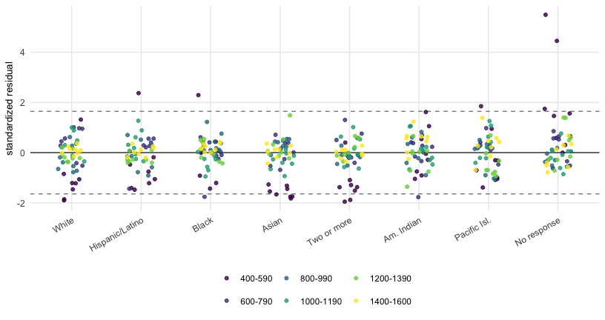
Figure 3: Standardized Posterior-Predictive Residuals by Group and Band. Each point is one (group, year, band) cell. Dashed lines mark $±1.645$, the Gaussian 90% reference under a calibrated model; the asymmetric Dirichlet 90% predictive intervals reported as the coverage statistic in the text are not identical to this Gaussian cut, so the count of points outside the dashed lines need not equal the cell count outside the coverage intervals. Color encodes the score band.

Validation
Each annual report prints, alongside the band breakdown the model is fit to, five further cohort numbers: the Total-score mean, the standard deviation, and the 25th, 50th, and 75th percentile scores. None of these enters the model. The five differ in the strength of the check they provide. The cohort mean is a weighted moment of the same band proportions the model fits, so any model that matches the band proportions well will recover the cohort mean close to mechanically (up to a skewness correction inside each top band); its posterior is identified essentially by the band proportions, and a small recovery error is a basic consistency check rather than a predictive test. The cohort SD is somewhat freer: the per-group log-linear scale trend and the per-cell scale residuals give the model flexibility to fit the cohort SD to within a few score points without that fit being mechanically pinned by the bands. The quartiles, by contrast, are a genuine out-of-sample test of the shape in the body of the distribution: the bands constrain the cumulative distribution at the five interior cut points (595, 795, 995, 1195, 1395), and where those cut points fall relative to the published $p_{25}$, $p_{50}$, $p_{75}$ depends on the parametric form between them. Across 2018–2025 that is $5×8=40$ cohort numbers, of which the 24 quartile cells are the operative out-of-sample evidence.
The mean and SD are compared in score points (Figure 4). Reported quartile scores live on the 10-point grid, so we compare in the dual direction: the model’s posterior rank of each published quartile, which varies smoothly and should equal the nominal 0.25, 0.50, or 0.75 (Figure 5).
The mean is the result that matters most. Locating each curve from the bands alone, the model’s recovered cohort mean is within a few points of the published value every year, and per group as well. Across the 56 named-group cells the recovered mean is within a point or two of the published one at the median, and the published value lies inside the model’s 95% interval in nearly all of them. Only the No response group falls clearly outside the interval, by tens of points in some years: its mean is exactly derivable from the cohort and named-group means by subtraction, but the band-proportion fit is looser because of the empirical volatility shown in Figure 1. The SD rises from approximately 209 in 2018 to approximately 239 in 2025, running about 4–5 points above the published rise from approximately 204 to 235 throughout. The small per-cell residual lets it track the year-to-year fluctuations but not entirely (2018 and 2022 sit just outside the posterior). These are the two years where the published cohort SD departs furthest from a smooth trend: 2018 sits about 6 points below the trajectory the later years define (a plausible reading is an early-redesign test-taker cohort not yet settled to its later composition, but the public record does not document a specific cause), and 2022 fell by one point against an otherwise monotone rise (the class of 2022 was the first to have been through its junior-year SAT window with the standardized-test requirement eliminated at almost all colleges, leaving a more selectively self-chosen cohort). The model’s per-group log-linear scale trend with a tight residual cannot reproduce departures of either size. The quartiles sit close to the nominal line: the median within about a percentage point in most years (with $+1.5$ pp deviations in 2018 and 2019), $p_{25}$ within about a percentage point in most years (rising to $+2.5$ pp in 2018), and $p_{75}$ within about a percentage point but running slightly high in 2024–2025 (the same recent-cohort right-skew residual). Overall, the target lies inside the model’s 95% interval in roughly nine of every ten of the 40 cells, with the bulk of the misses in the SD and quartile checks rather than the means. The misses themselves are small and mostly at the interval’s edge. The 24 quartile-rank checks, which exercise the shape of the cohort distribution at three interior points that the band proportions constrain only through the parametric form, are the operative out-of-sample validation. The cohort mean check is a near-mechanical consistency check of the same fit; the SD check is somewhat freer (the within-group variances depend on the SHASH shape the model estimates), but in practice the bands constrain it tightly enough that it tracks the published cohort SD to within a few points.
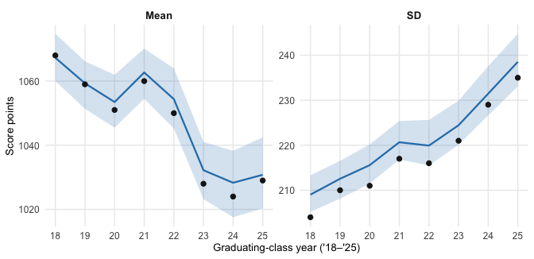
Figure 4: Held-Out Cross-Check of the Cohort Mean and Standard Deviation. By graduating-class year. Neither summary was used in fitting: the model was fit only to the six per-(race, year) banded percentages, and the implied cohort mean and SD are then computed as population-weighted moments of the fitted per-group score distributions. Blue line: posterior median of the model’s implied cohort value; shaded band: 95% credible interval. Black points: the College Board’s published cohort value. Y-axes differ between panels.
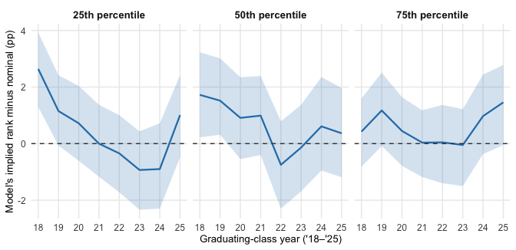
Figure 5: Held-Out Cross-Check of the Published Cohort Quartile Scores. By graduating-class year. For each year the College Board reports the score at the cohort’s 25th, 50th, and 75th percentile. We plug each of those three reported scores into the model’s posterior cumulative distribution to get the percentile the model itself assigns to that score (the model’s ‘implied rank’). A perfectly calibrated model places the published 25th-percentile score at percentile 25, the median score at 50, and the 75th-percentile score at 75. The vertical axis shows the model’s implied rank minus the nominal value; zero (dashed) is perfect agreement, identical across panels so the three checks line up visually. Blue line: posterior median; shaded band: 95% credible interval. None of the three published quartiles was used in fitting.
A second, finer check is independent of the band summaries entirely. The College Board publishes a SAT User Percentile table giving, in 10-point steps, the cumulative share of test-takers scoring at or below each total score in the three most recently graduated cohorts pooled. The table is built from individual scores and is updated annually as new cohorts are added and old ones drop out. We hold it out of the fit and use it as an external check.
The check has two distinct parts. Below the 1400 boundary, the comparison is primarily data-driven: the six observed band proportions pin the model’s cohort survival curve at five band-boundary anchors, and any smooth distribution interpolating between those anchors will track the SAT User Percentile curve to within rounding noise. Above 1400, the comparison becomes distributional extrapolation: the band data give a single anchor at the lower boundary of the top band ($s=1395$ in the latent-cut convention) and the model’s SHASH form fills in the rest. The within-top-band shape (that is, what fraction of the 1400–1600 band’s mass sits above 1500 or 1550) is not identifiable from six band totals. The SAT User Percentile table is, in effect, that missing within-top-band shape information made public. The model’s SHASH-based interpolation has no access to it during fitting; comparing the model’s induced cohort percentiles against the reference is therefore the strictest external check the public record allows.
The College Board publishes the SAT User Percentile table for five pooled-cohort windows: 2018–2020, 2019–2021, 2021–2023, 2022–2024, and 2023–2025 (the 2020–2022 window is not available). For the most recent window the model’s implied cohort survival is computed by population-weighting the per-group SHASH survival functions over the contributing years and compared in Figure 6 against the published SAT User Percentile curve. The SAT User Percentile is reported as an integer at each 10-point grid score, so the true $P(\text{score}≥t)$ lies in a one-percentage-point band (or a one-sided band of width 0.5 at the top scores reported as “99+”); see the Figure 6 caption for details. The model’s posterior median sits inside the SAT User Percentile rounding band at essentially every grid score through the headline threshold $t=1500$: for 2023–2025 the model puts 3.2% (95% CI 2.9%–3.7%) above 1500 and the SAT User Percentile band is $(2.5\%, 3.5\%]$. The credible interval’s upper edge (3.7%) extends about 0.2 percentage points above the band, so it is the median’s position inside the band, not full interval containment, that constitutes the check here. The model drifts modestly above the SAT User Percentile band from $t=1550$ upward — by about 0.5–1.0 percentage points — before integer rounding at the top of the table forecloses further comparison. The corresponding plots for the four earlier windows show the same pattern and are not reproduced here. The downstream consequence is taken up in the Discussion.
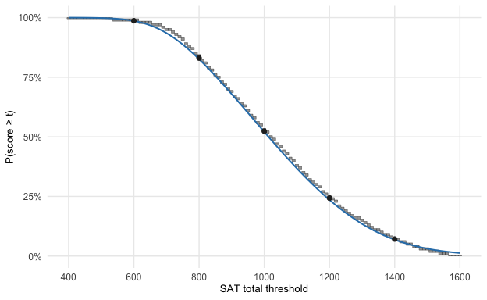
Figure 6: External Held-Out Validation against the SAT User Percentile Reference, 2023–2025 Pooled Cohort. Grey rectangles: the range of $P(\text{score}≥t)$ consistent with the integer SAT User Percentile at $t−10$ — a one-percentage-point band, or a one-sided $[0, 0.5\%]$ band at the topmost scores reported as ‘99+’. Solid blue: modeled cohort $P(\text{score}≥t)$, posterior median of the population-weighted survival across 2023–2025. Black points: exact cohort survival at each reported band lower-boundary (600, 800, 1000, 1200, 1400). Plots for the four earlier pooled-cohort windows look similar and are omitted.

Composition of the High-Scoring Pool
Figure 7 shows the Black share and the Asian-to-Black ratio of test-takers scoring at or above four thresholds (1400, 1450, 1500, 1550) for the 2025 graduating class cohort. At the 1400 boundary the values follow directly from the College Board’s published numbers (subject to their $±0.5$ percentage-point integer rounding, which is non-trivial when the printed share is itself near $1\%$): Black students are approximately 1.7% of the above-1400 pool, with about 23 Asian test-takers above 1400 per Black. The higher thresholds fall inside the top band, where the model interpolates. The credible intervals are wide (the 1450+ ratio is about 31 with 95% CI roughly 19–52, the 1550+ ratio about 60 with CI 31–123). We stop at 1550 because the model’s $P(\text{latent}≥t)$ includes mass past the 1600 ceiling that no reported score can realize: the effect is small at moderate thresholds (the SAT User Percentile check passes at 1500), grows toward the ceiling, and dominates as $t$ approaches 1600. The medians trace the familiar tail-divergence pattern; the figure’s substantive content is the width of the intervals, which would be tighter under any model that treated the rounded inputs as exact counts.
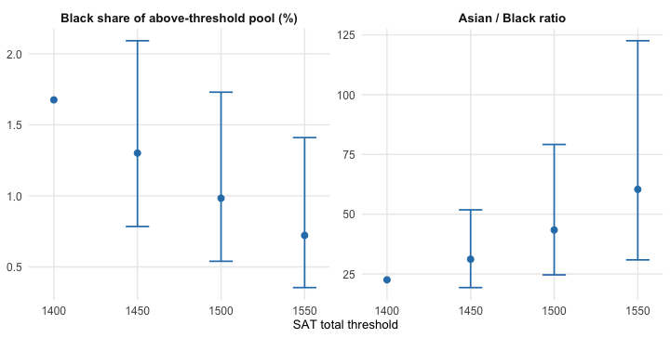
Figure 7: Principal Tail Quantities for the 2025 Graduating Class. Left: Black share of all test-takers above each threshold. Right: Asian-to-Black ratio of test-takers at or above each threshold. At $t=1400$ the values follow directly from the College Board’s published numbers and are shown as point estimates without a credible interval, since the model is not used at this threshold; the only uncertainty is the $±0.5$ percentage-point integer-rounding noise on each per-race share in the 1400–1600 band, which is a deterministic bound (not a credible interval) and is discussed in the text. The three higher thresholds fall inside the top band where the model interpolates: points show posterior medians and bars show 95% credible intervals.

Discussion
This paper presents a Bayesian hierarchical model that recovers a continuous per-group score distribution from coarsely banded summary data. We then apply it to the College Board’s reports of SAT total scores for the graduating classes of 2018 through 2025, using the fitted distributions to answer composition and tail-quantity questions about the 2025 cohort. Four modeling choices underpin the result. A sinh-arcsinh shape gives separate skewness and tail-weight parameters with a closed-form CDF that evaluates in constant time inside the likelihood. A free per-cell location holds the published group mean out of the fit, which both avoids double-counting it as a separate fact about the same students and makes it a held-out quantity that the model has to recover. A Dirichlet likelihood on the observed proportions provides a group-size-invariant overdispersion that the per-group concentration parameter fits to the actual residuals, in contrast to the sampling noise assumed by a multinomial on reconstructed counts. And a partial-pooling hierarchy across groups stabilizes the skewness, tail-weight, and concentration parameters for the smaller cohorts (Native Hawaiian/Other Pacific Islander, American Indian/Alaska Native), which would otherwise be too imprecise to support per-group tail-quantity claims.
The contribution is the model itself, in two respects. The sinh-arcsinh family (Jones & Pewsey, 2009) is well established in flexible distributional modeling, principally within the GAMLSS framework (Rigby & Stasinopoulos, 2005; Stasinopoulos & Rigby, 2007) for individual-level data; prior work has not, to our knowledge, applied it to coarsely banded score data with a Dirichlet likelihood whose group-size-invariant overdispersion accommodates the rounding step and the residual misfit of a parsimonious shape assumption. Separately, fitting a full parametric score distribution to each (group, year) cell of the College Board’s publicly released banded summaries is, to our knowledge, new. Published work on group differences in SAT performance has either relied on access to individual scores (e.g. Sackett et al., 2009; Kobrin & Patterson, 2011; Kuncel & Hezlett, 2010) or has stayed at the level of published moments and aggregate gap estimates (e.g. Roth et al., 2001; Hauser, 2002). The methods literature on inferring score gaps from coarse public data (Reardon, 2011; Reardon et al., 2019) uses multilevel structures to recover mean gaps with calibrated uncertainty from heaped or banded state-accountability test data, but has not paired a parametric within-group distribution with a group-size-invariant Dirichlet likelihood on the proportions themselves. The contribution here is complementary rather than competing: within-group shape on nationally aggregated SAT data, rather than between-group means on state-accountability data. The framework proposed here is therefore the first that allows a reader who has only the public banded reports to ask compositional and tail-quantity questions about each racial/ethnic group of SAT-takers separately, and to receive answers with calibrated uncertainty.
The validation has two held-out surfaces. The five-number cohort moments — mean, SD, and three quartile scores — are reproduced to within a few score points (for the mean and SD) or about a percentage point in implied rank (for the three quartiles) in most years. The fine-grained SAT User Percentile reference is tracked closely through the 1500 threshold, with a mild residual at 1550. The 24 quartile cells are the genuine out-of-sample test passed by the fit; the cohort mean is a near-mechanical consequence of fitting the band proportions, and the cohort SD a slightly looser corollary with some residual freedom in the within-group shape.
The model has real limitations. All credible intervals reported on tail quantities are conditional on the SHASH parametric form being correct. The SHASH form interpolates the within-1400–1600 shape that the band data cannot identify, and is checked against the held-out SAT User Percentile reference. The model agrees with the reference at $t=1500$ and drifts modestly above it at $t=1550$ (by 0.5–1.0 percentage points in recent windows). The cohort SD is missed in 2018 and 2022, and the posterior rank of the published $p_{75}$ runs about a percentage point high in 2024 and 2025.
A natural extension would be joint estimation against the SAT User Percentile reference table, which would tighten the upper-tail fit at $t=1550$ and above. Beyond the SAT, the framework applies to any aggregate testing report that publishes per-group banded distributions; any other published quantities — group or cohort means, SDs, percentiles — can be held out as additional validation checks as the SAT cohort SD and quartiles are here.
The paper estimates per-group latent score distributions conditional on test participation, not population cognitive distributions. Mapping the same estimates to the broader college-bound or U.S. 18-year-old population would require a model of who choses to take the SAT. We do not attempt that mapping here.

Data and Code Availability
The College Board reports used here are public (College Board, 2018–2025, 2025). Copies of those PDFs, the extraction scripts, the cleaned data, the Stan model, and the code that produced every table and figure in this paper are available in a public repository: [to be supplied after blind peer review is complete].

References
Azzalini, A. (1985). A class of distributions which includes the normal ones. Scandinavian Journal of Statistics, 12(2), 171–178.
Azzalini, A., & Capitanio, A. (2014). The skew-normal and related families. Cambridge University Press. https://doi.org/10.1017/CBO9781139248891
Betancourt, M. (2017). A conceptual introduction to Hamiltonian Monte Carlo. arXiv Preprint arXiv:1701.02434. https://doi.org/10.48550/arXiv.1701.02434
Bürkner, P.-C., Gabry, J., Kay, M., & Vehtari, A. (2025). posterior: Tools for working with posterior distributions.
Carpenter, B., Gelman, A., Hoffman, M. D., Lee, D., Goodrich, B., Betancourt, M., Brubaker, M. A., Guo, J., Li, P., & Riddell, A. (2017). Stan: A probabilistic programming language. Journal of Statistical Software, 76(1), 1–32. https://doi.org/10.18637/jss.v076.i01
College Board. (2018–2025). SAT suite of assessments annual report. Annual reports for the graduating classes of 2018–2025. College Board, New York.
College Board. (2024). SAT suite of assessments technical manual. College Board, New York.
College Board. (2025). Understanding SAT scores: Nationally representative and SAT user percentiles. College Board, New York.
Fay, R. E., & Herriot, R. A. (1979). Estimates of income for small places: An application of James–Stein procedures to census data. Journal of the American Statistical Association, 74(366), 269–277. https://doi.org/10.1080/01621459.1979.10482505
Frey, M. C., & Detterman, D. K. (2004). Scholastic assessment or $g$? The relationship between the scholastic assessment test and general cognitive ability. Psychological Science, 15(6), 373–378. https://doi.org/10.1111/j.0956-7976.2004.00687.x
Gabry, J., Češnovar, R., Johnson, A., & Bronder, S. (2024). cmdstanr: R interface to CmdStan.
Gabry, J., Simpson, D., Vehtari, A., Betancourt, M., & Gelman, A. (2019). Visualization in Bayesian workflow. Journal of the Royal Statistical Society, Series A, 182(2), 389–402. https://doi.org/10.1111/rssa.12378
Gelman, A., Carlin, J. B., Stern, H. S., Dunson, D. B., Vehtari, A., & Rubin, D. B. (2013). Bayesian data analysis (3rd ed.). Chapman and Hall/CRC. https://doi.org/10.1201/b16018
Gelman, A., Meng, X.-L., & Stern, H. (1996). Posterior predictive assessment of model fitness via realized discrepancies. Statistica Sinica, 6(4), 733–760.
Hauser, R. M. (2002). Meritocracy, cognitive ability, and the sources of occupational success (Center for Demography and Ecology Working Paper 98-07 (rev.)). Center for Demography and Ecology, University of Wisconsin–Madison.
Heitjan, D. F. (1989). Inference from grouped continuous data: A review. Statistical Science, 4(2), 164–179. https://doi.org/10.1214/ss/1177012601
Heitjan, D. F. (1994). Ignorability in general incomplete-data models. Biometrika, 81(4), 701–708. https://doi.org/10.1093/biomet/81.4.701
Heitjan, D. F., & Rubin, D. B. (1991). Ignorability and coarse data. The Annals of Statistics, 19(4), 2244–2253. https://doi.org/10.1214/aos/1176348396
Jones, M. C., & Pewsey, A. (2009). Sinh-arcsinh distributions. Biometrika, 96(4), 761–780. https://doi.org/10.1093/biomet/asp053
Kobrin, J. L., & Patterson, B. F. (2011). Contextual factors associated with the validity of SAT scores and high school GPA for predicting first-year college grades. Educational Assessment, 16(4), 207–226. https://doi.org/10.1080/10627197.2011.635956
Kruschke, J. K. (2014). Doing Bayesian data analysis: A tutorial with R, JAGS, and Stan (2nd ed.). Academic Press. https://doi.org/10.1016/C2012-0-00477-2
Kuncel, N. R., & Hezlett, S. A. (2010). Fact and fiction in cognitive ability testing for admissions and hiring decisions. Current Directions in Psychological Science, 19(6), 339–345. https://doi.org/10.1177/0963721410389459
Lemann, N. (1999). The big test: The secret history of the American Meritocracy. Farrar, Straus and Giroux.
Meng, X.-L. (1994). Posterior predictive p-values. Annals of Statistics, 22(3), 1142–1160. https://doi.org/10.1214/aos/1176325622
Pfeffermann, D. (2013). New important developments in small area estimation. Statistical Science, 28(1), 40–68. https://doi.org/10.1214/12-STS395
R Core Team. (2024). R: A language and environment for statistical computing. R Foundation for Statistical Computing.
Rao, J. N. K., & Molina, I. (2015). Small area estimation (2nd ed.). Wiley. https://doi.org/10.1002/9781118735855
Reardon, S. F. (2011). The widening academic-achievement gap between the rich and the poor: New evidence and possible explanations. In G. J. Duncan & R. J. Murnane (Eds.), Whither opportunity? Rising inequality, schools, and children’s life chances (pp. 91–116). Russell Sage Foundation.
Reardon, S. F., Kalogrides, D., & Shores, K. (2019). The geography of racial/ethnic test score gaps. American Journal of Sociology, 124(4), 1164–1221. https://doi.org/10.1086/700678
Rigby, R. A., & Stasinopoulos, D. M. (2005). Generalized additive models for location, scale and shape. Journal of the Royal Statistical Society, Series C, 54(3), 507–554. https://doi.org/10.1111/j.1467-9876.2005.00510.x
Roth, P. L., Bevier, C. A., Bobko, P., Switzer, F. S., & Tyler, P. (2001). Ethnic group differences in cognitive ability in employment and educational settings: A meta-analysis. Personnel Psychology, 54(2), 297–330. https://doi.org/10.1111/j.1744-6570.2001.tb00094.x
Rubin, D. B. (1984). Bayesianly justifiable and relevant frequency calculations for the applied statistician. Annals of Statistics, 12(4), 1151–1172. https://doi.org/10.1214/aos/1176346785
Rubin, D. B. (1987). Multiple imputation for nonresponse in surveys. Wiley. https://doi.org/10.1002/9780470316696
Sackett, P. R., Kuncel, N. R., Arneson, J. J., Cooper, S. R., & Waters, S. D. (2009). Does socioeconomic status explain the relationship between admissions tests and post-secondary academic performance? Psychological Bulletin, 135(1), 1–22. https://doi.org/10.1037/a0013978
Stasinopoulos, D. M., & Rigby, R. A. (2007). Generalized additive models for location scale and shape (GAMLSS) in R. Journal of Statistical Software, 23(7), 1–46. https://doi.org/10.18637/jss.v023.i07
Vehtari, A., Gelman, A., Simpson, D., Carpenter, B., & Bürkner, P.-C. (2021). Rank-normalization, folding, and localization: An improved $\hat{R}$ for assessing convergence of MCMC. Bayesian Analysis, 16(2), 667–718. https://doi.org/10.1214/20-BA1221
Wang, H., & Heitjan, D. F. (2008). Modeling heaping in self-reported cigarette counts. Statistics in Medicine, 27(19), 3789–3804. https://doi.org/10.1002/sim.3281
Wickham, H. (2016). ggplot2: Elegant graphics for data analysis (2nd ed.). Springer-Verlag. https://doi.org/10.1007/978-3-319-24277-4
Wickham, H., François, R., Henry, L., Müller, K., & Vaughan, D. (2023). dplyr: A grammar of data manipulation.

Throughout the tables and figures we abbreviate the longer labels: “Black” for Black/African American, “Two or more” for Two or More Races, “Am. Indian” for American Indian/Alaska Native, “Pacific Isl.” for Native Hawaiian/Other Pacific Islander, and “No response” for the residual described below.
The group is structurally a mixture of distinct ancestral populations, but a richer mixture density for this one group would not be identified by six band totals per cell, and the empirical residuals (see Figure 3) do not visibly require it.

