Table of Contents

Forward………………………………………………………………………………………….. 2-3

1. Introduction to Tips and Insights………………………………………………… 4
2. About the Development of Tips and Insights………………………4
3. What are Dynamic Bracing Solutions Braces………………………4-6
4. Developmental Perspective in this Work……………………………6-8
5. Purpose of the Project……………………………………………………….8
6. Goals……………………………………………………………………………… 8-9
7. Realities……………………………………………………………………………9
8. Overview of Learning to Use DBS Braces……………………………10
9. Steps in the Process…………………………………………………………. 10-11
10. A Developmental Perspective in the Learning Process…………………. 11
    1. Suggested Items to Use in the Learning Process…………………11-13
    2. Optimal Standing Position……………………………………………….. 13-14
    3. Hip Rotations………………………………………………………………….. 14-16
    4. Side to Sides……………………………………………………………………. 16-18
    5. Importance of Heel Strike………………………………………………… 19-21
    6. The Drag…………………………………………………………………………. 22-24
    7. Additional Tips……………………………………………………………….. 24
11. Acknowledgments and Thanks……………………………………………………25

# Foreword

Tips and Insights for User of DBS Users is a narrative document produced by The Human Gait Institute in accordance with its Mission Statement, which states:

*The mission of the Human Gait Institute is to assist people in reaping the benefits of lower extremity bracing (orthotic) technologies.*

*In support of its mission, the Human Gait Institute seeks to:*

* *explore innovative technologies related to bracing*
* *provide resources to support individuals who are considering or using braces*
* *foster education and training of wearers and professionals*
* *support related research*

*The focus of the original efforts of The Human Gait Institute was to support wearers of Dynamic bracing Solutions orthoses (DBS). This support will continue.*

The ***Human Gait Institute*** (“HGI”) was organized April 11, 2008. It is a Colorado non-profit corporation. It has obtained tax exempt status under Section 501(c)(3) of the federal Internal Revenue Code.

HGI is governed by its five Board members who have a combined 150 years of wearing leg braces, buying over 35 different types of braces. The Board members have gone through the process of obtaining leg braces in some form over these years. They currently all use innovative bracing technology.

The workbook is intended to be copied for personal use only. No part of it can be sold for profit. However, donations to HGI to help defray the cost of the workbook are greatly appreciated.

For questions or to make donations contact:

Dr. Marny Eulberg, M.D.

email: marnyeul@me.com  
phone: 303.829.1538

**Acknowledgements:**

Dr. Marny Eulberg, M.D.

Jim Dean

Margaret C. Hinman

Mike Mrozowicz

Karla Stromberger

**Tips and Insights**

**For Learning to Use DBS Braces**

1. **Introduction to Tips and Insights Project** (slide 4- )
2. **About the Development of Tips and Insights**: (slide 4)

The videos, narratives and PowerPoints are mainly developed by Human Gait Institute (HGI) Board members, and other interested contributors. Many of the ideas come from visitors to the HGI website (humangaitinstitute.org) or Closed Facebook page. The developers of this information receive no reimbursement from HGI or Dynamic Bracing Solutions (DBS). The initial material has been developed by Karla Stromberger who had polio at the age of 9, and who now wears Dynamic Bracing Solutions braces. Karla is a retired and no longer licensed physical therapist, and presents this material as a DBS wearer and not a PT.

For optimal success it is recommended that you read the Narrative for each topic and then watch the video. Pause the video part way through to do the activity and perfect your movements. The PowerPoint can serve as a summary of the activity

**2.** **What are Dynamic Bracing Solutions Braces?** (slide 5-8)

1. See website [www.dynamicbracingsolutions.net](http://www.dynamicbracingsolutions.net)
2. Short leg (AF) and long leg braces (KAFO)
3. They are different because they have the following:
4. Triplanar Control
5. Dynamic Response
6. Energy Storing and Releasing
7. KAFO for Knee Joint Instability
8. Measuring, casting, fitting, fabricating time
9. Made of carbon fiber composite

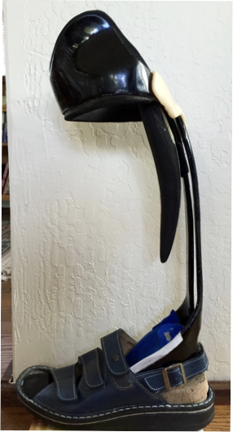

**J)** Components of DBS braces:

1. AFO - 5 piece system
2. Brace
3. Shoe
4. SACH heel
5. The person’s leg
6. Your brain - hardest one to manage!
7. Each brace is custom made/fabricated
8. Each person’s leg is analyzed, measured, and casted for their leg in great detail
9. Analyzed in all 3 planes
10. Provides control/remodeling/support in all 3 planes unlike most other braces

**3. Developmental Perspective in this work**: (slide 9-11)

**a.** Having worked mainly with infants and preschoolers with challenges for most of my career, I have a developmental focus when observing people moving, and/or re-learning to move after an injury or illness, no matter how long ago the challenge to movement occurred.

**b.** If you developed different/atypical movement patterns before 4 - 5 years of age, your brain may have never developed, and fully integrated, an entirely “normal/typical” neurological pattern of movement. No matter what the age of onset is, many of us have been moving atypically for 10 –70 years! Changing from the atypical way/pattern to the new one may be very challenging.

**c**. Development progresses in an infant starts at the head down and gradually moves to the feet and hands (cephalo-caudal). An infant works on becoming stable with head raising while on its tummy, back strengthens, abdominal muscles strengthen to give the baby a stable base. Then the shoulders and hips become stable followed later by the and legs. As the core/base is stabilizing the neck, trunk, arms and legs move in all directions/planes to provide a stable base for movement. These include side to side, rotational, and diagonal movements all combined for the purpose of later allowing the baby to move and attain its desires. All of this is done with the purpose of providing a stable base for being upright. One of the things that we often forget is that babies get a lot of sensory feedback from everything they touch, hear, smell, see, and more. These are important pieces for babies learning about their world and motivating them to move. It is important to provide all of these experiences for a person re-learning to walk no matter what the time of onset of their challenge.

**d.** I like to include the pre-standing components in looking at a person’s overall functioning and try to recognize how those may impact their present-day functioning. Rotation and alternating/reciprocal movements of the body must be considered in one’s present day movement patterns. Let’s jump ahead of rolling and crawling, and look at how infants stand and move initially:

Buttocks back

Feet apart

Knees flexed

Hips flexed

Head up

Arms up a bit holding on

It looks very similar to these babies:

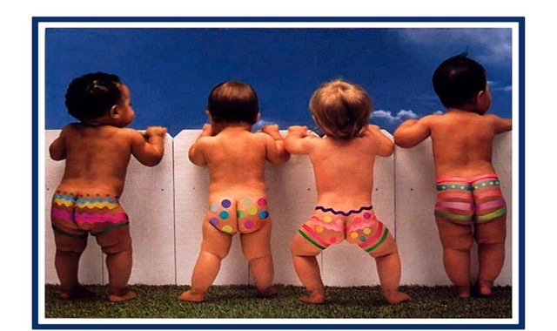

And very similar to how some of us stand and move! These positions allow the baby to develop a stable base for future walking. Note that three babies are standing with a wide base. The one who is standing with his/her feet closer together has more weight on one foot than the other and is looking more to the side. Which baby has the highest level of development in terms of standing?

**e.** This video shows early cruising by an infant:

[**https://www.youtube.com/watch?v=zlXzVRJDPPg&list=PLIEc8cE6zw4RQYd6sW2eQNQbYlvnCanP2**](https://www.youtube.com/watch?v=zlXzVRJDPPg&list=PLIEc8cE6zw4RQYd6sW2eQNQbYlvnCanP2)

See if you can notice some of these things: Side stepping, some difficulty separating legs in side stepping, slight trunk rotation, hands up on couch, stepping onto toes, some head turning (usually comes first), head is down part of the time, buttocks are back, wobbly transitioning to the table, reaching forward and leaning more, nice holding on with one hand with some hip wobble, and nice rotation to look at mom, waving and holding trunk tight to do so.

**4.Purpose of the Project**: (Slide 12)

The project is meant to supplement and break into smaller components the activities your DBS orthotist trained you to do. Hopefully you will be able to attain your goals with greater ease. There are some differences in perspective from what your DBS orthotist taught you to do. These activities will not work for everyone for many reasons. They can be adapted for many people. The project is offered in 3 parts:

Narrative of each activity which parallels the video with more content than the videos

Videos of each activity

Power Point/Keynote to parallel the narratives and the videos

More content will be added to this initial project over time.

1. **Goals** in putting this project together: (slide 13)

Supplement the recommended activities and break them down into smaller components if needed

Help you learn to TRUST the brace and, therefore, be able to move/walk more efficiently

Help you do the work of retraining your brain to move differently than you have before, or, attempt to re-create how you moved before your movement challenge occurred.

Help you use what already works for you and allow it to work to attain your highest functional level in your brace/s. This would allow you to move with greater efficiency and less energy expenditure.

Help you develop an awareness of how your body moves and what it feels like when you move more efficiently

Be Safe at all times. It is very difficult to learn a new movement pattern if you do not feel safe

Encourage you to not rush the process! It takes time to retrain the brain

Assist you in knowing when your brain and/or your body are reaching point of fatigue so that you will stop at that point

**6. Realities!** (slide 14)

1. There are no guarantees that the information in this project will work for you. These activities may not ever work for some of you for many reasons.
2. Each of us is VERY different. No one will ever walk like I do, or like anyone else in the world. Thus, NEVER compare how you are walking with anyone else.
3. Asking another DBS wearer how long it took them to learn to use their braces is not a predictor of how you will do. We are ALL different!
4. One must commit to doing the work necessary to learn to use the braces. Get support when needed: family member/friend, orthotist, physical therapist, another person
5. There will be progress and there will be regressions. Every regression has a purpose of stabilizing the base in order for more progress to occur so that you can move forward with greater stability!

**7. Overview of learning to use DBS braces:** (slide 15)

**a.** Change in how you move/walk requires **1000** repetitions of each single activity to break up old movement patterns and integrate new ones. You cannot do 1000 in one day – your muscles will fatigue – your brain fatigue. Nobody learns well when fatigued!

**b.** Doing an activity your “old way” reassures your brain that it does not have to be retrained and that the old way is best. This may be the hardest part of learning to use these braces!

**c. Do Not Rush** any of these activities! You want your brain to learn the new way of moving. There is NO QUICK FIX! That way you will really integrate the new pattern of movement

**d.** Practice 10 -20 min 1 to 3 times per day; increase when there is no fatigue. FATIGUE is not your friend! If you feel fatigue the next day you have done too much

**e.** Being tired or sick, causes you revert to old patterns. It is very hard to retrain your brain at those times! Just rest!

**f. COMMIT** to the process! Keeping that commitment when you are seeing no progress, or are plateaued for a while is most challenging in learning to use these braces

**g.** The work is yours to do. Another person cannot do the work for you. They can only give you guidance and support on how to do it

**h.** Take a day off on occasion. It’s called REST

**i.** Sit around in your braces to get the feel of them even if you are unable to walk in them yet

**j.** Do the activities in the order presented. They are a developmental progression so would be best to start with Optimal Standing Position (OSP) and end with the Drag.

**k. YES**! The activities are BORING! Let it be a meditation on your future walking

**8. Steps in the Process:** (slide 16)

1. Always start in optimal standing position – (OSP)
2. Head/ shoulders always in midlineand make them STAY there – Only Hips, knees and feet move. Watch this in the mirror
3. Start with feet farther apart gradually moving them closer together
4. Hold on to counter more firmly at first, then gradually reduce need to hold as quality of the movements remain consistent
5. Make smaller symmetrical movements at first progressing to wider movements
6. Start with slow movements, progressing to faster ones
7. As you hold on lessthe width of the movements will decrease – you want quality to remain consistent
8. ALWAYS want SYMMETRY in all movements
9. Have a friend take a video of your progress at the end of a given period of time (a week or two) to see how you are doing
10. If there is a knee or hip flexion contracture/tightness, work with a PT prior to receiving the braces to help reduce this tightness
11. There will be a Pre-DBS video in the future
12. At the end of a week of two of doing these activities, have a friend take a video of you and watch it to see how you did

**B. A Developmental perspective in Learning Process:**

1. **Suggested Items to Assist in Learning to Use DBS Braces** Video #1 (slide 17)
2. **Purpose:**
3. Learn to balance in your braces with assistive devices
4. Learn to TRUST your braces
5. Learn to observe/feel when you are doing activities correctly
6. Accept feedback from another person on how you are doing
7. **Mirror** – 4 – 5 feet-tall, portable, with tape vertically down the middle 12 inches from the top to mark midline
8. **Parallel bars** – the best to use – raised at LEAST to waist height, OR
9. **Kitchen counter with heavy/stable chair** beside you – bath counter if you are very short
10. **Hiking pole, once steady in parallel bars or at counter** at height between waist and chest
11. Hold it farther out in front of you than with traditional cane
12. This helps gain stability/balance, esp. in trunk and hips
13. With hiking pole people use it to stabilize and are better able to maintain OSP.
14. One can advance their hips and legs properly rather than reverting back to old way
15. **Forearm crutch** – handle up as high as forearm cuffs allow
16. **Cane** – raise up almost as high as hiking pole
17. **Walker** – least helpful for training – but can be raised up to at least waist level
18. **What happens when assistive device is too low:**
19. When cane/walker is used at traditional height people lean forward and down into it.
20. This makes them lose Optimal Standing Position - (OSP)
21. Buttocks will go back
22. Head will go forward, and maybe down
23. Shoulders will go forward,
24. Knees will bend – making it difficult to advance leg and benefit from spring/dynamics from the braces. Knee bending might allow brace to not support you/ buckle your knee
25. **Family, friend,** for support with feedback and cheerleading!

**j. Challenges to success:**

1. Painful or post- surgical leg on which you are not bearing full weight
2. Fear!
3. No availability of a cheerleader!
4. Difficulty maintaining Optimal Standing Position (video)

**k. Addendum:**

If you have a painful or post-surgical leg, then the assistive device needs to be at traditional lower height to take weight off of the painful area. It is important with DBS braces to be able to achieve stability in trunk and hips in the Optimal Standing Position (OSP –see next section) in order to moveone’s legs to get the most efficient use out of the braces.

**2. Optimal Standing Position (OSP)**: video #2 (Slide 18-20)

* 1. **Purpose:**

1. Attain the best position for your body to most successfully use dynamics of the braces
2. Train your body and brain that this is a comfortable position
3. Learn to relax in this position so you can stand for long periods of time
4. Learn that this is a place of optimal balance
5. Offers a starting point for most activities
   1. **Progression:**
6. Start facing counter/parallel bars. Later move to chair, then move away from counter/chair
7. All weight in knee cuff of brace
8. Feet placed wide below your hips or farther apart
9. Hips forward – way forward to almost a point of pain
10. Weight as far back towards heels as possible
11. Shoulders back
12. Head looking at least 10 feet ahead of you – this requires motor planning, which is the ability to anticipate what is coming up next for you and how you will move around the challenge ahead
13. What happens when buttocks goes back - head goes down, etc. Demo: Trying to take a step. See above B.1.i.1
14. Start holding this position while holding on - gradually let go. You will know when you have your balance in this position when you KNOW your knee will not collapse and you feel like you can relax/rest into this position.
15. Balance in this position longer and longer, and feel stable
    1. **Challenges to success:**
16. Knee flexion contracture (tightness)
17. Hip flexion contracture (tightness)
18. Back pain – probably from hip flexion contracture, and other things
19. Significant scoliosis
20. Your brain telling you: “It can’t be done; I will fall; my knee won’t hold; my body doesn’t do that; and, and, and…”
21. These obstacles do not mean you cannot succeed. They mean your way of doing them may need to be adapted

**3. Hip Rotation:** video #2(slide 21 – 23)

* + - * 1. **Purpose:**

1. Develop better flexibility in hips and low back in order to move more smoothly and efficiently with your braces
2. Improve balance for reaching backward and forward in rotation
3. Develop relaxed rotational movements in hips/trunk

**b. Importance of rotation movements:**

Rotational movements at the hip/leg help us advance the leg that is moving while the other hip/leg is stable/weight bearing and carrying the weight of the body

**c**. **What happened to limit rotation of the hips?**

As we age, we become less flexible in back and hips. Any challenge to movement (weakness, injury) and/or pain, esp. involving legs and trunk, causes us to tighten up and protect many areas of our body, esp. rotation of hips and back. This can often be improved over time with gentle, slow practice.

**d.** **Hip Rotation Progression**:

1. Start in Optimal standing position (OSP) – feet are slightly away from counter; hips are leaning into the counter a bit!
2. HOLD ON to the counter!
3. Minimally rotate stronger hip to press against counter – hold briefly. You may feel a pull in the front of your hip or feel slight pain in your low back. That tells you to not do too many of these in the beginning. Let that hip relax back to Optimal Standing Position
4. Do not move shoulders and head!
5. Now rotate the other hip to counter. It is as though you are pushing the counter forward with that hip
6. If you can hold on with one hand, put your other hand on your buttocks – you may feel your buttocks muscles (gluts) contract a little or a lot. You want that! When the buttocks muscle contracts the muscles in front of the hip are told by the brain to release/let go.
7. Try to hold this position longer and longer on each side. Try to achieve equal force on each side
8. Do NOT get into pain. Do NOT overdo this exercise. If you have pain don’t push as hard and don’t hold it for as long. As you attain more hip rotation the time and amount of pressure will increase as your muscles/joints release
9. Next, step back from the counter ½ step. Repeat the above.
10. Maintain symmetry!! Watch this in the mirror. Rotate one hip only as much as the other.
11. Maintain OSP -optimal standing position
12. Next, decrease amount that you are holding on
13. Now hold on with only one hand facing your mirror and watch for symmetry and amplitude
14. Gradually you should be able to do this exercise without a counter, and just free standing with no hand support
15. Do Rotations at all speeds and note reduced amplitude of your movements as speed increases
16. Now you can go to DBS recommended Hula Hoops
    1. **Challenges to Success**:
17. Scoliosis
18. Painful hips and low back from any cause
19. Weak hips and low back from any cause
20. Tightness (contracture) in any hip movements, especially hip flexion
21. Dislocating hip
22. Your brain telling you: “it can’t be done! I will fall! my knee won’t hold! my body doesn’t do that. and, and, and…”
23. These obstacles don’t mean you cannot succeed. They mean your way of doing them may need to be adapted, or work on stretching out the issue.
24. Fear

**4**. **Side to sides:** video # 3 & 4( slide 24- 27)

**A. Purpose**:

1. Improve balance for sideways balance loss/challenges
2. Improve range of motion in hips and low back
3. Strengthen outside and inside hip and trunk muscles areas

**B. Importance of side to side movements:**

Side to side movements are important if a person is bumped from the side or loses balance to the side since these movements may prevent the person from falling to the side. These activities may help a person catch themselves to prevent a fall.

**C. Why is there limitation in side to side movements**?

As we age we become less flexible in back and hips. Any challenge to movement (weakness, injury) and/or pain, esp. involving legs and trunk, causes a person to tighten up and protect many areas of the body. Tightening up with balance loss is a protective response and a person usually reverts to old patterns of movement when this happens. It is important for people to be able to recover without going into an “old patterns” that might cause them to fall in their braces. This can often be improved over time with gentle, slow practice.

**d. Side to Sides Progression**:

1. Assume OSP - Optimal Standing Position facing parallel bars or counter - HOLD ON!
2. Lean into counter (facing counter) feet slightly back from counter. Barely move hips from side to side –
3. Do NOT MOVE shoulders/head
4. You may feel a stretch or some pulling on the side you are moving toward
5. SYMMETRY: Move hips an equal amount from side to side.
6. Widen sway at counter with NO shoulder/head sway
7. Take a small step back from the counter but HOLD ON!
8. Next step: Stand between 2 chairs if they are heavy and watch yourself in a Mirror
9. Sway hips side to side minimally and later broaden sway
10. Be very careful to NOT FATIGUE!!
11. Keep movements symmetrical!! Without moving shoulders and head –
12. Remain in (OSP) optimal standing position. If you see your buttocks drop back, then you have lost OSP.
13. Do these slowly, fast, and medium speed without letting shoulders/head sway or buttocks dropping back
14. Gradually hold on less and less as long as you can maintain symmetry
15. Progress to not holding on. Notice that the amplitude (width of sway) decreases when you do this. Goal is to have the amplitude be the same holding on and not holding on, with no shoulder sway
16. SWAY to one side, unweight the opposite foot a bit and HOLD for a few seconds without letting your hip drop. If your hip drops on the non-weight bearing leg side, it means the opposite hip is weaker. Sway slightly less to side and hold, or decrease time of hold to make the movements symmetrical
    1. **Stepping Side to Side**: (Video #, Slide # )
17. Optimal standing position (OSP) at counter – HOLD ON!
18. Step to the side with the stronger leg and don’t let your buttocks drop back; your hip on non-weight bearing side should NOT drop down!
19. Step to the side. Make sure that your knee does not feel like it will give out. It shouldn't if you maintain OSP
20. Go both to left and right
21. Bring legs fully together with each step
22. You want your legs to take equal width steps
23. Take narrow steps, wide steps, fast, slow, medium steps without buttocks falling back or hip dropping.
24. Gradually do this without holding on
25. You have succeeded when you can do the grapevine/weave (define?) without holding on
    1. **Challenges to Success:**
26. Dislocated/dislocating hip
27. Significant weakness throughout the hip
28. Significant muscle imbalance throughout hip
29. Weakness of hip adductors – muscles that bring your legs together
30. Hip flexion contractures (tightness)
31. Hip pain, esp. from arthritis/bursitis
32. Limitation in hip and low back movements
33. Scoliosis impacting hip movements
34. Difficulty maintaining OSP
35. Your brain telling you: “it can’t be done!; I will fall!; My knee won’t hold!; And my body doesn’t do that!; And, and, and…”
36. These obstacles do not mean you cannot succeed. They mean your way of doing them may need to be adapted.
37. Fear

**5**. **Heel Strike:** (slide 28-35; video 5)

1. **Purpose:**
2. Heel strike tells the entire leg and body to straighten – it’s a neurological response
3. Heel strike triggers the dynamic response of the brace to propel you forward
4. **Typical Gait pattern** includes: forward movement, side to side movements; rotational movements; heel strike; weight bearing; non-weight bearing; push off from the toes
5. **Heel Strike** straightens the knee and activates dynamic response of brace:

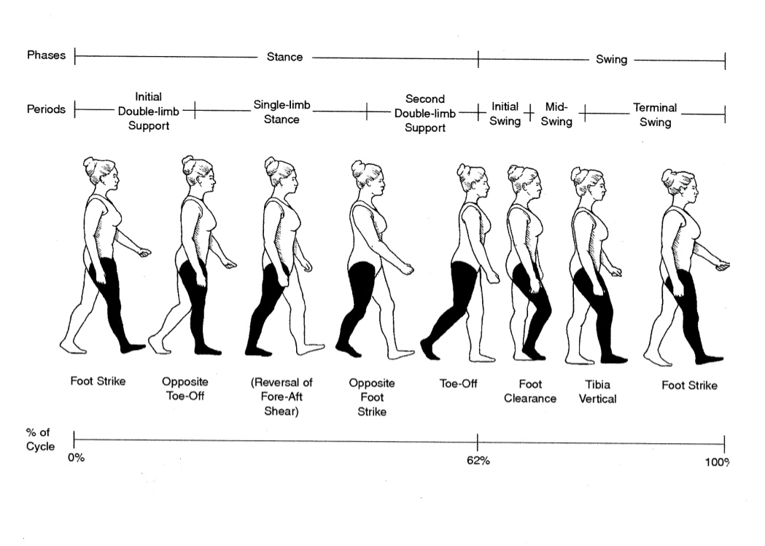

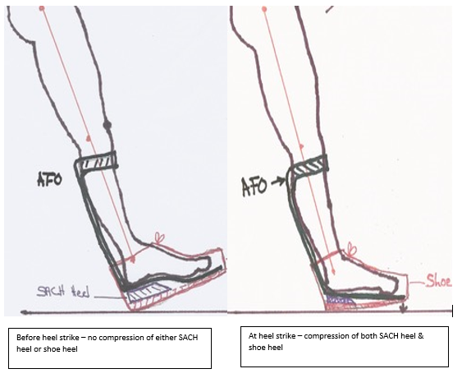

1. **Challenges to success**:
2. Heel strike feels scary at first because you are thrown forward
3. If you land flat footed, you will not get the spring from the brace and you will not walk as efficiently
4. If your knee does not fully straighten – (knee flexion contracture/tightness) – you cannot get an effective heel strike. Must work to stretch out knee flexion contracture
5. Increased muscle tone in either or both legs may make this movement difficult

**6. The Drag**: (slide 36 – 39; video 6)

This is an **ACTIVITY/EXERCISE – NOT a way of walk**ing! Refer to the prior section about Heel Strike before attempting this! This is a technique to teach you to activate heel strike to make your brace work properly. **This is NOT a way to walk!**

1. **Purpose**:
2. Learn what heel strike feels like
3. Learn to pull your leg forward with your hip rather than hip flexors
4. Learn what it feels like to have the brace throw you forward
5. Learn to integrate heel strike into walking pattern
6. **Drag:**
7. MIRROR: You would benefit from doing this activity in front of a mirror so that you can judge whether you are doing it correctly
8. HOLD ON to a counter with your side to the counter
9. Start by standing on your more involved (weaker) leg under you and your stronger leg back – looks like you are taking a step
10. ROTATE the HIP of your stronger leg forward.
11. Let your toe of the back shoe DRAG forward as the HIP rotates forward
12. This should give your stronger leg the momentum to swing the leg forward and land on your stronger leg (heel) HARD!
13. Don’t take a step! Just want get used to the feel of landing HARD on your stronger heel (NOT flat foot) – If you are on a kitchen floor you should hear contact with the floor. It is difficult for your knee to collapse when you do this correctly if there is no knee flexion contracture!
14. Repeat/Practice many times with your stronger leg! You need to learn what it FEELS like to do this activity so that you can later better judge whether you are doing it correctly with your weaker leg.
15. If you do not rotate the hip enough, and do not drag the toe you will not do it right. You do not need to use your hip flexor muscles to do this motion. Watch the video carefully.
16. SWITCH LEGS: Now put the less strong leg/hip back and do this same activity with your weaker leg back. It should look like what you did with your other leg. Watch this in the mirror and the video.
17. This activity can also be done as diagonals that your DBS Orthotist recommends. And the important thing is that you get that hip only rotated forward first

**C. TAKING A STEP**:

1. Start in OSP
2. Then move stronger leg back and weaker one forward
3. HOLD ON to counter!
4. Rotate hip forward and let it pull your leg forward (no toe drag) so that you have heel strike. Keep the movement going as you move your other foot
5. Getting thrown forward: You may feel like you are getting thrown forward when you start taking steps. This is expected and normal. That is why these are DYNAMIC Braces! Do NOT do this until you can do it correctly.
6. Keep practicing. If after a few steps on each leg you are advancing your leg with your hip flexor, STOP! Go back and either rest or start over!
7. NO FATIGUE please!

**D. Challenges to Success:**

1. Knee flexion contracture (your knee doesn’t straighten all of the way)- you will not be able to do the Drag until the contracture is stretched out. Get help!
2. Hip flexion contracture (tightness) - you might be able to do the Drag with less efficiency without stretching it out
3. Plantar Flexion contracture (foot and toes pointing downwards at all times) – With a knee flexion contracture, and with the heel of the shoe built up sufficiently, one might be able to get heel strike
4. Lack of hip rotation
5. Hip abduction contracture (leg is stuck out to the side)
6. Pain anywhere in lower body
7. Fatigue
8. Increased muscle tone in either or both legs may make this movement difficult
9. Your brain telling you: “It can’t be done; I will fall; my knee won’t hold; my body doesn’t do that and, and, and…”
10. These obstacles don’t mean you cannot succeed. They mean your way of doing them may need to be adapted.

**7. Additional Tip**s: (Slide 40)

**a.** Every time you change shoes go back and do your activities

**b.** Stop when fatigued - both muscles and brain

**c.** Hula hoops does not mean using a real Hula Hoop – it means wide rotational movements

**d.** Trunk Control is very important - will improve with some of these activities

**e.** Get HELP when you need it: Orthotist, Physical Therapist, Support Person

**f.** Think how long it takes a football basketball, hockey player, ballerina, ice skater to learn to make their moves - and you want to rush walking efficiently?

**C. Acknowledgement and Thanks to the following people who helped me make this project possible**: (slide 41)

Marmaduke Loke, CO – DBS President –Genius Engineer!

Drew Hittenberger, CP, BOCO

HGI Board: Marny Eulberg, MD, Margaret Hinman, Jim Dean, Mike Mrozowicz

Mary Margaret Wetzler, PT

Lori Kelly, PT

Valerie

Nancy

Donna

Pat

Gloria and Will

Sandy

Terri

Azza

Luz

Linda

Minhaj - humor, inspiration

Kevin - loan of mics, person to whine to, and son

Tami - website help, daughter-in-law

Angela - video help, person to whine to, and daughter

Bjarne and Kennet of AVCOM Video Production for excellent video help

Rachel - AV tech at home!

And all of the rest of you who gave me something to think about!