**5**. **Heel Strike:** (slide 28-35; video 5)

1. **Purpose:**
2. Heel strike tells the entire leg and body to straighten – it’s a neurological response
3. Heel strike triggers the dynamic response of the brace to propel you forward
4. **Typical Gait pattern** includes: forward movement, side to side movements; rotational movements; heel strike; weight bearing; non-weight bearing; push off from the toes
5. **Heel Strike** straightens the knee and activates dynamic response of brace:

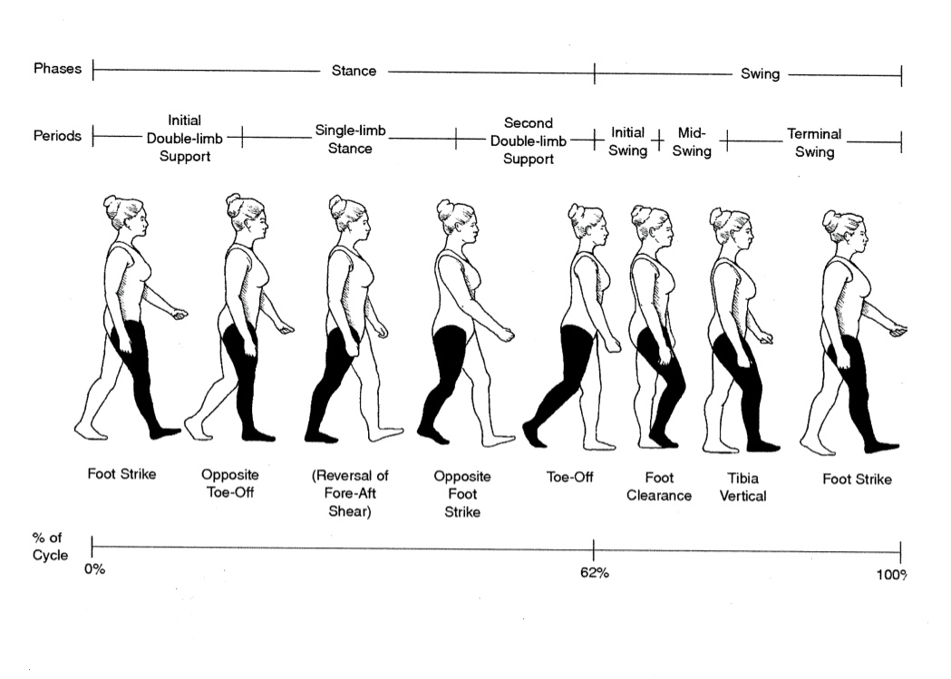

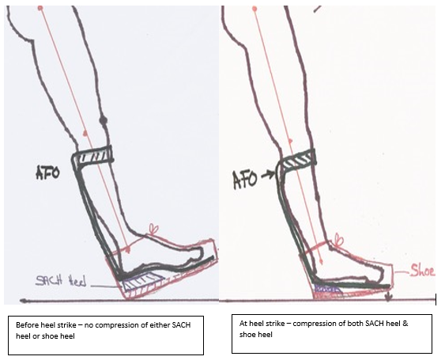

1. **Challenges to success**:
2. Heel strike feels scary at first because you are thrown forward
3. If you land flat footed you will not get the spring from the brace and you will not walk as efficiently
4. If your knee does not fully straighten – (knee flexion contracture/tightness) – you cannot get an effective heel strike. Must work to stretch out knee flexion contracture
5. Increased muscle tone in either or both legs may make this movement difficult