A Human Gait Institute Publication

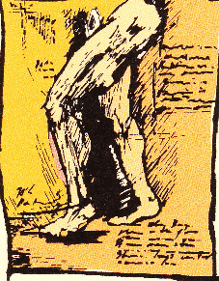

**TIPS AND INSIGHTS**

For Users of DBS Braces

Narrative View

**This document draws on the experiences of those of us who continue to actively explore bracing options with the goal of improving the quality of life of those impacted by musculo- skeletal limitations. www.humangaitinstitute.org**

©2017 Human Gait Institute

Table of Contents

Forward………………………………………………………………………………………….. 2-3

1. Introduction to Tips and Insights………………………………………………… 4
2. About the Development of Tips and Insights………………………4
3. What are Dynamic Bracing Solutions Braces………………………4-6
4. Developmental Perspective in this Work……………………………6-8
5. Purpose of the Project……………………………………………………….8
6. Goals……………………………………………………………………………… 8-9
7. Realities……………………………………………………………………………9
8. Overview of Learning to Use DBS Braces……………………………10
9. Steps in the Process…………………………………………………………. 10-11
10. A Developmental Perspective in the Learning Process…………………. 11
    1. Suggested Items to Use in the Learning Process…………………11-13
    2. Optimal Standing Position……………………………………………….. 13-14
    3. Hip Rotations………………………………………………………………….. 14-16
    4. Side to Sides……………………………………………………………………. 16-18
    5. Importance of Heel Strike………………………………………………… 19-21
    6. The Drag…………………………………………………………………………. 22-24
    7. Additional Tips……………………………………………………………….. 24
11. Acknowledgments and Thanks……………………………………………………25

# Foreword

Tips and Insights for User of DBS Users is a narrative document produced by The Human Gait Institute in accordance with its Mission Statement, which states:

*The mission of the Human Gait Institute is to assist people in reaping the benefits of lower extremity bracing (orthotic) technologies.*

*In support of its mission, the Human Gait Institute seeks to:*

* *explore innovative technologies related to bracing*
* *provide resources to support individuals who are considering or using braces*
* *foster education and training of wearers and professionals*
* *support related research*

*The focus of the original efforts of The Human Gait Institute was to support wearers of Dynamic bracing Solutions orthoses (DBS). This support will continue.*

The ***Human Gait Institute*** (“HGI”) was organized April 11, 2008. It is a Colorado non-profit corporation. It has obtained tax exempt status under Section 501(c)(3) of the federal Internal Revenue Code.

HGI is governed by its five Board members who have a combined 150 years of wearing leg braces, buying over 35 different types of braces. The Board members have gone through the process of obtaining leg braces in some form over these years. They currently all use innovative bracing technology.

The workbook is intended to be copied for personal use only. No part of it can be sold for profit. However, donations to HGI to help defray the cost of the workbook are greatly appreciated.

For questions or to make donations contact:

Dr. Marny Eulberg, M.D.

email: marnyeul@me.com  
phone: 303.829.1538

**Acknowledgements:**

Dr. Marny Eulberg, M.D.

Jim Dean

Margaret C. Hinman

Mike Mrozowicz

Karla Stromberger

©2017 Human Gait Institute

**Tips and Insights**

**For Learning to Use DBS Braces**

1. **Introduction to Tips and Insights Project** (slide 4- )
2. **About the Development of Tips and Insights**: (slide 4)

The videos, narratives and PowerPoints are mainly developed by Human Gait Institute (HGI) Board members, and other interested contributors. Many of the ideas come from visitors to the HGI website (humangaitinstitute.org) or Closed Facebook page. The developers of this information receive no reimbursement from HGI or Dynamic Bracing Solutions (DBS). The initial material has been developed by Karla Stromberger who had polio at the age of 9, and who now wears Dynamic Bracing Solutions braces. Karla is a retired and no longer licensed physical therapist, and presents this material as a DBS wearer and not a PT.

For optimal success it is recommended that you read the Narrative for each topic and then watch the video. Pause the video part way through to do the activity and perfect your movements. The PowerPoint can serve as a summary of the activity

**2.** **What are Dynamic Bracing Solutions Braces?** (slide 5-8)

1. See website [www.dynamicbracingsolutions.net](http://www.dynamicbracingsolutions.net)
2. Short leg (AF) and long leg braces (KAFO)
3. They are different because they have the following:
4. Triplanar Control
5. Dynamic Response
6. Energy Storing and Releasing
7. KAFO for Knee Joint Instability
8. Measuring, casting, fitting, fabricating time
9. Made of carbon fiber composite

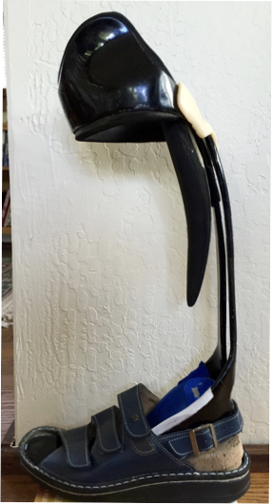

**J)** Components of DBS braces:

1. AFO - 5 piece system
2. Brace
3. Shoe
4. SACH heel
5. The person’s leg
6. Your brain - hardest one to manage!
7. Each brace is custom made/fabricated
8. Each person’s leg is analyzed, measured, and casted for their leg in great detail
9. Analyzed in all 3 planes
10. Provides control/remodeling/support in all 3 planes unlike most other braces

**3. Developmental Perspective in this work**: (slide 9-11)

**a.** Having worked mainly with infants and preschoolers with challenges for most of my career, I have a

developmental focus when observing people moving, and/or re-learning to move after an injury or illness, no matter how long ago the challenge to movement occurred.

**b.** If you developed different/atypical movement patterns before 4 - 5 years of age, your brain may have never developed, and fully integrated, an entirely “normal/typical” neurological pattern of movement. No matter what the age of onset is, many of us have been moving atypically for 10 – 70 years! Changing from the atypical way/pattern to the new one may be very challenging.

**c**. Development progresses in an infant starts at the head down and gradually moves to the feet and hands (cephalo- caudal). An infant works on becoming stable with head raising while on its tummy, back strengthens, abdominal muscles strengthen to give the baby a stable base. Then the shoulders and hips become stable followed later by the arms and legs. As the core/base is stabilizing the neck, trunk, arms and legs move in all directions/planes to provide a stable base for movement. These include side to side, rotational, and diagonal movements all combined together for the purpose of later allowing the baby to move and attain its desires. All of this is done with the purpose of providing a stable base for being upright. One of the things that we often forget is that babies get a lot of sensory feedback from everything they touch, hear, smell, see, and more. These are important pieces for babies learning about their world and motivating them to move. It is important to provide all of these experiences for a person re-learning to

walk no matter what the time of onset of their challenge.

**d.** I like to include the pre-standing components in looking at a person’s overall functioning and try to recognize how those may impact their present-day functioning. Rotation and alternating/reciprocal movements of the body must be considered in one’s present day movement patterns. Let’s jump ahead of rolling and crawling, and look at how infants stand and move initially:

Buttocks back

Feet apart

Knees flexed

Hips flexed

Head up

Arms up a bit holding on

It looks very similar to these babies:

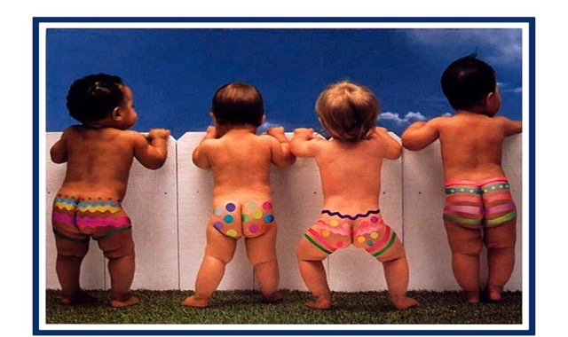

And very similar to how some of us stand and move! These positions allow the baby to develop a stable base for future walking. Note that three babies are standing with a wide base. The one who is standing with his/her feet closer together has more weight on one foot than the other and is looking more to the side. Which baby has the highest level of development in terms of standing?

**e.** This video shows early cruising by an infant:

[**https://www.youtube.com/watch?v=zlXzVRJDPPg&list=PLIEc8cE6zw4RQYd6sW2eQNQbYlvnCanP2**](https://www.youtube.com/watch?v=zlXzVRJDPPg&list=PLIEc8cE6zw4RQYd6sW2eQNQbYlvnCanP2)

See if you can notice some of these things: Side stepping, some difficulty separating legs in side stepping, slight trunk rotation, hands up on couch, stepping onto toes, some head turning (usually comes first), head is down part of the time, buttocks are back, wobbly transitioning to the table, reaching forward and leaning more, nice holding on with one hand with some hip wobble, and nice rotation to look at mom, waving and holding trunk tight to do so.

**4.Purpose of the Project**: (Slide 12)

The project is meant to supplement and break into smaller components the activities your DBS orthotist trained you to do. Hopefully you will be able to attain your goals with greater ease. There are some differences in perspective from what your DBS orthotist taught you to do. These activities will not work for everyone for many reasons. They can be adapted for many people. The project is offered in 3 parts:

Narrative of each activity which parallels the video with more content than the videos

Videos of each activity

Power Point/Keynote to parallel the narratives and the videos

More content will be added to this initial project over time.

1. **Goals** in putting this project together: (slide 13)

Supplement the recommended activities and break them down into smaller components if needed

Help you learn to TRUST the brace and, therefore, be able to move/walk more efficiently

Help you do the work of retraining your brain to move differently than you have before, or, attempt to re-create how you moved before your movement challenge occurred.

Help you use what already works for you and allow it to work to attain your highest functional level in your brace/s. This would allow you to move with greater efficiency and less energy expenditure.

Help you develop an awareness of how your body moves and what it feels like when you move more efficiently

Be Safe at all times. It is very difficult to learn a new movement pattern if you do not feel safe

Encourage you to not rush the process! It takes time to retrain the brain

Assist you in knowing when your brain and/or your body are reaching point of fatigue so that you will stop at that point

**6. Realities!** (slide 14)

1. There are no guarantees that the information in this project will work for you. These activities may not ever work for some of you for many reasons.
2. Each of us is VERY different. No one will ever walk like I do, or like anyone else in the world. Thus, NEVER compare how you are walking with anyone else.
3. Asking another DBS wearer how long it took them to learn to use their braces is not a predictor of how you will do. We are ALL different!
4. One must commit to doing the work necessary to learn to use the braces. Get support when needed: family member/friend, orthotist, physical therapist, another person
5. There will be progress and there will be regressions. Every regression has a purpose of stabilizing the base in order for more progress to occur so that you can move forward with greater stability!

**7. Overview of learning to use DBS braces:** (slide 15) **a.** Change in how you move/walk requires **1000** repetitions of each single activity to break up old movement patterns and integrate new ones. You cannot do 1000 in one day – your muscles will fatigue – your brain will fatigue. Nobody learns well when fatigued!

**b.** Doing an activity your “old way” reassures your brain that it does not have to be retrained and that the old way is

best. This may be the hardest part of learning to use these braces!

**c. Do Not Rush** any of these activities! You want your brain to learn the new way of moving. There is NO QUICK FIX! That way you will really integrate the new pattern of movement

**d.** Practice 10 -20 min 1 to 3 times per day; increase when there is no fatigue. FATIGUE is not your friend! If you feel fatigue the next day you have done too much

**e.** Being tired or sick, causes you revert to old patterns. It is very hard to retrain your brain at those times! Just rest!

**f. COMMIT** to the process! Keeping that commitment when you are seeing no progress, or are plateaued for a while is most challenging in learning to use these braces

**g.** The work is yours to do. Another person cannot do the work for you. They can only give you guidance and support on how to do it

**h.** Take a day off on occasion. It’s called REST

**i.** Sit around in your braces to get the feel of them even if you are unable to walk in them yet

**j.** Do the activities in the order presented. They are a developmental progression so would be best to start with Optimal Standing Position (OSP) and end with the Drag.

**k. YES**! The activities are BORING! Let it be a meditation on your future walking

**8. Steps in the Process:** (slide 16)

1. Always start in optimal standing position – (OSP)
2. Head/ shoulders always in midlineand make them STAY there – Only Hips, knees and feet move. Watch this in the mirror
3. Start with feet farther apart gradually moving them closer together
4. Hold on to counter more firmly at first, then gradually reduce need to hold as quality of the movements remain consistent
5. Make smaller symmetrical movements at first progressing to wider movements
6. Start with slow movements, progressing to faster ones
7. As you hold on lessthe width of the movements will decrease – you want quality to remain consistent
8. ALWAYS want SYMMETRY in all movements
9. Have a friend take a video of your progress at the end of a given period of time (a week or two) to see how you are doing
10. If there is a knee or hip flexion contracture/tightness, work with a PT prior to receiving the braces to help reduce this tightness
11. There will be a Pre-DBS video in the future
12. At the end of a week of two of doing these activities, have a friend take a video of you and watch it to see how you did