# Smart Light

Smart Light 1

Pictures 2

I. Introduction 3

II. Smart Light 3

1. Hardware 3

a) Esp8266 Node MCU 3

b) Avoidance Module 4

c) Photo resistor Module 4

d) RGB LED Module 5

e) Button Module 6

f) LED 6

2. Software 6

a) Arduino 6

b) ESP8266 Free RTOS 7

c) Web Design 7

3. Operation of Smart Light 8

4. Advantages and disadvantages 11

a) Advantages 11

b) Disadvantages 11

5. Future development 11

# Pictures

Figure 1. Esp8266 Node MCU 3

Figure 2. Avoidance Module 4

Figure 3. Photo resistor Module 5

Figure 4. RGB LED Module 5

Figure 5. LED 6

Figure 6. Web Server 8

Figure 7. Working principle IR 8

Figure 8. Smart light diagram 9

Figure 9. Operation Model 10

# Introduction

Update the trend of Smart Light development in Appliances and Industry, not only so Smart Light also applied in Smart Car Technology such as identified light, identifying gesture people... Smart Light is applied in many fields; this project is the choice for newbies to learning about embedded programming... In this project, our team introduces about Smart Light Application in identified daytime light and gesture of people to turn on/ turn off the light, detect impediment.

# Smart Light

Hardware

### Esp8266 Node MCU

After many years of development, there are now more than 14 ESP versions have been released, of which the most popular are the ESP-12. The ESP-12 module incorporates the ESP8266 firmware on the Arduino and the standard communication hardware design that makes up the Node MCU, kit Development ESP8266 common in the current. With usage, connect easy, you can programming, load the live program on the Arduino software, same as interactive with the Arduino library available, Node MCU is the first choose for you want to find understand the current ESP8266.

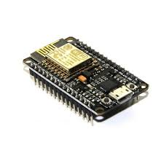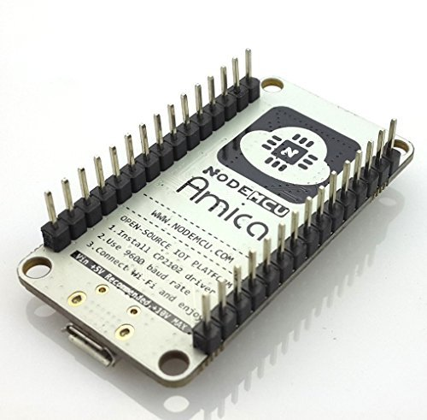

Figure 1. Esp8266 Node MCU

### Avoidance Module

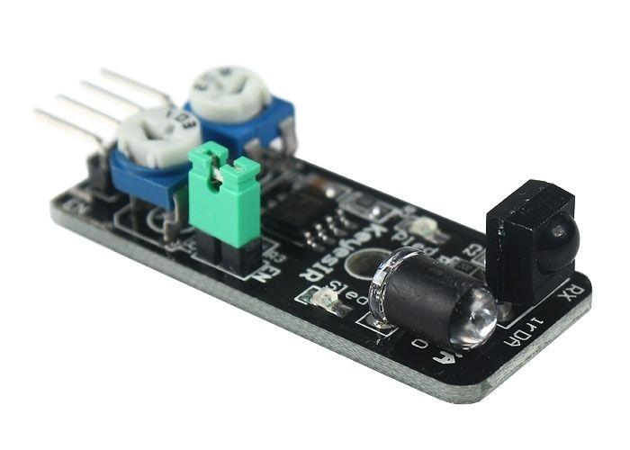IR-reflection sensor, useful for obstacle avoidance applications. When an obstacle is in front of the IR sender/receiver the ‘Out’ pin is switched low (active low). Working voltage 3.3V-5V.The circuit sensitivity can be adjusted with a pot. The obstacle detection distance can be adjusted up to approximately 7cm. An enable (EN) jumper can be fitted for continuous operation. Removal of the EN jumper allows an external logic signal (at the EN pin) to switch the detector on and off (low = active, high = off).

Figure 2. Avoidance Module

### Photo resistor Module

Photo resistor Module also is known as Light Dependent Resistors (LDR), are light sensitive devices most often used to indicate the presence or absence of light, or to measure the light intensity. In the dark, their resistance is very high, sometimes up to 1MΩ, but when the LDR sensor is exposed to light, the resistance drops dramatically, even down to a few ohms, depending on the light intensity. LDRs have a sensitivity that varies with the wavelength of the light applied and are nonlinear devices. LDR used to measure light intensity. It can determine the presence or absence of light.  
This module consists of a photo resistor and a 10kΩ in-line resistor:  
Turn left (look in the direction from bottom to optical): you will increase the sensitivity of the sensor with light: only need a small amount of light will break the circuit.  
Turn to the right: You will reduce the sensitivity of the sensor to light, requiring more intense light to switch off the circuit. The photo resistor's resistance will decrease in the presence of light and an increase in the absence of it. The output is analog and determines the intensity of light (Operating Voltage: 3.3V to 5V & Output type: Analog).  
Input: middle (+) +5V  
(-) GND  
Output: (S) signal 1/0 (True/False).

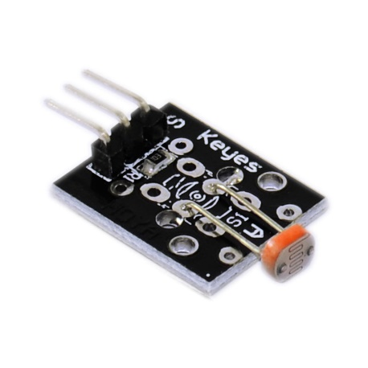

Figure 3. Photo resistor Module

### RGB LED Module

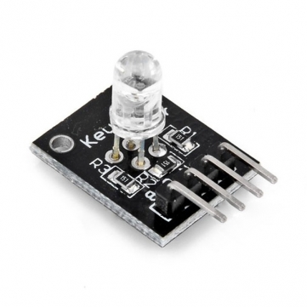An RGB LED is a combination of 3 LEDs in just one package:  
1x Red LED  
1x Green LED  
1x Blue LED  
The 3 LEDs can share the cathode, this results in an RGB LED that has 4 pins, one for each LED, and one common cathode. You can create one of those three colors – red, green or blue – by activating just one LED, or you can produce other colors, you can combine the three colors in different intensities. To generate different colors you can use PWM to adjust the brightness of each LED.  
Input: R: +5V (The anode of Red LED)  
B: +5V (The anode of Blue LED)  
G: +5V (The anode of Green LED)  
GND: GND  
Output: The light

Figure 4. RGB LED Module

### Button Module

Pushbuttons connect two points in a circuit when you press them. Once you've got pushbutton working, you often want to do some action based on how many times the button is pushed. To do this, you need to know when the button changes state from off to on, and count how many times this change of state happens. This is called **state change detection** or **edge detection.**

### LED

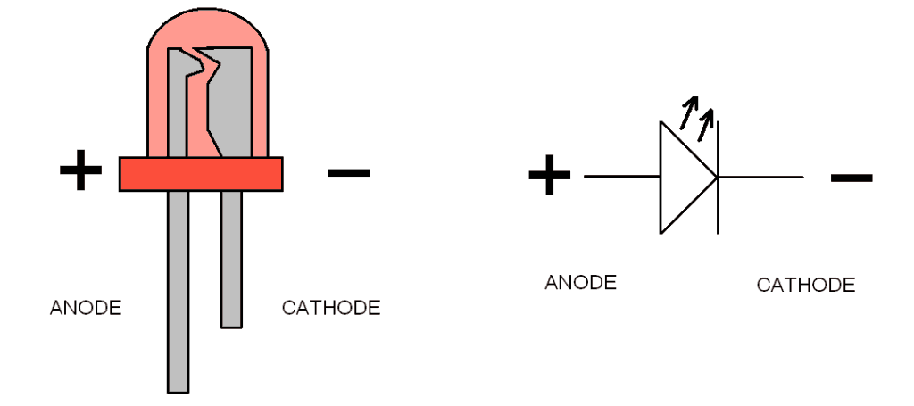An LED is a small component that gives light. LED stands for Light-Emitting Diode. It’s a type of diode that emits light when it has a current flowing through itself. An LED needs about 2 volts and about 15-20 mA to lit up. But this varies among different LED types. If you run too much current through an LED, it will get really hot and break down. That’s why the resistor is there – to control how much current that goes through the LED. We call this a current limiting resistor.

Figure 5. LED

## Software

### Arduino

Arduino's integrated development environment(IDE) is a cross platform application written in Java , and from this IDE it will be used for the programming language and for the project. It is designed for beginners familiar with the field of software development. Users only need to define two functions to create a program loop execution (cyclic executive) can run:

* setup()This function runs every time a program is started, used to set the settings
* loop()This function is called repeated until the circuit board is shut off

### ESP8266 Free RTOS

Developed in partnership with the world's leading chip companies over a 14 year period, the Free RTOS Kernel is a market leading real time operating system (or [RTOS](https://esp8266.vn/freertos-sdk/freertos-sdk/)), and the de-facto standard solution for microcontrollers and small microprocessors.

Free RTOS is truly free and supported, even when used in commercial applications. The Free RTOS open source MIT license does not require you to expose your proprietary IP. You can take a product to market using Free RTOS without even talking to us, let alone paying any fees, and thousands of people do just that

### Web Design

Web design control turn on, turn off from the server.

Web design in HTML, CSS, JavaScript, PHP.

Displaying light led from Node MCU on host.

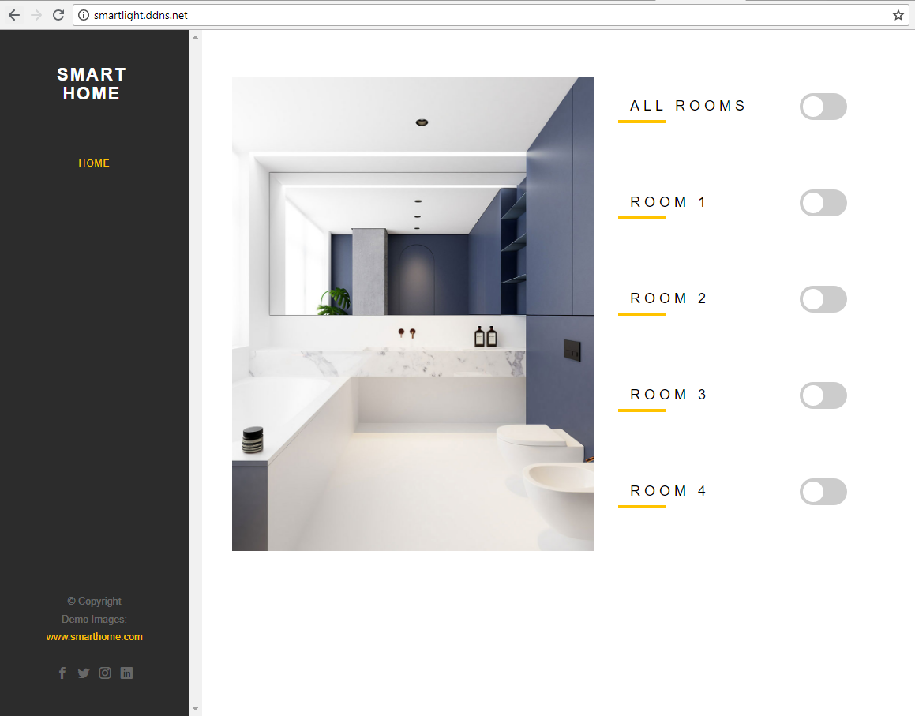Switch “Room 1”, “Room 2”, “Room 3”, “Room 4” control the light of 4 room in the house. And switch all rooms control all of them.

Figure 6. Web Server

## Operation of Smart Light

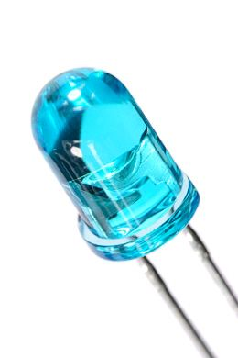

RGB led light when responding enough the sensor condition

**Avoidance Module**

The IR transmitter sends an infrared signal that, in case of a reflecting surface (e.g. white color), bounces off in some directions including that of the IR receiver that captures the signal detecting the object.

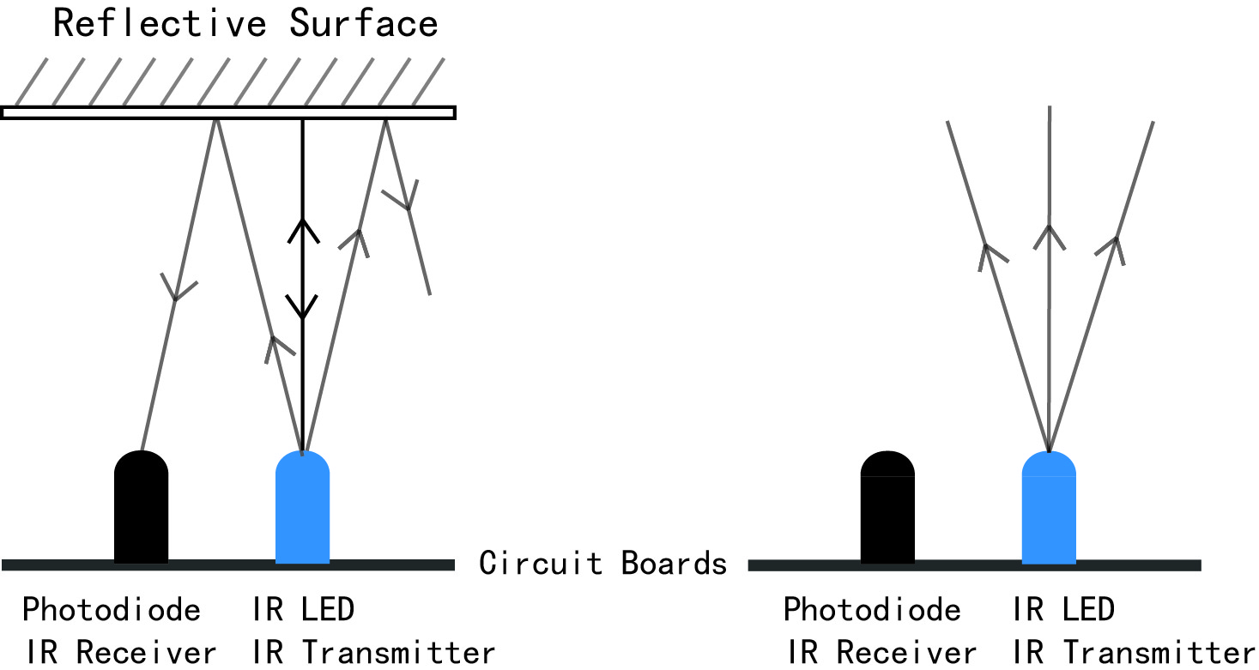

Figure 7. Working principle IR

When the surface is absorbent (e.g. black color) the IR signal isn’t reflected and the object cannot be detected by the sensor. This result would occur even if the object is absent.

**Photo resistor Module**

When the value read from the photo resistor sensor module goes below the threshold value, i.e. it becomes dark, the RGB LED is switched on. The LED is switched off when the analog value from the sensor goes above the threshold value.

A threshold value can be selected by using the previous sketch to determine the analog value at the desired light level when the LED should be triggered. The value assigned to the threshold variable at the top of the sketch can then be set to the new value

**Button Module**

When we press the button, it will send an analog to the ESP8266 Node MCU. The ESP8266 will turn off all system. It mean all of the light cannot turn on whatever sensor does.

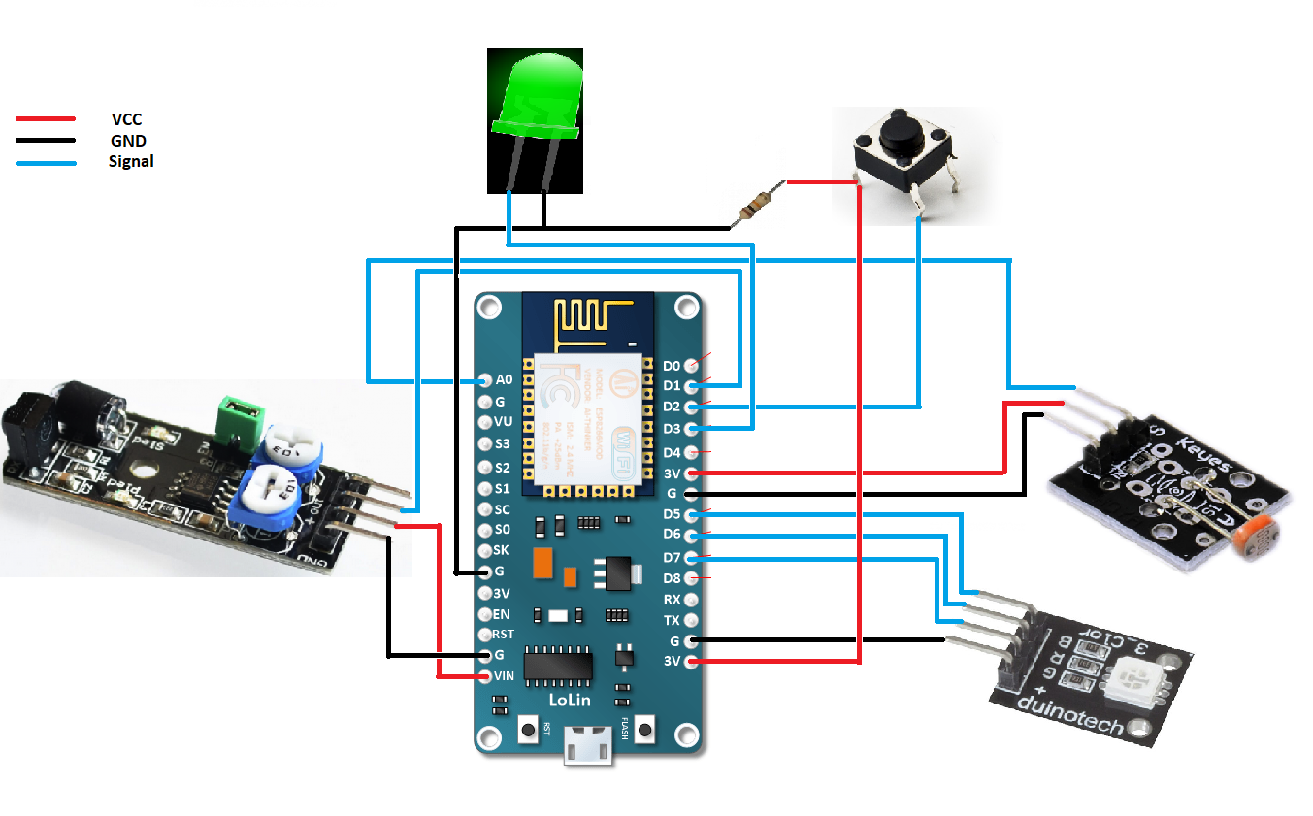

Figure 8. Smart light diagram

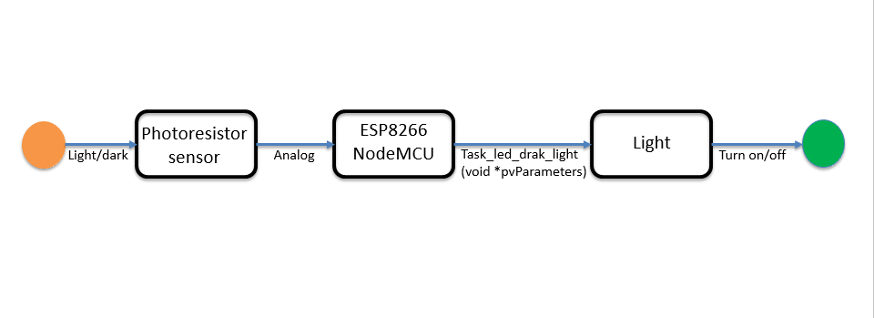

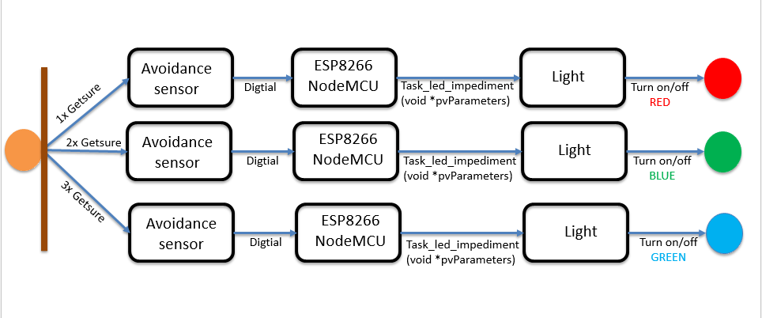

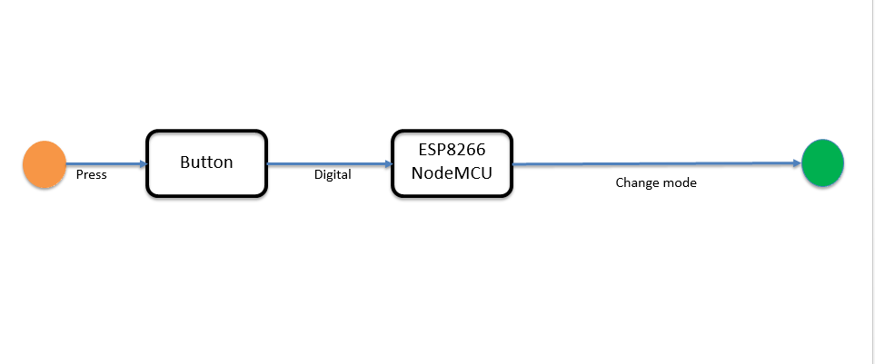

Figure 9. Operation Model

## Advantages and disadvantages

### Advantages

* The system is compact, easy to install
* The photo resistor module has the Infrared Obstacle Avoidance Sensor has Power, Ground, Signal, and Enable Pin
* Can develop more applications than the observation...

### Disadvantages

* Sensor is weak so sensitivity is low and delayed
* Delay up to a few seconds

## Future development

* Retreat
* Detecting light
* Predictable collisions (front and behind)