FT260 support lib 1.1.7 - Revision Comments

The files included in a standard support lib release are:
- FT260 Interface
  - LibFT260.h
  - Dynamic library
    - i386\LibFT260.dll (32-bit)
    - i386\LibFT260.lib (32-bit)
    - amd64\Lib260.dll (64-bit)
    - amd64\LibFT260.lib (64-bit)

- Sample codes
  - In Sample folder, LibFT260_examples.sln can be used to browser all samples.
  - This Sample code is linked to Dynamic library

On making a new release the files will be posted on FTDI’s web site https://ftdichip.com/products/ft260q/ in ZIP file format.

If the version is lower than or equal to 1.1.5. Libft260 bases on Microsoft Visual C++ 2010 x86 and x64 Redistributable package.
Please install the below package on the target machine.
https://docs.microsoft.com/en-us/cpp/windows/latest-supported-vc-redist?view=msvc-170
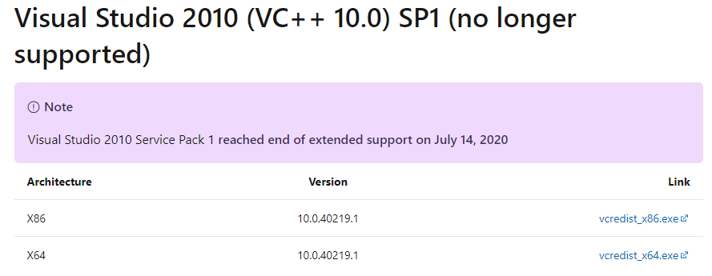
If the version is higher than or equal to 1.1.6. Microsoft Visual C++ 2010 runtime library is built in LibFt260. The user does not need to install Microsoft Visual C++ 2010 x86 and x64 Redistributable package on the target machine.
Release version
1.1.7 (May 22, 2024)
Maintenance release.

Release Fixes

- Fixed memory leak

Release version
1.1.6 (Oct 26, 2022)
Maintenance release.

Release Fixes

- Microsoft Visual C++ 2010 runtime library is already built in

Release version
1.1.5 (Feb 7, 2022)
Maintenance release.

Release Fixes

- In some specific pcs , it may occur error on API FT260_OpenByVidPid/FT260_OpenBySerialNumber/ FT260_OpenByVidPid even the device is ready.

Release version
1.1.4 (Mar 26, 2021)
Maintenance release.

Release Fixes

- Fix wrong parameters in API FT260_SetParam_U16

Release version
1.1.3 (Nov 16, 2020)
Maintenance release.

Release Fixes

- The same interface can be opened more than one time.
- Make 100K to 400 i2c frequency more accurately.
- Add API FT260_OpenBySerialNumber
- Add combined message support for i2c
- Sort device path

Release version
1.1.2 (July 30, 2019)
Maintenance release.

Release Fixes

- Add API FT260_SetGPIOToUartPin
- Add timeout to APIFT260_I2CMaster_Read
- Add API FT260_GPIO_Set_OD/FT260_GPIO_Set_OD to set opendrain

Release version
1.1.1 (Nov 14, 2018)
Maintenance release.

Release Fixes

- Initial version

