Design the simulation application as shown below:

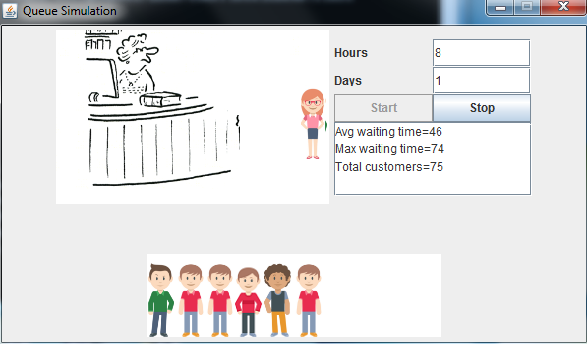

A recorded video is posted on blackboard.

Please implement as much as possible.