Product Requirements Document (PRD): Market Intelligence Swarm
1. Overview
Product Name
Market Intelligence Swarm - An AI-powered competitive intelligence platform
Vision Statement
To democratize market intelligence by providing real-time, actionable insights through automated data aggregation and AI analysis, enabling businesses to make informed strategic decisions without expensive consulting services.
Problem Statement
Businesses struggle to:
- Monitor competitors effectively in real-time
- Process vast amounts of market data efficiently
- Separate signal from noise in financial news and social media
- Access affordable, comprehensive market intelligence
- Generate actionable insights from unstructured data
Solution
A dual-architecture platform combining:
- Web Dashboard: Real-time market sentiment visualization
- AI Agent System: On-demand competitive analysis

2. Product Architecture
2.1 Dual-Mode System
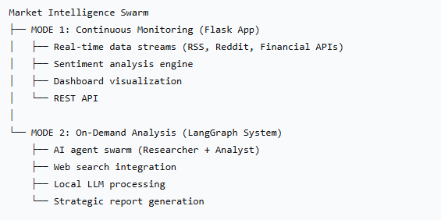
2.2 Core Components
Component A: Flask Web Application
- Purpose: Continuous market monitoring
- Key Features:
  - Real-time sentiment tracking
  - Trending stock identification
  - Multi-source data aggregation
  - Historical data caching
  - Web dashboard interface
Component B: LangGraph Agent System
- Purpose: Deep-dive competitor analysis
- Key Features:
  - Multi-agent workflow orchestration
  - Live web research capability
  - Strategic analysis generation
  - Local LLM integration (Ollama)
  - Structured report output

3. User Personas
Primary User: Small/Medium Business Owner
- Needs: Competitive insights without large budgets
- Use Case: Weekly competitor check, market entry decisions
- Technical Level: Basic
Secondary User: Financial Analyst
- Needs: Quick sentiment analysis, trend spotting
- Use Case: Daily market scanning, report supplementation
- Technical Level: Intermediate
Tertiary User: Startup Founder
- Needs: Market positioning insights
- Use Case: Investor pitch preparation, competitive landscaping
- Technical Level: Basic-Intermediate

4. Functional Requirements
4.1 Core Features
FR-001: Real-time Market Monitoring
Description: Continuous collection of market data from multiple sources
Acceptance Criteria:
- Collects from ≥3 RSS feeds every 5 minutes
- Monitors ≥4 Reddit communities
- Tracks major market indices (S&P 500, NASDAQ, DJIA)
- Caches data for 10 minutes minimum
- Processes ≥100 articles per update
FR-002: Sentiment Analysis Engine
Description: Analyze sentiment from text content
Acceptance Criteria:
- Classifies sentiment as positive/negative/neutral
- Tracks sentiment per stock symbol
- Calculates percentage positive sentiment
- Processes both news and social media content
- Updates sentiment in real-time
FR-003: Trending Stock Detection
Description: Identify frequently mentioned stocks
Acceptance Criteria:
- Extracts stock symbols from text
- Ranks stocks by mention frequency
- Displays top 20 trending stocks
- Filters invalid symbols (<6 characters)
- Updates trending list every 5 minutes
FR-004: AI Agent Research System
Description: On-demand competitor analysis
Acceptance Criteria:
- Accepts company name input
- Searches web for latest information
- Processes raw data through LLM
- Generates structured report
- Provides strategic recommendations
FR-005: Web Dashboard
Description: User interface for data visualization
Acceptance Criteria:
- Displays real-time sentiment metrics
- Shows trending stocks table
- Presents top news articles
- Visualizes market index performance
- Provides force-refresh capability
4.2 API Requirements
FR-006: REST API Endpoints
- GET /api/intelligence - Get current market intelligence
- GET /api/intelligence/refresh - Force data refresh
- GET /api/health - System health check
- Response Format: JSON with timestamp, data, metadata

5. Non-Functional Requirements
NFR-001: Performance
- Dashboard loads in <3 seconds
- API response time <2 seconds
- Supports 100 concurrent users
- 99% uptime for data collection
NFR-002: Scalability
- Modular architecture for easy expansion
- Configurable worker count (default: 5)
- Adjustable update intervals
- Cache system for reduced API calls
NFR-003: Cost Efficiency
- Uses only free-tier APIs
- No paid data source dependencies
- Local LLM processing (Ollama)
- Open-source stack
NFR-004: Privacy & Security
- No user data storage required
- API key management via environment variables
- CORS enabled for web access
- Input validation on all endpoints
NFR-005: Usability
- Simple command-line interface for agent system
- Intuitive web dashboard
- Clear error messages
- Comprehensive logging

6. Technical Specifications
6.1 Technology Stack
Backend Framework: Flask (Python)
AI Framework: LangGraph
LLM Integration: Ollama (llama3.2)
Web Scraping: BeautifulSoup4, feedparser
Financial Data: yfinance
Async Processing: asyncio, aiohttp
Data Processing: pandas, numpy
6.2 Data Sources
- News: Yahoo Finance, CNBC, Reuters, CNN RSS feeds
- Social: Reddit (r/stocks, r/investing, etc.)
- Financial: yfinance (free), Alpha Vantage (optional)
- Web Search: DuckDuckGo (via search API)
6.3 System Architecture Diagram
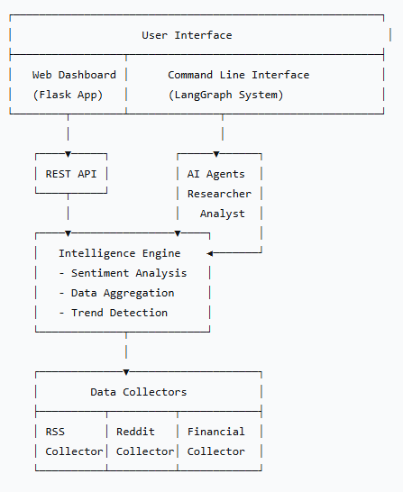

7. User Flows
Flow 1: Continuous Monitoring (Passive User)
User opens dashboard → System displays current intelligence
→ User views sentiment metrics
→ User checks trending stocks
→ User reads top news
→ (Optional) User refreshes data
Flow 2: Deep Analysis (Active User)
User runs agent system → Enters competitor name
→ Researcher agent searches web
→ Analyst agent processes data
→ System generates report
→ User receives strategic analysis

8. Success Metrics
Quantitative Metrics
- Data Freshness: <5 minutes for market data
- Sentiment Accuracy: >85% human-aligned classification
- System Uptime: >99% availability
- Processing Speed: <30 seconds for agent analysis
- API Latency: <2 second response time
Qualitative Metrics
- User satisfaction with insights quality
- Ease of setup and use
- Actionability of generated reports
- Dashboard clarity and usability

9. Future Roadmap
Phase 2 (Next 3 Months)
- Additional data sources (Twitter/X, SEC filings)
- Advanced sentiment models (BERT-based)
- Alert system for significant events
- Historical data analysis
- Export functionality (PDF/CSV)
Phase 3 (Next 6 Months)
- Predictive analytics
- Custom watchlists
- Multi-company comparison
- API key for external integration
- Mobile responsive design
Phase 4 (Next 12 Months)
- Industry-specific modules
- Advanced visualization (charts, graphs)
- Team collaboration features
- Scheduled report generation
- Plugin architecture
10. Constraints & Assumptions
Constraints
- Must use free APIs where possible
- Local deployment focus (not cloud-native)
- Limited to English language content
- No real-time stock trading recommendations
- Educational/research purposes only
Assumptions
- Users have basic Python knowledge for setup
- Local LLM (Ollama) is installed and configured
- Stable internet connection available
- Free API limits won't be exceeded
- Users understand financial market risks

11. Risks & Mitigations
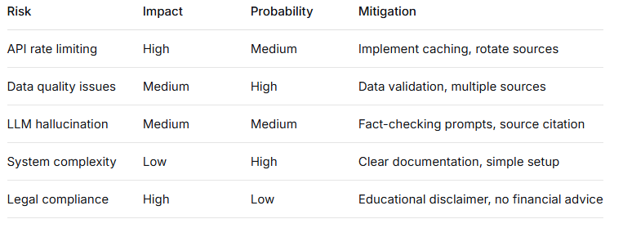

12. Open Questions
- Should we add user authentication?
- How to handle non-US stock markets?
- What's the optimal cache duration?
- How to scale for enterprise use?
- Should we add database persistence?

Document Version: 1.0
Status: Draft for Review
Stakeholders: Product Team, Engineering, Design, QA

