David Kurniawan – Homework 3 – MongoDB

Link GitHub : <https://github.com/davidkurniawan947/mongo_hw>

1. Find all books authored by "Author 5" that have been borrowed by any user but not yet returned.

Query:

{

"author": "Author 5",

"borrowed_by.return_date": null

}

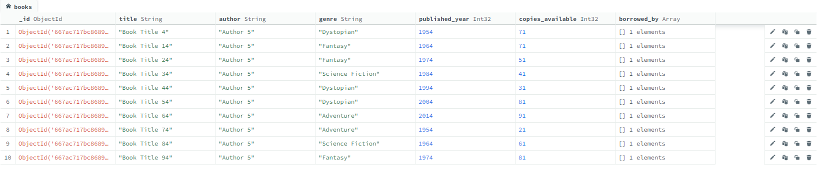

1. List all books published before the year 1980 and have more than 5 copies available.

Query:

{

"published_year": { "$lt": 1980 },

"copies_available": { "$gt": 5 }

}

1. Find the top 5 most recently published books in the "Fantasy" genre.

Query :

{

"genre": "Fantasy"

}

Sort :

{

"published_year": -1

}

Limit : 5

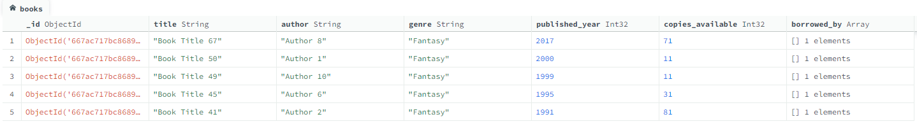

1. Count the number of books available for each genre.

$group stage :

{

"_id": "$genre",

"count": { "$sum": 1 }

}

1. Find all books that have never been borrowed by any user.

Query:

{

"$or": [

{ "borrowed_by": { "$exists": false } },

{ "borrowed_by": { "$size": 0 } }

]

}



Tidak ada bukuk yang tidak dipinjam, keseluruhan buku kini sedang di pinjam oleh para user aktif.