Technical Paper

Configuring and Operating Streamed Processing in PeopleSoft Global Payroll
Prepared By David Kurtz, Go-Faster Consultancy Ltd.
Technical Paper
Version 0.01
Friday 8 May 2009
(E-mail: david.kurtz@go-faster.co.uk, telephone +44-7771-760660)
File: 0000.doc, 8 May 2009

Contents
Contents 1
Introduction 4
Caveat 4
Streaming 5
Benefits of Streaming 5
Drawbacks of Streaming 6
Read Consistency 6
Causes of Consistent Read 7
Physically Separating the Streams 7
Avoiding Consistent Reads 7
Partitioned Result Tables 8
Range Partitioning 8
Partition Elimination 8
Sub-Partitioning 9
Range Partitioning, List Sub-Partitioning 9
Global Temporary Working Storage Tables 10
Payroll Calculation 10
Implementation Recipie 12
Phyiscal Database Changes 12
PeopleSoft Configuration Changes 12
Physical Database Changes 14
How many streams? 14
Single Server Example 14
Two Server Example 14
Calculate Stream Boundaries 15
Create Tablespaces 15
Range Partitioned Tables 15
List Sub-Partitioned Tables 15
Building the Partitioned & Global Temporay Tables 16
Other Database Configuration Issues 16
Temporary Space Management 16
Partitioning & Parallel Query 17
Optimizer Statistics 17
Reversing the Changes 17
PeopleSoft Configuration Changes 18
Definition of the Streams 18
Newly Hired and Terminated Employees 18
Specification of Streams 18
Process Scheduler Configuration 20
Process Type Definitions 20
Process Definitions 22
Job Definitions 25
Server Definition 27
Other Configuration Issues 28
Calendar Group ID 28
Run Controls 29
Operational Issues 33
Rebalancing the Streams 33
Bugs & Fixes 33
AE.GPGB_PSLIP 33
Scripts 34
Tablespaces for Partitioned Tables (genpartspc.sql or mkpartspc.sql) 34
Calculate Stream Range Values (gpstrmit.sql) 38
Preventing Accidental Stream Boundary Changes (nostrmchg.sql) 40
Stream Test (strmtest.sql) 40
Stream Volume Reports (strmvols.sql) 42
DDL Build Scripts 47
gfcbuild.sql 47
gfcbuildone.sql 47
gfcbuildpkg.sql 48
Global Payroll Meta Data (gp-partdata.sql) 51
Spool Output (gfcbuildspool.sql) 58
Sample Output - Partitioned Table 59
Sample Output - Global Temporary Table 63
Process Type Definitions (gen_prcstypedefn.sql) 63
Process Definitions 64
Payroll Calculation 64
Banking and GL processes (gen_prcsdefn2.sql) 68
Job Definitions 72
Payroll Calculation Job (gen_prcsjobdefn.sql) 72
GL and Banking Jobs (gen_prcsjobdefn2.sql) 74
Server Process Types(gen_serverclass.sql) 81
Run Control Management 82
Run control builder for Payroll Calculation (gpcalcall849.sql) 82
Run control copier for Payroll Calculation Process (gpcopy.sql) 84
Run control builder for Banking process (gppmtprep.sql) 86
Run control builder for GL Process (gpglprep.sql) 88

Introduction
This document has been prepared to explain the changes need and the operation of ‘Streamed’ processing in PeopleSoft Global Payroll (GP). It is based on a generic technical paper, specific customer installations may require particular configurations..
By splitting each of the major payroll processes into a number of sections that can be run simultaneously it is possible to reduce overall execution time by utilising additional available system resources. PeopleSoft refers to each of these sections and concurrent processes as streams.
It is necessary not simply to configure the streaming option, but also to make certain configuration changes to PeopleSoft, and some physical changes to the database. These changes are set out in the Implementation Recipie (see page 12).

Caveat
This is still a draft document. If you have any comments or queries please contact me and I will be happy to make updates.

Streaming
The Global payroll processes are typical financial batch process. Although the detailed aspects of the application are complicated, the architecturally concepts are quite straightforward. They are all simple two-tier processes. The payroll calculation process is written in COBOL, although the other processes use Application Engine.
PeopleSoft COBOL process can only run on on one CPU at any one time. There is not multi-threading. Therefore, to reduce processing time, and to make full use of a multi-CPU machine it is necessary to run a number of processes in parallel.
Streaming is the term that PeopleSoft uses to describe breaking the set of employees for whom Payroll is to be calculated into a number of subsets and processing each subset with a separate COBOL program. These COBOL processes can then be run in parallel. PeopleSoft, rather confusingly, uses the term ‘stream’ to refer to both the process and the subset of data being processed.
The ‘streaming’ facility is a part of the GP product delivered by PeopleSoft. Using it is not a matter of application customisation, but rather one of configuration.
It is only possible to have a single, global definition for the stream boundaries. If there are different calendars, either for different companies or legislatures, or for different frequencies, then it is not possible to balance the streams for each frequency. Some sort of compromise must be be made. This is also why multiple payrolls with the same frequency may as well be processes in the same run.
At some companies employees and pensioners are paid monthly. They are in different pay groups, but where they have the same pay frequency, generally they have still been set up to processes together.
In this paper, most attention will be given to GPPDPRUN, the payroll calculation process, but the banking and GL process can also be run in streams.

Benefits of Streaming
The Global Payroll calculation program is capable of fully utilising up to one processor while it is not waiting for the database. When it waits for the database, either the Oracle shadow process or the core, database server processes will consume processor time.
Therefore, a single payroll calculation process is incapable of using more than a single CPU. Modern UNIX servers have many CPUs. I have worked on some that have as many as 20 CPUs of each node of a two-node cluster. The objective has been mimimise the time taken to calculate payroll, by utilising all available CPUs and by running a number of instances of the GP engine in parallel. With the physical database changes described below it has been possible to run a GP calculation with as many as 36 streams in parallel, without significant inter-stream contention in the database.
The streams are defined as ranges of employee IDs. The decision to use employee ID was made by PeopleSoft. There is no option for the customer to use a different attribute or a different method of partitioning.

Drawbacks of Streaming
That sounds straightforward, but if streaming can produce some technical challenges. When it is enabled on an otherwise vanilla PeopleSoft/Oracle installation the usual result is that all but one of the streams will fail with Oracle error 'ORA-1555, Snapshot too old, Rollback Segment Too Small'.

Read Consistency
One of the principles at the heart of Oracle is 'read consistency'. This means that the version of data that any user sees is consistent throughout the life of a query. When a query reads a block from the database it checks that it has not changed since the query started. If it has changed, then the database duplicates the block in memory and recovers the copy back to the state it was in when the query started. This undo information is obtained from the undo segment. If the undo information is not available, then the query will raise the 'Snapshot Too Old' error. The important thing to remember is that the query fails because somebody else has changed the data that the failed process was trying to read.
The additional copies of the block increase the memory demands on the buffer cache, forcing other blocks to be aged out. This can lead to increased datafile I/O (you would observe a fall in the buffer cache hit ratio).
As updates are made, the undo information is written to the rollback segment. The undo segments behave as circular buffers. When the end of the undo segment is reached, the database goes back to writing data at the start again. This is called wrapping. Entries in the undo segment that relate to uncommitted changes cannot be overwritten. Oracle will also attempt to preserve undo information in the undo segment for at least as long as is specified by the parameter undo_retention. Oracle will extend the undo segment if no data can be overwritten. So, if an update was made shortly after the query started, and was the committed, and then many other updates were made, all while the long running query was still running, then the undo information may well have been overwritten.
This makes read consistency sound like an expensive problem, but in fact is it one of reasons to buy Oracle in the first place. The processes that guarentee read consistency are highly sophisticated, and lie at the very heart of the database kernel. However, performing a consistent read is an extremely expensive operation and should be avoid where possible.
In the case of Global Payroll the queries are cursors that are kept open during almost the entire calculation process. Rows are only fetched as required by the calculation. So queries may be long running because the application takes time to deal with the data that they produce.
The payroll calculationg writes batches of result data to the database, and commits after batch insert.

Causes of Consistent Read
As described above, a consistent read, occurs when a user starts a long running query, and somebody else updates the data blocks being queried. However, a long running delete or update is also a long running query because first you have to find the rows being updated or deleted. If two sessions are both running a long running update on the same table at the same time, they can update a completely distinct set of rows, thus never locking each other out. However, if they update different rows in the same block then it is possible for the first transaction to update at least one session will have to perform a consistent read on that block.
If GP payroll streams are run in parallel where the result and working storage tables are not partitioned, then it is likely that most of the data blocks in these tables will contain rows required by most of the streams. This effectively guarantees that a significant amount of consistent read will be take place.
During the cancellation phase the results are deleted from the result tables using monolithic delete statements. All the data is copied to the undo segments. The undo segment must be large enough to hold all of the data for any one pay period without wrapping otherwise payroll streams will fail with an ORA-1555 error.
So, consistent reads affect both the performance and stability of the payroll processing, and can also lead to an increase the size of the undo tablespace.

Physically Separating the Streams
When processes that share common resources run concurrently they are likely to contend. The total execution time of the processes will increase although the total elapsed time will be reduced. As the number of concurrenly executing processes increases so this effect will grow.
In GP, the same calculation process executes in each stream, but each process acts on different data. The following sections describe how to separate the resources for each stream.

Avoiding Consistent Reads
To avoid consistent read during the GP calculation is it necessary to avoid having rows for different streams in the same database block. Or, to put the other way around, each database block must contain only rows relating to a single stream.
So, we require a technique that consistently maps the physical location of data within the database to the logical data value.

Partitioned Result Tables

Range Partitioning
Oracle introduced the ability to physically partition a table by a range of data values from version 8.0. Logically the table remains a single entity. However, physically each partition is a table. The value of the data inserted into a table determines the physical partition into which the data is actually placed. So, here we do have a relationship between logical value and physical location.
If each of the GP result tables were range partitioned on the employee ID in exactly the same ranges as the processing is partitioned, then each streamed process will update one and only one partition. That partition would not be updated by another process. This guarantees that there would be no more than one image in the buffer cache of any block in a partitioned table. This effectively eliminates consistent read.
The range of employees that define a stream is applied to queries on many tables within GP processing. Therefore, it is sensible that all tables that are to be partitioned share the same partition boundary values as the GP streams.

Partition Elimination
Oracle designed partitioning for use with what are sometimes called ‘decision support systems (also referred to as ‘data warehouses’). These involved queries of data from very large tables.
The usual benefit of partitioning is Oracle’s ability to eliminate whole partitions from a query, if possible at parse time, and thus reduce the amount of data that is scanned by a query.
Streamed payroll processing in PeopleSoft allocates different ranges of employees to different processes. Therefore, most of the payroll queries will contain a range predicate on EMPLID, and they usually specify a single calendar group ID.
WHERE A.EMPLID BETWEEN :1 AND :2
AND A.CAL_RUN_ID=:3

Hence, it is clear that we should use range partitioning on the EMPLID column, and we should match the physical partitioning of the tables to the definition of the payroll streams.
If a partition corresponds to a stream then all the other partitions will be eliminated from this query, and only the one partition with the required data will be examined. In the case of the above examine the elimination will not be done at parse time because the values of the bind variables are not known at that stage. However, when the query is executed, partitions that could not contain any results will not be scanned.
I have found that partitioning is effective even on smaller tables. The payroll result tables are the obvious candidates for partitioning. However, experience has shown that other tables, such as PS_JOB, that are only read by the calculation process may also be partitioned to improve the performance of queries on them.

Sub-Partitioning
Oracle 8.1 permitted range partitions to be sub-partitioned by the hash value of a column. Thus different pay periods would be held in different physical sub-partitions. This enabled Oracle to eliminate partitions with other pay periods from the query. However, on its own, the hash function did not produce a good distribution of hash values. It became necessary to adjust the Calendar Group IDs values in order to control which hash partition held the data, and hence ensure different pay periods were stored in different partitions. The hash value of a character column can be determined using the Oracle get_hash() function, and hence the partition in which it will be stored. Then by carefully controlling the Calendar Group ID it was possible to ensure each partition only contained a single pay period.
From Oracle 9iR2 it has been possible to build composite Range-List partitions. This makes it possible to effectively produce two-dimensional partitioning. It is now possible to specify any number of list partitions and to allocate any Calendar Groups to any partition as desired, and without asking the business to choose specific values for their Calendar Group IDs. This approach has replaced hash sub-partitioning.
Composite partitioning is effective for the very largest of the payroll result tables, where it will enable Oracle to eliminate partitions relating to other pay periods for the query.
This strategy also offers some other possibilities:
- It is easier to archive data for specific pay periods. Instead of deleting individual rows, whole partitions can be dropped from these tables.
- Separate tablespaces could be built to hold the list partitions, and as periods are closed, it would be possible to make the tablespace reads only. It is then easy to move data for closed pay periods from faster RAID 1+0 disks to slower (for write) RAID5 disks.

Range Partitioning, List Sub-Partitioning
The following tables are range partitioned in UK payroll. Other tables will be required for other countrues the following tables, and of these 7 will be list sub-partitioned. In addition to this fixed list and tables specified as writable arrays will also be range partitioned. If other range partitioned tables become very large, they can be list sub-partitioned at a later date.
Partitioned Tables

PeopleSoft Part Part Part SubP Sub-Part
Record Name ID Column Type Type Column
------------------ ---- ---------- ---- ---- ----------
GPGB_ABS_EVT_JR GP EMPLID R
GPGB_EE_EXCEP GP EMPLID R
GPGB_EE_RSLT GP EMPLID R
GPGB_LOAN_WA GP EMPLID R
GPGB_P11DRSLT_L GP EMPLID R
GPGB_P11DRSLT_M GP EMPLID R
GPGB_P11DRSLT_S GP EMPLID R
GPGB_PAYMENT GP EMPLID R
GPGB_PSLIP_P_BL GP EMPLID R
GPGB_PSLIP_P_ED GP EMPLID R
GPGB_PSLIP_P_FT GP EMPLID R
GPGB_PSLIP_P_HR GP EMPLID R
GP_ABS_EVENT GP EMPLID R
GP_GL_DATA GP EMPLID R L CAL_RUN_ID
GP_GRP_LIST_RUN GP EMPLID R
GP_ITER_TRGR GP EMPLID R
GP_MESSAGES GP EMPLID R
GP_PAYMENT GP EMPLID R
GP_PI_GEN_DATA GP EMPLID R L CAL_RUN_ID
GP_PI_MNL_DATA GP EMPLID R
GP_PI_MNL_SOVR GP EMPLID R
GP_PSLP_MSG_WA GP EMPLID R
GP_PYE_OVRD GP EMPLID R
GP_PYE_PRC_STAT GP EMPLID R
GP_PYE_SEG_STAT GP EMPLID R L CAL_RUN_ID
GP_RCP_PYE_DTL GP EMPLID R
GP_RSLT_ABS GP EMPLID R
GP_RSLT_ACUM GP EMPLID R L CAL_RUN_ID
GP_RSLT_DELTA GP EMPLID R
GP_RSLT_ERN_DED GP EMPLID R
GP_RSLT_PIN GP EMPLID R L CAL_RUN_ID
GP_RSLT_PI_DATA GP EMPLID R L CAL_RUN_ID
GP_RSLT_PI_SOVR GP EMPLID R L CAL_RUN_ID
GP_RTO_TRGR GP EMPLID R
GP_SEG_GUIDE_WA GP EMPLID R
JOB GP EMPLID R
TRN_DIF_WA GP EMPLID R

Global Temporary Working Storage Tables

Payroll Calculation
The payroll process also writes workng storage data to some tables. These can also be a source of consistent reads, leading to ‘snapshot too old’ errors. The solution is to recreate these tables as Global Temporary tables (GT). This feature was introduced in Oracle 8.1. GT tables have a permanent definition but temporary content that is private to the session that created it.
Physically, for each session that references a GT table, a copy of the table will be automatically created in the temporary segment by the database. Thus different GP calculation streams will reference different segments, and again, like partitioned tables, there will be no consistent read, and there will only be a single copy of the blocks in the buffer cache.
One of their other benefits is that there is a reduction in redo logging, and therefore I/O. The redo records are not written to the redo log, although the undo records are still written.
The following 36 tables will be rebuilt as Global Temporary Tables
PeopleSoft Record Name
------------------
GPCHTX011_TMP
GPCHTX012_TMP
GPGB_PSLIP_BL_D
GPGB_PSLIP_BL_W
GPGB_PSLIP_ED_D
GPGB_PSLIP_ED_W
GP_CAL_TS_WRK
GP_CANCEL_WRK
GP_CANC_WRK
GP_DB2_SEG_WRK
GP_DEL2_WRK
GP_DEL_WRK
GP_EXCL_WRK
GP_FREEZE_WRK
GP_HST_WRK
GP_NET_DST1_TMP
GP_NET_DST2_TMP
GP_NET_PAY1_TMP
GP_NET_PAY2_TMP
GP_NEW_RTO_WRK
GP_OLD_RTO_WRK
GP_PAYMENT_TMP
GP_PI_HDR_WRK
GP_PKG_ELEM_WRK
GP_PYE_ITER_WRK
GP_PYE_ITR2_WRK
GP_PYE_STAT_WRK
GP_RTO_PRC_WRK
GP_RTO_TRGR_WRK
GP_RTO_TRG_WRK1
GP_SEG_WRK
GP_TLPTM_WRK
GP_TLTRC_WRK
GP_TL_PIGEN_WRK
GP_TL_PIHDR_WRK
GP_TL_TRG_WRK

Implementation Recipie
- The PL/SQL to generate the DDL to build partitioned and Global Temporary tables is now in a PL/SQL package. This should be installed by running gfcbuildpkg.sql (this script also calls gfcbuildtab.sql).
  - The T_LOCK trigger should be created in the SYSADM schema before proceeding.

Phyiscal Database Changes
- How many streams? (see page 14).
- Create Tablespaces (see page 16) using script to create Tablespaces for Partitioned Tables (genpartspc.sql or mkpartspc.sql) (see page 41)
- Make sure that the most significant pay group(s) is/are identified. If necessary run an identify process.
- Disable trigger on PS_GP_STRM (see Preventing Accidental Stream Boundary Changes (nostrmchg.sql) on page 47.
- Calculate Stream Range Values (gpstrmit.sql) (see page 45).
- Reenable or rebuild trigger on PS_GP_STRM (see point 5).
- Stream Test (strmtest.sql) (see page 47).
- Stream Volume Reports (strmvols.sql) (see page 49).
- If satisfied with balance of streams commit update made by gpstrmit.sql, otherwise rollback, check identification and possibly consider adjustments to gpstrmit.sql.
- Build the script to build the partitioned and GT tables (see DDL Build Scripts on page 54), and then use the resultant script to build the objects.

PeopleSoft Configuration Changes
- Add addition Process Scheduler Configuration (see page 21) in order to be able to PSJobs to run all streams.
NB: Remember to commit the updates made by each script because some of the scripts issue a rollback at the start.
  - Process Type Definitions (see page 21).
    - gen_prcstypedefn.sql
  - Process Definitions (see page 24).
    - gen_prcsdefn849.sql
    - gen_prcsdefn849_2.sql
  - Job Definitions (see page 28).
    - gen_prcsjobdefn.sql
    - gen_prcsjobdefn2.sql
  - Server Definition (see page 31).
    - gen_serverclass.sql
- Run controls should be created for each of the processes (see Run Control Management on page 88).

Physical Database Changes

How many streams?
The first question is to decide how many streams. This is usually determined by the number of processors on the production application/database server(s). The purpose of parallel processing is to bring more resources to bear upon a problem in order to complete the work in a shorter elapsed time. The number of streams should be as many as are required to fully consume all the CPUs, or all that you are allowed to use!
If the calculation is run during the working day, as is sometimes a payroll operational requirement, this will certainly degrade the performance of the on-line system. I would recommend running the batch environment with a lower operating system priority by using the UNIX ‘nice’ command. This can either be incorporated into the process scheduler Tuxedo configuration.
In a well-tuned GP system I would expect that the COBOL process would consume 2/3 of the processing time and the SQL would be the other third. If you are not achieving this ratio, then there might be some scope for SQL performance tuning.

Single Server Example
If the COBOL programs and the database are co-resident, then either the Cobol will be active, or the database will be active, although the database might be waiting for the disk sub-system. Thus 1 stream should full consume most of one CPU. Therefore, I would suggest that the number of streams should be equal to the number of CPUs.
If more streams than this are run then the effect might be to starve the database of CPU, and this might have undesirable effects.

Two Server Example
Consider the situation where two servers are in use, with the database on one, and the Cobol running on the other. Both of the servers have 4 identical CPUs.
Assuming that the Cobol is active for 2/3 of the time, then with 6 streams, on average, 4 of the COBOL processes should be active, rather than waiting on the database, and this should consume 100% of all 4 CPUs on the application server while consuming approximately 2 CPUs on the database server. The limiting factor is therefore the application server, and I would recommend using 6 streams.

Calculate Stream Boundaries
Next, calculate the stream boundaries (see Calculate Stream Range Values (gpstrmit.sql) (see page 45).
The execution time of the payroll is the time when the first stream starts, to the end of the last stream. The idea is to have all the streams take roughly the same amount of time. Therefore, the streams should have roughly the same amount of work to do. The amount of work is roughly proportional to number of segments that are to be processed. The gpstrmit.sql script performs this calculation. It also makes an allowance for an addition 1% rows that will be added to the last stream as new employees are hired. Hence the last stream is slightly smaller.
The most recently identified payroll is used for this calculation. The identification process populates the table PS_GP_PYE_SEG_STAT. There is one row for each calculation type (absence, pay etc) for each segment for each segment for each employee to be paid. Thus the number of rows provides a good approximation of the amount of work to be done.
The script gpstrmit.sql (see page 44) is used to calculate the stream ranges. It notionally breaks the table GP_PYE_SEG_STAT into as many equal sized pieces, allowing for some extra rows added to the end of the last piece, and writes the values directly into PS_GP_STRM, which is the table that specifies the streams in GP. The update made by this script is not committed. Two further scripts have been provided to check that the results of the stream boundary calculation are reasonable. If the results are satisfactory the update can be committed manually.
- Stream Test (strmtest.sql) (see page 47) checks that every employee is a member of a stream.
- Stream Test (strmtest.sql) (see page 49) reports of the data volumes in each stream of employees, payees, segments by calendar ID, paygroup, and retro period.

Create Tablespaces

Range Partitioned Tables
A pair of tablespaces should be created for each payroll Stream; one for data, one for indexes (see Tablespaces for Partitioned Tables (genpartspc.sql or mkpartspc.sql) on page 41). In a world where databases are stored on SANs, there is no need to separate indexes from tables for performance reasons. However, it can be advantageous if a data file corruption occurs. An index tablespace can just be rebuilt, tables would require media recover. It also permits a finer degree of measurement and monitoring.
The suggested naming convention for these tablespaces is GP01TAB, GP01IDX, GP02TAB, GP02IDX etc. This convention must be followed because the gfcbuild.sql that generates the DDL to build the partitioned tables will explicitly reference these tablespaces.
The only merit in separating indexes from tables is that these could then be placed on different physical disks, and if only one stream were running, the I/O would be distributed.

List Sub-Partitioned Tables
For the list subpartitioned tables a different strategy could be adopted. I would suggest a pair of tablespaces for for each lunch month, and another pair for each. The suggested naming convention is: GP2008TAB, GP2008IDX, GP2008L01TAB, GP2008L01IDX, GP2008L02TAB, GP2008L02IDX etc.

Building the Partitioned & Global Temporay Tables
The PeopleSoft Application Designer is unable to create the DDL to create either partitioned or global temporary tables. It is unlikely that PeopleSoft will ever introduce this because both require Oracle specific syntax. Other database platforms have no log objects, but they are implemented differently. Other databases support partitioning, but the syntax will vary widely.
It is possible to coax the Application Designer into generating the DDL to build a Global Tempoary table, it requires rather convoluted changes to the DDL model.
Therefore, a utility has been developed to generate the DDL to build these types of tables and their indexes (see DDL Build Scripts on page 54). This simply replaces the object build facility in Application Designer. The stream boundaries must be calculated before this script is run, because the literal values for the boundaries are included in the DDL script that is generated by this script.
There are three DDL scripts generated by gfcbuild.sql.
- gfcbuild_<database name>.sql: This is similar in structure to the alter script built by Application Desinger. The existing tables are renamed, new tables are built, populated, renamed and indexed, and then original tables are dropped, The script should be run with SQL*Plus. It contains pauses so that the operator can determine that there have been no errors before dropping the original tables. This is the script that will be used most often when installing streaming or after rebalancing the streams.
- gpindex_<database name>.sql: This simply drops and recreates the indexes in place. This is useful to when the keys on a table have been adjusted.
- gpstats_<database name>.sql: This script can be used to regenerate the statistics for Oracle’s cost based optimiser, It can be given to the DBA to be incorporated into the process that regenerates statistics.

Other Database Configuration Issues

Temporary Space Management
Changing a table from permanent to global temporary will remove it physically from its tablespace thus saving space, but it may be necessary to increase the size of the temporary tablespace.
The situation is similar for indexes. An index on a GT table is a global temporary index and only exists in the temporary segment and then only when the table exists.

Partitioning & Parallel Query
There will be queries, especially end-of-year reporting queries, that will scan some of all of the partitions in the result tables, and not just one. Typically, these will not query data by EMPLID. These queries will not eliminate many, or sometimes even any partitions, and will perform concatenated partition scans, which will work through some or all of the partitions and repeat the same scan on each.
Partitioning is a special form of parallelism, and can cause the parallel query functionality to be invoked, in which case a parallel query slave will be allocated to each partition. This approach allows the database to use extra CPU to execute the same query in less elapsed time. It is fine for a data warehouse were there are few user sessions. It is not suitable for an OLTP system because it is highly likely that queries will have to wait for a parallel query slave to come free. Therefore, parallel query should be disabled by setting the following initialisation parameters.
PARALLEL_MAX_SERVERS=0

Optimizer Statistics
Working storage tables in Global Payrol have been recreated as Oracle Global Temporary Table. Optimizer statistics on these tables have been deleted and locked so that queries per Dynamic Sampling.
Research has found that performance is both better and more stable if the database initialisation parameter OPTIMIZER_DYNAMIC_SAMPLING is increased from the default of 2 to 4.
OPTIMIZER_DYNAMIC_SAMPLING=4

Reversing the Changes
Even with the physical changes described, it is still possible to run the entire payroll in a single stream. The physical changes do not imply any logical change.
The gfcbuild.sql script that builds these objects also creates an Application Designer project GFC_GFCBUILD, which contains all the objects that have been physically changes.
The purpose of the project is two-fold:
- It provides a list of tables that are created by the script, and so must not be built be Application Designer.
- The project can be used to build a script to rebuild the tables as ordinary tables, so reversing the physical changes described in this document. It may also be necessary to rebuild the global temporary tables as normal tables in order to assist debugging. It is not possible to see what another session has put in a GT table.
The original run controls and process definitions will continue to work alongside the new ones described in this document.

PeopleSoft Configuration Changes
This section discusses some of the configuration that is required within PeopleSoft.

Definition of the Streams

Newly Hired and Terminated Employees
As new employees are hired, and new employee I.D.s are allocated, so they will have to be processed by payroll. Similarly, as employees are terminated they will be dropped from the payroll. Over time this will cause an imbalance in the execution time of the streams. Eventually, it will be necessary to rebalance the streams by recalculating the boundaries and rebuilding the partitioned objects.

Specification of Streams
The values for the stream ranges can be defined by a page in the GP Rules step up.
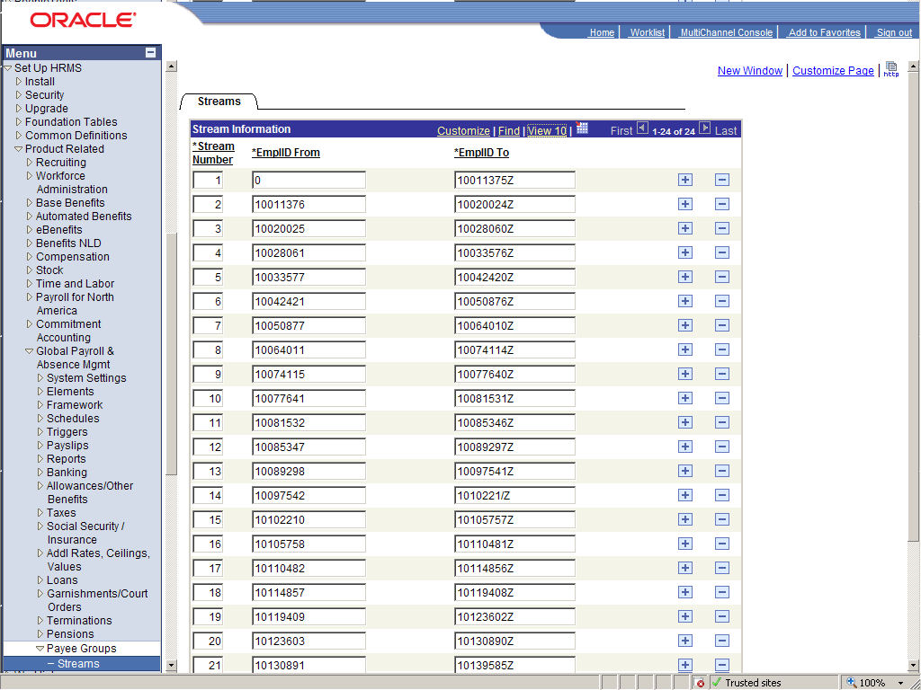
This page is no more than a view of the database table PS_GP_STRM.
STRM_NUM EMPLID_FROM EMPLID_TO
---------- ----------- -----------
1 0 10011375Z
2 10011376 10020024Z
3 10020025 10028060Z
4 10028061 10033576Z
5 10033577 10042420Z
6 10042421 10050876Z
7 10050877 10064010Z
8 10064011 10074114Z
9 10074115 10077640Z
10 10077641 10081531Z
11 10081532 10085346Z
12 10085347 10089297Z
13 10089298 10097541Z
14 10097542 1010221/Z
15 10102210 10105757Z
16 10105758 10110481Z
17 10110482 10114856Z
18 10114857 10119408Z
19 10119409 10123602Z
20 10123603 10130890Z
21 10130891 10139585Z
22 10139586 10153106Z
23 10153107 10223793Z
24 10223794 ZZZZZZZZZZZ

However, I prefer to populate this table with the script gpstrmit.sql (see page 44). It calculates stream boundary values. The above page can be used to view the results.
It might be advisable to prevent accidental updates to this page by
- Making the page read only
- Adding a trigger to PS_GP_STREAM that will raise an error when the table is updated, see Preventing Accidental Stream Boundary Changes (nostrmchg.sql) on page 47.

Process Scheduler Configuration
The next stage is to configure the process scheduler to run the streamed payroll within a job on the process scheduler.

Process Type Definitions
I have created new process types that are clones of the default COBOL SQL and Application Engine process type definitions, one for each stream. The reason for this is so that should there be two streamed payrolls, only one of them can run in the same stream at the same time. The occurance level on each stream in the process scheduler will be 1. This will also, for example, prevent a cancel being run at the same time as a calculated.
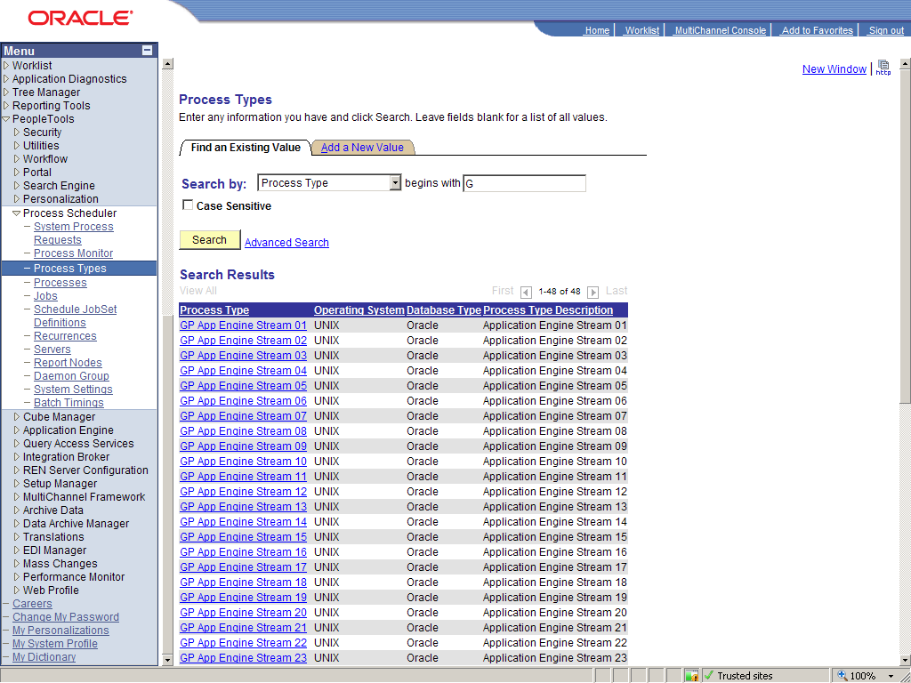
The command line on the new type definitions has been changed from that in COBOL SQL. The run control is fixed as 'GPStreamn' where n is the stream number.
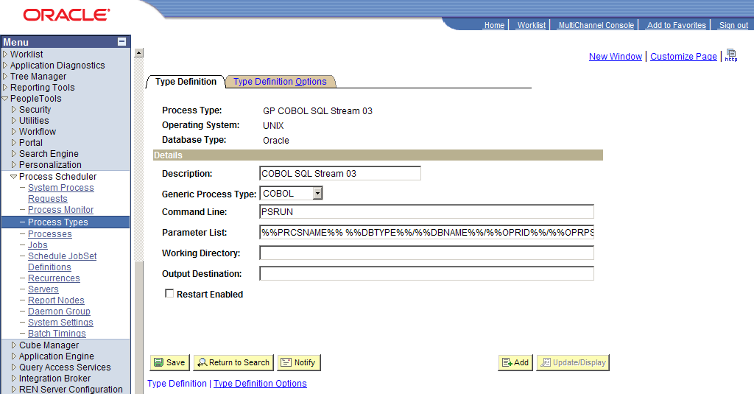
The only way to relate a particular stream to a particular process or process type is via the run control. The stream number is on the run control, and the run control ID is embedded into the command line in the process type definition.
So that the entire payroll can be run from a process scheduler JOB, the name of the run control has been hard coded into the process type definition. GP Cobol SQL Stream 1 can only run runcontrol GPStream1, etc.
N.B. The Run control must be a single string, and may not contain embedded spaces.
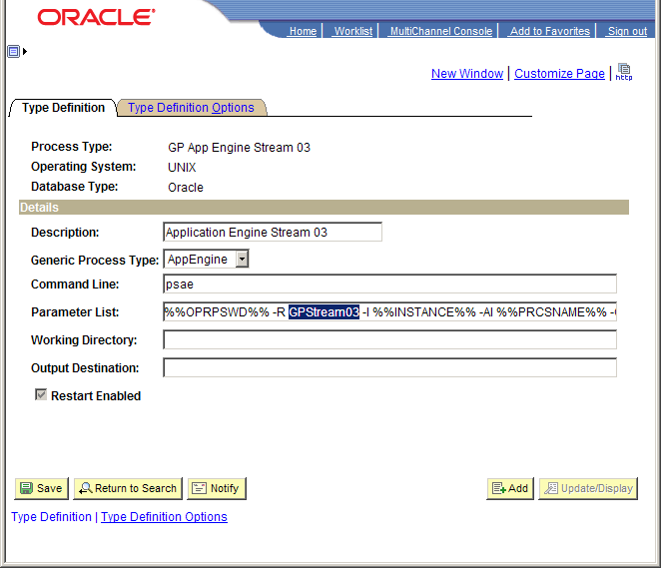
The new type definitions can also be created with a script (see Process Type Definitions (gen_prcstypedefn.sql) on page 70).

Process Definitions
A new process type has been created for each of the process type definitions.
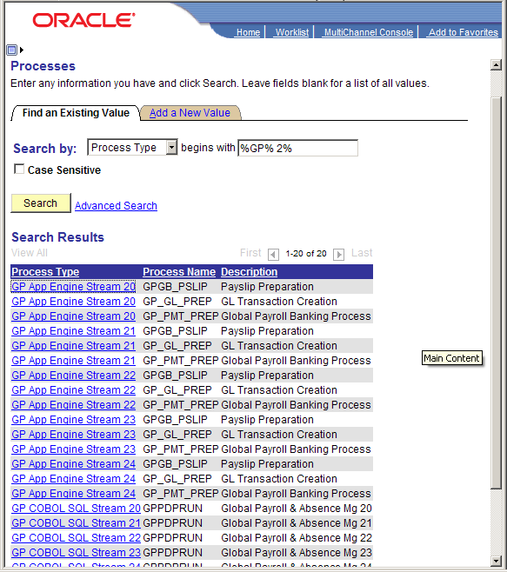
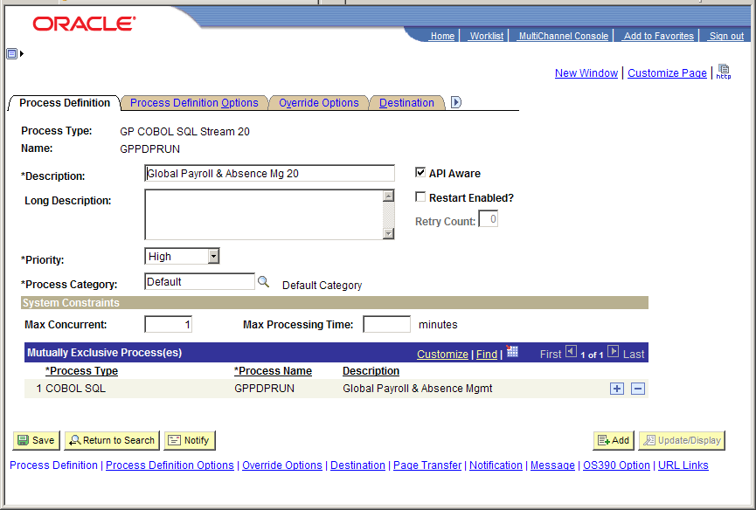
Note that
- The new processes are defined as high priority. They will be scheduled by the process sheduler in preference to lower priority jobs.
- Only a single occurance of each stream is permitted.
- The streamed GPPDPRUN processes are each mutually exclusive with the non-streamed one to prevent these processes overlapping.
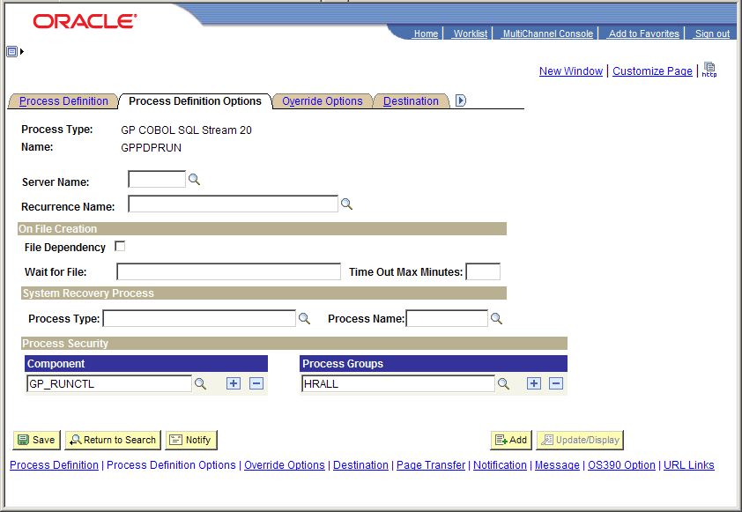
These process defnitions can be set up by scripts gen_prcsdefn849.sql and gen_prcsdefn849_2.sql (see Process Definitions on page 71).
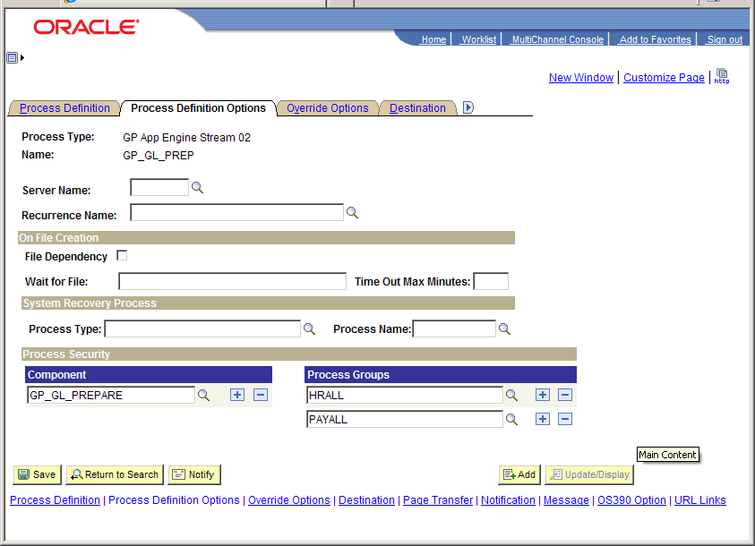
They have the same security set up as the original COBOL SQL and Application Engine process definitions.

Job Definitions
A job has been created to run the streams in parallel.
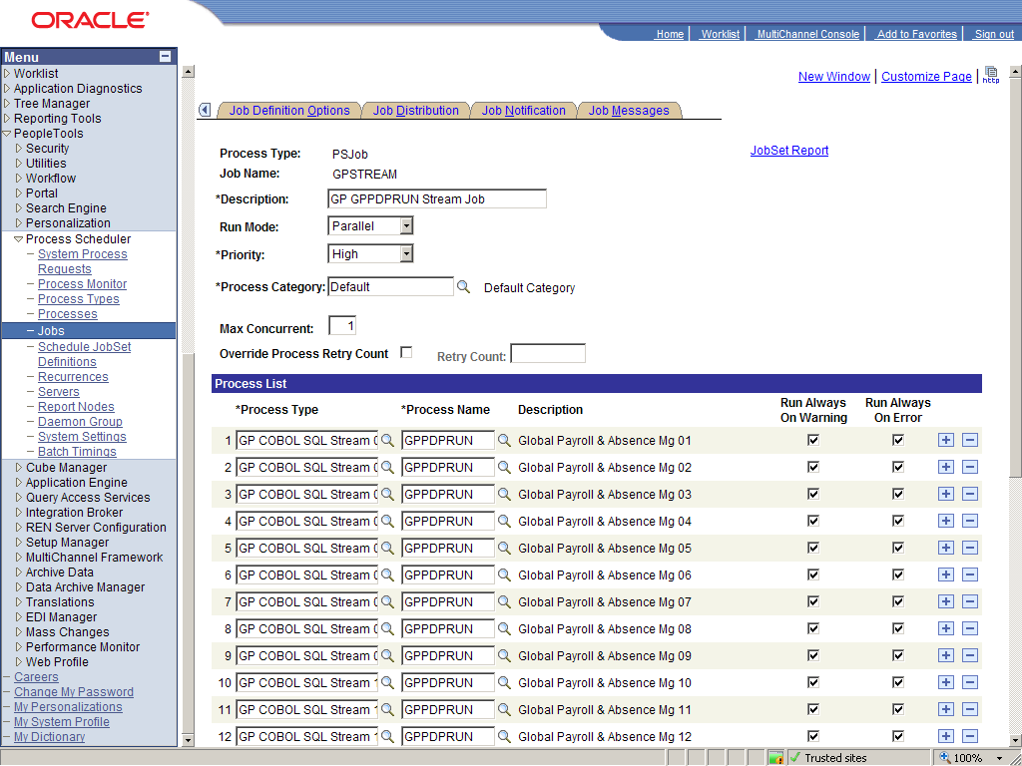
Only one instance of the job is permitted to run at any one time.
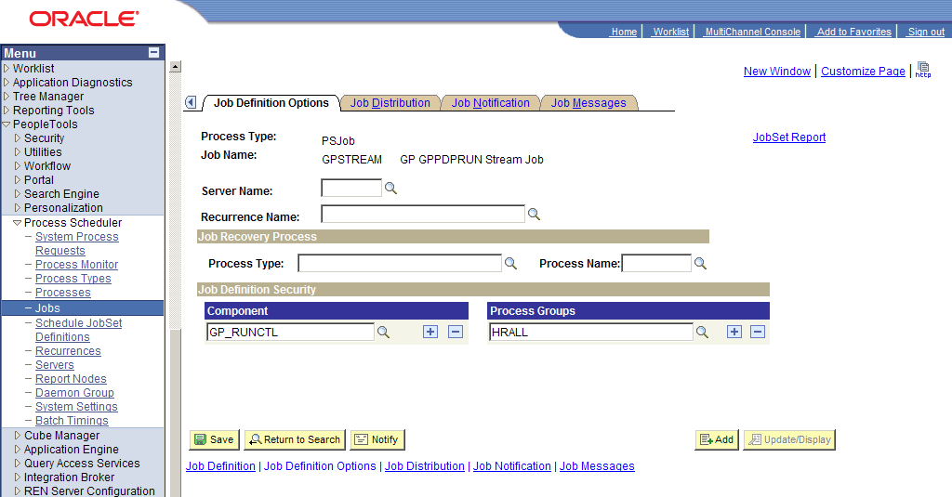
The security definition for the job is also copied from the process definitions.
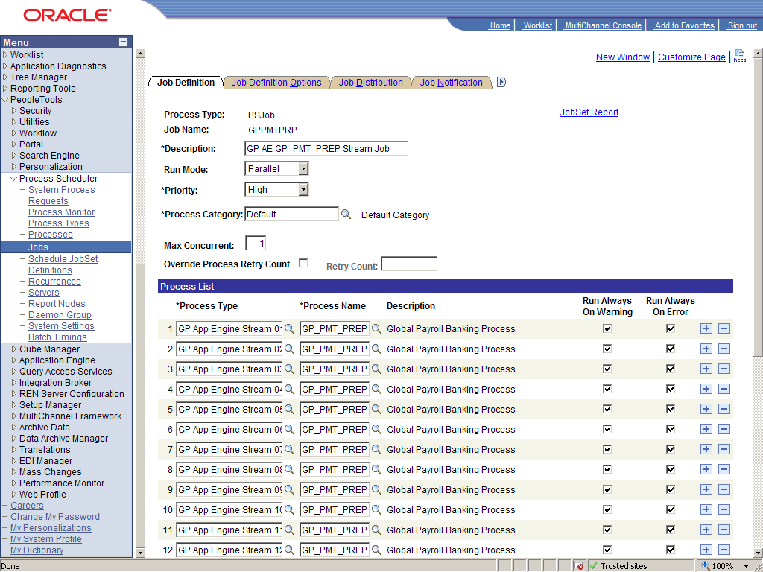
A process scheduler job has been set up for each process.
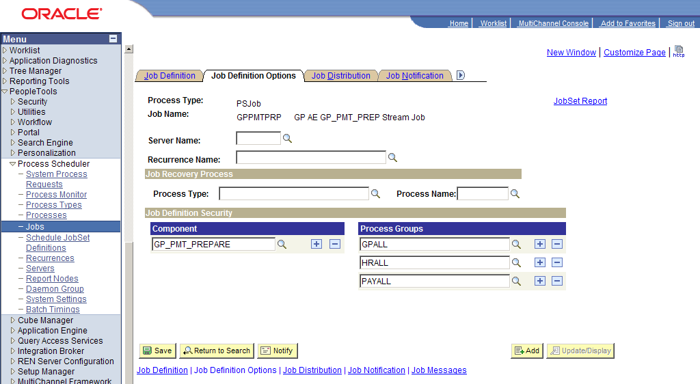
The jobs can be created by scripts gen_prcsjobdefn.sql and gen_prcsjobdefn2.sql (see page 79).

Server Definition
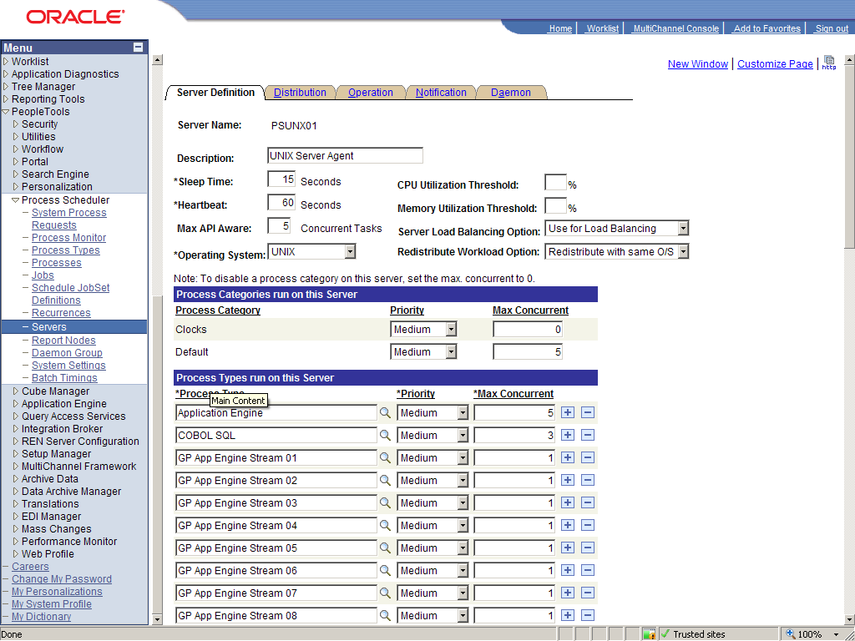
NB: The new process types have been added to the process scheduler server definiton. They have an occurance level of 1. This prevents more than one instance of each payroll stream being run in any one stream at the same time.
The maximum number of API aware jobs has also been set to 6. This will prevent any other jobs from running while all the payroll processes are running. If any other jobs are running when all the payroll processes are scheduled, one stream will wait per running process. The payroll processes have been given high priority. They will be run before previously scheduled processes of a lower priority.
The new process types can be added to the server by script gen_serverclass.sql (see page 88).

Other Configuration Issues

Calendar Group ID
The calendar group must be set up manually though the panel. .
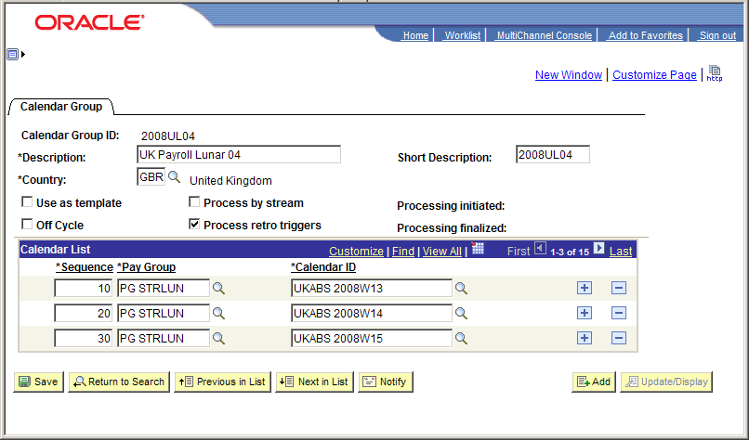

Run Controls
It is necessary to create a run control for each stream. The run controls MUST be called GPSteam01 through GPStream24 because these values are hard coded in the process definition names.
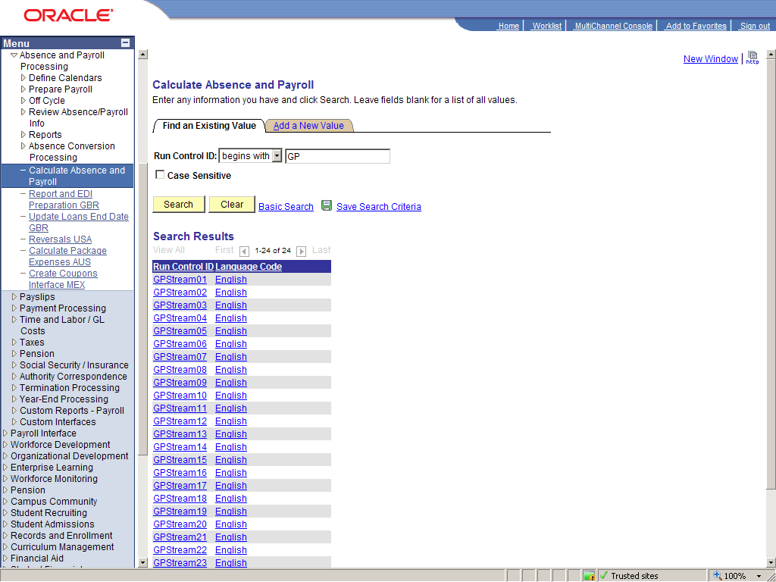
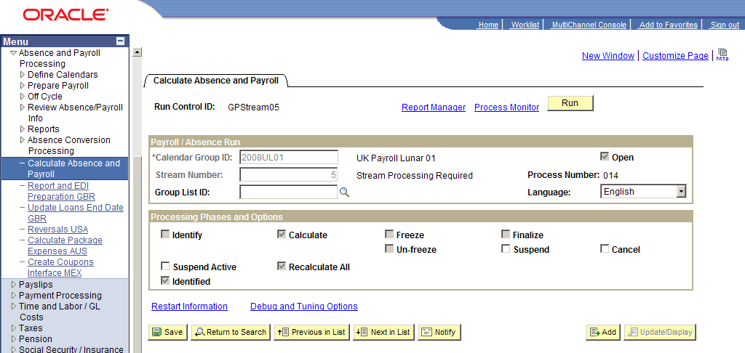
It follows that the calculation flags, stream numbers and calendar group needs to be set the same way for all the stream. This is very tiresome to repeat for 24 streams.
As an interim workaround I have created a script that copies run control for Stream 1 to the other streams (see Run control copier for Payroll Calculation Process (gpcopy.sql) on page 91). Ultimately a customisation needs to be added to this component to perform the same operation.
A quirk of the above panel is that a processing option must be specified before the stream number can be entered. This is not immediately obvious in the PIA because the stream number filed does not grey as it does in the windows client.
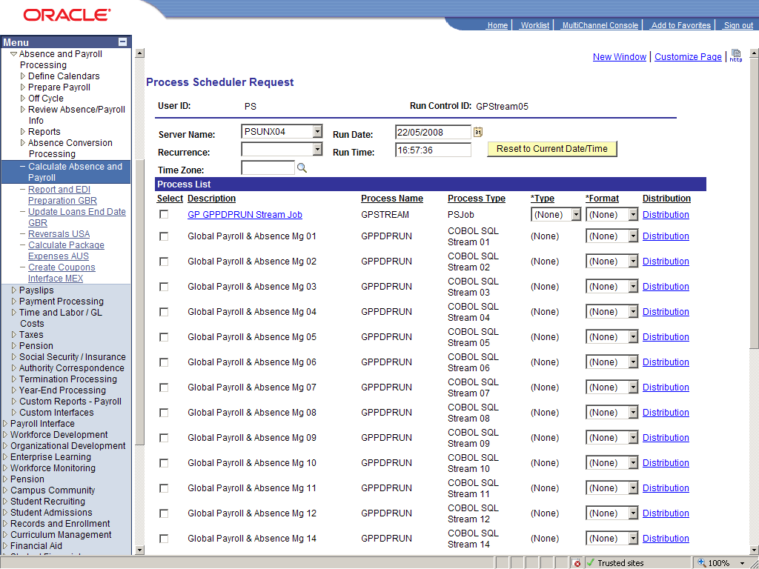
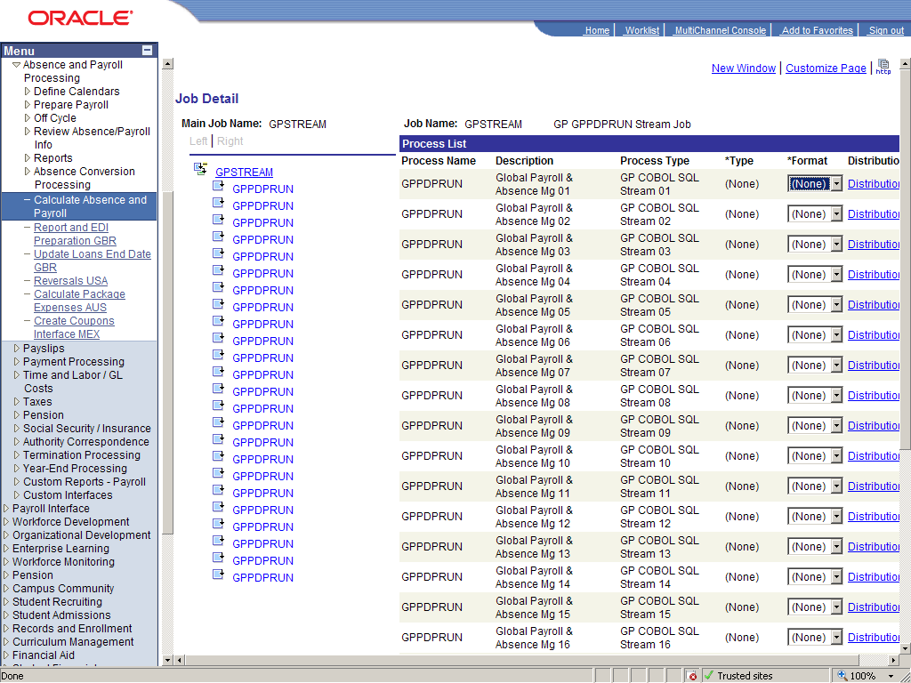
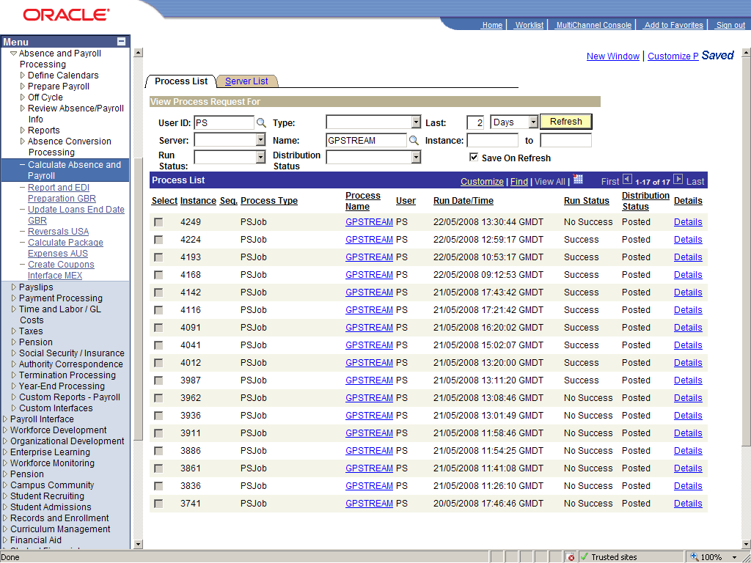
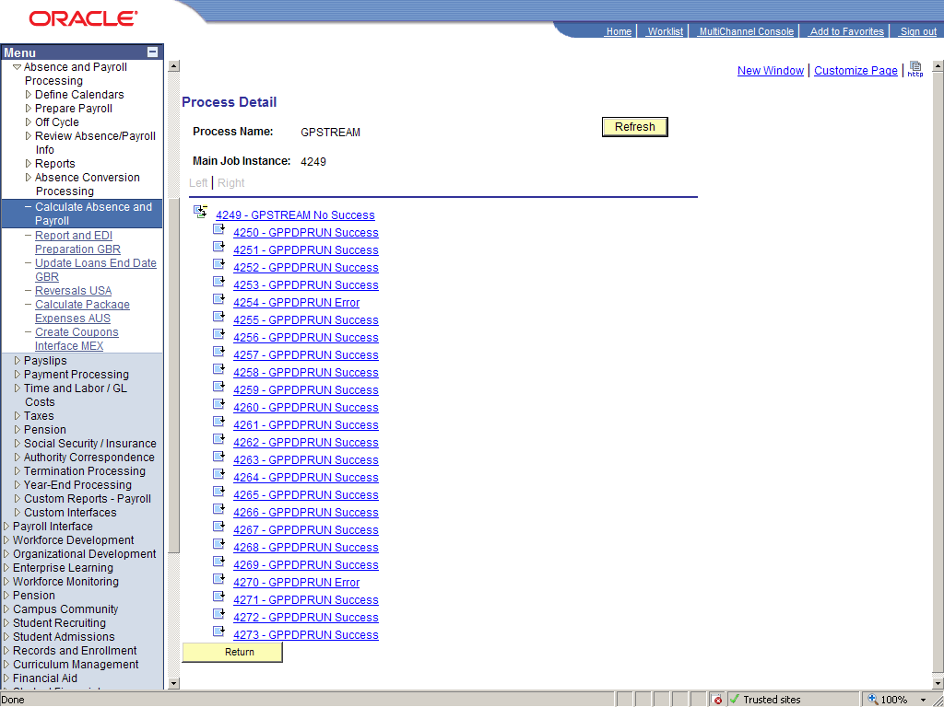
Each stream within the job is reported separately in the process monitor if the 'View Job Items' box is checked.
Operational Issues

Rebalancing the Streams
In 'Definition of the Streams' (see page 19) I discussed how the streams should be defined so that they have roughly equal numbers of employees to process. It is also known that as new employees are hired, and existing employees are terminated the streams will go out of balance. That is to say that they will take different amounts of time because they have different amount of work to do. This becomes a problem because the processing time of payroll is really the processing time of the longest stream. When this becomes a problem will depend on the rates or hire and termination of employees.
However, the solution is simple. It will be necessary to recalculate the stream boundaries and rebuild the partitioned tables with the same number of partitions, but with new partition boundaries. There will be no operational change as a result of this.
The number of streams is mainly determined by the number of CPUs available to the Cobol GP calculation processes. If the hardware configuration changes then it might well be appropriate to change the number of streams. In which case the stream boundaries should be recalculated, and the partitioned tables should be rebuilt accordingly.

Bugs & Fixes

AE.GPGB_PSLIP
This application engine process generates the payslips in the UK GP extentions. Although it appears to be capable of being run in streams, in fact it cannot.

Appendix

Scripts
The scripts reproduced in the appendix are supplied with this document. All of these scripts are intended to run in SQL*Plus.

Tablespaces for Partitioned Tables (genpartspc.sql or mkpartspc.sql)
A pair of new tablespace is created for each partition. Each tablespace only contains objects for a particular stream. The tablespaces are created as locally managed tablespace with uniform extent size of just 1M, therefore there are no storage clauses on the create statements for the partitioned objects.
There is no demonstrable link between the number of extents in a table and the performance of DML on that table, so there should be no problem with some segments having a large number of extents.
For some installations with many streams, and annual tablespaces for list sub-partition tables and indexes, it is easier to generate the mkpartspc script to build the tablespaces dynamically with something along the lines of the following SQL script. This is only an example, every system is different.
set echo off
set head off feedback off echo off verify off pages 9999 termout off pause off autotrace off timi off
column SPOOL_FILENAME new_value SPOOL_FILENAME
SELECT 'mkpartspc_'||lower(name)||'.sql' SPOOL_FILENAME
FROM v$database;
set termout on lines 80
break on report
spool &&SPOOL_FILENAME

SELECT 'spool mkpartspc_'||lower(name)
FROM v$database
/

REM range partitions
SELECT 'CREATE TABLESPACE gpstrm'||strm||type
, ' DATAFILE ''/oradata/MHRPRD1A/data/'||path||'/gpstrm'||strm||type||'_01.dbf'''
, ' SIZE 2M AUTOEXTEND ON NEXT 1M MAXSIZE 2001M'
, ' EXTENT MANAGEMENT LOCAL UNIFORM SIZE 1M'
, '/ '
FROM (
SELECT 'tab' type
, 'data2' path
FROM dual
UNION ALL
SELECT 'idx'
, 'data3' path
FROM dual
) typ
, (
SELECT LTRIM(TO_CHAR(rownum,'00')) strm
FROM all_objects
WHERE rownum <= 24
) strm
ORDER BY strm, path
/

REM lunar monthly partitions
SELECT 'CREATE TABLESPACE gp'||year||'L'||mnth||type
, ' DATAFILE ''/oradata/MHRPRD1A/data/'||path||'/gp'||year||'L'||mnth||type||'_01.dbf'''
, ' SIZE 2M AUTOEXTEND ON NEXT 1M MAXSIZE 2001M'
, ' EXTENT MANAGEMENT LOCAL UNIFORM SIZE 1M'
, '/ '
FROM (
SELECT 'tab' type
, 'data2' path
FROM dual
UNION ALL
SELECT 'idx'
, 'data3' path
FROM dual
) typ
, (
SELECT LTRIM(TO_CHAR(2007+rownum,'0000')) year
FROM all_objects
WHERE rownum <= 3
) strm
, (
SELECT LTRIM(TO_CHAR(rownum,'00')) mnth
FROM all_objects
WHERE rownum <= 13
) strm
ORDER BY year, mnth, path
/

REM pensioners annual
SELECT 'CREATE TABLESPACE gp'||year||type
, ' DATAFILE ''/oradata/MHRPRD1A/data/'||path||'/gp'||year||type||'_01.dbf'''
, ' SIZE 2M AUTOEXTEND ON NEXT 1M MAXSIZE 2001M'
, ' EXTENT MANAGEMENT LOCAL UNIFORM SIZE 1M'
, '/ '
FROM (
SELECT 'tab' type
, 'data2' path
FROM dual
UNION ALL
SELECT 'idx'
, 'data3' path
FROM dual
) typ
, (
SELECT LTRIM(TO_CHAR(2007+rownum,'0000')) year
FROM all_objects
WHERE rownum <= 2
) strm
ORDER BY year, path
/

SELECT 'spool off'
FROM v$database
/

spool off
set echo on verify on feedback on
genpartspc.sql
The output from genpartspc.sql is another SQL script mkpartspc_<dbname>.sql.
spool mkpartspc_mhrprd1a

CREATE TABLESPACE gpstrm01tab
DATAFILE '/oradata/MHRPRD1A/data/data2/gpstrm01tab_01.dbf'
SIZE 2M AUTOEXTEND ON NEXT 1M MAXSIZE 2001M
EXTENT MANAGEMENT LOCAL UNIFORM SIZE 1M
/

CREATE TABLESPACE gpstrm01idx
DATAFILE '/oradata/MHRPRD1A/data/data3/gpstrm01idx_01.dbf'
SIZE 2M AUTOEXTEND ON NEXT 1M MAXSIZE 2001M
EXTENT MANAGEMENT LOCAL UNIFORM SIZE 1M
/
…

CREATE TABLESPACE gpstrm24tab
DATAFILE '/oradata/MHRPRD1A/data/data2/gpstrm24tab_01.dbf'
SIZE 2M AUTOEXTEND ON NEXT 1M MAXSIZE 2001M
EXTENT MANAGEMENT LOCAL UNIFORM SIZE 1M
/

CREATE TABLESPACE gpstrm24idx
DATAFILE '/oradata/MHRPRD1A/data/data3/gpstrm24idx_01.dbf'
SIZE 2M AUTOEXTEND ON NEXT 1M MAXSIZE 2001M
EXTENT MANAGEMENT LOCAL UNIFORM SIZE 1M
/

CREATE TABLESPACE gp2008L01tab
DATAFILE '/oradata/MHRPRD1A/data/data2/gp2008L01tab_01.dbf'
SIZE 2M AUTOEXTEND ON NEXT 1M MAXSIZE 2001M
EXTENT MANAGEMENT LOCAL UNIFORM SIZE 1M
/

CREATE TABLESPACE gp2008L01idx
DATAFILE '/oradata/MHRPRD1A/data/data3/gp2008L01idx_01.dbf'
SIZE 2M AUTOEXTEND ON NEXT 1M MAXSIZE 2001M
EXTENT MANAGEMENT LOCAL UNIFORM SIZE 1M
/
…

CREATE TABLESPACE gp2008tab
DATAFILE '/oradata/MHRPRD1A/data/data2/gp2008tab_01.dbf'
SIZE 2M AUTOEXTEND ON NEXT 1M MAXSIZE 2001M
EXTENT MANAGEMENT LOCAL UNIFORM SIZE 1M
/

CREATE TABLESPACE gp2008idx
DATAFILE '/oradata/MHRPRD1A/data/data3/gp2008idx_01.dbf'
SIZE 2M AUTOEXTEND ON NEXT 1M MAXSIZE 2001M
EXTENT MANAGEMENT LOCAL UNIFORM SIZE 1M
/
…

spool off
mkpartspc.sql

Calculate Stream Range Values (gpstrmit.sql)
This script calculates the stream boundary values.
set pause off
column ADJ new_value ADJ heading 'Adjustment'
column EMP heading 'Total|Employees'
column RPE heading 'Rows per|Employee'

spool gpstrmit
Select min(emplid)
, max(emplid)
, count(*)
from ps_gp_pye_seg_stat;

select cal_run_id
, count(distinct emplid) EMP
, count(*) num_rows
, count(*)/count(distinct emplid) RPE
, count(*)*.04 ADJ
FROM ps_gp_pye_seg_stat
WHERE cal_run_id = (
SELECT MAX(cal_run_id) max_cal_run_id
FROM ps_gp_pye_seg_stat
WHERE cal_run_id LIKE '200_UL__'
)
group by cal_run_id
;

rollback;
delete FROM ps_gp_strm;

INSERT INTO ps_gp_strm
(strm_num, emplid_FROM , emplid_to)
SELECT partition_number
, MIN(part_value) part_start
, MAX(part_value) part_end
FROM ( --calculate partition for each emplid
SELECT part_value
, CEIL(&num_partitions*
LEAST( 1,
SUM(proportion) OVER (ORDER BY part_value range unbounded preceding)
)) partition_number
FROM ( --calculate proportion of month
SELECT part_value
, ratio_to_report(elements) OVER () proportion
FROM ( -- sum elements by partion value
SELECT part_value
, SUM(elements) elements
FROM ( --filter and generate partition key
SELECT s.emplid part_value
, COUNT(*) elements
FROM ps_gp_pye_seg_stat s
WHERE cal_run_id = (
SELECT MAX(cal_run_id) max_cal_run_id
FROM ps_gp_pye_seg_stat
WHERE cal_run_id LIKE '2007UL__')
GROUP BY s.emplid
UNION ALL
SELECT MAX(emplid), &&ADJ
-- FROM ps_personal_data
FROM ps_gp_payee_data
)
GROUP BY part_value
)
)
)
GROUP BY partition_number
ORDER BY partition_number
/

UPDATE ps_gp_strm
SET emplid_from = '0'
WHERE strm_num = (
SELECT MIN(strm_num)
FROM ps_gp_strm)
;

UPDATE ps_gp_strm a
SET emplid_to = (
SELECT SUBSTR(emplid_from,1,LENGTH(emplid_from)-1)
|| CHR(ASCII(SUBSTR(emplid_from,LENGTH(emplid_from),1))-1)
|| 'Z'
FROM ps_gp_strm b
WHERE b.strm_num = a.strm_num + 1)
WHERE strm_num < (
SELECT MAX(strm_num)
FROM ps_gp_strm);

UPDATE ps_gp_strm
SET emplid_to = 'ZZZZZZZZZZZ'
WHERE strm_num = (
SELECT MAX(strm_num)
FROM ps_gp_strm);

SELECT * from ps_gp_strm;

spool off
gpstrmit.sql

Preventing Accidental Stream Boundary Changes (nostrmchg.sql)
The following trigger will raise an exception if a process attempts to update the PS_GP_STRM table. The trigger can be disabled when the streams are calculated with gpstrmit.sql, and then reenabled.
CREATE OR REPLACE TRIGGER sysadm.no_strm_changes
BEFORE INSERT OR UPDATE OR DELETE ON sysadm.ps_gp_strm
BEGIN
RAISE_APPLICATION_ERROR(-20100,'No updates permitted on PS_GP_STRM');
END;
/

ALTER TRIGGER sysadm.no_strm_changes ENABLE;

Stream Test (strmtest.sql)
This script is used to check that all employees are within a stream. It should return no rows.
set lines 100
break on cal_run_id skip 1
spool strmtest

ttitle personal_data

select emplid
from ps_personal_data p
where not exists(select 'x'
from ps_gp_strm s
where p.emplid between s.emplid_from and s.emplid_to)
/

ttitle gp_pye_seg_stat

select emplid
from ps_gp_pye_seg_stat p
where not exists(select 'x'
from ps_gp_strm s
where p.emplid between s.emplid_from and s.emplid_to)
/

ttitle off
strmtest.sql

Stream Volume Reports (strmvols.sql)
This script streams have roughly the same number of segments to process.
set lines 100
break on cal_run_id skip 1 on gp_paygroup skip 1
column min_emp format a11
column max_emp format a11
column cal_run_id format a18
column cal_id format a18
column gp_paygroup format a10

spool strmvols

ttitle gp_pye_seg_stat

select emplid
from ps_gp_pye_seg_stat p
where not exists(select 'x'
from ps_gp_strm s
where p.emplid between s.emplid_from and s.emplid_to)
/

ttitle 'personal_data by stream'

select s.strm_num
, min(p.emplid) min_emp
, max(p.emplid) max_emp
, count(*) emps
from ps_personal_data p, ps_gp_strm s
where p.emplid between s.emplid_from and s.emplid_to
group by s.strm_num
/

ttitle 'gp_pye_seg_stat by stream'

select s.strm_num
, min(p.emplid) min_emp
, max(p.emplid) max_emp
, count(distinct emplid) emps
, count(*) num_rows
from ps_gp_pye_seg_stat p, ps_gp_strm s
where p.emplid between s.emplid_from and s.emplid_to
group by s.strm_num
/

ttitle 'gp_pye_seg_stat by calendar and stream '

select p.cal_run_id, s.strm_num
, min(p.emplid) min_emp
, max(p.emplid) max_emp
, count(distinct emplid) emps
, count(*) num_rows
from ps_gp_pye_seg_stat p, ps_gp_strm s
where p.emplid between s.emplid_from and s.emplid_to
group by p.cal_run_id, s.strm_num
/

ttitle 'gp_pye_seg_stat by calendar, stream and paygroup'

select p.cal_run_id, p.gp_paygroup, s.strm_num
, min(p.emplid) min_emp
, max(p.emplid) max_emp
, count(distinct emplid) emps
, count(*) num_rows
from ps_gp_pye_seg_stat p, ps_gp_strm s
where p.emplid between s.emplid_from and s.emplid_to
group by p.cal_run_id, p.gp_paygroup, s.strm_num
/

ttitle 'gp_pye_seg_stat by calendar, retro and stream '

select p.cal_run_id, SUBSTR(p.cal_id,1,LENGTH(p.cal_run_id)) cal_id, s.strm_num
, min(p.emplid) min_emp
, max(p.emplid) max_emp
, count(distinct emplid) emps
, count(*) num_rows
from ps_gp_pye_seg_stat p, ps_gp_strm s
where p.emplid between s.emplid_from and s.emplid_to
group by p.cal_run_id, SUBSTR(p.cal_id,1,LENGTH(p.cal_run_id)), s.strm_num
/

ttitle 'gp_pye_seg_stat by calendar and retro'

select p.cal_run_id, SUBSTR(p.cal_id,1,LENGTH(p.cal_run_id)) cal_id
, min(p.emplid) min_emp
, max(p.emplid) max_emp
, count(distinct emplid) emps
, count(*) num_rows
from ps_gp_pye_seg_stat p
group by p.cal_run_id, SUBSTR(p.cal_id,1,LENGTH(p.cal_run_id))
/

ttitle 'gp_pye_seg_stat by calendar and retro'

select p.cal_run_id, p.cal_id
, min(p.emplid) min_emp
, max(p.emplid) max_emp
, count(distinct emplid) emps
, count(*) num_rows
from ps_gp_pye_seg_stat p
group by p.cal_run_id, p.cal_id
/
ttitle 'gp_rslt_ern_ded by calendar and stream'

select p.cal_run_id, s.strm_num
, min(p.emplid) min_emp
, max(p.emplid) max_emp
, count(distinct emplid) emps
, count(*) num_rows
from ps_gp_rslt_ern_ded p, ps_gp_strm s
where p.emplid between s.emplid_from and s.emplid_to
group by p.cal_run_id, s.strm_num
/

ttitle 'gp_rslt_acum by calendar and stream'

select p.cal_run_id, s.strm_num
, min(p.emplid) min_emp
, max(p.emplid) max_emp
, count(distinct emplid) emps
, count(*) num_rows
from ps_gp_rslt_acum p, ps_gp_strm s
where p.emplid between s.emplid_from and s.emplid_to
group by p.cal_run_id, s.strm_num
/

ttitle 'gp_rslt_pin by calendar and stream'

select p.cal_run_id, s.strm_num
, min(p.emplid) min_emp
, max(p.emplid) max_emp
, count(distinct emplid) emps
, count(*) num_rows
from ps_gp_rslt_pin p, ps_gp_strm s
where p.emplid between s.emplid_from and s.emplid_to
group by p.cal_run_id, s.strm_num
/

ttitle 'gp_payment by calendar and stream'

select p.cal_run_id, s.strm_num
, min(p.emplid) min_emp
, max(p.emplid) max_emp
, count(distinct emplid) emps
, count(*) num_rows
from ps_gp_payment p, ps_gp_strm s
where p.emplid between s.emplid_from and s.emplid_to
group by p.cal_run_id, s.strm_num
/

ttitle 'gpgb_payment by calendar and stream'

select p.cal_run_id, s.strm_num
, min(p.emplid) min_emp
, max(p.emplid) max_emp
, count(distinct emplid) emps
, count(*) num_rows
from ps_gpgb_payment p, ps_gp_strm s
where p.emplid between s.emplid_from and s.emplid_to
group by p.cal_run_id, s.strm_num
/

spool off

ttitle comparison

select p.recname
, a.num_rows PS
, b.num_rows DMK
, c.num_rows OLD
from (SELECT table_name
, SUBSTR(table_name,4) recname
FROM user_part_tables
WHERE table_name like 'PS_GP%'
) p
, (SELECT table_name
, SUBSTR(table_name,4) recname
, num_rows
FROM user_tables a
WHERE table_name like 'PS_GP%'
AND tablespace_name IS NOT NULL
UNION
SELECT table_name
, SUBSTR(table_name,4) recname
, SUM(num_rows) num_rows
FROM user_tab_partitions a
WHERE table_name like 'PS_GP%'
GROUP BY table_name
) a
, (SELECT table_name
, SUBSTR(table_name,5) recname
, num_rows
FROM user_tables a
WHERE table_name like 'DMK_GP%'
AND tablespace_name IS NOT NULL
UNION
SELECT table_name
, SUBSTR(table_name,5) recname
, SUM(num_rows)
FROM user_tab_partitions a
WHERE table_name like 'DMK_GP%'
GROUP BY table_name
) b
, (SELECT table_name
, SUBSTR(table_name,5) recname
, num_rows
FROM user_tables a
WHERE table_name like 'OLD_GP%'
AND tablespace_name IS NOT NULL
UNION
SELECT table_name
, SUBSTR(table_name,5) recname
, SUM(num_rows)
FROM user_tab_partitions a
WHERE table_name like 'OLD_GP%'
GROUP BY table_name
) c
where a.recname(+) = p.recname
and b.recname(+) = p.recname
and c.recname(+) = p.recname
and 1=2
;

ttitle off

spool off
strmvols.sql

DDL Build Scripts

gfcbuild.sql
This script calls a packaged procedure gfc_pspart which generates the DDL to build all of the partitioned and global temporary tables. The output is stored in a working storage table and is then spooled to scripts files by SQL.
This script calls partdata.sql which also calls gp_partdata.sql which sets up certain meta-data tables that hold details of the partitions.
rem gfcbuild.sql
rem (c) Go-Faster Consultancy Ltd.
…
clear screen

spool gfcbuild

execute gfc_pspart.truncate_tables;
@@partdata
execute gfc_pspart.main;

--pause
--extract script to file
@@gfcbuildspool.sql
…
gfcbuild.sql

gfcbuildone.sql
However, after the initial installation you probably won’t need to rebuild everything again. You are more likely to want to rebuild just one or some tables.
rem gfcbuildone.sql
rem (c) Go-Faster Consultancy Ltd.
clear screen

spool gfcbuild

execute gfc_pspart.truncate_tables(p_all=>TRUE);
@@partdata

execute gfc_pspart.truncate_tables;

--all tables
--execute gfc_pspart.main;

--just generate global temporary tables
--execute gfc_pspart.main(p_rectype => 'T');

--just generate named tables
--execute gfc_pspart.main(p_recname => 'GP_RSLT_ACUM', p_rectype => 'P');
--execute gfc_pspart.main(p_recname => 'GP_RSLT_PIN', p_rectype => 'P');
--execute gfc_pspart.main(p_recname => 'GP_RSLT%', p_rectype => 'P');
execute gfc_pspart.main(p_recname => 'TL_PAYABLE_TIME', p_rectype => 'P');

--pause
--extract script to file
@@gfcbuildspool.sql

--select * from table(gfc_pspart.spooler);

set head on feedback on termout on pages 50
--DROP TABLE gfc_ps_tables;
--DROP TABLE gfc_ps_tab_columns;
--DROP TABLE gfc_ora_tab_columns;
--DROP TABLE gfc_ps_indexdefn;
--DROP TABLE gfc_ps_keydefn;
--DROP TABLE gfc_ps_idxddlparm;
--DROP TABLE gfc_ddl_script;
--DROP VIEW gfc_ps_alt_ind_cols;
--DROP VIEW gfc_ps_keydefn_vw;
--DROP TABLE gfc_part_tables;
--DROP TABLE gfc_part_ranges;
--DROP TABLE gfc_part_range_lists;

gfcbuildpkg.sql
This script implements a package of procedures that dynamically build a script that can be used to build the Partitioned and Global Temporary tables required for payroll. It replaces the build functionality of the PeopleSoft Application Designer for these tables only. The full operation of this script is described in a separate document ‘Implementing and Managing Oracle Table Partitioning in PeopleSoft Applications’.
If a PeopleSoft patch or customisation changes the structure of the tables or their indexes, then instead of generating a build script with Application desginer, this script should be used instead.
This script is enhanced an adjusted from time to time. The package itself is wrapped. Only the package header is reproduced in here
rem gfcbuildpkg.sql
rem (c) Go-Faster Consultancy Ltd.…

…
CREATE OR REPLACE PACKAGE gfc_pspart AS

PROCEDURE banner;
PROCEDURE display_defaults;
PROCEDURE reset_defaults;
PROCEDURE set_defaults
(p_chardef VARCHAR2 DEFAULT ''
,p_logging VARCHAR2 DEFAULT ''
,p_parallel VARCHAR2 DEFAULT ''
,p_roles VARCHAR2 DEFAULT ''
,p_scriptid VARCHAR2 DEFAULT ''
,p_update_all VARCHAR2 DEFAULT ''
,p_read_all VARCHAR2 DEFAULT ''
,p_drop_index VARCHAR2 DEFAULT ''
,p_pause VARCHAR2 DEFAULT ''
,p_explicit_schema VARCHAR2 DEFAULT ''
,p_block_sample VARCHAR2 DEFAULT ''
,p_build_stats VARCHAR2 DEFAULT ''
,p_deletetempstats VARCHAR2 DEFAULT ''
,p_longtoclob VARCHAR2 DEFAULT ''
,p_ddltrigger VARCHAR2 DEFAULT '*'
,p_drop_purge VARCHAR2 DEFAULT ''
--,p_noalterprefix VARCHAR2 DEFAULT '*'
,p_forcebuild VARCHAR2 DEFAULT ''
,p_desc_index VARCHAR2 DEFAULT ''
);

PROCEDURE truncate_tables
(p_all BOOLEAN DEFAULT FALSE
);

PROCEDURE main
(p_recname VARCHAR2 DEFAULT '' --name of table(s) to be built - pattern matching possible - default null implies all
,p_rectype VARCHAR2 DEFAULT 'A' --Build (P)artitioned tables, Global (T)emp tables, or (A)ll tables - default ALL
);

END gfc_pspart;
/

…

extracts from gfcbuildpkg.sql

Global Payroll Meta Data (gp-partdata.sql)
gfcbuild.sql derives some of its meta-data from the PeopleTools tables, and some from additional tables set up with other scripts. For Global Payroll, a script called gp-partdata.sql identifies the tables to be partitioned or built as Global Temporary.
REM gp-partdata.sql
-----------------------------------------------------------------------------------------------------------
--view to identify country extention tables
-----------------------------------------------------------------------------------------------------------
CREATE OR REPLACE VIEW gfc_installed_gp AS
SELECT recname,
CASE SUBSTR(r.recname,1,5)
WHEN 'GPAU_' THEN i.INSTALLED_GP_AUS
WHEN 'GPAR_' THEN i.INSTALLED_GP_ARG
WHEN 'GPBR_' THEN i.INSTALLED_GP_BRA
WHEN 'GPCA_' THEN i.INSTALLED_GP_CAN
WHEN 'GPCH_' THEN i.INSTALLED_GP_CHE
WHEN 'GPCHT' THEN i.INSTALLED_GP_CHE
WHEN 'GPDE_' THEN i.INSTALLED_GP_DEU
WHEN 'GPES_' THEN i.INSTALLED_GP_ESP
WHEN 'GPFR_' THEN i.INSTALLED_GP_FRA
WHEN 'GPGB_' THEN i.INSTALLED_GP_UK
WHEN 'GPIE_' THEN i.INSTALLED_GP_IRL
WHEN 'GPIT_' THEN i.INSTALLED_GP_ITA
WHEN 'GPJP_' THEN i.INSTALLED_GP_JPN
WHEN 'GPIN_' THEN i.INSTALLED_GP_IND
WHEN 'GPHK_' THEN i.INSTALLED_GP_HKG
WHEN 'GPMX_' THEN i.INSTALLED_GP_MEX
WHEN 'GPMY_' THEN i.INSTALLED_GP_MYS
WHEN 'GPNL_' THEN i.INSTALLED_GP_NLD
WHEN 'GPNZ_' THEN i.INSTALLED_GP_NZL
WHEN 'GPSG_' THEN i.INSTALLED_GP_SGP
WHEN 'GPTW_' THEN i.INSTALLED_GP_TWN
WHEN 'GPUS_' THEN i.INSTALLED_GP_USA
ELSE 'Y'
END AS installed_gp
FROM psrecdefn r
, ps_installation i
WHERE r.rectype = 0 --only SQL tables can be partitioned
;

-----------------------------------------------------------------------------------------------------------
--insert data to describe temporary tables
--country specific tables for installed country extentions only will be added
-----------------------------------------------------------------------------------------------------------
INSERT INTO gfc_temp_tables
SELECT r.recname
FROM gfc_installed_gp r
WHERE r.installed_gp != 'N'
--AND r.recname LIKE 'GPGB_PSLIP%' --restrict tables
AND r.recname IN( /*payroll calculation work tables*/
'GP_CAL_TS_WRK',
'GP_CANC_WRK',
'GP_CANCEL_WRK', /*new in 8.4*/
…
'S1H_VGP_RSLT')
/
-----------------------------------------------------------------------------------------------------------
--insert data to specify the tables to be partitioned
--country specific tables for installed country extentions only will be added
-----------------------------------------------------------------------------------------------------------
DELETE FROM gfc_part_tables
WHERE part_id = 'GP'
/

INSERT INTO gfc_part_tables
(recname, part_id, part_column, part_type)
SELECT r.recname, 'GP'
, 'EMPLID', 'R'
FROM gfc_installed_gp r
WHERE r.installed_gp != 'N'
AND ( r.recname IN(
'GP_ABS_EVENT', /*absence - added 3.10.2003*/
'GP_GL_DATA', /*gl transfer table*/
'GP_GRP_LIST_RUN', /*new in 8.4*/
…
)
OR r.recname IN( /*range partition any writable arrays*/
SELECT recname
FROM ps_gp_wa_array
)
)
/

-----------------------------------------------------------------------------------------------------------
--move temp tables to partitioned tables
-----------------------------------------------------------------------------------------------------------
--just want to build partitioned working storage table
--DELETE FROM gfc_part_tables;

--INSERT INTO gfc_part_tables
--(recname, part_id, part_column, part_type, stats_type)
--SELECT recname, 'GP', 'EMPLID', 'R', 'D'
--FROM gfc_temp_tables
--WHERE 1=1
--AND recname LIKE 'GP%WRK'
--AND NOT recname IN('GP_CAL_TS_WRK','GP_PKG_ELEM_WRK','GP_TLTRC_WRK')
--/

--DELETE FROM gfc_temp_tables
--WHERE recname IN (SELECT recname FROM gfc_part_tables)
--/

-----------------------------------------------------------------------------------------------------------
--delete rows from meta data tables which are not to be built, use this to restrict output
-----------------------------------------------------------------------------------------------------------
--DELETE FROM gfc_part_tables
--WHERE NOT recname IN('GP_RTO_TRGR')
--/
--
--DELETE FROM gfc_temp_tables
--/

-----------------------------------------------------------------------------------------------------------
--specify list subpartitioned tables
-----------------------------------------------------------------------------------------------------------
UPDATE gfc_part_tables
SET subpart_type = 'L'
, subpart_column = 'CAL_RUN_ID'
, hash_partitions = 0
WHERE recname IN('GP_RSLT_ACUM', 'GP_RSLT_PIN'
--,'GP_GL_DATA' --not worth subpartitioning at Kelly
--,'GP_PYE_SEG_STAT' -- subpartitioning does not work well with retro queries
--,'GP_PYE_PRC_STAT' -- subpartitioning does not work well with retro queries
--,'GP_RSLT_PI_SOVR', 'GP_RSLT_PI_DATA' --14.2.2008 removed
)
/

UPDATE gfc_part_tables
SET subpart_type = 'L'
, subpart_column = 'SRC_CAL_RUN_ID'
, hash_partitions = 0
WHERE recname IN('GP_PI_GEN_DATA')
/

-----------------------------------------------------------------------------------------------------------
--set storage options on partitioned objects
-----------------------------------------------------------------------------------------------------------

UPDATE gfc_part_tables
SET tab_tablespace = 'GPAPP' /*default PSFT tablespace*/
, idx_tablespace = 'PSINDEX' /*default PSFT tablespace*/
, tab_storage = 'PCTUSED 80 PCTFREE 1'
, idx_storage = 'PCTFREE 1'
/

UPDATE gfc_part_tables
SET tab_storage = 'PCTUSED 80 PCTFREE 15'
WHERE recname IN('GP_PYE_SEG_STAT')
/

-----------------------------------------------------------------------------------------------------------
--describe indexes that are not to be locally partitioned
-----------------------------------------------------------------------------------------------------------
INSERT INTO gfc_part_indexes
(recname, indexid, part_id, part_type, part_column, subpart_type, subpart_column, hash_partitions)
SELECT t.recname
, i.indexid
, t.part_id
, t.part_type
, t.part_column
, 'N' subpart_type
, '' subpart_column
, t.hash_partitions
FROM gfc_part_tables t
, psindexdefn i
WHERE t.recname = i.recname
AND t.subpart_type = 'L'
AND NOT EXISTS(
SELECT 'x'
FROM pskeydefn k, psrecfielddb f
WHERE f.recname = i.recname
AND k.recname = f.recname_parent
AND k.indexid = i.indexid
AND k.fieldname = t.subpart_column
AND k.keyposn <= 3
)
;

--GP_PYE_SEG_STAT B&D

-----------------------------------------------------------------------------------------------------------
--insert data to specify range partitioning strategry
-----------------------------------------------------------------------------------------------------------
DELETE FROM gfc_part_ranges
WHERE part_id = 'GP'
/

INSERT INTO gfc_part_ranges
(part_id, part_no, part_name, part_value)
SELECT 'GP', strm_num
, LTRIM(TO_CHAR(strm_num,'00')) part_name
, NVL(LEAD(''''||emplid_from||'''',1) OVER (ORDER BY strm_Num),'MAXVALUE') part_value
FROM ps_gp_strm
/

UPDATE gfc_part_ranges
SET tab_tablespace = 'GPSTRM'||part_name||'TAB'
, idx_tablespace = 'GPSTRM'||part_name||'IDX'
--SET tab_tablespace = 'GPTABPART'||part_name||''
--, idx_tablespace = 'GPIDXPART'||part_name||''
--, tab_storage = '/*TAB STORAGE*/'
--, idx_storage = '/*IDX STORAGE*/'
WHERE 1=1
/

-----------------------------------------------------------------------------------------------------------
--insert data to list partitions
--2007 onwards
-----------------------------------------------------------------------------------------------------------
DELETE FROM gfc_part_lists
WHERE part_id = 'GP'
/

INSERT INTO gfc_part_lists
(part_id, part_no, part_name, list_value)
VALUES ('GP',9999,'Z_OTHERS','DEFAULT')
;

-----------------------------------------------------------------------------------------------------------
--monthly partitions for Pensioners
-----------------------------------------------------------------------------------------------------------
INSERT INTO gfc_part_lists
(part_id, part_no, part_name, list_value)
SELECT 'GP'
, year
, LTRIM(TO_CHAR(y.year,'0000'))
, ''''||LTRIM(TO_CHAR(y.year,'0000'))||'PM01'','||
''''||LTRIM(TO_CHAR(y.year,'0000'))||'PM02'','||
''''||LTRIM(TO_CHAR(y.year,'0000'))||'PM03'','||
''''||LTRIM(TO_CHAR(y.year,'0000'))||'PM04'','||
''''||LTRIM(TO_CHAR(y.year,'0000'))||'PM05'','||
''''||LTRIM(TO_CHAR(y.year,'0000'))||'PM06'','||
''''||LTRIM(TO_CHAR(y.year,'0000'))||'PM07'','||
''''||LTRIM(TO_CHAR(y.year,'0000'))||'PM08'','||
''''||LTRIM(TO_CHAR(y.year,'0000'))||'PM09'','||
''''||LTRIM(TO_CHAR(y.year,'0000'))||'PM10'','||
''''||LTRIM(TO_CHAR(y.year,'0000'))||'PM11'','||
''''||LTRIM(TO_CHAR(y.year,'0000'))||'PM12'''
FROM (
SELECT 2007+rownum as year
FROM dba_objects
WHERE rownum <= 3
) y
ORDER BY 1,2,3
/

-----------------------------------------------------------------------------------------------------------
--lunar monthly partitions for weekly and lunar monthy payees
-----------------------------------------------------------------------------------------------------------
INSERT INTO gfc_part_lists
(part_id, part_no, part_name, list_value)
SELECT 'GP'
, year
, LTRIM(TO_CHAR(y.year,'0000'))||'L'||LTRIM(TO_CHAR(p.period,'00'))
, ''''||LTRIM(TO_CHAR(y.year,'0000'))||'GL'||LTRIM(TO_CHAR( p.period ,'00'))||''','||
''''||LTRIM(TO_CHAR(y.year,'0000'))||'GW'||LTRIM(TO_CHAR(4*p.period-3,'00'))||''','||
''''||LTRIM(TO_CHAR(y.year,'0000'))||'GW'||LTRIM(TO_CHAR(4*p.period-2,'00'))||''','||
''''||LTRIM(TO_CHAR(y.year,'0000'))||'GW'||LTRIM(TO_CHAR(4*p.period-1,'00'))||''','||
''''||LTRIM(TO_CHAR(y.year,'0000'))||'GW'||LTRIM(TO_CHAR(4*p.period-0,'00'))||''','||
''''||LTRIM(TO_CHAR(y.year,'0000'))||'UL'||LTRIM(TO_CHAR( p.period ,'00'))||''','||
''''||LTRIM(TO_CHAR(y.year,'0000'))||'UW'||LTRIM(TO_CHAR(4*p.period-3,'00'))||''','||
''''||LTRIM(TO_CHAR(y.year,'0000'))||'UW'||LTRIM(TO_CHAR(4*p.period-2,'00'))||''','||
''''||LTRIM(TO_CHAR(y.year,'0000'))||'UW'||LTRIM(TO_CHAR(4*p.period-1,'00'))||''','||
''''||LTRIM(TO_CHAR(y.year,'0000'))||'UW'||LTRIM(TO_CHAR(4*p.period-0,'00'))||''','||
''''||LTRIM(TO_CHAR(y.year,'0000'))||'AA'||LTRIM(TO_CHAR(4*p.period-3,'00'))||''','||
''''||LTRIM(TO_CHAR(y.year,'0000'))||'AA'||LTRIM(TO_CHAR(4*p.period-2,'00'))||''','||
''''||LTRIM(TO_CHAR(y.year,'0000'))||'AA'||LTRIM(TO_CHAR(4*p.period-1,'00'))||''''
FROM (
SELECT rownum as period
FROM dba_objects
WHERE rownum <= 14
) p
, (
SELECT 2007+rownum as year
FROM dba_objects
WHERE rownum <= 3
) y
WHERE period <= DECODE(y.year,2023,14,13)
ORDER BY 1,2,3
/

--need to add specific years where W53
UPDATE gfc_part_lists a
SET a.list_value = a.list_value ||','''||SUBSTR(a.part_name,1,4)||'GW53'''
||','''||SUBSTR(a.part_name,1,4)||'UW53'''
WHERE a.part_id = 'GP'
AND a.part_name = (
SELECT MAX(b.part_name)
FROM gfc_part_lists b
WHERE a.part_id = 'GP'
AND SUBSTR(a.part_name,1,5) = SUBSTR(b.part_name,1,5))
AND (a.part_name LIKE '2013_' OR
a.part_name LIKE '2023_') -- and others
;

UPDATE gfc_part_lists
SET tab_tablespace = 'GP'||part_name||'TAB'
, idx_tablespace = 'GP'||part_name||'IDX'
--, tab_storage = '/*TAB STORAGE*/'
--, idx_storage = '/*IDX STORAGE*/'
WHERE part_id = 'GP'
AND part_no < 9999
AND 1=1
/

-----------------------------------------------------------------------------------------------------------
--mapping between ranges and lists
-----------------------------------------------------------------------------------------------------------
DELETE FROM gfc_part_range_lists
WHERE part_id = 'GP'
/

INSERT INTO gfc_part_range_Lists
(part_id, range_name, list_name)
SELECT r.part_id, r.part_name, l.part_name
FROM gfc_part_ranges r
, gfc_part_lists l
WHERE l.part_id = r.part_id
/

-----------------------------------------------------------------------------------------------------------
--delete range/list combinations that are not needed
-----------------------------------------------------------------------------------------------------------
--UPDATE gfc_part_range_lists
--SET build = 'N'

--DELETE FROM gfc_part_range_lists
--WHERE build = 'Y'
--AND ( (list_name like 'IRL%' AND range_name != '01')
-- OR (list_name like 'UK%' AND NOT range_name IN('02','03','04','05','06','07','08')))
--AND build = 'Y'
--AND part_id = 'GP'
--/

--Uncomment this if you to just rebuild composite partitioned tables
--DELETE FROM gfc_temp_tables --WHERE RECNAME != ' '
--;
--DELETE FROM gfc_part_tables
--WHERE subpart_type = 'N'
--RECNAME != 'GP_PYE_SEG_STAT'
--;

--Uncomment this if you to just rebuild composite partitioned tables
--DELETE FROM gfc_temp_tables;
--DELETE FROM gfc_part_tables WHERE SUBPART_TYPE IS NULL;
extracts from gp-partdata.sql

Spool Output (gfcbuildspool.sql)
rem gfcbuildspool.sql
rem (c) Go-Faster Consultancy Ltd.
rem 17.9.2008 - moved spool commands from gfcbuild.sql to this script

column line format a254
set head off feedback off echo off verify off pages 0 lines 1024 trimspool on
set termout off

column SPOOL_FILENAME new_value SPOOL_FILENAME
select LOWER('gfcbuild_'||MAX(dbname)||'.sql') SPOOL_FILENAME from ps.psdbowner where UPPER(ownerid) = user;
spool &&SPOOL_FILENAME
undefine SPOOL_FILENAME
select line from gfc_ddl_script
where type = 0
order by lineno;
spool off

column SPOOL_FILENAME new_value SPOOL_FILENAME
select LOWER('gfcindex_'||MAX(dbname)||'.sql') SPOOL_FILENAME from ps.psdbowner where UPPER(ownerid) = user;
spool &&SPOOL_FILENAME
undefine SPOOL_FILENAME
select line from gfc_ddl_script
where type = 1
order by lineno;
spool off

column SPOOL_FILENAME new_value SPOOL_FILENAME
select LOWER('gfcstats_'||MAX(dbname)||'.sql') SPOOL_FILENAME from ps.psdbowner where UPPER(ownerid) = user;
spool &&SPOOL_FILENAME
undefine SPOOL_FILENAME
select line from gfc_ddl_script
where type = 2
order by lineno;
spool off

column SPOOL_FILENAME new_value SPOOL_FILENAME
select LOWER('gfcalter_'||MAX(dbname)||'.sql') SPOOL_FILENAME from ps.psdbowner where UPPER(ownerid) = user;
spool &&SPOOL_FILENAME
undefine SPOOL_FILENAME
select line from gfc_ddl_script
where type = 3
order by lineno;
spool off

set head on feedback on termout on pages 50

Sample Output - Partitioned Table
The following is an extract from the generated build script for one of the partitinoed tables
set echo on pause off message on verify on feedback on timi on autotrace off pause off lines 100
spool gfcbuild_XXXX_gp_rslt_acum.lst
REM XXXX @ 14:04:29 20.05.2008 WHENEVER SQLERROR CONTINUE

rem Partitioning Scheme GP
WHENEVER SQLERROR EXIT FAILURE

WHENEVER SQLERROR CONTINUE

DROP TABLE sysadm.old_gp_rslt_acum PURGE;

WHENEVER SQLERROR EXIT FAILURE
WHENEVER SQLERROR CONTINUE

ALTER TABLE sysadm.ps_gp_rslt_acum RENAME PARTITION gp_rslt_acum_01 TO old_gp_rslt_acum_01;
…
ALTER TABLE sysadm.ps_gp_rslt_acum RENAME PARTITION gp_rslt_acum_24 TO old_gp_rslt_acum_24;

DROP INDEX ps_gp_rslt_acum;
WHENEVER SQLERROR EXIT FAILURE

WHENEVER SQLERROR CONTINUE

ALTER TABLE sysadm.ps_gp_rslt_acum RENAME PARTITION gp_rslt_acum_01_2008 TO old_gp_rslt_acum_01_2008;
…
ALTER TABLE sysadm.ps_gp_rslt_acum RENAME PARTITION gp_rslt_acum_24_z_others TO old_gp_rslt_acum_24_z_others;

DROP INDEX ps_gp_rslt_acum;
WHENEVER SQLERROR EXIT FAILURE

CREATE TABLE sysadm.gfc_gp_rslt_acum
(emplid VARCHAR2(11) NOT NULL
,cal_run_id VARCHAR2(18) NOT NULL
,empl_rcd SMALLINT NOT NULL
,gp_paygroup VARCHAR2(10) NOT NULL
,cal_id VARCHAR2(18) NOT NULL
,orig_cal_run_id VARCHAR2(18) NOT NULL
,rslt_seg_num SMALLINT NOT NULL
,pin_num INTEGER NOT NULL
,empl_rcd_acum SMALLINT NOT NULL
,acm_from_dt DATE
,acm_thru_dt DATE
,slice_bgn_dt DATE
,slice_end_dt DATE
,seq_num8 INTEGER NOT NULL
,user_key1 VARCHAR2(25) NOT NULL
,user_key2 VARCHAR2(25) NOT NULL
,user_key3 VARCHAR2(25) NOT NULL
,user_key4 VARCHAR2(25) NOT NULL
,user_key5 VARCHAR2(25) NOT NULL
,user_key6 VARCHAR2(25) NOT NULL
,country VARCHAR2(3) NOT NULL
,acm_type VARCHAR2(1) NOT NULL
,acm_prd_optn VARCHAR2(1) NOT NULL
,calc_rslt_val DECIMAL(18,6) NOT NULL
,calc_val DECIMAL(18,6) NOT NULL
,user_adj_val DECIMAL(18,6) NOT NULL
,pin_parent_num INTEGER NOT NULL
,corr_rto_ind VARCHAR2(1) NOT NULL
,valid_in_seg_ind VARCHAR2(1) NOT NULL
,called_in_seg_ind VARCHAR2(1) NOT NULL
)
TABLESPACE GPAPP
PCTUSED 80 PCTFREE 1
PARTITION BY RANGE(EMPLID)
SUBPARTITION BY LIST (CAL_RUN_ID)
(PARTITION gp_rslt_acum_01 VALUES LESS THAN ('10003608') TABLESPACE GPSTRM01TAB
(SUBPARTITION gp_rslt_acum_01_2008
VALUES ('2008PM01','2008PM02','2008PM03','2008PM04','2008PM05','2008PM06','2008PM07','2008PM08','2008PM09','2008PM10','2008PM11','2008PM12') TABLESPACE GP2008TAB
…
,SUBPARTITION gp_rslt_acum_01_z_others
VALUES (DEFAULT)
)
…
)
ENABLE ROW MOVEMENT
PARALLEL
NOLOGGING
;

LOCK TABLE sysadm.ps_gp_rslt_acum IN EXCLUSIVE MODE;

CREATE OR REPLACE TRIGGER sysadm.gp_rslt_acum_nochange
BEFORE INSERT OR UPDATE OR DELETE ON sysadm.ps_gp_rslt_acum
BEGIN
RAISE_APPLICATION_ERROR(-20100,'NO OPERATIONS ALLOWED ON SYSADM.PS_GP_RSLT_ACUM');
END;
/

LOCK TABLE ps_gp_rslt_acum IN EXCLUSIVE MODE;

INSERT /*+APPEND NOLOGGING*/ INTO sysadm.gfc_gp_rslt_acum(
emplid,cal_run_id,empl_rcd,gp_paygroup,cal_id,orig_cal_run_id,rslt_seg_num,pin_num
,empl_rcd_acum,acm_from_dt,acm_thru_dt,slice_bgn_dt,slice_end_dt,seq_num8,user_key1
,user_key2,user_key3,user_key4,user_key5,user_key6,country,acm_type,acm_prd_optn
,calc_rslt_val,calc_val,user_adj_val,pin_parent_num,corr_rto_ind,valid_in_seg_ind
,called_in_seg_ind
) SELECT
emplid,cal_run_id,empl_rcd,gp_paygroup,cal_id,orig_cal_run_id,rslt_seg_num,pin_num
,empl_rcd_acum,acm_from_dt,acm_thru_dt,slice_bgn_dt,slice_end_dt,seq_num8,user_key1
,user_key2,user_key3,user_key4,user_key5,user_key6,country,acm_type,acm_prd_optn
,calc_rslt_val,calc_val,user_adj_val,pin_parent_num,corr_rto_ind,valid_in_seg_ind
,called_in_seg_ind
FROM sysadm.ps_gp_rslt_acum;

COMMIT;
pause

CREATE UNIQUE INDEX sysadm.gfc_gp_rslt_acum ON sysadm.gfc_gp_rslt_acum
(emplid
,cal_run_id
,empl_rcd
,gp_paygroup
,cal_id
,orig_cal_run_id
,rslt_seg_num
,pin_num
,empl_rcd_acum
,acm_from_dt
,acm_thru_dt
,slice_bgn_dt
,seq_num8
)
LOCAL
(PARTITION gp_rslt_acum_01 TABLESPACE GPSTRM01IDX
(SUBPARTITION gp_rslt_acum_01_2008 TABLESPACE GP2008IDX
,SUBPARTITION gp_rslt_acum_01_2008l01 TABLESPACE GP2008L01IDX
…
,SUBPARTITION gp_rslt_acum_01_32
)
…
)
NOLOGGING
;

ALTER INDEX gfc_gp_rslt_acum LOGGING NOPARALLEL;

ALTER INDEX sysadm.gfc_gp_rslt_acum LOGGING;
ALTER INDEX sysadm.gfc_gp_rslt_acum PARALLEL;

WHENEVER SQLERROR CONTINUE
DROP INDEX sysadm.ps_gp_rslt_acum;
WHENEVER SQLERROR EXIT FAILURE

ALTER INDEX sysadm.gfc_gp_rslt_acum RENAME TO ps_gp_rslt_acum;

WHENEVER SQLERROR CONTINUE
ALTER TABLE sysadm.ps_gp_rslt_acum LOGGING NOPARALLEL MONITORING;
WHENEVER SQLERROR EXIT FAILURE

ALTER TABLE sysadm.ps_gp_rslt_acum RENAME TO old_gp_rslt_acum;
ALTER TABLE sysadm.gfc_gp_rslt_acum RENAME TO ps_gp_rslt_acum;
DROP TABLE sysadm.old_gp_rslt_acum PURGE;
WHENEVER SQLERROR CONTINUE

DROP TRIGGER sysadm.gp_rslt_acum_nochange;

spool off
gfcbuild_xxxx.sql

Sample Output - Global Temporary Table
The following is an extract from the generated build script for one of the Global Temporary tables
set echo on pause off verify on feedback on timi on autotrace off pause off lines 100
spool gfcbuild_mhrprd1a.gpgb_pslip_bl_d.lst
REM MHRPRD1A @ 16:01:31 20.05.2008
WHENEVER SQLERROR CONTINUE

DROP TABLE sysadm.ps_gpgb_pslip_bl_d PURGE;

WHENEVER SQLERROR EXIT FAILURE

CREATE GLOBAL TEMPORARY TABLE sysadm.ps_gpgb_pslip_bl_d
(gpgb_ele_order INTEGER NOT NULL
,gpgb_pslip_detail INTEGER NOT NULL
,gpgb_pslip_descr VARCHAR2(15) NOT NULL
,gpgb_pin_num_cur INTEGER NOT NULL
,gpgb_pin_num_ytd INTEGER NOT NULL
,gpgb_pslip_uk2_dis VARCHAR2(1) NOT NULL
) ON COMMIT PRESERVE ROWS;

CREATE UNIQUE INDEX ps_gpgb_pslip_bl_d ON ps_gpgb_pslip_bl_d
(gpgb_ele_order
);

spool off

Process Type Definitions (gen_prcstypedefn.sql)
This script creates the new GP COBOL SQL Stream <n> and GP Application Engine Stream <n> process type definitions for the streamed payroll processes.
rem gen_prcstypedefn.sql
rollback
/
drop table dmk
/
create table dmk as
select 'GP '|| replace(PRCSTYPE,'Application Engine','App Engine')||' Stream '||LTRIM(TO_CHAR(s.strm_num,'00')) prcstype
, OPSYS
, DBTYPE
, VERSION
, replace(PARMLIST,'%%RUNCNTLID%%','GPStream'||LTRIM(TO_CHAR(s.strm_num,'00'))) parmlist
, CMDLINE
, WORKINGDIR
, OUTPUTDEST
, GENPRCSTYPE
, WINPARM
, MVSSHELLID
, AS4JOBDESCNAME
, AS4JOBDESCLIB
, PRCSTYPEDESCR ||' Stream '||LTRIM(TO_CHAR(s.strm_num,'00')) PRCSTYPEDESCR
, '0' RESTARTENABLED
, sysdate LASTUPDDTTM
, LASTUPDOPRID
from ps_prcstypedefn t
, ps_gp_strm s
where t.prcstype IN('COBOL SQL','Application Engine')
and t.dbtype = 2 /*ORACLE*/
and t.opsys = 4 /*UNIX*/
/

delete from ps_prcstypedefn t
where ( t.prcstype like 'GP COBOL SQL Stream%'
or t.prcstype like 'GP App Engine Stream%'
or t.prcstype like 'GP Application Engine Stream%')
and t.dbtype = 2 /*ORACLE*/
and t.opsys = 4 /*UNIX*/
/

insert into ps_prcstypedefn
select * from dmk
minus
select * from ps_prcstypedefn
/

select * from ps_prcstypedefn
where (prcstype like '%COBOL SQL%'
or prcstype like '%App%Engine%')
and dbtype = 2
and opsys = 4
/
gen_prcstypedefn.sql

Process Definitions
The following scripts create new process definitions for the streamed payroll processes.

Payroll Calculation

PeopleTools 8.4 (gen_prcsdefn849sql)
rem gen_prcsdefn849.sql

lock table ps_prcsdefn in exclusive mode;
delete from ps_prcsdefn where prcstype like 'GP COBOL SQL%';
delete from ps_prcsdefngrp where prcstype like 'GP COBOL SQL%';
delete from ps_prcsdefnpnl where prcstype like 'GP COBOL SQL%';

DECLARE
CURSOR PS_CURSOR IS
SELECT
t.PRCSTYPE,
d.PRCSNAME,
d.VERSION,
replace(d.PARMLIST,'%%RUNCNTLID%%','GPStream'||LTRIM(TO_CHAR(s.strm_num,'00'))) parmlist,
d.PARMLISTTYPE,
d.CMDLINE,
d.CMDLINETYPE,
d.WORKINGDIR,
d.WORKINGDIRTYPE,
d.OUTDESTTYPE,
d.OUTDEST,
d.OUTDESTSRC,
d.SQRRTFLAG,
d.LOGRQST,
d.APIAWARE,
9 PRCSPRIORITY, --high priority
2 RUNLOCATION,
' ' SERVERNAME,
d.MVSSHELLID,
d.MSGLOGTBL,
d.RQSTTBL,
d.RECURNAME,
SUBSTR(d.DESCR||' Stream',1,27)||' '||LTRIM(TO_CHAR(s.strm_num,'00')) descr,
d.LASTUPDDTTM,
d.LASTUPDOPRID,
d.RECVRYPRCSTYPE,
d.RECVRYPRCSNAME,
d.RETENTIONDAYS,
d.OUTDESTFORMAT,
d.PSRF_FOLDER_NAME,
d.RESTARTENABLED, --added PT8.49
d.RETRYCOUNT, --added PT8.49
d.TIMEOUTMINUTES, --added PT8.49
1 MAXCONCURRENT, --added PT8.49
d.PRCSCATEGORY, --added PT8.49
d.FILEDEPEND, --added PT8.49
d.PRCSFILENAME, --added PT8.49
d.TIMEOUTMAXMINS, --added PT8.49
d.PRCSSHOWURL, --added PT8.49
d.DESCRLONG
FROM PS_PRCSDEFN D
, ps_prcstypedefn t
, ps_gp_strm s
where d.prcstype = 'COBOL SQL'
and d.prcsname = 'GPPDPRUN'
and t.dbtype = 2
and t.opsys = 4
and 'GP COBOL SQL Stream '||LTRIM(TO_CHAR(s.strm_num,'00')) = t.prcstype
;
PS_REC PS_CURSOR%ROWTYPE;
COMMIT_INTERVAL CONSTANT INTEGER := 10000;
RECORDS_PROCESSED INTEGER := 0;
BEGIN
OPEN PS_CURSOR;
LOOP
FETCH PS_CURSOR INTO PS_REC;
EXIT WHEN PS_CURSOR%NOTFOUND;
INSERT INTO ps_prcsdefn (
PRCSTYPE,
PRCSNAME,
VERSION,
PARMLIST,
PARMLISTTYPE,
CMDLINE,
CMDLINETYPE,
WORKINGDIR,
WORKINGDIRTYPE,
OUTDESTTYPE,
OUTDEST,
OUTDESTSRC,
SQRRTFLAG,
LOGRQST,
APIAWARE,
PRCSPRIORITY,
RUNLOCATION,
SERVERNAME,
MVSSHELLID,
MSGLOGTBL,
RQSTTBL,
RECURNAME,
DESCR,
LASTUPDDTTM,
LASTUPDOPRID,
RECVRYPRCSTYPE,
RECVRYPRCSNAME,
RETENTIONDAYS,
OUTDESTFORMAT,
PSRF_FOLDER_NAME,
RESTARTENABLED, --added PT8.49
RETRYCOUNT, --added PT8.49
TIMEOUTMINUTES, --added PT8.49
MAXCONCURRENT, --added PT8.49
PRCSCATEGORY, --added PT8.49
FILEDEPEND, --added PT8.49
PRCSFILENAME, --added PT8.49
TIMEOUTMAXMINS, --added PT8.49
PRCSSHOWURL, --added PT8.49
DESCRLONG)
VALUES (
PS_REC.PRCSTYPE,
PS_REC.PRCSNAME,
PS_REC.VERSION,
PS_REC.PARMLIST,
PS_REC.PARMLISTTYPE,
PS_REC.CMDLINE,
PS_REC.CMDLINETYPE,
PS_REC.WORKINGDIR,
PS_REC.WORKINGDIRTYPE,
PS_REC.OUTDESTTYPE,
PS_REC.OUTDEST,
PS_REC.OUTDESTSRC,
PS_REC.SQRRTFLAG,
PS_REC.LOGRQST,
PS_REC.APIAWARE,
9 /*PRCSPRIORITY=HIGH*/,
2 /*RUNLOCATION=SERVER*/,
PS_REC.SERVERNAME,
PS_REC.MVSSHELLID,
PS_REC.MSGLOGTBL,
PS_REC.RQSTTBL,
PS_REC.RECURNAME,
PS_REC.DESCR,
PS_REC.LASTUPDDTTM,
PS_REC.LASTUPDOPRID,
PS_REC.RECVRYPRCSTYPE,
PS_REC.RECVRYPRCSNAME,
PS_REC.RETENTIONDAYS,
PS_REC.OUTDESTFORMAT,
PS_REC.PSRF_FOLDER_NAME,
PS_REC.RESTARTENABLED, --added PT8.49
PS_REC.RETRYCOUNT, --added PT8.49
PS_REC.TIMEOUTMINUTES, --added PT8.49
PS_REC.MAXCONCURRENT, --added PT8.49
PS_REC.PRCSCATEGORY, --added PT8.49
PS_REC.FILEDEPEND, --added PT8.49
PS_REC.PRCSFILENAME, --added PT8.49
PS_REC.TIMEOUTMAXMINS, --added PT8.49
PS_REC.PRCSSHOWURL, --added PT8.49
PS_REC.DESCRLONG);
RECORDS_PROCESSED := RECORDS_PROCESSED + 1;
IF RECORDS_PROCESSED = COMMIT_INTERVAL THEN
-- COMMIT;
RECORDS_PROCESSED := 0;
END IF;
END LOOP;
COMMIT;
CLOSE PS_CURSOR;
END;
/

insert into PS_PRCSDEFNGRP
select t.prcstype
, d.prcsname
, d.prcsgrp
FROM PS_PRCSDEFNGRP d
, ps_prcstypedefn t
where d.prcstype = 'COBOL SQL'
and d.prcsname = 'GPPDPRUN'
and t.dbtype = 2
and t.opsys = 4
and t.prcstype like 'GP COBOL SQL%'
minus
select * from ps_prcsdefngrp
;

insert into PS_PRCSDEFNPNL
select t.prcstype
, .prcsname
, .pnlgrpname
FROM PS_PRCSDEFNPNL d
, s_prcstypedefn t
where d.prcstype = 'COBOL SQL'
and d.prcsname = 'GPPDPRUN'
and t.dbtype = 2
and t.opsys = 4
and t.prcstype like 'GP COBOL SQL%'
minus
select * from ps_prcsdefnpnl
;
gen_prcsdefn84.sql

Banking and GL processes (gen_prcsdefn2.sql)
rem gen_prcsdefn849_2.sql

lock table ps_prcsdefn in exclusive mode;
delete from ps_prcsdefn where prcstype like 'GP App%Engine%';
delete from ps_prcsdefngrp where prcstype like 'GP App%Engine%';
delete from ps_prcsdefnpnl where prcstype like 'GP App%Engine%';

DECLARE
CURSOR PS_CURSOR IS
SELECT
t.PRCSTYPE,
d.PRCSNAME,
d.VERSION,
d.PARMLIST,
d.PARMLISTTYPE,
d.CMDLINE,
d.CMDLINETYPE,
d.WORKINGDIR,
d.WORKINGDIRTYPE,
d.OUTDESTTYPE,
d.OUTDEST,
d.OUTDESTSRC,
d.SQRRTFLAG,
d.LOGRQST,
d.APIAWARE,
9 PRCSPRIORITY,
2 RUNLOCATION,
'PSUNX' SERVERNAME,
d.MVSSHELLID,
d.MSGLOGTBL,
d.RQSTTBL,
d.RECURNAME,
d.DESCR,
d.LASTUPDDTTM,
d.LASTUPDOPRID,
d.RECVRYPRCSTYPE,
d.RECVRYPRCSNAME,
d.RETENTIONDAYS,
d.OUTDESTFORMAT,
d.PSRF_FOLDER_NAME,
d.RESTARTENABLED, --added PT8.49
d.RETRYCOUNT, --added PT8.49
d.TIMEOUTMINUTES, --added PT8.49
1 MAXCONCURRENT, --added PT8.49
d.PRCSCATEGORY, --added PT8.49
d.FILEDEPEND, --added PT8.49
d.PRCSFILENAME, --added PT8.49
d.TIMEOUTMAXMINS, --added PT8.49
d.PRCSSHOWURL, --added PT8.49
d.DESCRLONG
FROM PS_PRCSDEFN D
, ps_prcstypedefn t
where d.prcstype = 'Application Engine'
and d.prcsname IN('GP_PMT_PREP','GP_GL_PREP','GPGB_PSLIP')
and t.dbtype = 2
and t.opsys = 4
and t.prcstype like 'GP App Engine%'
and not exists(select 'x'
from ps_prcsdefn d1
where d1.prcstype = t.prcstype
and d1.prcsname = d.prcsname
)
;
PS_REC PS_CURSOR%ROWTYPE;
COMMIT_INTERVAL CONSTANT INTEGER := 10000;
RECORDS_PROCESSED INTEGER := 0;
BEGIN
OPEN PS_CURSOR;
LOOP
FETCH PS_CURSOR INTO PS_REC;
EXIT WHEN PS_CURSOR%NOTFOUND;
INSERT INTO ps_prcsdefn (
PRCSTYPE,
PRCSNAME,
VERSION,
PARMLIST,
PARMLISTTYPE,
CMDLINE,
CMDLINETYPE,
WORKINGDIR,
WORKINGDIRTYPE,
OUTDESTTYPE,
OUTDEST,
OUTDESTSRC,
SQRRTFLAG,
LOGRQST,
APIAWARE,
PRCSPRIORITY,
RUNLOCATION,
SERVERNAME,
MVSSHELLID,
MSGLOGTBL,
RQSTTBL,
RECURNAME,
DESCR,
LASTUPDDTTM,
LASTUPDOPRID,
RECVRYPRCSTYPE,
RECVRYPRCSNAME,
RETENTIONDAYS,
OUTDESTFORMAT,
PSRF_FOLDER_NAME,
RESTARTENABLED, --added PT8.49
RETRYCOUNT, --added PT8.49
TIMEOUTMINUTES, --added PT8.49
MAXCONCURRENT, --added PT8.49
PRCSCATEGORY, --added PT8.49
FILEDEPEND, --added PT8.49
PRCSFILENAME, --added PT8.49
TIMEOUTMAXMINS, --added PT8.49
PRCSSHOWURL, --added PT8.49
DESCRLONG)
VALUES (
PS_REC.PRCSTYPE,
PS_REC.PRCSNAME,
PS_REC.VERSION,
PS_REC.PARMLIST,
PS_REC.PARMLISTTYPE,
PS_REC.CMDLINE,
PS_REC.CMDLINETYPE,
PS_REC.WORKINGDIR,
PS_REC.WORKINGDIRTYPE,
PS_REC.OUTDESTTYPE,
PS_REC.OUTDEST,
PS_REC.OUTDESTSRC,
PS_REC.SQRRTFLAG,
PS_REC.LOGRQST,
PS_REC.APIAWARE,
9 /*PRCSPRIORITY=HIGH*/,
2 /*RUNLOCATION=SERVER*/,
PS_REC.SERVERNAME,
PS_REC.MVSSHELLID,
PS_REC.MSGLOGTBL,
PS_REC.RQSTTBL,
PS_REC.RECURNAME,
PS_REC.DESCR,
PS_REC.LASTUPDDTTM,
PS_REC.LASTUPDOPRID,
PS_REC.RECVRYPRCSTYPE,
PS_REC.RECVRYPRCSNAME,
PS_REC.RETENTIONDAYS,
PS_REC.OUTDESTFORMAT,
PS_REC.PSRF_FOLDER_NAME,
PS_REC.RESTARTENABLED, --added PT8.49
PS_REC.RETRYCOUNT, --added PT8.49
PS_REC.TIMEOUTMINUTES, --added PT8.49
PS_REC.MAXCONCURRENT, --added PT8.49
PS_REC.PRCSCATEGORY, --added PT8.49
PS_REC.FILEDEPEND, --added PT8.49
PS_REC.PRCSFILENAME, --added PT8.49
PS_REC.TIMEOUTMAXMINS, --added PT8.49
PS_REC.PRCSSHOWURL, --added PT8.49
PS_REC.DESCRLONG);
RECORDS_PROCESSED := RECORDS_PROCESSED + 1;
IF RECORDS_PROCESSED = COMMIT_INTERVAL THEN
-- COMMIT;
RECORDS_PROCESSED := 0;
END IF;
END LOOP;
COMMIT;
CLOSE PS_CURSOR;
END;
/

insert into PS_PRCSDEFNGRP
select t.prcstype
,d.prcsname
,d.prcsgrp
FROM PS_PRCSDEFNGRP d
, ps_prcstypedefn t
where d.prcstype = 'Application Engine'
and d.prcsname IN('GP_PMT_PREP','GP_GL_PREP','GPGB_PSLIP')
and t.dbtype = 2
and t.opsys = 4
and t.prcstype like 'GP App Engine%'
minus
select * from ps_prcsdefngrp
;

insert into PS_PRCSDEFNPNL
select t.prcstype
,d.prcsname
,d.pnlgrpname
FROM PS_PRCSDEFNPNL d
, ps_prcstypedefn t
where d.prcstype = 'Application Engine'
and d.prcsname IN('GP_PMT_PREP','GP_GL_PREP','GPGB_PSLIP')
and t.dbtype = 2
and t.opsys = 4
and t.prcstype like 'GP App Engine%'
minus
select * from ps_prcsdefnpnl
;
gen_prcsdefn849_2.sql

Job Definitions
The PeopleSoft jobs can be created by script.

Payroll Calculation Job (gen_prcsjobdefn.sql)
rem gen_prcsjobdefn.sql
rollback
/
delete from ps_prcsjobdefn where prcsjobname = 'GPSTREAM';
delete from ps_prcsjobdefnlang where prcsjobname = 'GPSTREAM';
delete from ps_prcsjobitem where prcsjobname = 'GPSTREAM';
delete from ps_prcsjobpnl where prcsjobname = 'GPSTREAM';
delete from ps_prcsjobgrp where prcsjobname = 'GPSTREAM';

rem-----------------------------------------------------------------------rem

insert into ps_prcsjobdefn
values
('GPSTREAM'
,'PSJob'
,0
--123456789012345678901234567890
,'GP GPPDPRUN Stream Job'
,'PSUNX'
,' '
,'5' /*jobpriority*/
,'1'
,' '
,' '
,sysdate
,'GFC'
,0 --added 8.49
,' ' --added 8.49
,' ' --added 8.49
,' ' --added 8.49
,' ' --added 8.49
,'Default' --added 8.49
,0 --added 8.49
,1 --added 8.49
);

insert into ps_prcsjobitem
select j.prcsjobname,
TO_NUMBER(substr(p.prcstype,LENGTH(p.prcstype)-1,2))
, p.prcstype
, p.prcsname
, '1' runalways
from ps_prcsjobdefn j
, ps_prcsdefn p
WHERE j.prcsjobname = 'GPSTREAM'
and p.prcsname = 'GPPDPRUN'
and p.prcstype like 'GP COBOL SQL Stream%'
minus
select *
from ps_prcsjobitem
WHERE prcsjobname = 'GPSTREAM'
;

insert into ps_prcsjobgrp
select j.prcsjobname, d.prcsgrp
FROM PS_PRCSDEFNGRP d
, ps_prcsjobdefn j
where d.prcstype = 'COBOL SQL'
and d.prcsname = 'GPPDPRUN'
and j.prcsjobname = 'GPSTREAM'
minus select * from ps_prcsjobgrp
;

insert into ps_prcsjobpnl
select j.prcsjobname, d.pnlgrpname
FROM PS_PRCSDEFNPNL d
, ps_prcsjobdefn j
where d.prcstype = 'COBOL SQL'
and d.prcsname = 'GPPDPRUN'
and j.prcsjobname = 'GPSTREAM'
minus
select * from ps_prcsjobpnl
;
gen_prcsjobdefn.sql

GL and Banking Jobs (gen_prcsjobdefn2.sql)
rem gen_prcsjobdefn2
rollback
/
delete from ps_prcsjobdefn where prcsjobname IN('GPGLPREP','GPPMTPRP','GPGB_PSLIP');
delete from ps_prcsjobdefnlang where prcsjobname IN('GPGLPREP','GPPMTPRP','GPGB_PSLIP');
delete from ps_prcsjobitem where prcsjobname IN('GPGLPREP','GPPMTPRP','GPGB_PSLIP');
delete from ps_prcsjobpnl where prcsjobname IN('GPGLPREP','GPPMTPRP','GPGB_PSLIP');
delete from ps_prcsjobgrp where prcsjobname IN('GPGLPREP','GPPMTPRP','GPGB_PSLIP');

rem---------------------------------------------------------------------------------
rem GPPMTPRP - GP_PMT_PREP

insert into ps_prcsjobdefn
values
('GPPMTPRP'
,'PSJob'
,0
--123456789012345678901234567890
,'GP AE GP_PMT_PREP Stream Job'
,'PSUNX'
,' '
,'9'
,'1'
,' '
,' '
,sysdate
,'GFC'
,0 --added 8.49
,' ' --added 8.49
,' ' --added 8.49
,' ' --added 8.49
,' ' --added 8.49
,'Default' --added 8.49
,0 --added 8.49
,1 --added 8.49
);

insert into ps_prcsjobgrp
select j.prcsjobname, d.prcsgrp
FROM PS_PRCSDEFNGRP d
, ps_prcsjobdefn j
where d.prcstype = 'Application Engine'
and d.prcsname = 'GP_PMT_PREP'
and j.prcsjobname = 'GPPMTPRP'
minus select * from ps_prcsjobgrp
;

insert into ps_prcsjobpnl
select j.prcsjobname, d.pnlgrpname
FROM PS_PRCSDEFNPNL d
, ps_prcsjobdefn j
where d.prcstype = 'Application Engine'
and d.prcsname = 'GP_PMT_PREP'
and j.prcsjobname = 'GPPMTPRP'
minus
select * from ps_prcsjobpnl
;

insert into ps_prcsjobitem
select j.prcsjobname,
TO_NUMBER(substr(p.prcstype,LENGTH(p.prcstype)-1,2))
, p.prcstype
, p.prcsname
, '1' runalways
from ps_prcsjobdefn j
, ps_prcsdefn p
WHERE j.prcsjobname = 'GPPMTPRP'
and p.prcsname = 'GP_PMT_PREP'
and p.prcstype like 'GP App Engine Stream%'
minus
select *
from ps_prcsjobitem
WHERE prcsjobname = 'GPPMTPRP'
;

rem---------------------------------------------------------------------------------
rem GPGLPREP - GP_GL_PREP

insert into ps_prcsjobdefn
values
('GPGLPREP'
,'PSJob'
,0
--123456789012345678901234567890
,'GP AE GP_GL_PREP Stream Job'
,'PSUNX'
,' '
,'9'
,'1'
,' '
,' '
,sysdate
,'GFC'
,0 --added 8.49
,' ' --added 8.49
,' ' --added 8.49
,' ' --added 8.49
,' ' --added 8.49
,'Default' --added 8.49
,0 --added 8.49
,1 --added 8.49
);

insert into ps_prcsjobgrp
select j.prcsjobname, d.prcsgrp
FROM PS_PRCSDEFNGRP d
, ps_prcsjobdefn j
where d.prcstype = 'Application Engine'
and d.prcsname = 'GP_GL_PREP'
and j.prcsjobname = 'GPGLPREP'
minus select * from ps_prcsjobgrp
;

insert into ps_prcsjobpnl
select j.prcsjobname, d.pnlgrpname
FROM PS_PRCSDEFNPNL d
, ps_prcsjobdefn j
where d.prcstype = 'Application Engine'
and d.prcsname = 'GP_GL_PREP'
and j.prcsjobname = 'GPGLPREP'
minus
select * from ps_prcsjobpnl
;

insert into ps_prcsjobitem
select j.prcsjobname,
TO_NUMBER(substr(p.prcstype,LENGTH(p.prcstype)-1,2))
, p.prcstype
, p.prcsname
, '1' runalways
from ps_prcsjobdefn j
, ps_prcsdefn p
WHERE j.prcsjobname = 'GPGLPREP'
and p.prcsname = 'GP_GL_PREP'
and p.prcstype like 'GP App Engine Stream%'
minus
select *
from ps_prcsjobitem
WHERE prcsjobname = 'GPGLPREP'
;

insert into ps_prcsjobdefn
values
('GPGLPREP'
,'PSJob'
,0
--123456789012345678901234567890
,'GP AE GP_GL_PREP Stream Job'
,'PSUNX'
,' '
,'9'
,'1'
,' '
,' '
,sysdate
,'GFC'
,0 --added 8.49
,' ' --added 8.49
,' ' --added 8.49
,' ' --added 8.49
,' ' --added 8.49
,'Default' --added 8.49
,0 --added 8.49
,1 --added 8.49
);

insert into ps_prcsjobgrp
select j.prcsjobname, d.prcsgrp
FROM PS_PRCSDEFNGRP d
, ps_prcsjobdefn j
where d.prcstype = 'Application Engine'
and d.prcsname = 'GP_GL_PREP'
and j.prcsjobname = 'GPGLPREP'
minus select * from ps_prcsjobgrp
;

insert into ps_prcsjobpnl
select j.prcsjobname, d.pnlgrpname
FROM PS_PRCSDEFNPNL d
, ps_prcsjobdefn j
where d.prcstype = 'Application Engine'
and d.prcsname = 'GP_GL_PREP'
and j.prcsjobname = 'GPGLPREP'
minus
select * from ps_prcsjobpnl
;

insert into ps_prcsjobitem
select j.prcsjobname,
TO_NUMBER(substr(p.prcstype,LENGTH(p.prcstype)-1,2))
, p.prcstype
, p.prcsname
, '1' runalways
from ps_prcsjobdefn j
, ps_prcsdefn p
WHERE j.prcsjobname = 'GPGLPREP'
and p.prcsname = 'GP_GL_PREP'
and p.prcstype like 'GP App Engine Stream%'
minus
select *
from ps_prcsjobitem
WHERE prcsjobname = 'GPGLPREP'
;

insert into ps_prcsjobdefn
values
('GPGLPREP'
,'PSJob'
,0
--123456789012345678901234567890
,'GP AE GP_GL_PREP Stream Job'
,'PSUNX'
,' '
,'9'
,'1'
,' '
,' '
,sysdate
,'GFC'
,0 --added 8.49
,' ' --added 8.49
,' ' --added 8.49
,' ' --added 8.49
,' ' --added 8.49
,'Default' --added 8.49
,0 --added 8.49
,1 --added 8.49
);

insert into ps_prcsjobgrp
select j.prcsjobname, d.prcsgrp
FROM PS_PRCSDEFNGRP d
, ps_prcsjobdefn j
where d.prcstype = 'Application Engine'
and d.prcsname = 'GP_GL_PREP'
and j.prcsjobname = 'GPGLPREP'
minus select * from ps_prcsjobgrp
;

insert into ps_prcsjobpnl
select j.prcsjobname, d.pnlgrpname
FROM PS_PRCSDEFNPNL d
, ps_prcsjobdefn j
where d.prcstype = 'Application Engine'
and d.prcsname = 'GP_GL_PREP'
and j.prcsjobname = 'GPGLPREP'
minus
select * from ps_prcsjobpnl
;

insert into ps_prcsjobitem
select j.prcsjobname,
TO_NUMBER(substr(p.prcstype,LENGTH(p.prcstype)-1,2))
, p.prcstype
, p.prcsname
, '1' runalways
from ps_prcsjobdefn j
, ps_prcsdefn p
WHERE j.prcsjobname = 'GPGLPREP'
and p.prcsname = 'GP_GL_PREP'
and p.prcstype like 'GP App Engine Stream%'
minus
select *
from ps_prcsjobitem
WHERE prcsjobname = 'GPGLPREP'
;

rem---------------------------------------------------------------------------------
rem GPGBPSLP - GPGB_PSLIP

insert into ps_prcsjobdefn
values
('GPGBPSLP'
,'PSJob'
,0
--123456789012345678901234567890
,'GP AE GPGB_PSLIP Stream Job'
,'PSUNX'
,' '
,'9'
,'1'
,' '
,' '
,sysdate
,'GFC'
,0 --added 8.49
,' ' --added 8.49
,' ' --added 8.49
,' ' --added 8.49
,' ' --added 8.49
,'Default' --added 8.49
,0 --added 8.49
,1 --added 8.49
);

insert into ps_prcsjobgrp
select j.prcsjobname, d.prcsgrp
FROM PS_PRCSDEFNGRP d
, ps_prcsjobdefn j
where d.prcstype = 'Application Engine'
and d.prcsname = 'GPGB_PSLIP'
and j.prcsjobname = 'GPGBPSLP'
minus select * from ps_prcsjobgrp
;

insert into ps_prcsjobpnl
select j.prcsjobname, d.pnlgrpname
FROM PS_PRCSDEFNPNL d
, ps_prcsjobdefn j
where d.prcstype = 'Application Engine'
and d.prcsname = 'GPGB_PSLIP'
and j.prcsjobname = 'GPGBPSLP'
minus
select * from ps_prcsjobpnl
;

insert into ps_prcsjobitem
select j.prcsjobname,
TO_NUMBER(substr(p.prcstype,LENGTH(p.prcstype)-1,2))
, p.prcstype
, p.prcsname
, '1' runalways
from ps_prcsjobdefn j
, ps_prcsdefn p
WHERE j.prcsjobname = 'GPGBPSLP'
and p.prcsname = 'GPGB_PSLIP'
and p.prcstype like 'GP App Engine Stream%'
minus
select *
from ps_prcsjobitem
WHERE prcsjobname = 'GPGBPSLP'
;
gen_prcsjobdefn849_2.sql

Server Process Types(gen_serverclass.sql)
This script adds the new process type definitions to the server.
rem gen_serverclass.sql
rollback;

delete from ps_serverclass
WHERE ( prcstype like 'GP COBOL SQL Stream%'
or prcstype like 'GP App% Engine Stream%')
;

insert into ps_serverclass
select DISTINCT
s.SERVERNAME
, s.OPSYS
, t.PRCSTYPE
, '5' PRCSPRIORITY
, 1 MAXCONCURRENT
FROM ps_prcstypedefn t
, ps_prcsdefn p
, ps_serverdefn s
, ps_servercategory c
WHERE ( t.prcstype like 'GP COBOL SQL Stream%'
or t.prcstype like 'GP App% Engine Stream%')
AND p.prcstype = t.prcstype
AND s.opsys = t.opsys
AND s.servername = c.servername
AND c.prcscategory = p.prcscategory
--AND C.maxconcurrent > 0
;

update ps_servercategory
set maxconcurrent = 5
where prcscategory = 'Default'
and maxconcurrent BETWEEN 1 AND 5
/

update pslock
set version = version + 1
where objecttypename = 'PPC'
;

update psversion
set version = version + 1
where objecttypename = 'PPC'
;

update ps_serverdefn
set version = (SELECT version from pslock where objecttypename = 'PPC')
, maxapiaware = 5
where opsys = 4 /*Unix*/
and servername LIKE 'PSUNX%'
;
gen_serverclass.sql

Run Control Management

Run control builder for Payroll Calculation (gpcalcall849.sql)
Each stream requires a separate run control. The name of the run controls are fixed because they are hard coded in the command line for the Cobol process (see Process Type Definitions on page 21). The run controls need to be set up prior to each run. This can be done via the PIA, but it can also be done by updating the run control table PS_GP_RUNCTL as below. All that is necessary is to the flags as desired.
DELETE FROM ps_prcsruncntl
WHERE oprid IN('PS')
AND run_cntl_id like 'GPStream%'
;

INSERT INTO ps_prcsruncntl
SELECT o.oprid
, 'GPStream'||LTRIM(TO_CHAR(s.strm_num,'00')) run_cntl_id
, 'ENG','0'
FROM ps_gp_strm s
, psoprdefn o
WHERE o.oprid IN('PS')
AND NOT EXISTS(
SELECT 'x'
FROM ps_prcsruncntl r
WHERE r.oprid = o.oprid
AND r.run_cntl_id = 'GPStream'||LTRIM(TO_CHAR(s.strm_num,'00'))
)
;

DELETE FROM ps_gp_runctl r
WHERE EXISTS(
SELECT 'x'
FROM ps_prcsruncntl p
WHERE r.oprid = p.oprid
AND r.run_cntl_id = p.run_cntl_id)
AND r.run_cntl_id like 'GPStream%'
;

INSERT INTO ps_gp_runctl
SELECT p.oprid
, p.run_cntl_id
, c.cal_run_id
, 0 TXN_ID
, s.strm_num
, 0 PRC_NUM
, ' ' GROUP_LIST_ID
, 'Y' RUN_IDNT_IND
, 'N' SUSP_ACTIVE_IND
, 'N' RUN_UNFREEZE_IND
, 'Y' RUN_CALC_IND
, 'N' RUN_RECALC_ALL_IND
, 'N' RUN_FREEZE_IND
, 'N' RUN_FINAL_IND
, 'N' RUN_CANCEL_IND
, 'N' RUN_SUSPEND_IND
, 'N' RUN_TRACE_OPTN
, '1' RUN_PHASE_OPTN
, '01' RUN_PHASE_STEP
, ' ' IDNT_PGM_OPTN
, ' ' NEXT_PGM
, 0 NEXT_STEP
, 0 NEXT_NUM
, ' ' CANCEL_PGM_OPTN
, ' ' NEXT_EMPLID
, 'N' UPDATE_STATS_IND
, 'N' STOP_BULK_IND
, 'ENG' LANGUAGE_CD
, 'N' OFF_CYCLE
, ' ' EXIT_POINT
, 0 SEQ_NUM5
, ' ' UE_CHKPT_CH1
, ' ' UE_CHKPT_CH2
, ' ' UE_CHKPT_CH3
, NULL UE_CHKPT_DT1
, NULL UE_CHKPT_DT2
, NULL UE_CHKPT_DT3
, 0 UE_CHKPT_NUM1
, 0 UE_CHKPT_NUM2
, 0 UE_CHKPT_NUM3
, NULL PRC_SAVE_TS
FROM ps_gp_strm s
, ps_gp_cal_run c
, ps_prcsruncntl p
WHERE c.process_strm_ind = 'Y'
AND p.run_cntl_id = 'GPStream'||LTRIM(TO_CHAR(s.strm_num,'00'))
AND C.RUN_FINALIZED_IND = 'N'
--AND c.run_open_ind = 'Y'
AND c.cal_run_id = '2007UL13'
AND NOT EXISTS(
SELECT 'x'
FROM ps_gp_runctl r
WHERE r.oprid = p.oprid
AND r.run_cntl_id = p.run_cntl_id)
;

--COMMIT
--;
gpcalcall849.sql

Run control copier for Payroll Calculation Process (gpcopy.sql)
A possibly easier approach is to set up one of the streams run controls (GPStream01) and then to copy those settings to the others.
REM gpcopy.sql

spool gpcalcall849

DELETE
FROM ps_prcsruncntl
WHERE run_cntl_id like 'GPStream%'
AND run_cntl_id != 'GPStream01'
;

INSERT INTO ps_prcsruncntl
SELECT r.oprid
, 'GPStream'||LTRIM(TO_CHAR(s.strm_num,'00')) run_cntl_id
, 'ENG','0'
FROM ps_gp_strm s
, ps_prcsruncntl r
WHERE run_cntl_id = 'GPStream01'
AND s.strm_num > 1
;

DELETE
FROM ps_gp_runctl r
WHERE run_cntl_id like 'GPStream%'
AND run_cntl_id != 'GPStream01'
;

INSERT INTO ps_gp_runctl
SELECT r.OPRID
, p.RUN_CNTL_ID
, r.CAL_RUN_ID
, r.TXN_ID
, s.strm_num
, r.PRC_NUM
, r.GROUP_LIST_ID
, r.RUN_IDNT_IND
, r.SUSP_ACTIVE_IND
, r.RUN_UNFREEZE_IND
, r.RUN_CALC_IND
, r.RUN_RECALC_ALL_IND
, r.RUN_FREEZE_IND
, r.RUN_FINAL_IND
, r.RUN_CANCEL_IND
, r.RUN_SUSPEND_IND
, r.RUN_TRACE_OPTN
, r.RUN_PHASE_OPTN
, r.RUN_PHASE_STEP
, r.IDNT_PGM_OPTN
, r.NEXT_PGM
, r.NEXT_STEP
, r.NEXT_NUM
, r.CANCEL_PGM_OPTN
, r.NEXT_EMPLID
, r.UPDATE_STATS_IND
, r.STOP_BULK_IND
, r.LANGUAGE_CD
, r.OFF_CYCLE
, r.EXIT_POINT
, r.SEQ_NUM5
, r.UE_CHKPT_CH1
, r.UE_CHKPT_CH2
, r.UE_CHKPT_CH3
, r.UE_CHKPT_DT1
, r.UE_CHKPT_DT2
, r.UE_CHKPT_DT3
, r.UE_CHKPT_NUM1
, r.UE_CHKPT_NUM2
, r.UE_CHKPT_NUM3
, r.PRC_SAVE_TS
FROM ps_gp_runctl r
, ps_prcsruncntl p
, ps_gp_Strm s
WHERE r.oprid = p.oprid
AND r.run_cntl_id != p.run_cntl_id
AND r.run_cntl_id = 'GPStream01'
AND 'GPStream'||LTRIM(TO_CHAR(s.strm_num,'00')) = p.run_cntl_id
/

UPDATE ps_gp_runctl
SET strm_num = TO_NUMBER(SUBSTR(run_cntl_id,9))
WHERE strm_num != TO_NUMBER(SUBSTR(run_cntl_id,9))
AND run_cntl_id like 'GPStream__'
/

UPDATE psprcsruncntls
SET servername = ' '
WHERE runcntlid like 'GPStream__'
/

COMMIT
;

spool off

Run control builder for Banking process (gppmtprep.sql)
There is a corresponding script to set up the run control for the Banking process.
DELETE FROM ps_prcsruncntl
WHERE oprid IN('PS')
AND run_cntl_id like 'GPStream%'
;

INSERT INTO ps_prcsruncntl
SELECT o.oprid
, 'GPStream'||LTRIM(TO_CHAR(s.strm_num,'00')) run_cntl_id
, 'ENG','0'
FROM ps_gp_strm s
, psoprdefn o
WHERE o.oprid IN('PS')
AND NOT EXISTS(
SELECT 'x'
FROM ps_prcsruncntl r
WHERE r.oprid = o.oprid
AND r.run_cntl_id = 'GPStream'||LTRIM(TO_CHAR(s.strm_num,'00')))
;

DELETE FROM ps_gp_pmt_prepare r
WHERE r.run_cntl_id like 'GPStream%'
--AND EXISTS(
-- SELECT 'x'
-- FROM ps_prcsruncntl p
-- WHERE r.oprid = p.oprid
-- AND r.run_cntl_id = p.run_cntl_id)
;

INSERT INTO ps_gp_pmt_prepare
SELECT p.run_cntl_id
, p.oprid
, c.cal_run_id
, s.strm_num
, 'Y' RUN_CALC_IND
, 'N' RUN_FINAL_IND
, 'Y' UPDATE_STATS_IND
FROM ps_gp_strm s
, ps_gp_cal_run c
, ps_prcsruncntl p
WHERE p.run_cntl_id = 'GPStream'||LTRIM(TO_CHAR(s.strm_num,'00'))
--AND c.run_open_ind = 'Y'
AND c.cal_run_id = (
SELECT MAX(c1.cal_run_id)
FROM ps_gp_cal_run c1
WHERE C1.RUN_FINALIZED_IND = 'Y'
AND c1.pmt_sent_ind = 'N'
AND c1.process_strm_ind = 'Y'
)
AND NOT EXISTS(
SELECT 'x'
FROM ps_gp_pmt_prepare r
WHERE r.oprid = p.oprid
AND r.run_cntl_id = p.run_cntl_id)
AND p.oprid IN('PS')
;
COMMIT
;
gppmtprep.sql

Run control builder for GL Process (gpglprep.sql)
There is a corresponding script to set up the run control for the GL process.
DELETE FROM ps_prcsruncntl
WHERE oprid IN('PS')
AND run_cntl_id like 'GPStream%'
;

INSERT INTO ps_prcsruncntl
SELECT o.oprid
, 'GPStream'||LTRIM(TO_CHAR(s.strm_num,'00')) run_cntl_id
, 'ENG','0'
FROM ps_gp_strm s
, psoprdefn o
WHERE o.oprid IN('PS')
AND NOT EXISTS(
SELECT 'x'
FROM ps_prcsruncntl r
WHERE r.oprid = o.oprid
AND r.run_cntl_id = 'GPStream'||LTRIM(TO_CHAR(s.strm_num,'00')))
;

DELETE FROM ps_gp_gl_prepare r
WHERE EXISTS(
SELECT 'x'
FROM ps_prcsruncntl p
WHERE r.oprid = p.oprid
AND r.run_cntl_id = p.run_cntl_id)
AND r.run_cntl_id like 'GPStream%'
;

INSERT INTO ps_gp_gl_prepare
SELECT p.run_cntl_id
, p.oprid
, c.cal_run_id
, s.strm_num
, TRUNC(sysdate) POSTING_DATE
, 'Y' RUN_CALC_IND
, 'N' RUN_FINAL_IND
, 'Y' UPDATE_STATS_IND
FROM ps_gp_strm s
, ps_gp_cal_run c
, ps_prcsruncntl p
WHERE p.run_cntl_id = 'GPStream'||LTRIM(TO_CHAR(s.strm_num,'00'))
AND c.cal_run_id = (
SELECT MIN(c1.cal_run_id)
FROM ps_gp_cal_run c1
WHERE C1.RUN_FINALIZED_IND = 'Y'
AND c1.process_strm_ind = 'Y'
AND c1.run_open_ts is not null
)
AND NOT EXISTS(
SELECT 'x'
FROM ps_gp_gl_prepare r
WHERE r.oprid = p.oprid
AND r.run_cntl_id = p.run_cntl_id)
AND p.oprid IN('PS')
;
COMMIT
;
gpglprep.sql

Do not confusion PeopleSoft Global Payroll Streaming with Oracle RDBMS Streams, which is a database-to-database replication technology introduced in Oracle 9i.
See description at http://blog.psftdba.com/2006/04/using-ddl-triggers-to-protect-database.html and download script from http://www.go-faster.co.uk/t_lock.sql.
The equivalent to this on Windows is ‘start … /below normal’. However, I have never attempted to incorporate this into the process scheduler.
NB: The employee IDs shown in this screen shot are only examples.
In UK there is also a process definition for the Application Engine process GPGB_PSLIP.
Need to verify whether this is still the case in HCM9.0
Data Modification Language: SELECT, INSERT, UPDATE, DELETE SQL statements.
A pair of tablespaces per range partition, which is also per stream.
A pair of partitions for each lunar month.
A pair of partitions per tax year for pensioners monthly payroll.
There were 36381 employees in the period 1 payroll in 2003. 1% have be removed from the 4th stream to allow for some growth of this segment. Fri Jun 27 page 1 gp_pye_seg_stat by calendar and stream CAL_RUN_ID STRM_NUM MIN_EMP MAX_EMP EMPS NUM_ROWS ------------------ ---------- ----------- ----------- ---------- ---------- XX2003/01 1 00000713 10000493 6977 22300 2 10000506 10363684 6198 22300 3 10363692 10628366 6091 22304 4 10628518 10816457 5827 22300 5 10816473 10938447 5890 22300 6 10938455 11015502 5398 20980
The script will prompt the user for the number of streams. The number of streams will depend upon the number of CPUs available.
The range for the first stream will begin with 0
The range for the last stream will end with ZZZZZZZZZZZ, thus including all employees.
An idea from Urs Messerli, Messerli Datenbanktechnik GmbH, http://www.datenbanktechnik.ch/.
This call clears all of the working storage tables used in the package, including any meta data..
Plain text SQL script that populates the meta-data that describes which tables are to be partitioned and how.
This call only clears the working storage data, but does NOT clear the meta data.
It is only necessary to clear all the partitioning meta data if you need to reload the meta data.
And it is only necessary to reload the meta data if you have added or removed a table from the list of tables to be partitioned, or rebuilt as global temporary tables, or if the definition of the partitions has changed (this includes rebalancing the stream partitions).
Procedure display_defaults prints out the defaults.
In all but the production database, the result tables could reasonably be rebuilt and populated in the script with NOLOGGING operations. This will improve the performance of the build script. An object that has been built with a NOLOGGING operation cannot be recovered unless a full backup is table.
This script also creates an Application Designer project GFC_GFCBUILD. This serves three purposes. - It documents which records have been converted to partitioned and global temporary tables - It enables a script to be built to rebuild the records are normal tables, thus enabling the changes for streaming to be easily reversed. - By building ALTER scripts, it is possible to check for missing or incorrectly created indexes.
Some sites add Oracle roles to grant access to PeopleSoft tables to other schemas. The role names are specified here.
The build script was not originally intended to be run unattended. A space management error during the script could lead to data loss, so pause commands have been added to the script. However, SQL*Plus error handling has been added that will cause the script to terminate on an error has been added in which case the pauses could be removed.
The view gfc_installed_gp identifies PeopleSoft records in the Application Designer that are used by installed payroll modules.
The section lists the tables to be created a Global Temporary tables. Again, it includes tables for various legislatures. If a table that is not used then it is still made into a GT table, then some physical space will be saved!
This section is a list of the tables to be partitioned within GP. They are the core result tables, and the writable array tables, which are country specific. This list includes Swiss as well as UK tables. If the table is not present in PSRECDEFN (for example, because the Swiss GP module has not been loaded) then this script will not attempt to build it.
Some GP customers have chosen to partition the working storage tables, so here the list of temporary tables is moved to the partitioning list.
Only the very largest tables will by list sub-partitioned.
SQL*Plus will terminate if an error is raised. This prevents this script causing data loss.
Only existing partitions are renamed.
The values in partition 1 must be less than the EMPLID_FROM for stream 2, and so on. The values in the last partition have no limit. The build script takes these values from PS_GP_STRM.
Changes to the table being rebuilt are not permitted when this script is running. The trigger will be dropped with the old table.
This ensures that the stream numbers are set correctly on all GPStream run controls.
This removes the process scheduler name from the run controls, so that it does not remember the process scheduler upon which it was previously run. Thus the master process scheduler distributes the requests across all available process schedulers.

