Installation

System requirements:
- IBMi v7R2 (worked for us on POWER7 and POWER8).
- 1GB disk space.
- No other instance of mysql or mariadb should be installed on the server.
- PASE (Option 33).
- OpenSSH is recommended for advanced management (although you should be able to use QSH for non-interactive commands).

Installation instructions:
- Unzip zmysql.zip file on your computer.
- Create save file in IBMi using following command CRTSAVF qgpl/zmysql
- ftp zmysql zmysql (Upload the unzipped ZMYSQL to the QGPL library on your IBMi server)
- DLTLIB ZMYSQL
- RMVLNK '/etc/my.cnf'
- RSTLIB SAVLIB(ZMYSQL) DEV(*SAVF) SAVF(QGPL/ZMYSQL)
- CHGCURLIB ZMYSQL
- CALL ZCMYSQLCHK
- Press F3 when installation completed.

To check daemon status:
- GO ZCMYSQL
- Select option 2 from the menu
If MariaDB is running properly it should look like this:
​​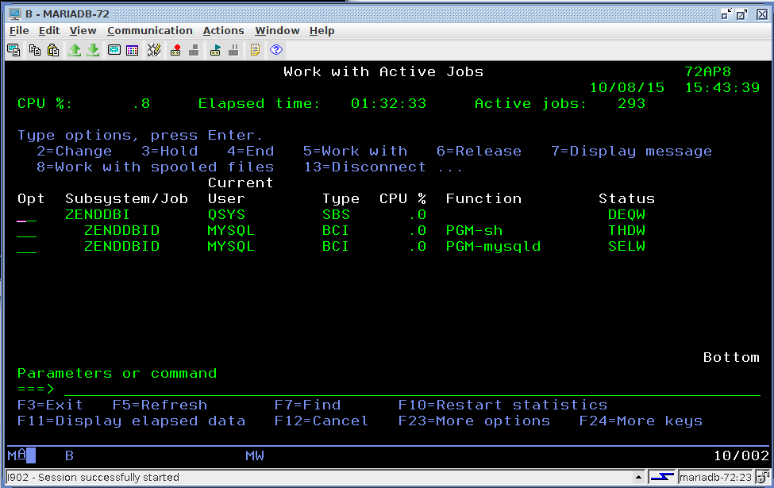

Day to Day Management
You can install phpmyadmin to manage the server if you wish or manage it from command line:

1. ssh to your server (we tested as QSECOFR).
2. I recommend adding the directory /usr/local/mariadb/bin to your path.
3. /usr/local/mariadb/bin/mysql (by default 'root' has no password from localhost) .

the Mariadb daemon listens on port 3306 by default and is open to outside computers. Access from outside is only allowed for users with passwords.
(GRANT will fail to create users with no password).

