Impedance Lab – Results
David Laeer – 20341480
Friday, Feb 2nd 2024

Lab Overview:
This lab measures the capacitance or inductance of capacitors and inductors in RC, RL, and RLC circuits using two different methods, and compares the resulting measurements. The first method involves directly measuring the components’ capacitance/inductance, and the second method involves varying either the voltage or the frequency of the AC current applied to the circuit, and calculating the inductance/capacitance from the measured change in impedance.

Theory:
The impedance, , of capacitors and inductors is given by for capacitors, and for inductors. The impedance of RLC circuits is calculated by adding the individual impedances ()or their reciprocals (), for series and parallel circuits respectively. Since the impedance of both types of components depend on frequency, the change in impedance resulting in a change in the applied frequency can be used to determine the remaining unknowns, i.e. inductance, resistance or capacitance. These results can be confirmed by measurements made with a DMM.

Results and Data
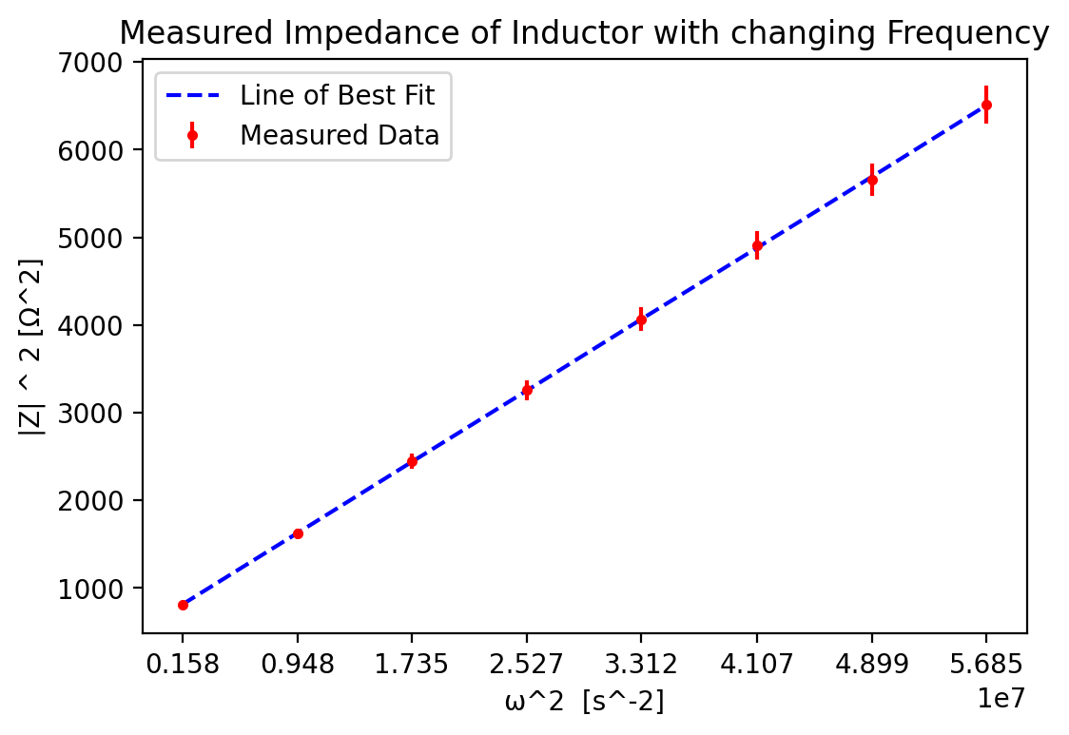
The first part of the experiment involved varying the frequency applied to RC and RL circuits. Figure 1. shows the data obtained by applying frequencies from 200-1200Hz to an inductor:

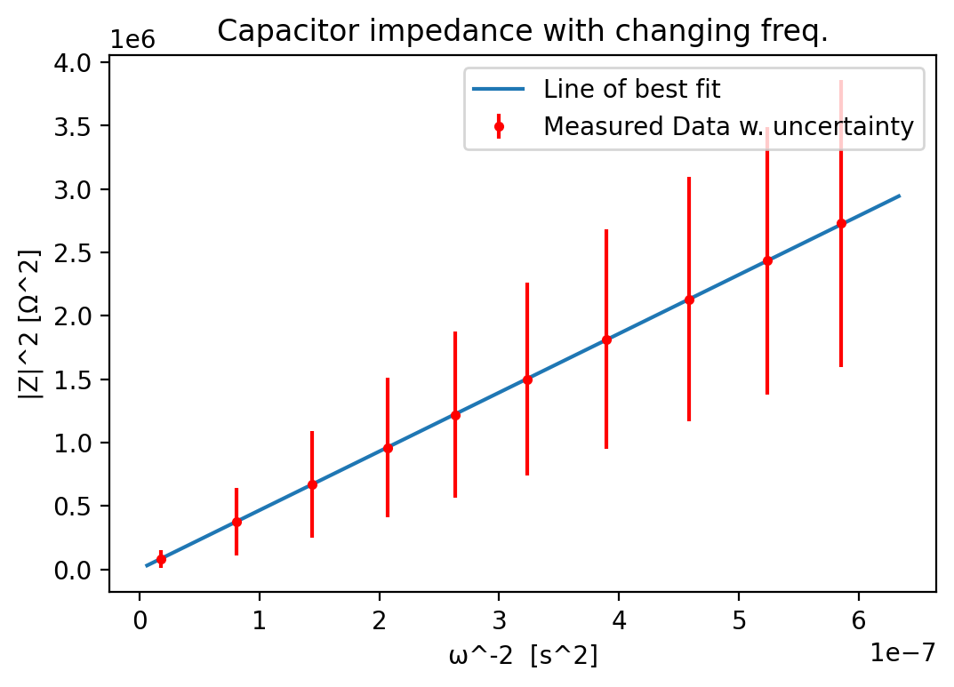
Figure 2 shows change in the impedance of an RC circuit with varying frequency:

These results all fall squarely within error of the line of best fit, indicating little to no random error in the measurements. Furthermore, the slope and intercept of the lines of best fit for these charts were calculated to yield values for and . Expected (DMM measured) values are
. Comparing these to the calculated values obtained below
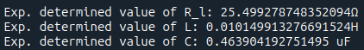
shows that fall within error of the expected values; does not.
The second part of the experiment involved measuring the voltage or current across series or parallel RLC circuits, composed of the same capacitor/inductor pair as in the first part. Results from this are shown below in Figure 3:
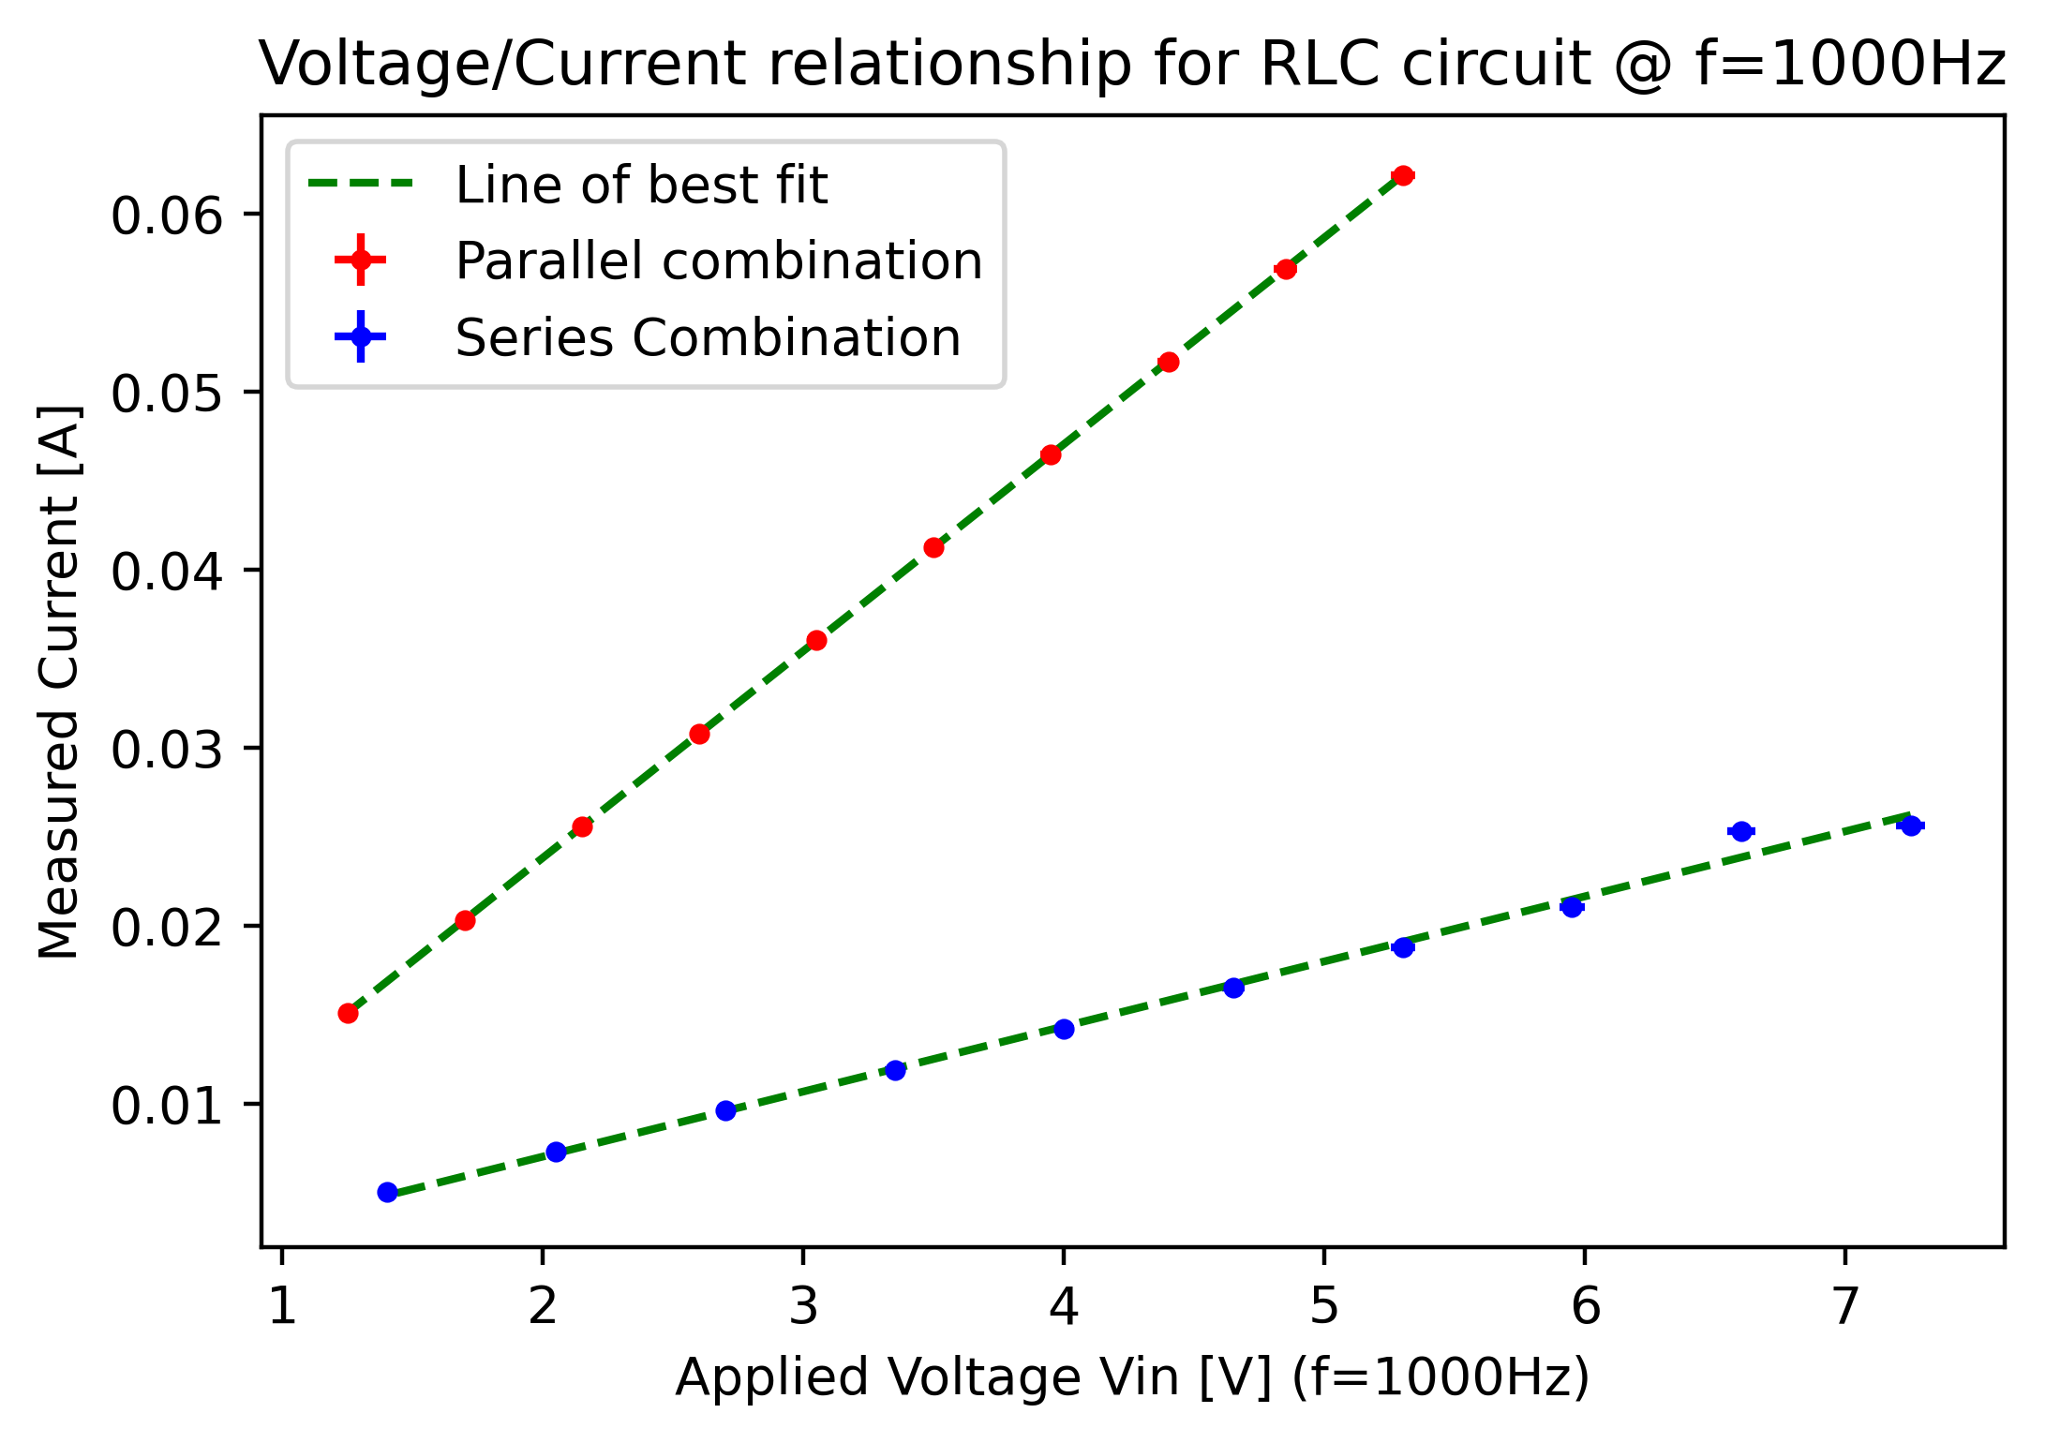
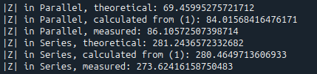
All points but the second-last on the series data align with the line of best fit within error. This was determined during the lab to be caused by an issue with the function generator, though further investigation would be required. Analyzing the slope and intercept of the lines of best fit, and comparing with estimated impedance calculation using the results from the first part yields the following results:

The discrepancy of these results likely arises from a combination of measurement error, equipment error, and (possible) calculation errors. The main concern stems from the discrepancy in the theoretical, calculated, and measured values for the parallel RLC circuit. Furthermore, the small residual values for the linear regressions indicate that these discrepancies stem from systematic measurement or calculation errors.

Conclusion
While the results were mostly satisfactory, the experiment should be repeated with more care being taken to assess systematic instrument and measurement errors, and better accounting of possible error sources. This applies especially to the second part of the experiment, where discrepancies were significant and could not be accounted for by the error sources identified by the team.

