Analysis Appendix
David Laeer – 20341480 – ENPH253 – Queen’s University
Friday, February 2nd, 2024

Lab Overview:
The response of RL, RC, and RLC circuits was observed and measured across a range of varying voltages and frequencies. An inductor with L=10mH, RL = 24.5, and a capacitor with C=0.464nF were used to construct these circuits on a breadboard. A function generator was used to apply AC signals of varying frequencies and voltages, and a DMM was used to measure the circuits’ responses.

Tables/Data:
In the first part of the experiment, an AC signal with variable frequency and constant voltage was applied to separate RC/RL circuits. The results of this part are shown in Table 1:
part 1
 | f (Hz) | vrms (V) | deltav (V) | irms (mA) | deltai (mA)
inductor | 200 | 2.61 | 0.03305 | 91.73 | 0.707975
 | 490 | 3.45 | 0.03725 | 85.72 | 0.6629
 | 663 | 4.08 | 0.0404 | 82.53 | 0.638975
 | 800 | 4.49 | 0.04245 | 78.69 | 0.610175
 | 916 | 4.81 | 0.04405 | 75.44 | 0.5858
 | 1020 | 5.08 | 0.0454 | 72.50 | 0.56375
 | 1114 | 5.26 | 0.0463 | 69.93 | 0.544475
 | 1200 | 5.43 | 0.04715 | 67.26 | 0.52445
capacitor
 | 208 | 7.48 | 0.0574 | 4.528 | 0.05396
 | 220 | 7.48 | 0.0574 | 4.795 | 0.0559625
 | 235 | 7.48 | 0.0574 | 5.124 | 0.05843
 | 255 | 7.47 | 0.05735 | 5.545 | 0.0615875
 | 280 | 7.46 | 0.0573 | 6.090 | 0.065675
 | 310 | 7.45 | 0.05725 | 6.745 | 0.0705875
 | 350 | 7.43 | 0.05715 | 7.582 | 0.076865
 | 420 | 7.40 | 0.057 | 9.060 | 0.08795
 | 560 | 7.50 | 0.0575 | 12.222 | 0.111665
 | 1200 | 7.38 | 0.0569 | 25.68 | 0.2126
Note that the AC input was generated using a BK Precision 4011A 5MHz function generator. In the second portion of the experiment, parallel and series versions of an RLC circuit were constructed, and a constant frequency, variable voltage AC signal was applied. Response data for these circuits is show below:
Table 2
parallel | f = 1000 Hz |  |  | series | f = 1000 Hz
vin (V) | deltav | irms (mA) | deltai | vrms (V) | deltav | irms (mA) | deltai
5.30 | 0.0465 | 62.13 | 0.000485975 | 7.25 | 0.05625 | 25.61 | 0.000212075
4.85 | 0.04425 | 56.88 | 0.0004466 | 6.60 | 0.053 | 25.31 | 0.000209825
4.40 | 0.042 | 51.66 | 0.00040745 | 5.95 | 0.04975 | 21.02 | 0.00017765
3.95 | 0.03975 | 46.46 | 0.00036845 | 5.30 | 0.0465 | 18.785 | 0.000160888
3.50 | 0.0375 | 41.24 | 0.0003293 | 4.65 | 0.04325 | 16.483 | 0.000143623
3.05 | 0.03525 | 36.03 | 0.000290225 | 4.00 | 0.04 | 14.175 | 0.000126313
2.60 | 0.033 | 30.76 | 0.0002507 | 3.35 | 0.03675 | 11.865 | 0.000108988
2.15 | 0.03075 | 25.58 | 0.00021185 | 2.70 | 0.0335 | 9.585 | 9.18875E-05
1.70 | 0.0285 | 20.31 | 0.000172325 | 2.05 | 0.03025 | 7.271 | 7.45325E-05
1.25 | 0.02625 | 15.062 | 0.000132965 | 1.40 | 0.027 | 5.005 | 5.75375E-05

Furthermore, at V=5.3V for the parallel circuit and V=7.25V for the series circuit, currents IL and IC were measured as 73.72mA and 21.55mA (parallel), and voltages VL and VC were measured as 1.7645V and 8.852V.
Calculations were performed using the attached python script, which yielded the following results:
Exp. determined value of R_l: 25.499278748352094Ω
Exp. determined value of L: 0.010149913276691524H
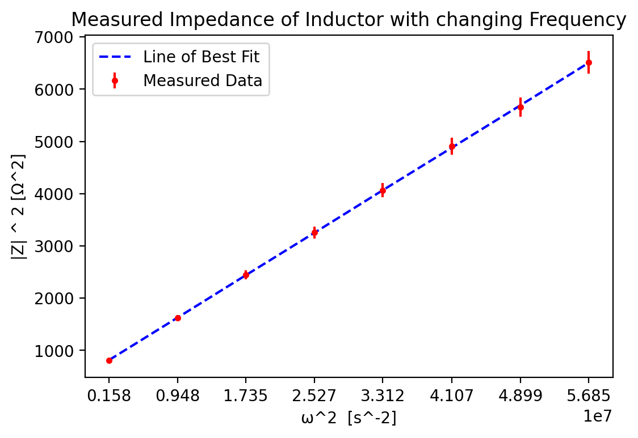
Exp. determined value of C: 0.463904192751495 uF
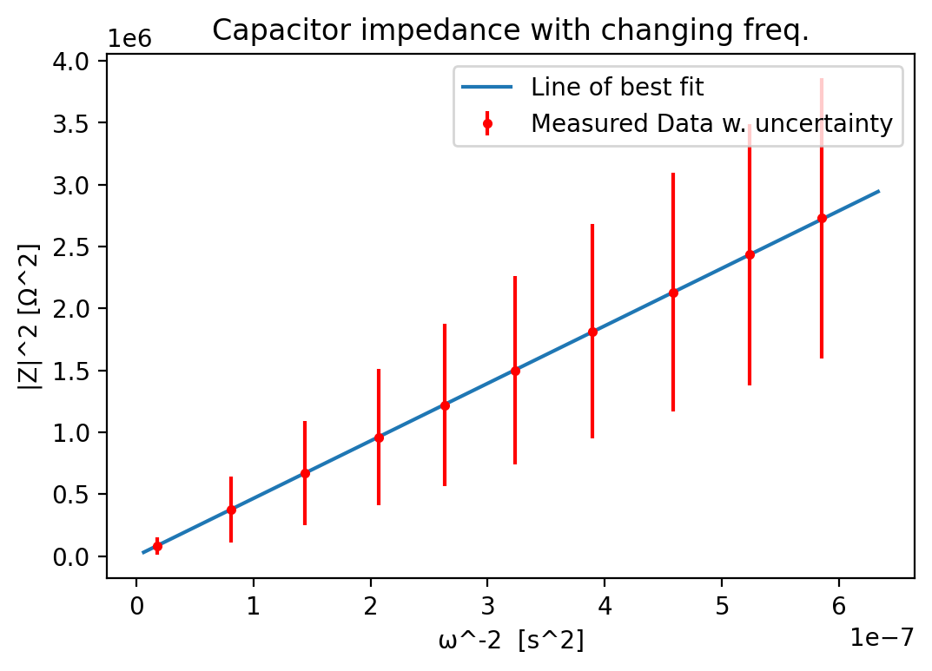
Part 2:
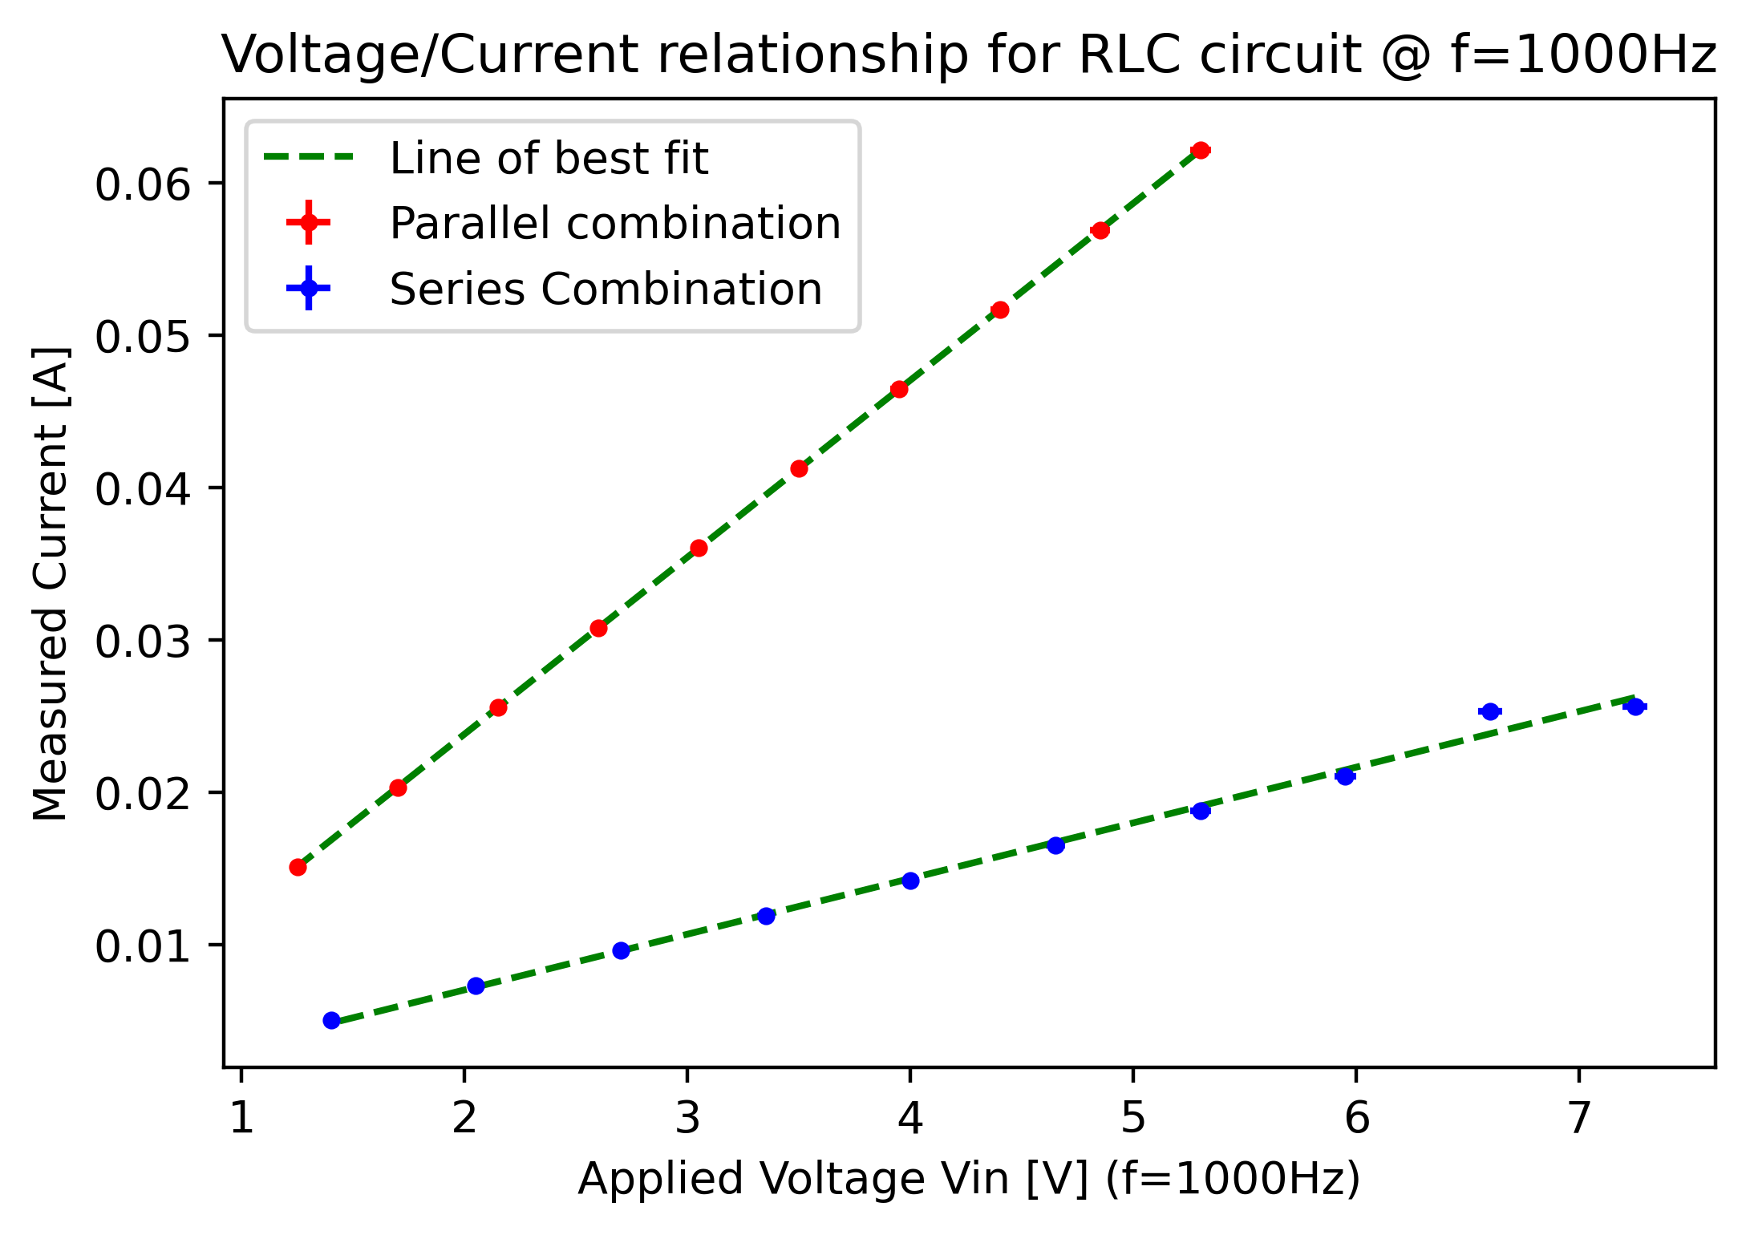

|Z|**2 in Parallel: 84.01568416476171
|Z|**2 in Series: 280.4649713606933
Measured Current IL, IC: 0.07372, 0.02155
Expected Currents IL, IC: 0.07716648308187195, 0.01544841884152656
Measured Voltages VL, VC: 1.7645, 8.852
Expected Voltages VL, VC: 1.7754422107926813, 5.474557789207319

It is important to note that Fig. 3’s second last data point appears to be escaping the trend line. This was noted during the procedure and it was determined that this was due to an error in the function generator.

