Low Pass Filter – Analysis Appendix
David Laeer – 20341480 – Friday, Jan. 26th, 20204

Overview
This lab explores the filtering of high frequencies using the changing impedance of capacitors at various frequency regimes. A voltage divider consisting of a resistor and capacitor is subjected to varying frequencies and the output’s magnitude and phase shift is measured using a digital oscilloscope over a wide range of frequencies. A so-called ‘transfer function’ is used to model the behavior of this circuit, and these predictions are compared with experimental data collected during the experiment.
Quantities used in the experiment include the applied frequency , the applied voltage , the output voltage , as well as the phase shift .
f(Hz) | V_in (V) +/- (V) | V_in scale | V_out(V) +/- (V) | V_out scale | Delta t (ms) | Time scale
100 | 19.8(2) | 5V/square | 19.6(1) | 5V/square | 0.000(2) | N/A
300 | 20.0(2) | 5V/square | 19.6(1) | 5V/square | 0.010(2) | N/A
972 | 20.0(2) | 5V/square | 18.8(2) | 5V/square | 0.032(4) | N/A
3003 | 19.6(2) | 5V/square | 15.2(2) | 5V/square | 0.034(1) | N/A
10000 | 19.2(2) | 5V/square | 7.2(2) | 5V/square | 0.020(1) | N/A
30000 | 19.2(2) | 5V/square | 3.0(2) | 5V/square | 0.0076(1) | N/A
100000 | 19.4(2) | 5V/square | 0.82(2) | 5V/square | 0.00220(2) | N/A
Table 1: Data collected during the experiment.

The values above were generated using a standard 50 MHz function generator with a 50 output resistance, and results were recorded using a 20 MHz digital oscilloscope. The circuit in question is depicted below:
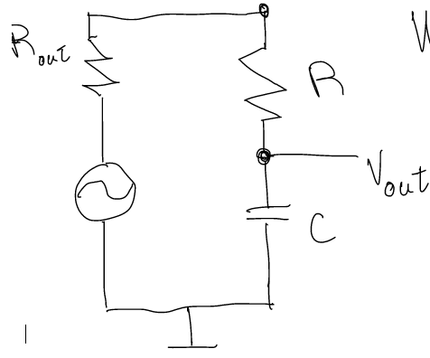
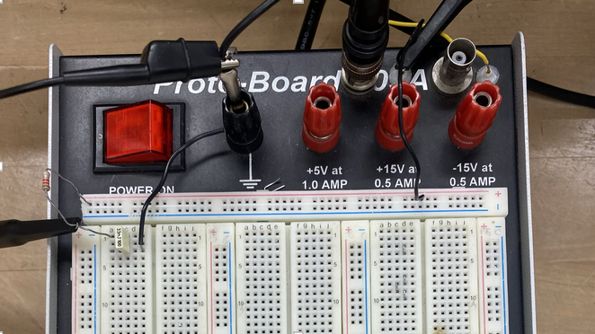
The Low Pass Filter Circuit The circuit, constructed on a breadboard

The values of the capacitor and resistor used were measured using DMM’s, and were determined to be .
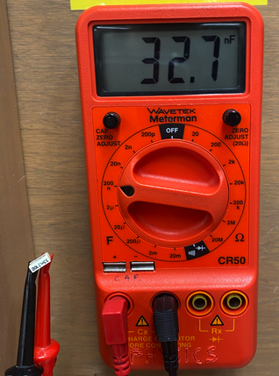
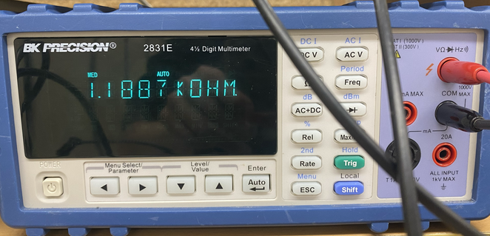
Capacitor measurement Resistor Measurement

Graphs
Graphs of the collected data are shown below. Measurements are within error for the magnitude of the transfer function (Fig 1), while this is not the case for measurements of the phase shift (Fig 2). This difference is believed to be due in part to the method used to collect the data; while the digital oscilloscope used is able to read peak-to-peak voltage directly, the use of cursors was required. Furthermore, instead of directly measuring phase shift in radians, the shift was measured in milliseconds and converted to radians using data on the period of the applied signal. This is a further source of error, and while it was accounted for in the error propagation calculation, the fact that very small shift values are measured for low frequencies () further increases the error in the low frequency range.
Fig 1.
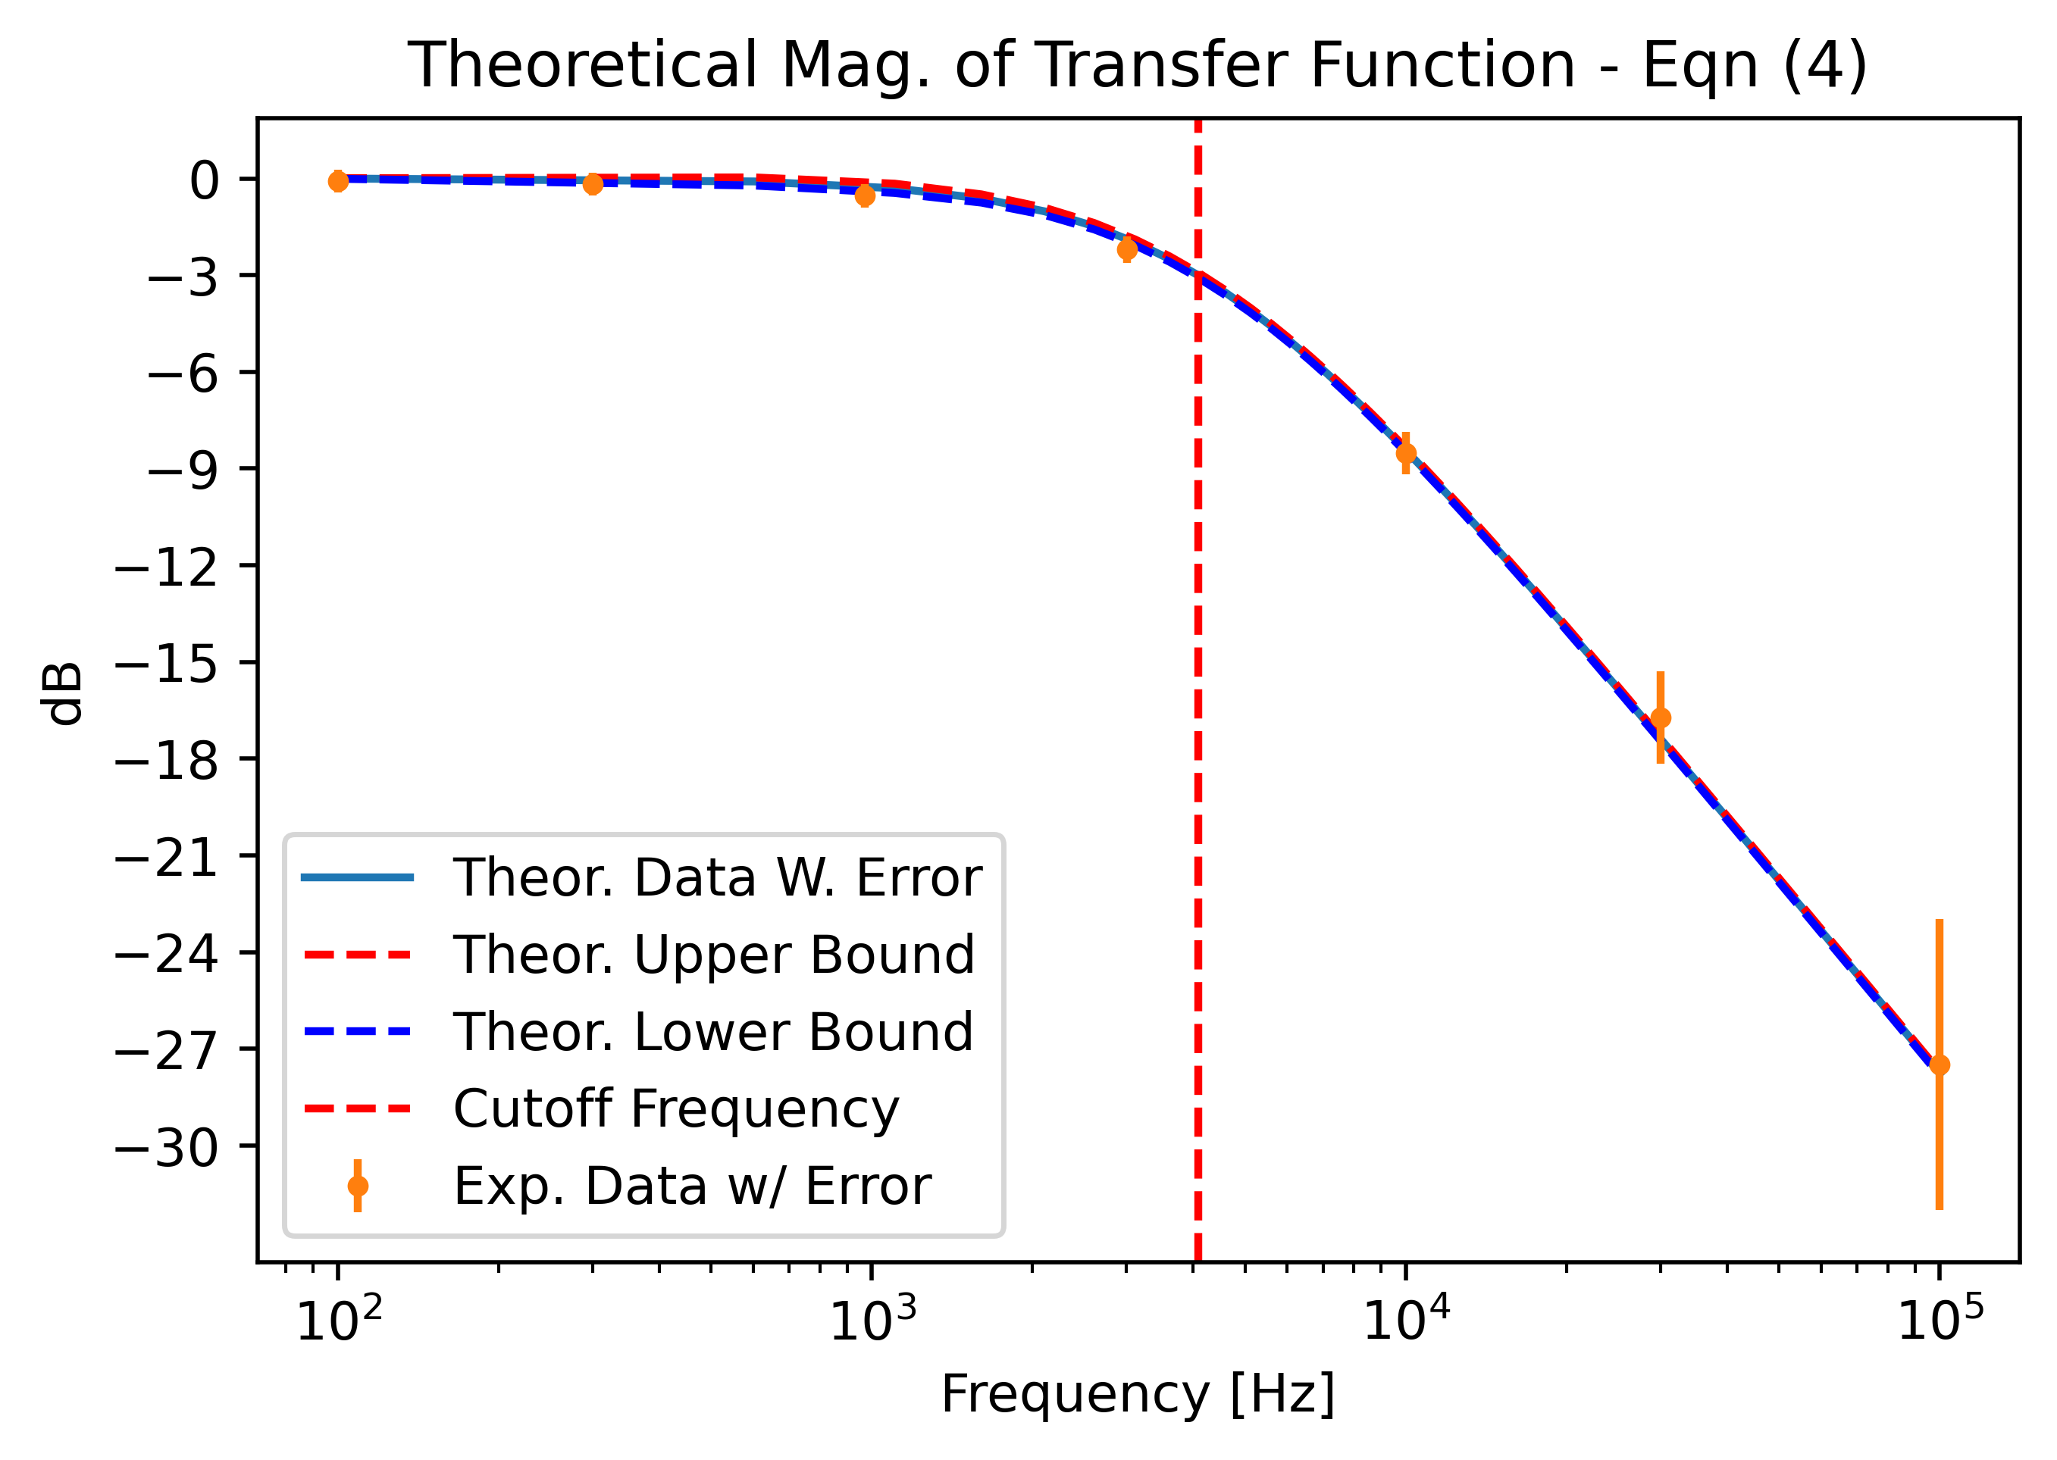

Fig 2.
