Low Pass Filter – Results and Report
David Laeer – 20341480
ENPH253 – Queen’s University
January 26th, 2024

Lab Overview:
The aim of this experiment is to validate the behavior of a simple circuit, the low pass filter. The experiment involves constructing a low pass filter (LPF) circuit on a breadboard and measuring its response to a range of applied frequencies using a digital oscilloscope.

Theory:
This circuit acts similarly to a voltage divider, except that by replacing the lower resistor with a capacitor, the circuit’s response is modified such that higher frequencies are filtered out, whereas lower frequencies below a certain ‘cutoff frequency’ are allowed to pass through. This is due to the behavior of capacitors, whose impedance is dependent on frequency. A ‘transfer function’ predicts this behavior for any given frequency, both phase shift and voltage magnitude.

Graphs and Results
The results of the experiment are plotted below. Both magnitude (Fig. 1) and phase shift (Fig. 2) of the output voltage are plotted against the values predicted by the transfer function. Data collected during the experiment mostly agree with theoretical predictions, except in the case of phase shift measurements, which is discussed further below.
Fig 1.
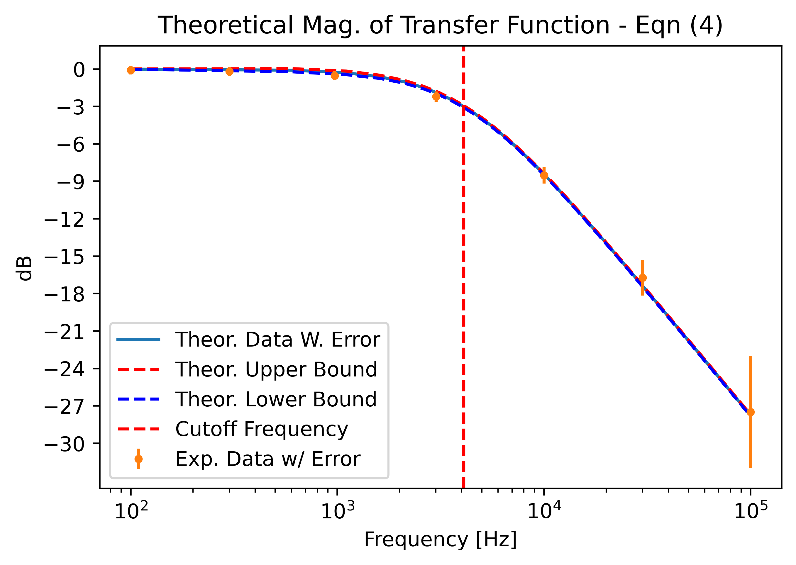
The vast majority of voltage magnitude measurements agree with the theoretical prediction (in blue). The cutoff frequency is shown as the vertical red dotted line.
Fig 2.
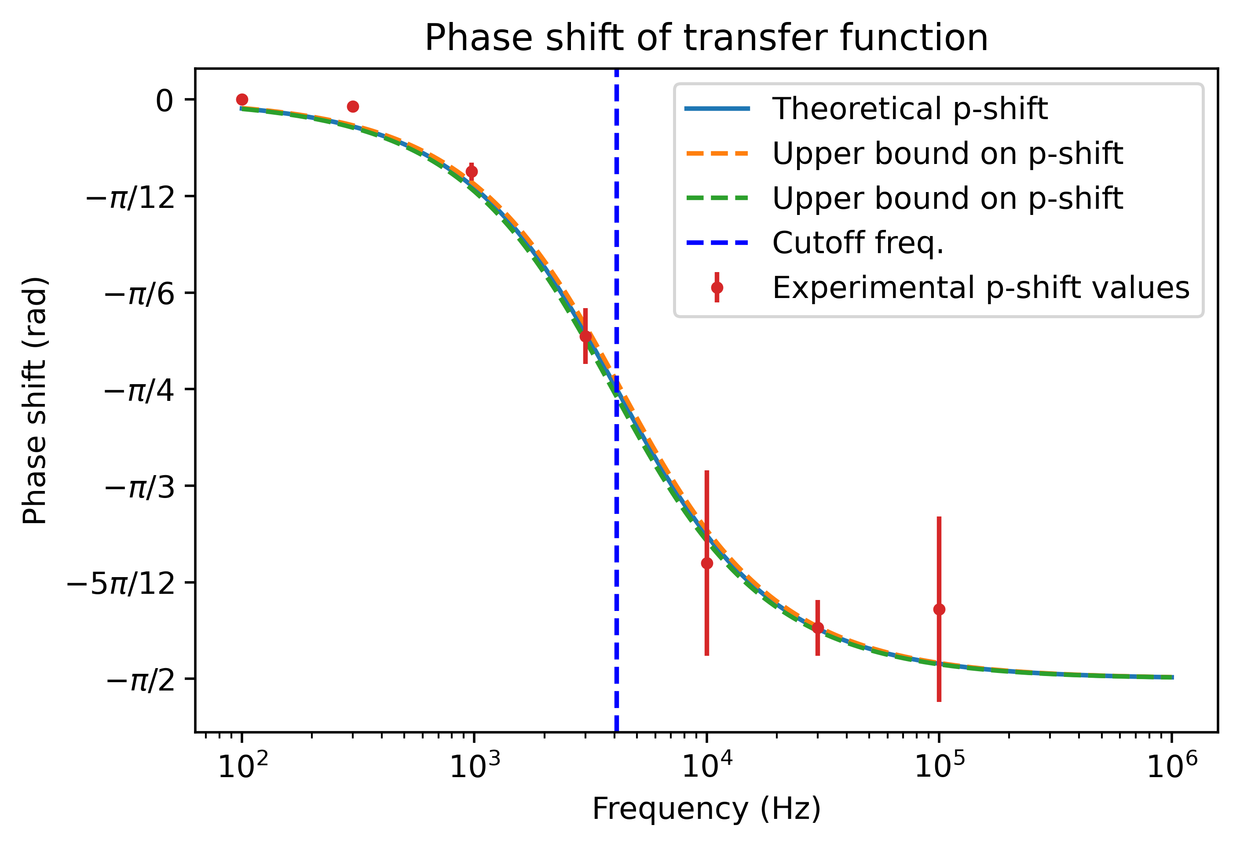
The experimental data for phase shift mostly agrees with predictions, however data points collected at low frequencies below the cutoff frequency do not. This is due to the way the data were obtained: phase shift was measured manually with the oscilloscope’s cursors, relying on human estimates of where on the scope graph the shifted output peaks. This explains the discrepancy between theory and measurement in the lower part of the frequency range.

Conclusion
In conclusion, the results of the experiment mostly agree with prediction, however improved measuring techniques for collecting phase shift data are required to better confirm the behavior of an LPF circuit as predicted by the transfer function model. Furthermore, more data points should be collected to further confirm the validity of the transfer function hypothesis. The experiment was a success, given that it also confirmed the behavior of the LPF circuit around the cutoff frequency.

