# Is Ted O'Brien a fit for purpose shadow Minister?

It is disappointing to have to write about politics, but recent events have signalled that the Federal Opposition is opposed to cheaper electricity, opposed to new supply if it comes from wind and solar, opposed to the concurrent $40 bn or more that would be invested in regional Australia, opposed to AEMO's integrated system plan, opposed to fuel efficiency standards, and at odds with each and every State Govt, energy policy. In pursuit of blind, dogged virtue signalling to their base they are prepared to sacrifice what remains of the Liberal Party in favour of a declining rural constituency.

The Federal opposition has decided to oppose ongoing wind and solar development despite the convincing and heavy weight of evidence that wind and solar are the most cost effective ways for Australia to generate electricity. This denial of facts for the sake of perceived and yet actually illusionary short term political optics works to the disadvantage of Australians. The National party and their brothers in arms, the QLD LNP could do so much to help but instead set out to wreck. It must be obvious to the Liberal Party brains trust that favouring pandering to the base over rational economic policy as modelled by AEMO and broadly supported by electricity industry stakeholders paints the Federal Opposition into an ever smaller corner. The same discredited and long past their use by date politicitans that opposed acknowleding the reality of climate change science, now oppose renewable energy.

Federal opposition shadow Minister for Energy, Ted O'Brien thunders on in Parliament about the lack of social license when its his party doing its utmost to make that license difficult to attain.

Until the Liberal Party finds a leader that can reassert the primacy of rational policy, made for the long term interest of most Australians, and free the Liberal Party from the thrall of the Nationals and the LNP, until that day, they will struggle to gain credibility. You can sell bull sh** for a long time to your base, but as Lincoln said you can't sell everyone bs all the time. The Federal Liberal party has an absolute duty to lead rather than follow, to play to the best side of its voters, rather than acting as a megaphone for their fears and worries.

By way of where we are today, let alone where we will be in a few years time, no matter who is in power Federally, onc can look at the Australian crocodile.

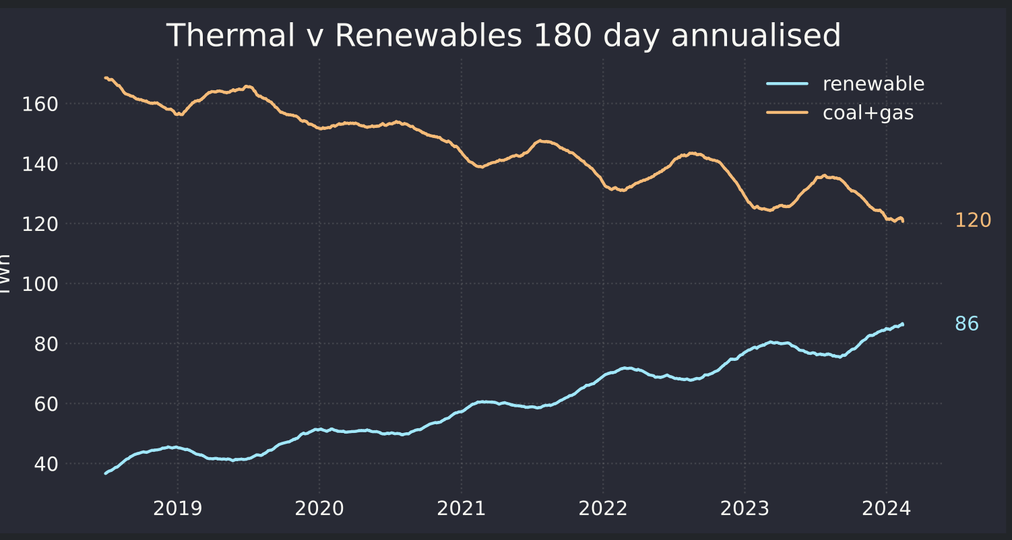

Figure 1Crocodile approaches mirror. Source: NEM Review

# Politicians who make a difference

Four politicians in Australia over the past 15 years stand out as having made a real difference in energy policy in a way that will benefit most Australians. They are:

* Lily D'Ambrosio
* Matt Kean
* Mick Di Brenni
* Chris Bowen

Notwithstanding the mark of all good policiticans, and that is the courage of their convictions, D'Ambrosio and Di Brenni enjoy a dominant position in their parliament. Both are distinguished.

Matt Kean stands out for being the Energy Minister of a Parliament that collectively agreed on a policy designed to move NSW forward. However his achievement was only possible because he proposed and the ALP and the NSW National party accepted. His achievement was consensus. Consensus was possible because the policy was likely to succeed and be effective and served the interests of NSW. It had something for everyone even voters.

Chris Bowen stands out as having achieved more than any other Federal Energy Minister in the past 15 years without actually making too many waves. It is easy to criticise Federal policy as not going far enough but the achievements include:

* Restoring Federalism and genuine consultation in energy policy after Angus Taylor in particular had created animosity with everything he touched. The importance of this goes to how Federal and State policy can be coordinated ie NSW LTESA with Federal CIS. More than that if the "word" is kick the Planning Depts into action then maybe it will happen.
* An improved, if still imperfect, "Safeguard mechanism"
* Capacity Investment Scheme;
* A genuine fuel efficiency standard (yet to be legislated)
* Funding for transmission that one way and and another has enabled early works on say Hume Link.
* I would add that it seems to me Bowen does his homework, consults widely and listens. John Howard was the same.

# The Federal opposition opposes wind and solar and supports nuclear

Imagine you were AEMO. You have spent $millions with a significant team of people developing over 4 years what is now the second comprehensive version of the ISP. You have had basically the enitre set of industry stakeholders formally input via the "Delphi" method their consensus opinion of the way forward. No showstoppers have been identified by industry stakeholders over the four years of the ISP although of course there are concerns and issues.

Then we all observe the dominant faction in the Federal Opposition encouraging and speaking at an [anti wind and solar forum](https://reneweconomy.com.au/rally-betrays-anti-renewables-desperation-as-joyce-calls-on-army-to-go-home-and-recruit/), . The leader of the Nationals, David Littleproud, not at the rally, nevertheless leaned in to the anti renewables push as the [SMH]<https://www.smh.com.au/politics/federal/call-to-cancel-renewable-rollout-nationals-declare-bush-is-full-20240206-p5f2sf.html()> reported.

New renewable energy projects in regional Australia must be stopped now, Nationals leader David Littleproud has declared as he claims the nation should downgrade its commitment under the Paris Agreement, signalling a major escalation in the political brawl over climate policy.

Regional communities and farmland cannot cope with more wind and solar farms, as well as transmission lines, Littleproud said.

This of course factually garbage. Its complete and utter tripe. How can Australia progress when leaders make statements like this? Imagine General Monash telling the Australian troops that the Germans don't have any guns. That's the level Littleproud is at. Just depressing to me as there so many interesting and real problems to solve.

Look at the politicians that were reported in the above article to have attended the Canberra rally!

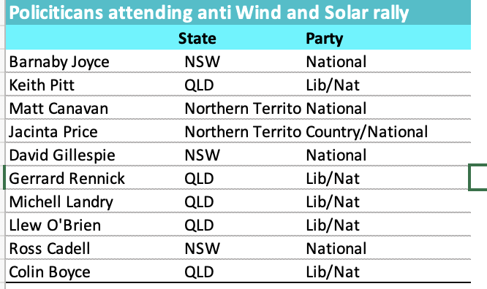

Figure 2 Anti renewable attendees. Source: Reneweconomy via AAP

# The Nationals could make a real difference but as it stands they will try to make electricity expensive and unreliable

If they wanted to the National Party could actually make a big difference to lowering prices of electricity by helping to smooth the way for renewable energy to be built in regional Australia. Not only would this benefit the vast majority of Australia but it brings the many $billions of investment. It also brings costs. But instead of helping to bridge the gap, instead of adopting the mainstream view of the electricity industry, the Federal Opposition for the sake of cheap politics, make it as hard as it possibly can to get the job done. They subscribe to net zero and then talk about the "ute tax". Peter Dutton could basically tell his team to back AEMO. He could show some real leadership like Gladys Berijiklian did in appointing Matt Kean. His failure to grasp the nettle is not going to stop anything longer term because climate change and economics will inevitably win the battle longer term. All he does is paint his party into a smaller and smaller corner.

# Liberals are presently in reality the smaller group from one perspective in the Federal Opposition

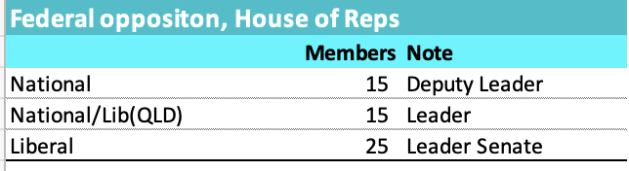

Figure 3 Federal opposition lower house. Source: Wikipedia

QLD Nationals/Lib and the Nationals are presently the largest force in the Federal Opposition. Most will say this classification is wrong because the Queensland LNP sit in the Liberal partyroom where they notionally could be outvoted. However to an amateur like me it seems that the Nationals and LNP make policy which they then impose on the Liberal Party Room. To the best of my knowledge Dutton is not differentiated from the National Party on any substanial policy issue.

As is well known low Liberal number are partly because a number of Liberal seats were lost to Teals and partly because of perhaps one off events in West Australia. Liberal seats were lost to Teals because their moderate members, lets call them the Keans, a were unable to stand up to the dominant QLD/National faction and had zero influence on policy. Their constitutents wanted members that represented their values.

Having lost so many seats the Liberals seem now to be even less influential, even inconsequential. Other than Angus Taylor who is a de facto member of the LNP, its hard to think of a single Liberal with anything important to say or any real influence on Opposition policy

From a perspective of a Matt Kean supporter the problem was the merging of the National and Liberals in QLD. As things stand it now seems that has made the Nationals more powerful and the Liberals weaker.

None of this is news. How it will work out I don't know. It could work out by a strong Liberal moving the LNP back into middle Australia. Something Turnbull was unable to do and Morrison had no need of or interest in doing.

What I do know is that no matter who is in power, decarbonsiation will proceed. It would seem more sensible to swim with the tide than pretend it doesn't exist and make the job harder and harder