# Is Ted O'Brien a fit for purpose shadow Minister?

Ted O'Brien has already showed by his attendance at an anti wind and solar rally, support for Nuclear and in other ways that he is no fan of the ISP or anything that resembles it. This is highly disappointing and will make the job harder than it needs to be but will likely condemn history to see him as a loser even should the opposition win office.

# Politicians who make a difference

Four politicians in Australia over the past 15 years stand out as having made a real difference in energy policy in a way that will benefit most Australians. They are:

* Lily D'Ambrosio
* Matt Kean
* Mick Di Brenni
* Chris Bowen

Notwithstanding the mark of all good policiticans, and that is the courage of their convictions, D'Ambrosio and Di Brenni enjoy a dominant position in their parliament. Both are distinguished.

Matt Kean stands out for being the leader of a Parliament that collectively agreed on a policy designed to move NSW forward. However his achievement was only possible because he lead and the ALP and the NSW National party followed. His achievement was consensus. Consensus was possible because the policy was likely to succeed and be effective and served the interests of NSW. It had something for everyone including voters.

Chris Bowen stands out as having achieved more than any other Federal Energy Minister in the past 15 years without actually making too many waves. It is easy to criticise Federal policy as not going far enough but the achievements include:

* Restoring Federalism and genuine consultation in energy policy after Angus Taylor in particular had created animosity with everything he touched. The importance of this goes to how Federal and State policy can be coordinated ie NSW LTESA with Federal CIS. More than that if the "word" is kick the Planning Depts into action then maybe it will happen.
* An improved, if still imperfect, "Safeguard mechanism"
* Capacity Investment Scheme;
* A genuine fuel efficiency standard (yet to be legislated)
* Funding for transmission that one way and and another has enabled early works on say Hume Link.
* I would add that it seems to me Bowen does his homework, consults widely and listens. John Howard was the same.

# By contrast the Federal opposition opposes wind and solar and supports nuclear

Imagine you were AEMO. You have spent $millions with a significant team of people developing over 4 years what is now the second comprehensive version of the ISP. You have had basically the enitre set of industry stakeholders formally input via the "Delphi" method their consensus opinion of the way forward.

Then you observe the dominant faction in the Federal Opposition encouraging and speaking at an [anti wind and solar forum](https://reneweconomy.com.au/rally-betrays-anti-renewables-desperation-as-joyce-calls-on-army-to-go-home-and-recruit/), . The leader of the Nationals, David Littleproud, not at the rally, nevertheless leaned in to the anti renewables push as the [SMH]<https://www.smh.com.au/politics/federal/call-to-cancel-renewable-rollout-nationals-declare-bush-is-full-20240206-p5f2sf.html()> reported.

New renewable energy projects in regional Australia must be stopped now, Nationals leader David Littleproud has declared as he claims the nation should downgrade its commitment under the Paris Agreement, signalling a major escalation in the political brawl over climate policy.

Regional communities and farmland cannot cope with more wind and solar farms, as well as transmission lines, Littleproud said.

This of course factually garbage. Its complete and utter tripe. How can Australia progress when leaders make statements like this? Imagine General Monash telling the Australian troops that the Germans don't have any guns. That's the level Littleproud is at. Just depressing to me as there so many interesting and real problems to solve.

Look at the politicians that were reported in the above article to have attended the Canberra rally

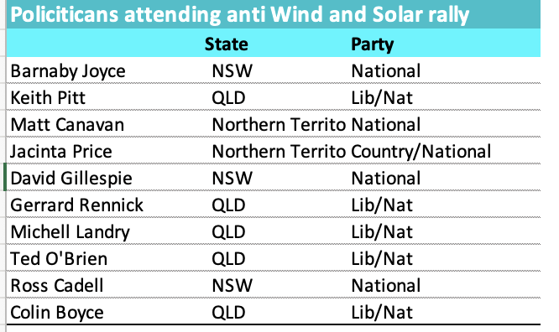

Figure 1Politicians attending anti renewables rally. Source: Reneweconomy(via AAP)

The list includes Ted O'Brien the Federal shadow Minister for Energy another Lib/Nat and a nuclear advocate. I say nothing of the nuclear advocacy other than I don't know any significant player in the Australian Electricity Industry that actively advocates nuclear and I know several, including some that have worked in the nuclear that think nuclear ill suited and unecessary for Australia. Supporting nuclear may endear O'Brien to the base but leads to separation from the industry. It would seem to me a bit of public support for AEMO and the ISP and a willingness to facilitate the transition instead of opposing it would benefit all.

What is really concerning is the active opposition to wind and solar that his attendance .

# The Nationals could make a real difference but as it stands they will try to make electricity expensive and unreliable

If they wanted to the National Party could actually make a big difference to lowering prices of electricity by helping to smooth the way for renewable energy to be built in regional Australia. Not only would this benefit the vast majority of Australia but it brings the many $billions of investment. It also brings costs. But instead of helping to bridge the gap, instead of adopting the mainstream view of the electricity industry the Federal Opposition make it as hard as it possibly can to get the job done. They subscribe to net zero and then talk about the "ute tax". Peter Dutton could basically tell his team to back AEMO. He could tell Ted O'Brien not to attend a fringe rally. He could show some real leadership like Gladys Berijiklian did in appointing Matt Kean. His failure to grasp the nettle is not going to stop anything longer term because climate change and economics will always win the battle longe term. All he does is paint his party into a smaller and smaller corner.

# Liberals are presently in reality the smaller group from one perspective in the Federal Opposition

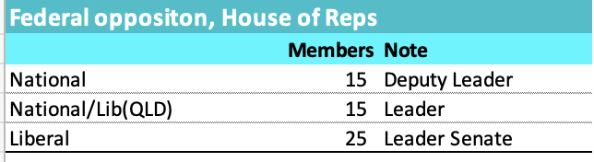

Figure 2Source: Wikipedia

QLD Nationals/Lib and the Nationals are presently the largest force in the Federal Opposition. Most will say this classification is wrong because the Queensland LNP sit in the Liberal partyroom where they notionally could be outvoted. However to an amateur like me it seems that the Nationals and LNP make policy which they then impose on the Liberals.

As is well known this is partly because a number of Liberal seats were lost to Teals and partly because of events in West Australia. Liberal seats were lost to Teals because their moderate members, lets call them the Keans, a were unable to stand up to the dominant QLD/National faction and had zero influence on policy.

Having lost their seats the Liberals seem now to be even less influential, even in consequential. Other than Angus Taylor who is a de facto member of the Group, its hard to think of a single Liberal with anything important to say or any real influence on Opposition policy

From this perspective the problem was the merging of the National and Liberals in QLD. As things stand it now seems that has made the Nationals more powerful and the Liberals weaker.

None of this is news. How it will work out I don't know. It could work out by a strong Liberal moving the LNP back into middle Australia. Something Turnbull was unable to do and Morrisson had no need of or interest in doing.

What I do know is that no matter who is in power decarbonsiation will proceed. It would seem more sensible to swim with the tide than pretend it doesn't exist and make the job harder and harder