^{DATE} : To implement CI/CD using Jenkins and to
deploy an Smart Notice Board website

Aim
To implement the CI/CD using the Jenkins and to deploy an Smart Notice Board website in the live server.

Tools required
- Jenkins
- Github
- Git
- Vercel

Procedure

Step 1: Create Simple Web Page(folder named jenkins-demo). Step 2: Inside create file: index.html
Step 3: Write the code in the index.html.
Step 4: Go to GitHub and create a repository named jenkins-demo
Step 5: After creating the repo run the below code in the command prompt terminal .
- git remote add origin https://github.com/your-username/jenkins-demo.git
- git branch -M main
- git push -u origin main
Step 6: Install the Jenkins and go to Jenkins dashboard and click new item and name it jenkins-pipeline and select pipeline and click ok.
Step 7: Now configure the pipeline buy scrolling down to the pipeline and paste the below code in the pipeline script:
pipeline { agent any stages {
stage('Clone') { steps {

git branch: 'main', url: 'https://github.com/username /jenkins-demo.git'
}
}
stage('Build') { steps {
echo 'Building project...'
}
}
stage('Deploy') { steps {
bat 'if not exist C:\\deploy mkdir C:\\deploy' bat 'xcopy * C:\\deploy /E /I /Y'
}
}
}
}
Step 8: After copying the code click save
Step 9:To enable Auto CI/CD in Jenkins go to the triggers and enable Poll SCM
Step 10: After ticking a box will appear , type ***** there Step 11: Now click save.
Step 12:Now the next step is to deploy the website to the server Step 13: Install the vercel and click Add New then Project
Step 14:Import the Jenkins-demo from the GitHub and click deploy
Step 15:Now vercel will:
- Pull your code
- Deploy it
- Give a URL like:
https://jenkins-demo-xxxx.vercel.app
Step 16: Now Push the code to the github . type the following in the command prompt teminal:
- git add .
- git commit -m "test1"

- git push
Step 17:Now the code will be pushed to the GitHub and Jenkins will auto run the job and build the job and deploy to the vercel:

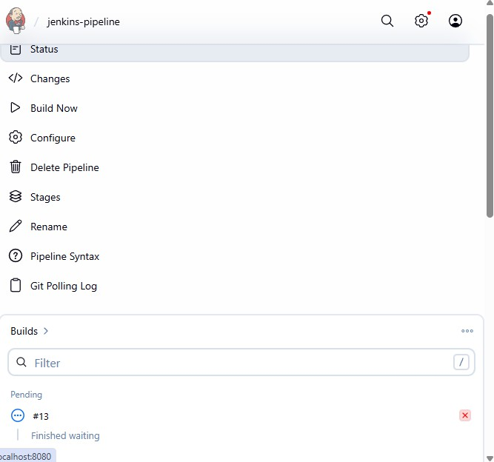

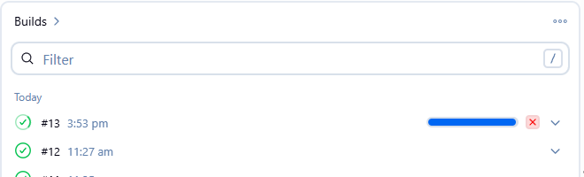

Step 17:Now after auto deployment the website will be live to the user:

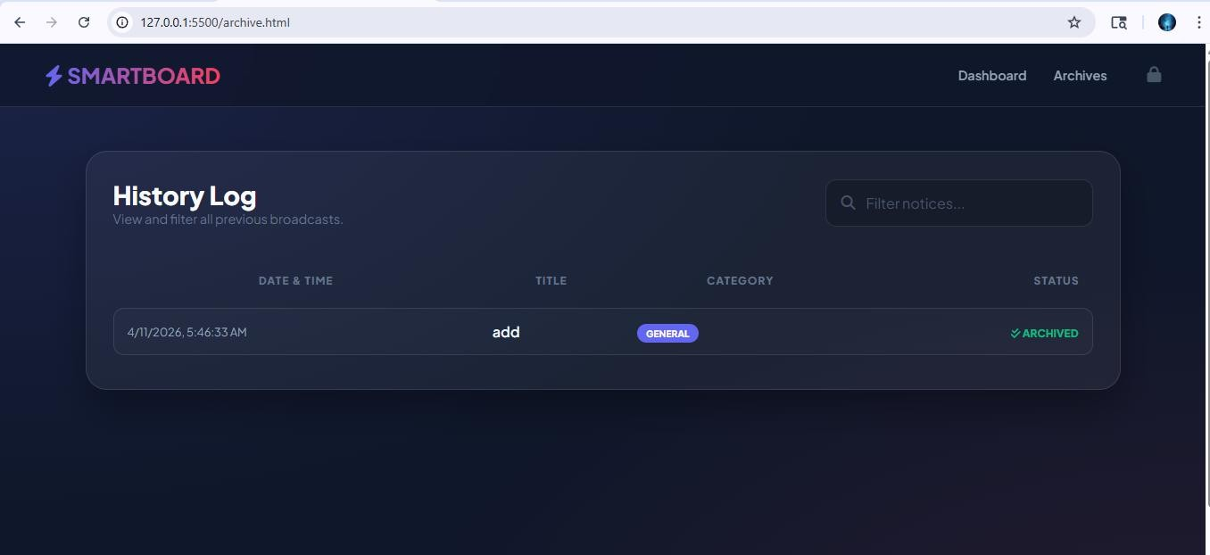

Step 18:Now make some changes in the code like changing the heading of the website.In our project the SMARTBOARD is changed to NOTIEBOARD.
Step 19:Now again only push the code to the GitHib:
- git add .
- git commit -m "test2
- git push
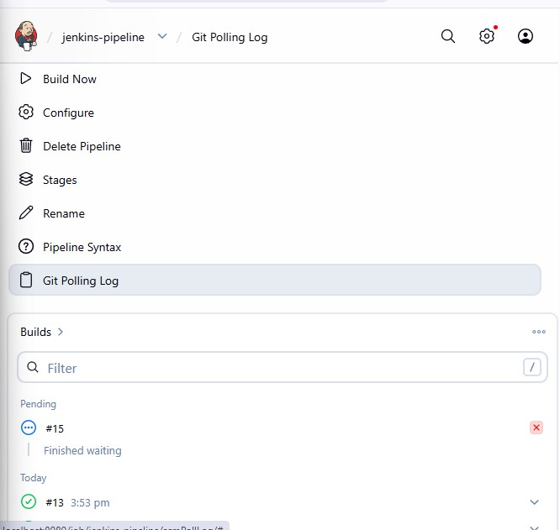

Step 20: Now refresh the URL to see the implementation of CI/CD using the jenkins :
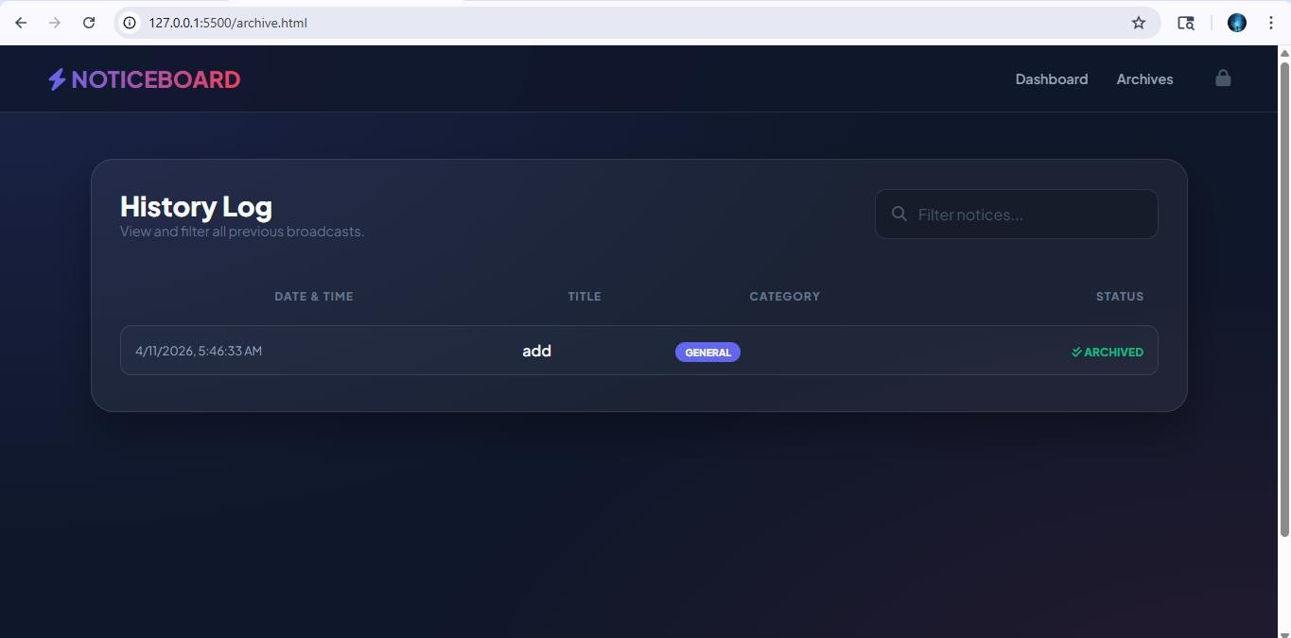

Architechture:

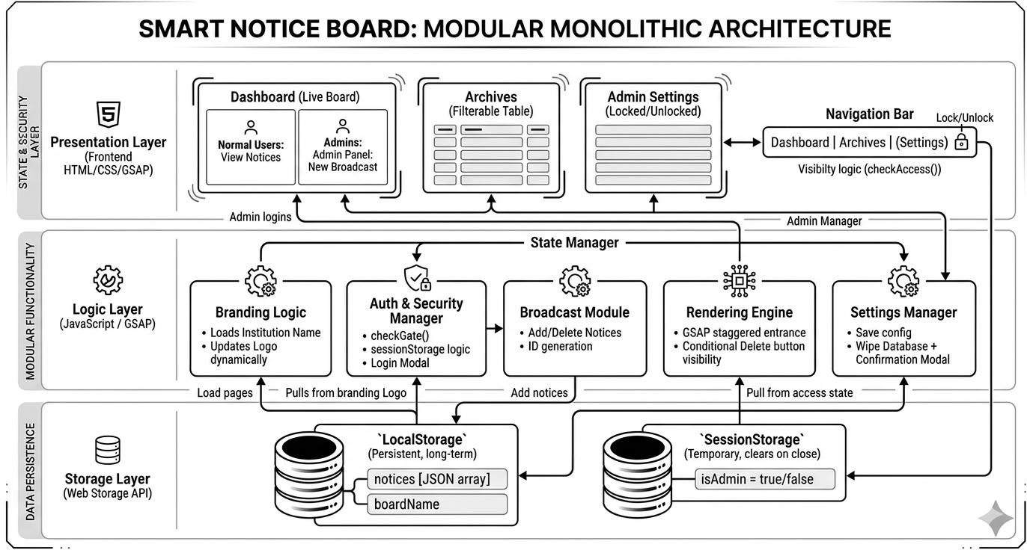

GitHubRepository Link:
https://github.com/SriJainthu/jenkins-demo

Deployment Link:
jenkins-demo-one.vercel.app

Cetificates in InfosysSpringBoard:

- Introduction to Agile methodology
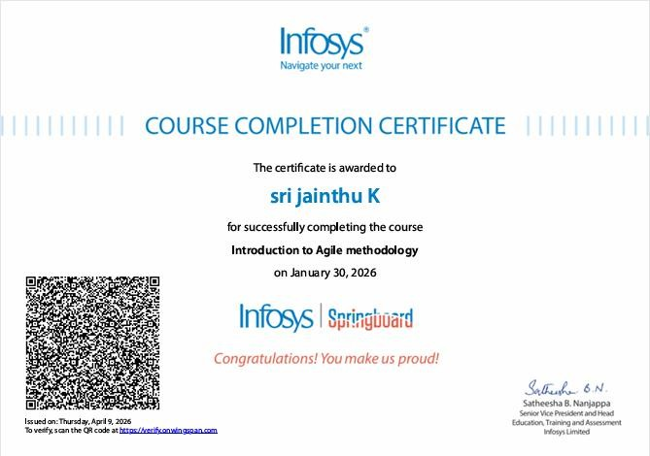

- Continuous Integration and Delivery - DevOps
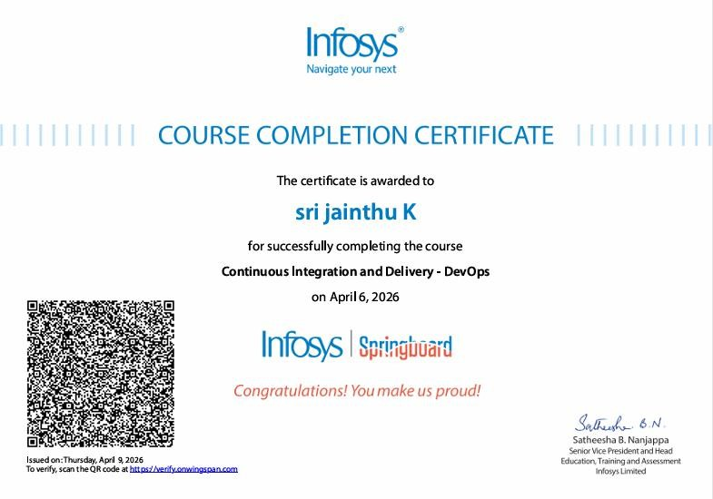

Conculsion:
Thus the implementation of CI/CD using the Jenkins tool was successfully done and the Smart Notice Board website was deployed in the vercel for live to the user and the achievements in the Infosys springboard also attached to the document.

