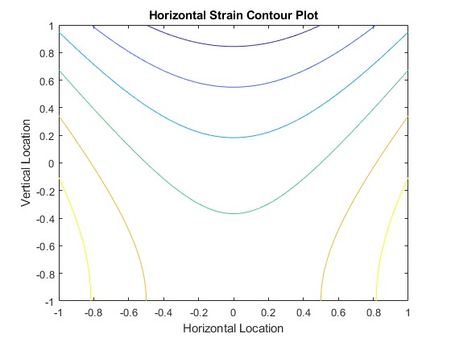

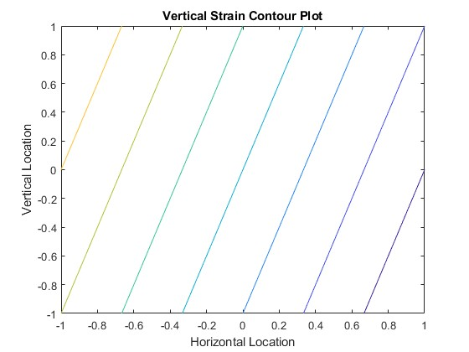

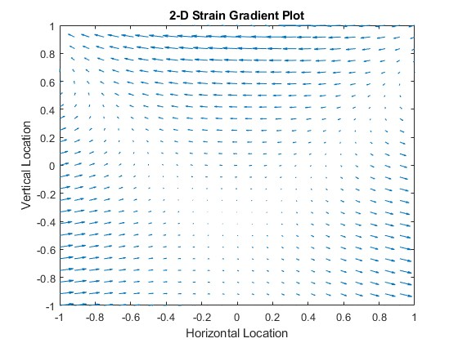

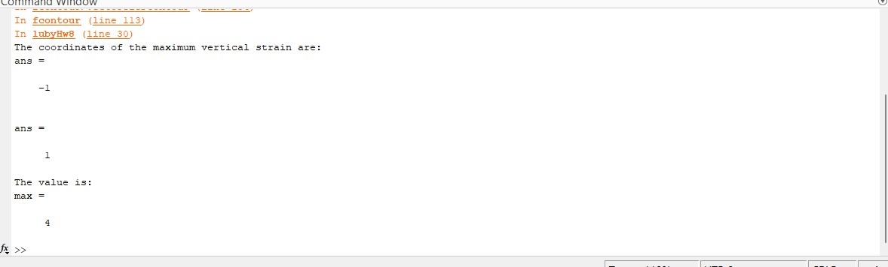

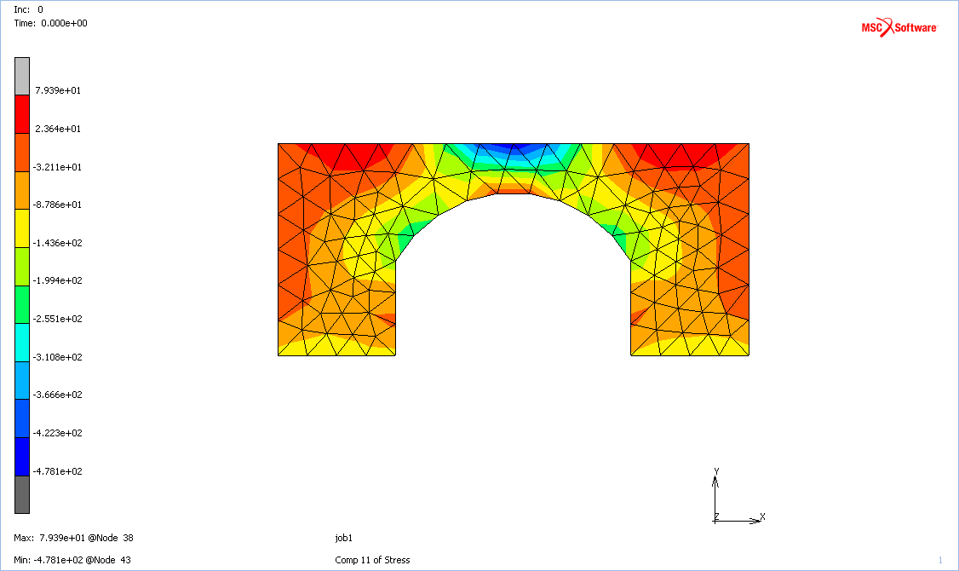

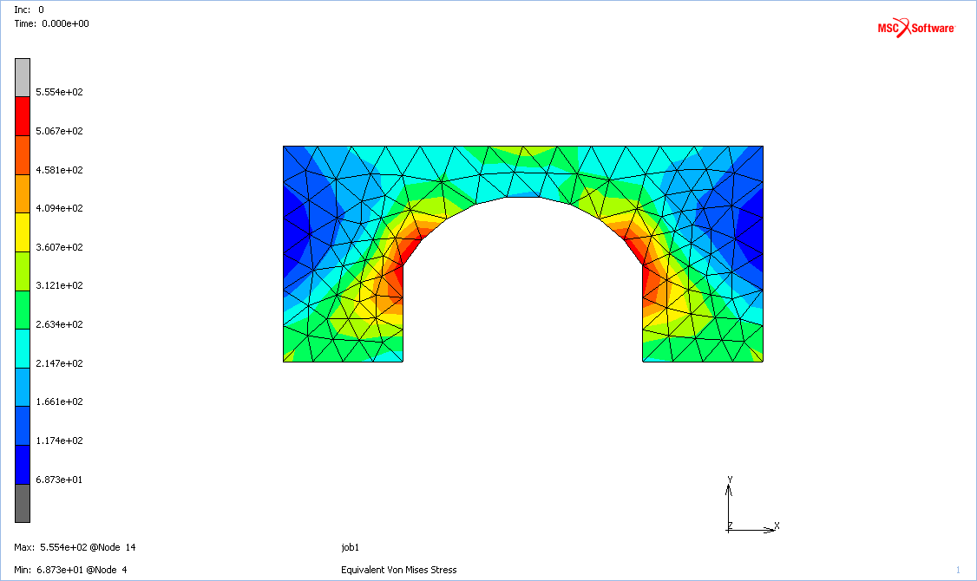

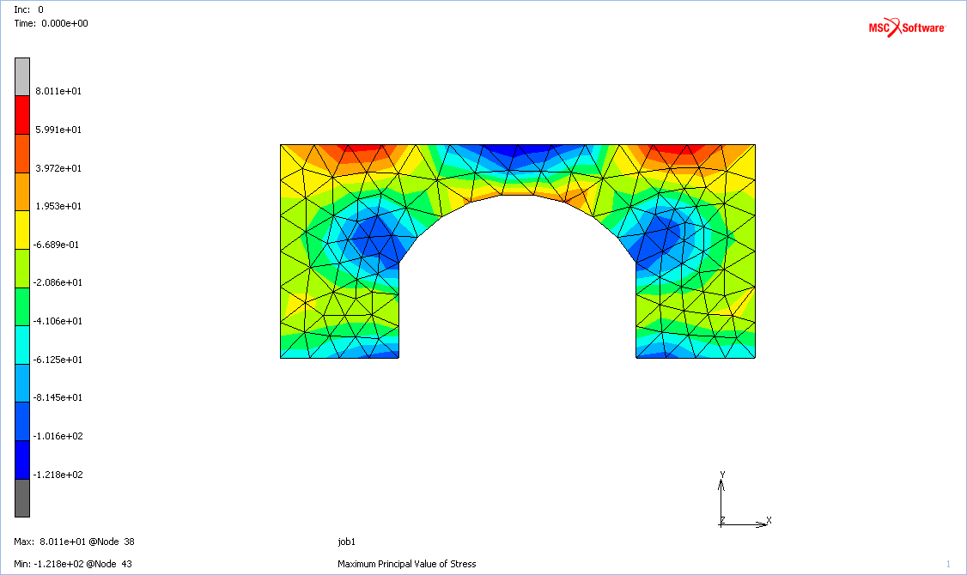

Theoretically, yes, because of Poisson interactions (not sure if that is what is at play, but I will explain what is). When a solid is compressed, like in the simulation, the dimension in the direction of the compressive force shrinks. The other dimensions, in this case, x and z, compensate with expansion because the compressed matter in the solid cannot simply fold in on itself. It is like displacing water. Floating something in water causes the water around it to move away.

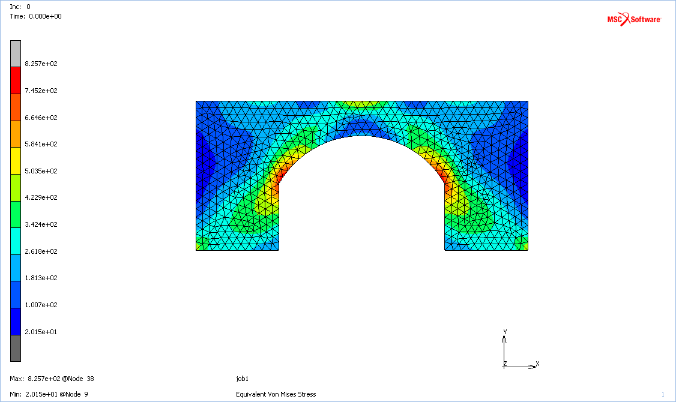

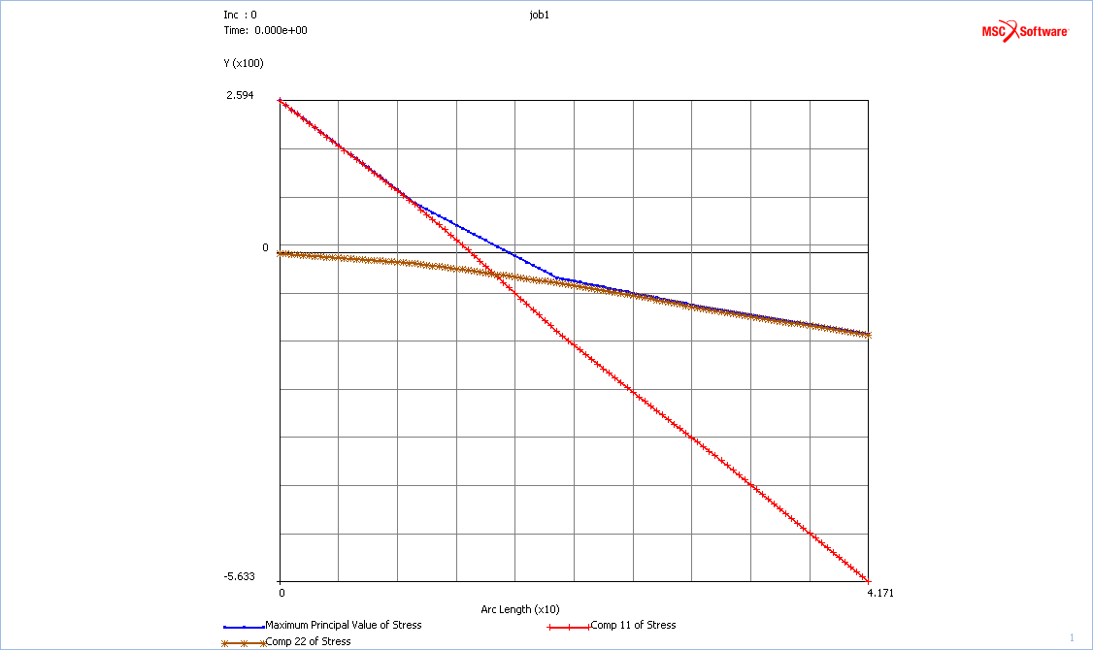

The maximum principal stress is greater near the bottom of the section. This is logical, since the weakest point of the section should be at the location of the maximum bending moment—in the middle.