Week 4 Assignment

David Russo

2/15/2017

* 4.7 #4
  1. In this scenario, 10% of the observations will be used to make a prediction.
  2. In this scenario, 1% of the observations will be used to make a prediction.
  3. In this scenario, ${10}^{−100}$ of the observations will be used to make a prediction.
  4. Consider a scenario where there are n = 1000 observations. If p = 1, we will utilize 100 observations per prediction on average. If p = 2, we will use 10 observations per prediction on average. If p = 100, we will use approximately 0 observations per prediction on average. In order to use even 10 observations on average, we would need n = ${10}^{21}$ observations when p = 100. The plot below demonstrates the percentage of observations used as a function of p (note that the y-axis is on a log scale).

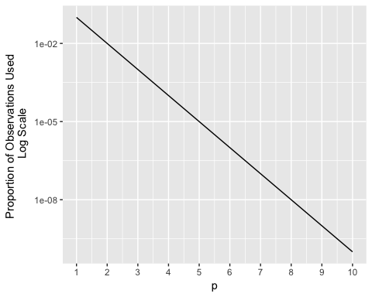

* 1. When p = 1, the hypercube (in this case, a 1D line) will have length 0.10. When p = 2, the hypercube (in this case, a 2D square) will have length $\sqrt{0.10}$ = 0.316. When p = 100, the hypercube (in this case, a 100D cube) will have length ${0.10}^{1/100}$ = 0.977. In general, for a given p, the hypercube will require a length of ${0.10}^{1/p}$. For an arbitrary percentage of the training observations $t$ for a hypercube of dimension $p$, the hypercube will need to be of length $t^{1/p}$.