March 22nd 2021
David Maluti
c/o Millennium1 Solutions

Dear David,

This letter is to inform you that your request to change your employment status from Full-time to Part-time has been approved. This change in status and the following conditions of employment will take effect on March 22, 2021:

- Your position as a Customer Services Representative in the Loblaw department and your base hourly rate will remain the same as current;
- You will receive 4% vacation pay based on your earnings each pay equivalent to two weeks’ pay per year to be scheduled and taken in accordance with Millennium1 Solutions vacation policy;
- You will no longer be eligible to participate in Millennium1 Solutions’ Employee Benefit plan;
- You will continue to report to your Team Leader.

All other conditions of your employment will remain the same.

Millennium1 Solutions operates on a 24/7/365 basis. You confirm your ability to be flexible and willing to move between the various shifts. The nature of our business requires flexibility from the company and all employees. Shifts and schedules may be subject to change depending on the needs of the business. Since this is a production environment, actual hours of work are dependent on work volume. During busy periods, you may be asked to work additional hours.

Should you be in agreement with the foregoing, please indicate your acceptance by signing and returning the duplicate copy of this letter.

In the event that you have questions or concerns, please do not hesitate to contact me.
Sincerely,
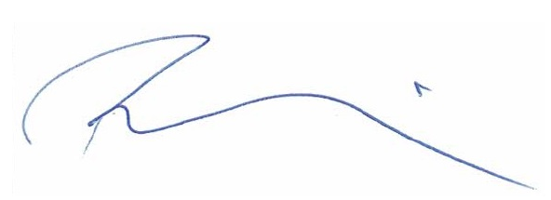

Ron Goodwin
Manager, Operations

I, David Maluti, accept this offer of Part-Time Hourly position on the terms outlined above.

Signature. dmaluti _________________________________________ Date March 22,2021

