Aircraft Power Network Requirements

Revision 2.0

April 12, 2013

### Overall System Requirements

The following requirements apply to the Aircraft Power Network.

* 1. Architecture

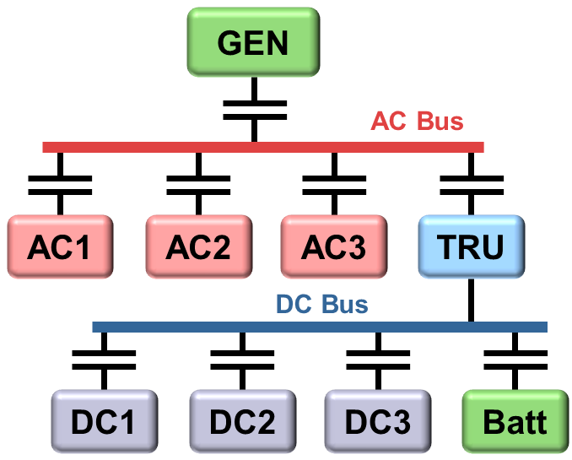

* 1. AC Bus 400 Hz, 200 V L-L
  2. DC Bus 28V

### Generator Requirements

The following requirements apply to the functionality of this module.

Generator

* 1. Power 50kW
  2. AC 400 Hz
  3. Line-Line Voltage 200V
  4. Rotor Inertia 0.2 kg*m^2

…

### TRU Requirements

The following requirements apply to the Transformer Rectifier Unit (TRU) module.

* 1. Power 4.2kW
  2. Frequency 400 Hz
  3. Winding 1 200 Vrms
  4. Winding 2 22 Vrms

…

### AC1 Requirements

The following requirements apply to the hydraulic pump:  
  
 Regular Gas

* 1. Power 12 kW
  2. Frequency 400 Hz
  3. Voltage (RMS) 200V Line-Line

…

### AC2 Requirements

The following requirements apply to the lighting system:

* 1. Power 1 kW
  2. Frequency 400 Hz
  3. Voltage (RMS) 200V Line-Line

…

### AC3 Requirements

The following requirements apply to the actuation system:

* 1. Power 2 kW
  2. Frequency 400 Hz
  3. Voltage (RMS) 200V Line-Line

…

…