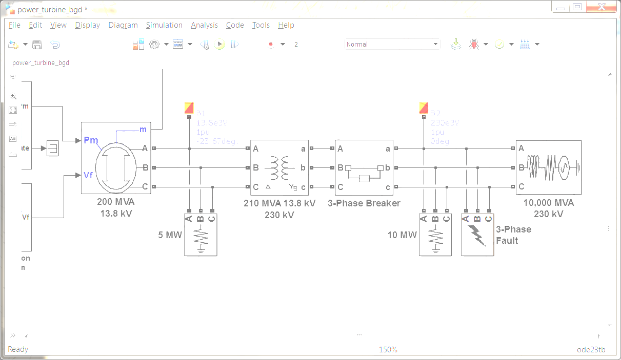**SimPowerSystems Hands-on Workshop**

**Modeling and Simulation of Electrical Power Systems with SimPowerSystemsTM**

**Description:** The primary goal of this workshop is to provide an in-depth look at some of the most important features and capabilities of SimPowerSystems. Through a variety of guided hands-on exercises and demonstration models, the participants will learn how to use MathWorks tools to appropriately handle typical problems associated with common electrical and electronic applications. In addition, the exercises in the workshop are designed to expose the users to numerous best practices and specific recommendations – tips and tricks – aimed at enhancing their Simulink modeling skills in general as well as helping them improve the overall performance of their electrical system simulations in particular.

**Modules:**

1. Introduction
2. Three-Phase Systems
3. Electrical Machines
4. Simulation Performance
5. Control of Electrical Machines
6. Custom Electrical Components
7. Power Electronics

**Duration:** Given the hands-on nature of this workshop, we recommend allotting between 90 to 120 minutes for each module. A standard one day session – 8 hours – should include the Introduction and a combination of four (4) additional modules at the most.

**Pre-requisites:**

* A working knowledge of both MATLAB and Simulink.
* A basic background in the fundamentals of electrical power systems and power electronics.
* Some experience with SimPowerSystems is desirable but not a must.

**Required MathWorks products:** *MATLAB, Simulink, Simscape and SimPowerSystems.*

**Additional products highlighted in the workshop:** *SimElectronics, SimHydraulics, Stateflow, Control System Toolbox, System Identification Toolbox, Robust Control Toolbox, Simulink Control Design, Optimization Toolbox, Global Optimization Toolbox, Simulink Design Optimization, MATLAB Report Generator, Simulink Report Generator, Parallel Computing Toolbox, MATLAB Coder and Simulink Coder.*

**Module Description:**

1. Introduction
   * SimPowerSystems component libraries
   * How does SimPowerSystems work?
2. Three-Phase Systems
   * Measurements
   * State initialization
   * Transformers
   * Star vs. delta connections
   * Floating vs. neutral connections
   * Reference frame transformations
3. Electrical Machines
   * Machine measurements
   * Machine initialization
   * Load flow calculation
   * Mechanical connections to loads and prime movers
4. Simulation Performance
   * Model fidelity vs. simulation speed
   * SimPowerSystems simulation modes
5. Control of Electrical Machines
   * Electrical disturbances
   * Control of synchronous generators
   * Electric motor drives
6. Custom Electrical Components
   * Simulink-based electrical components
   * Modifying Specialized Technology library components
   * Simscape language and Simscape Components library
   * Simscape and SimPowerSystems interfaces
   * Model sharing and IP protection
7. Power Electronics
   * SimElectronics or SimPowerSystems?
   * Ideal switching algorithm
   * Power quality and harmonic analysis
   * Control design and linearization

**Workshop Check List:**

This is a checklist of things that must be done prior to the day of the workshop:

* Participants need to bring their own laptops or workstations – this workshop is a hands-on event that will allow users to build and test models with the instructor – Sharing is OK, but we recommend no more than two people per station.
* The exercises and demonstration models were created using the latest release of MATLAB. Currently **R2014a**. Workstations should be running this release. If needed, contact your MathWorks account representative for a trial license of the required products.
* All software needs to be installed prior to the class. Installing the necessary products takes up a non-trivial amount of time. Attendees should be ready to hit the ground running.