Tags: Photography

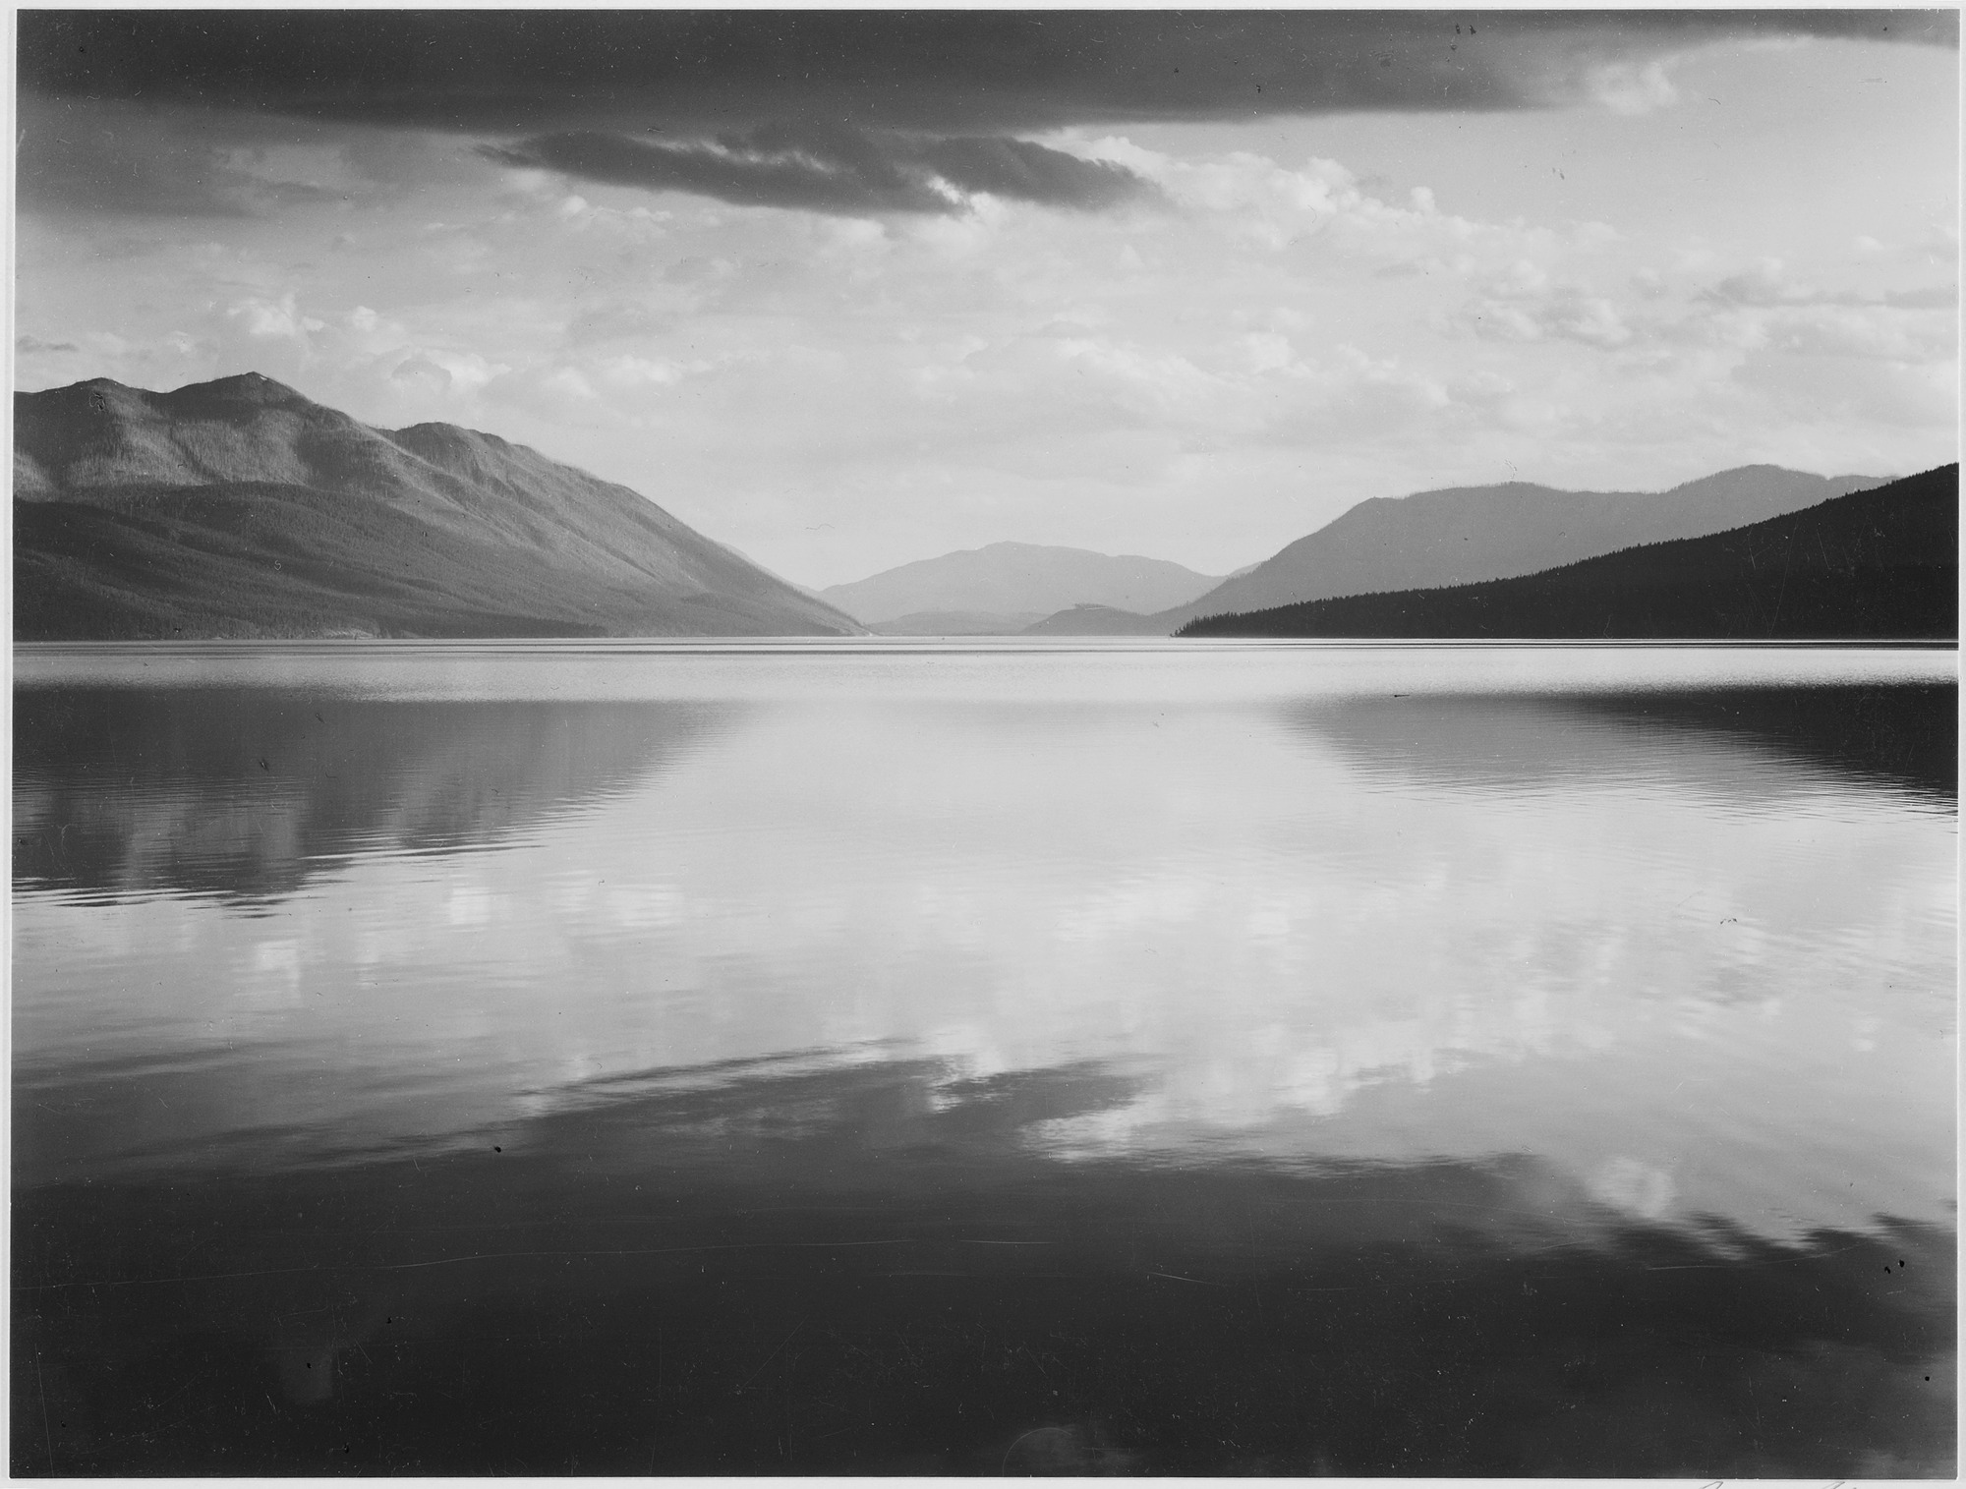

|  |  |
| --- | --- |
| **Title** | Looking across lake toward mountains, Evening, McDonald Lake, Glacier National Park, Montana |
| **Author** | Ansel Adams |
| **Record creator** | Department of the Interior. National Park Service. Branch of Still and Motion Pictures. |
| **Date** | between 1933 and 1942 |
| **Collection** | National Archives at College Park |
| **Source** | [NARA record: 1332556](https://research.archives.gov/person/1332556) |