Tags: Photography

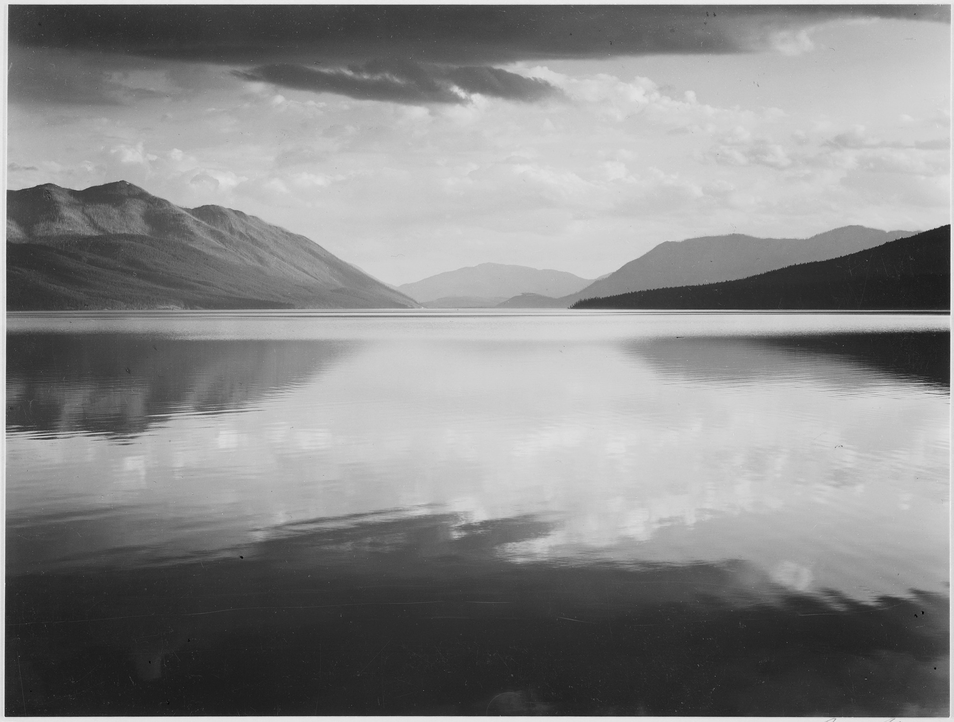
Title | Looking across lake toward mountains, Evening, McDonald Lake, Glacier National Park, Montana
Author | Ansel Adams
Record creator | Department of the Interior. National Park Service. Branch of Still and Motion Pictures.
Date | between 1933 and 1942
Collection | National Archives at College Park
Source | NARA record: 1332556

