EBTM 350 Pilot project (Lab 9)

18 November, 2024

# Background or Introduction

Labor market success has historically been linked with human capital aspects such as education and job training. There has also been interested in examining the impact of non-cognitive factors such as workers’ sex, age, and personality trait. We will rely on the Net Promoter Score (NPS) to understand customer loyalty at Cassius Weatherby. Focusing on the NPS of their sales professionals to identify factors influencing these scores. What are the key variables that significantly influence the salary of sales representatives at Cassius Weatherby? What are the most determinants for predicting the salary? What is the gender gap in the salary of sales representatives? The insights from this research will guide hiring and training decisions at the company

## Exploratory analysis

### 1. Exploring the range and distribution

# Loading the dataset   
library(readxl)  
TechSales <- read_excel("TechSales.xlsx")  
summary(TechSales)

## Sales_Rep Business Age Female   
## Min. : 1 Length:21990 Min. :21.0 Min. :0.000   
## 1st Qu.: 5498 Class :character 1st Qu.:32.0 1st Qu.:0.000   
## Median :10996 Mode :character Median :41.0 Median :0.000   
## Mean :10996 Mean :41.5 Mean :0.383   
## 3rd Qu.:16493 3rd Qu.:51.0 3rd Qu.:1.000   
## Max. :21990 Max. :65.0 Max. :1.000   
## Years College Personality Certficates   
## Min. : 1.000 Length:21990 Length:21990 Min. :0.000   
## 1st Qu.: 1.000 Class :character Class :character 1st Qu.:1.000   
## Median : 2.000 Mode :character Mode :character Median :2.000   
## Mean : 2.646 Mean :2.612   
## 3rd Qu.: 2.000 3rd Qu.:4.000   
## Max. :13.000 Max. :6.000   
## Feedback Salary NPS   
## Min. :1.080 Min. : 21000 Min. : 1.000   
## 1st Qu.:1.990 1st Qu.: 57000 1st Qu.: 5.000   
## Median :2.660 Median : 70000 Median : 6.000   
## Mean :2.665 Mean : 73674 Mean : 6.278   
## 3rd Qu.:3.390 3rd Qu.: 87000 3rd Qu.: 8.000   
## Max. :4.000 Max. :197000 Max. :10.000

The age range starts at the minimum of 21 years to a maximum of 65 years and the average age is 41.5 years. For the NPS, the third quartile (8) and the minimum are (1) which shows that,50% of scores are clustered within this range. The median salary is $70,000. The average salary is approximately $73,674, indicating a few higher salaries influencing the average. The first quartile is $57,000 and the third quartile is $87,000, suggesting that 50% of salaries fall within this range. The maximum salary also shows that you can earn up to $197,000.

# Understand the distribution of these variables   
hist(TechSales$Salary)

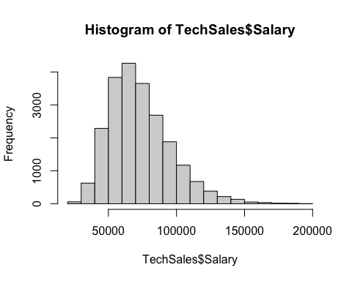

boxplot(TechSales$Salary, horizontal = TRUE)

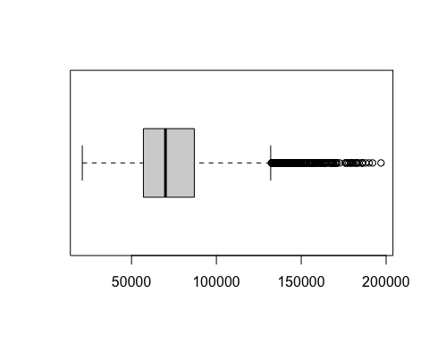

# Try to explore other variables   
hist(TechSales$Certficates)

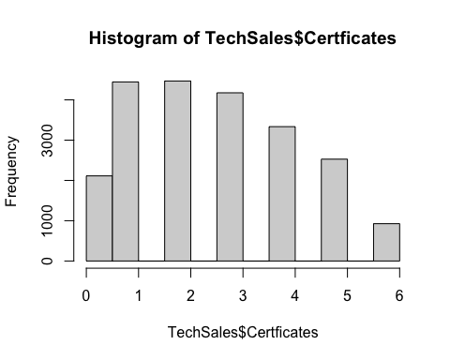

boxplot(TechSales$Certficates, horizontal = TRUE)

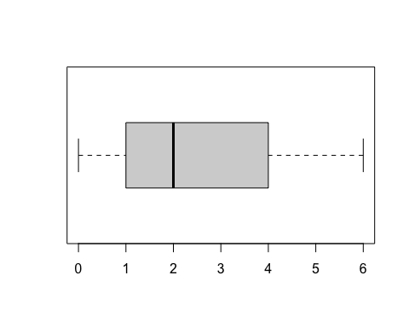

hist(TechSales$NPS)

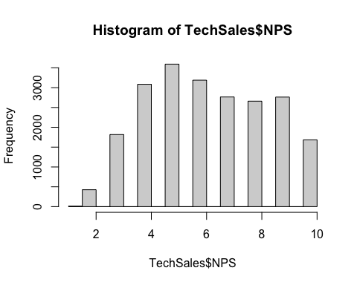

summary(TechSales$NPS)

## Min. 1st Qu. Median Mean 3rd Qu. Max.   
## 1.000 5.000 6.000 6.278 8.000 10.000

boxplot(TechSales$NPS, horizontal = TRUE)

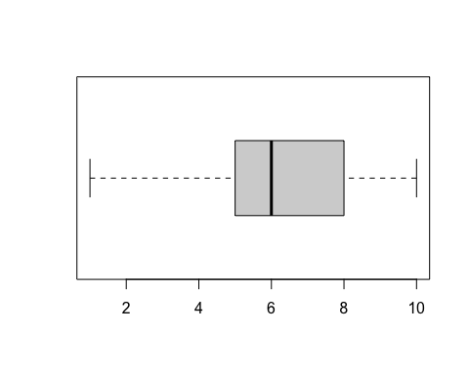

hist(TechSales$Years)

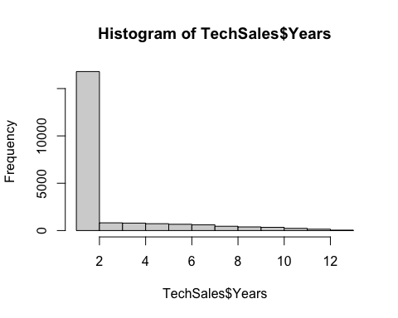

The population average salary @ 95% confidence level is around 73.3K

# Hint: how to construct confidence interval in R? Is it t.test() function?  
t.test(TechSales$Salary, conf.level = 0.95)

##   
## One Sample t-test  
##   
## data: TechSales$Salary  
## t = 479.8, df = 21989, p-value < 2.2e-16  
## alternative hypothesis: true mean is not equal to 0  
## 95 percent confidence interval:  
## 73372.81 73974.75  
## sample estimates:  
## mean of x   
## 73673.78

Exploring the main variables to study: For the most significant variables we can visualize a histogram for the NPS Score and the Salary, the higher the NPS Score the higher the salary, followed by a box plot for both Variables. The number of certifications by a representative also affects NPS and the salary of the sales representative.

# For categorical variables, how should you tabulate or visualize them? Histogram doesn't work  
table(TechSales$Female)

##   
## 0 1   
## 13567 8423

tab1 <- table(TechSales$Female)  
barplot(table(TechSales$Female))

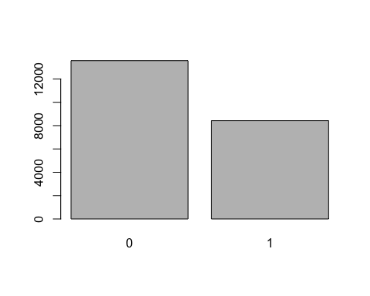

tab2 <- prop.table(tab1)  
tab2

##   
## 0 1   
## 0.6169623 0.3830377

barplot(tab2)

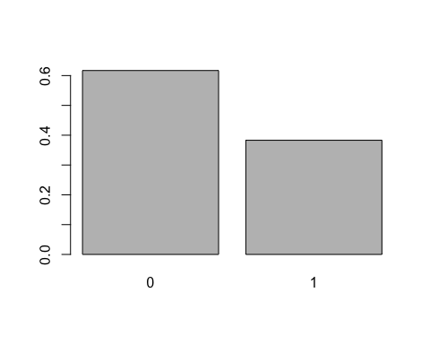

table(TechSales$Female)

##   
## 0 1   
## 13567 8423

tab3 <- table(TechSales$Personality)  
tab3

##   
## Analyst Diplomat Explorer Sentinel   
## 2659 7849 8200 3282

table(TechSales$Business)

##   
## Hardware Software   
## 9860 12130

boxplot(TechSales$Salary ~ TechSales$Female)

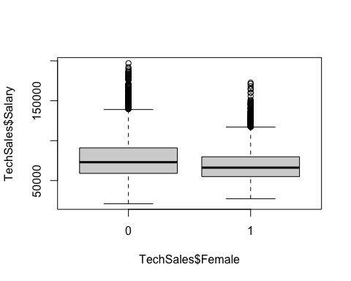

plot(TechSales$Salary ~ TechSales$Female)

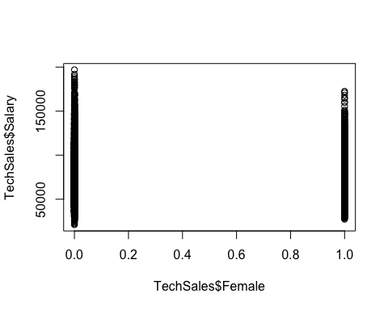

result <- aov(Salary ~ Personality, data = TechSales)  
summary(result)

## Df Sum Sq Mean Sq F value Pr(>F)   
## Personality 3 9.885e+11 3.295e+11 695.8 <2e-16 ***  
## Residuals 21986 1.041e+13 4.736e+08   
## ---  
## Signif. codes: 0 '***' 0.001 '**' 0.01 '*' 0.05 '.' 0.1 ' ' 1

# Try to do this for other categorical variables  
table(TechSales$Certficates)

##   
## 0 1 2 3 4 5 6   
## 2113 4445 4468 4175 3335 2528 926

hist(TechSales$Age)

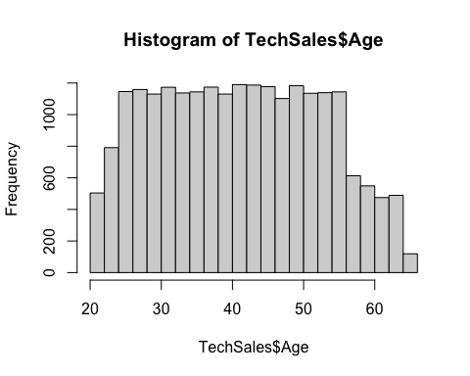

62% of the sales representatives are males and 38% are females, where male sales averages approximately 13,357, while for females (represented as 1), it’s around 8,423. Average salaries among the four personality types. Sales professionals identified as Diplomats and Explorers have higher average salaries, approximately $78,597 and $77,899 respectively, compared to Analysts and Sentinels, who earn around $62,994 and $62,388 respectively.

### 2. Exploring the association between Earnings and other numerical variables

# 2. Exploring the association between Salary and other numerical variables  
# Visualization tool  
plot(TechSales$Salary ~ TechSales$Age)

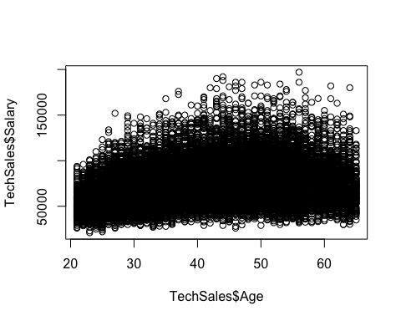

# Quantification using correlation coefficient  
cor(TechSales$Salary, TechSales$Years)

## [1] 0.09308011

cor(TechSales$Salary, TechSales$Certficates)

## [1] 0.4584402

cor(TechSales$Salary, TechSales$NPS)

## [1] 0.5499314

The relationship between Sales and certifications and NPS is strong as it is approximately closer to 1 as compared to years of working which has a week relationship.

### 3. Exploring the association between Earnings and categorical variables

# 3. Exploring the association between Salary and categorical variables  
tapply(TechSales$Salary, TechSales$Female, mean)

## 0 1   
## 76597.70 68964.19

# How to visualize this relationship using boxplot tool  
boxplot(TechSales$Salary ~ TechSales$Female)



62% of the sales representatives are males and 38% are females, where male earning averages approximately $76,598, while for females (represented as 1), it’s around $68,964.

## 4.Building models

# Build simple models based on your intuition  
TechSales$Sales_Rep <- NULL   
# If you want to predict salary using: Age, Female, Years, College, how?  
SalaryModel1 <- lm(Salary ~ Age + Female +Years+ College, data = TechSales)  
summary(SalaryModel1, digits = 3)

##   
## Call:  
## lm(formula = Salary ~ Age + Female + Years + College, data = TechSales)  
##   
## Residuals:  
## Min 1Q Median 3Q Max   
## -59642 -14841 -2753 11850 112918   
##   
## Coefficients:  
## Estimate Std. Error t value Pr(>|t|)   
## (Intercept) 43441.39 631.75 68.76 <2e-16 ***  
## Age 516.92 12.45 41.52 <2e-16 ***  
## Female -7463.47 291.85 -25.57 <2e-16 ***  
## Years 738.76 58.38 12.65 <2e-16 ***  
## CollegeYes 12157.41 352.52 34.49 <2e-16 ***  
## ---  
## Signif. codes: 0 '***' 0.001 '**' 0.01 '*' 0.05 '.' 0.1 ' ' 1  
##   
## Residual standard error: 21030 on 21985 degrees of freedom  
## Multiple R-squared: 0.1468, Adjusted R-squared: 0.1466   
## F-statistic: 945.4 on 4 and 21985 DF, p-value: < 2.2e-16

model2 <- lm(Salary ~ Age+Female+Certficates, data = TechSales)  
summary(model2)

##   
## Call:  
## lm(formula = Salary ~ Age + Female + Certficates, data = TechSales)  
##   
## Residuals:  
## Min 1Q Median 3Q Max   
## -56649 -13083 -2027 11011 114043   
##   
## Coefficients:  
## Estimate Std. Error t value Pr(>|t|)   
## (Intercept) 37257.58 536.67 69.42 <2e-16 ***  
## Age 542.00 11.17 48.51 <2e-16 ***  
## Female -7466.69 262.26 -28.47 <2e-16 ***  
## Certficates 6425.83 77.36 83.06 <2e-16 ***  
## ---  
## Signif. codes: 0 '***' 0.001 '**' 0.01 '*' 0.05 '.' 0.1 ' ' 1  
##   
## Residual standard error: 18900 on 21986 degrees of freedom  
## Multiple R-squared: 0.3109, Adjusted R-squared: 0.3108   
## F-statistic: 3307 on 3 and 21986 DF, p-value: < 2.2e-16

model3 <- lm(Salary ~ Certficates+Feedback, data = TechSales)  
summary(model3)

##   
## Call:  
## lm(formula = Salary ~ Certficates + Feedback, data = TechSales)  
##   
## Residuals:  
## Min 1Q Median 3Q Max   
## -64993 -13064 -1646 11203 109867   
##   
## Coefficients:  
## Estimate Std. Error t value Pr(>|t|)   
## (Intercept) 34274.79 472.39 72.56 <2e-16 ***  
## Certficates 6352.67 77.44 82.03 <2e-16 ***  
## Feedback 8558.61 152.54 56.11 <2e-16 ***  
## ---  
## Signif. codes: 0 '***' 0.001 '**' 0.01 '*' 0.05 '.' 0.1 ' ' 1  
##   
## Residual standard error: 18930 on 21987 degrees of freedom  
## Multiple R-squared: 0.3091, Adjusted R-squared: 0.309   
## F-statistic: 4918 on 2 and 21987 DF, p-value: < 2.2e-16

plot(TechSales$Salary ~ TechSales$Certficates)  
lines(lowess(TechSales$Age, TechSales$Salary), col = "blue")

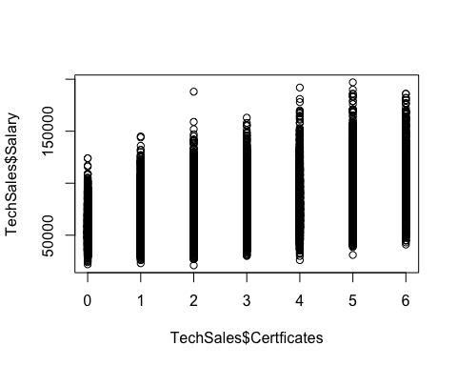

plot(TechSales$Salary ~ TechSales$NPS)

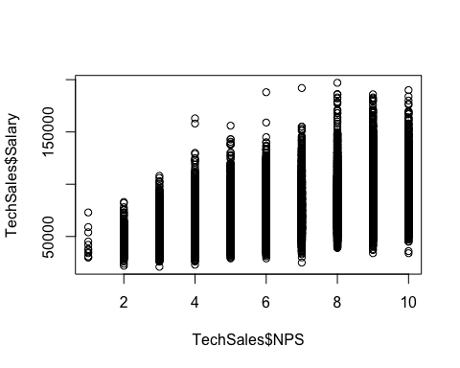

full_model <- lm(Salary ~ ., data = TechSales)  
summary(full_model)

##   
## Call:  
## lm(formula = Salary ~ ., data = TechSales)  
##   
## Residuals:  
## Min 1Q Median 3Q Max   
## -49027 -9758 -1007 8658 102669   
##   
## Coefficients:  
## Estimate Std. Error t value Pr(>|t|)   
## (Intercept) -7156.280 667.630 -10.719 < 2e-16 ***  
## BusinessSoftware -1623.446 211.592 -7.673 1.76e-14 ***  
## Age 508.906 9.123 55.784 < 2e-16 ***  
## Female -7654.444 208.179 -36.769 < 2e-16 ***  
## Years 386.313 43.306 8.920 < 2e-16 ***  
## CollegeYes 11235.487 252.571 44.484 < 2e-16 ***  
## PersonalityDiplomat 11483.177 357.370 32.132 < 2e-16 ***  
## PersonalityExplorer 11698.514 355.437 32.913 < 2e-16 ***  
## PersonalitySentinel -275.133 390.116 -0.705 0.481   
## Certficates 5351.422 73.021 73.286 < 2e-16 ***  
## Feedback 7233.601 129.304 55.942 < 2e-16 ***  
## NPS 1894.261 65.084 29.105 < 2e-16 ***  
## ---  
## Signif. codes: 0 '***' 0.001 '**' 0.01 '*' 0.05 '.' 0.1 ' ' 1  
##   
## Residual standard error: 14950 on 21978 degrees of freedom  
## Multiple R-squared: 0.5691, Adjusted R-squared: 0.5689   
## F-statistic: 2639 on 11 and 21978 DF, p-value: < 2.2e-16

plot(full_model)

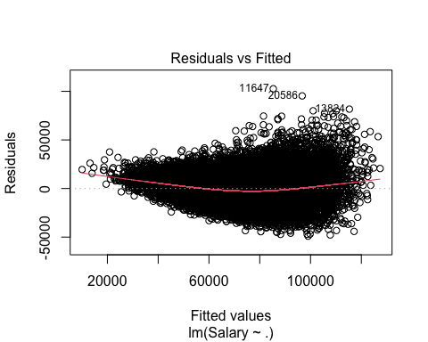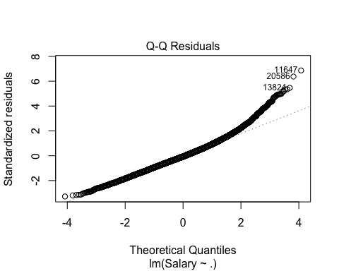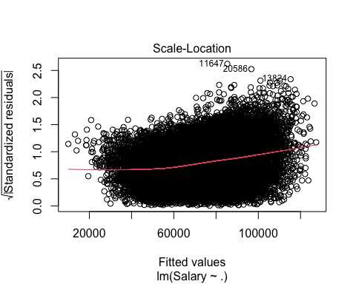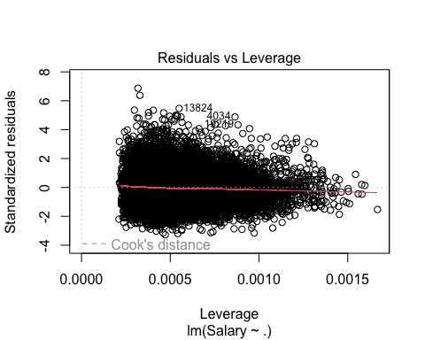

model4 <- lm(Salary ~ NPS+ Certficates + Feedback, data = TechSales)  
  
# If you want to predict NPS using: Age, Female, Years, College, how?  
#NPSModel1 <- lm(NPS ~ , data = TechSales)  
#summary(NPSModel1, digits = 3)

# If you're interested in a different model using Age, Female, Years, College, Certificates, Business, how?  
#SalaryModel2 <- lm(Salary ~ , data = TechSales)  
#summary(SalaryModelFull, digits = 3)  
  
# What if you want to use all available variables for your linear regression model, how?  
#SalaryModelFull <- lm(Salary ~ , data = TechSales)  
#summary(SalaryModelFull, digits = 3)

## Interpreting models

model1: being everything constant, the coefficient for female is negative, indicating that being female is associated with a decrease in salary of approximately $7463.47 compared to males. The R-squared is 0.1468, indicating that about 1.5% of the variation in salary can be explained by age, gender,years and college.

model2 for each additional year of experience, there is an average salary increase of $542.00, a figure that does not hold statistical significance, suggesting a weak positive correlation between age and earnings. For each certification, salary increases by 6425.83, indicating a strong relationship between certification and salary. Multiple R-squared values of 0.3109, meaning nearly 31.09% of the salary variation is accounted for by the second model.

full_model R-squared value is 0.5691, indicating that about 56.92% of the variation in salary can be explained by all the predictors in the model. The t-tests show that most are significant, with p-values well below the 0.05 threshold, indicating a strong likelihood that these variables have a true effect on salary. Notably, the coefficients for age, college education, personality types (Diplomat and Explorer), certificates, feedback, and NPS are all positive, suggesting that higher values in these predictors are associated with higher salaries.

## Conclusion

Upon examining the variables, we discovered that the number of Certificates obtained, and the Feedback score, NPS are the variables most strongly correlated with the Salary of sales representatives at Cassius Weatherby. These variables significantly contribute to explaining the salary variations, which is why Model 4 (constructed as model4 <- lm(Salary ~ NPS+ Certificates + Feedback, data = TechSales)) performs comparably to the full model in terms of the Multiple R-squared and Adjusted R-squared values.